VLA Client and Service Data Analysis

January 2017

Acknowledgment: This report was written by Analytics for Change as part of a project commissioned by Victoria Legal Aid.

Contact: research@vla.vic.gov.au

© 2017 Victoria Legal Aid. This work is licensed under a [Creative Commons Attribution 4.0 licence](http://creativecommons.org/licenses/by/4.0/). You are free to re-use the work under that licence, on the condition that you credit Analytics for Change and Victoria Legal Aid, indicate if changes were made and comply with other licence terms. The licence does not apply to any images or branding, including the Victoria Legal Aid and the Analytics for Change logo

Disclaimer. The material in this publication is intended for general information only. Any views expressed are those of the author and not intended to represent the views of Victoria Legal Aid.

Published by Victoria Legal Aid

Contents

VLA Client and Service Data Analysis 1

Crossover between Top Matter Types 1

Aboriginal and Torres Strait Islander 3

10-17 years of age at time of first service 4

LOTE (Cultural and Linguistically Diverse) 5

Priority Clients 6

Interpreting this report 6

Aboriginal and Torres Strait Islander 7

Demographics 7

Services 14

Culturally and Linguistically Diverse 18

Demographics 18

Services 27

Youth (10-17) at time of first service 31

Demographics 31

Services 37

Crossover Clients 41

High Cost Clients 41

Appendix 1 - List of tables 50

Appendix 2 - List of figures 52

# VLA Client and Service Data Analysis

VLA has offered 1,565,713 legal services across all 79 local government areas. This report provides an analysis of how VLA’s clients utilised the different services provided by the organisation from July 2006 to June 2016 to identify trends in the levels of service delivery.

## Crossover between Top Matter Types

To examine the crossover between top matter types for particular client groups, four data sets were created:

* ‘Services’, which contained every service delivered;
* ‘Services to Aboriginal and Torres Strait clients’, which contained every service delivered to clients who identify as Aboriginal and Torres Strait Islanders;
* ‘Services to LOTE clients’, which contained every service delivered to clients who spoke a language other than English at home; and
* ‘Services to Youth clients’, which contained every service delivered to clients who were 10 years or older and younger than 18 years at the date of their first service.

For each of the four data sets, the top 10 occurring matter types were identified.

A matrix was produced for each data set that indicated, for each client of that data set, which of those top 10 matters for that data set, they had been involved with, at least once.

Another matrix was produced for each data set that indicated, for each of the top 10 matter types for that data set, the number of unique clients that had been delivered a service of that matter type in concurrence with each of the other 9 matter types.

Of the top 10 matter types for all clients, a significant number of clients were involved in matters relating to both the Family Violence Protection Act and spending time with their children. A significant number of clients involved in matters relating to the Family Violence Protection Act had also dealt with a matter of assault. In addition, a significant number of clients who had been involved in a matter relating to theft also required assistance with a matter relating to theft from a shop.

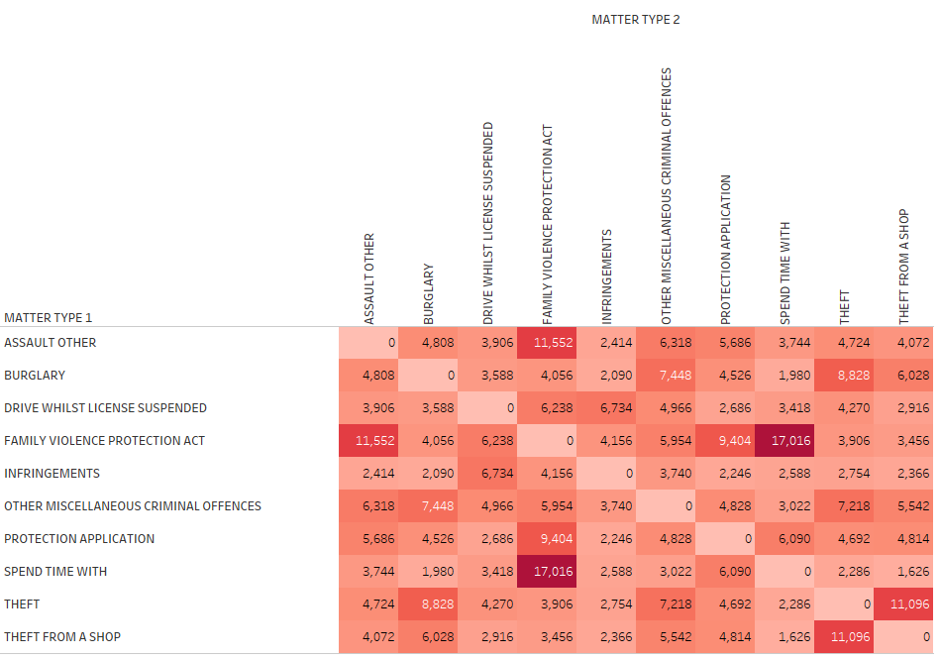

Figure : Heat map for crossover between top matter types (service numbers)

## Aboriginal and Torres Strait Islander

Of the top 10 matter types for all clients, a significant number of Aboriginal and Torres Strait Islanders were involved in matters relating to both the Family Violence Protection Act and a protection application. A significant number of clients involved in matters relating to a protection application had also dealt with a matter of assault, and a significant number of clients who had been assisted with a charge of burglary had also been helped with a charge of theft.

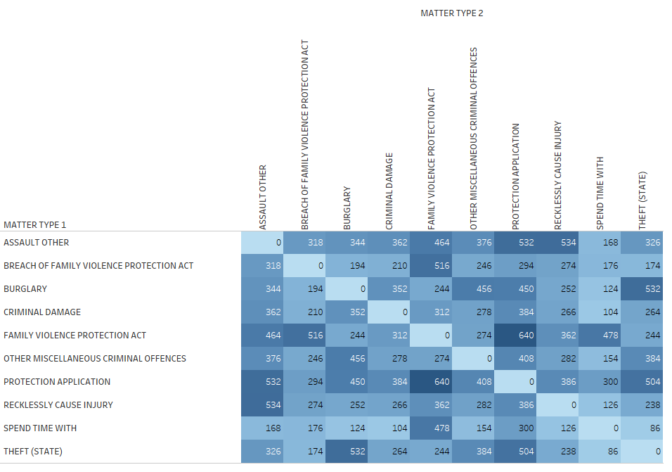

Figure : Heat map for crossover between top matter types for Aboriginal and Torres Strait Islander clients

## 10-17 years of age at time of first service

Of the top 10 matter types for all clients, a significant number of clients who were 10-17 years of age at their first time of service and involved in matters relating to a protection application were also involved in a matter relating to assault, burglary, the Family Violence Protection Act, theft, or other miscellaneous criminal offences.

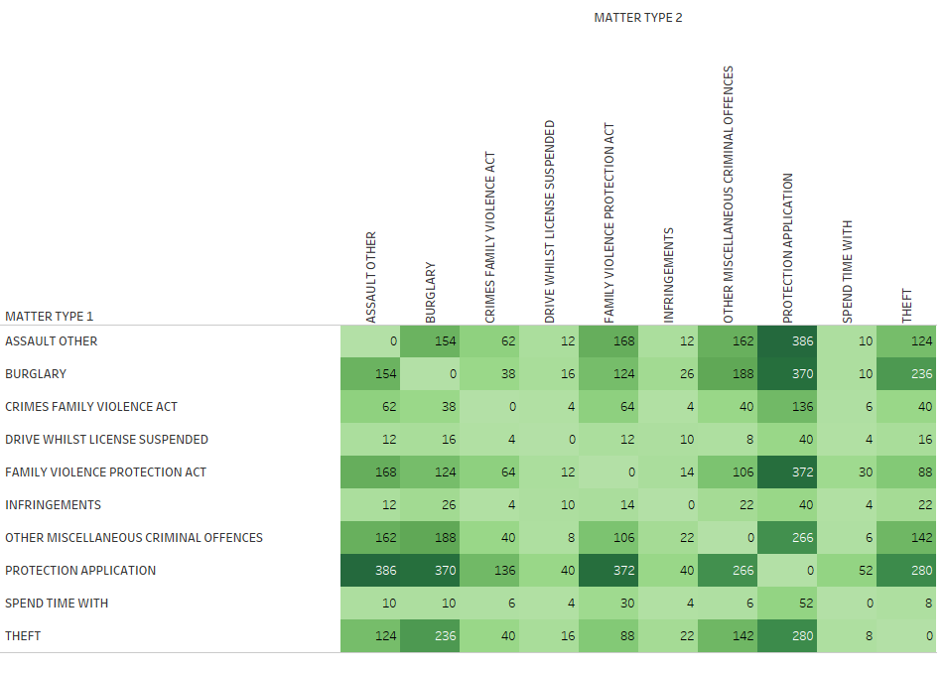

Figure : Heat map for crossover between top matter types for 10-17 years of age at time of first service clients

## LOTE (Cultural and Linguistically Diverse)

Of the top 10 matter types for all clients, a significant number of clients who use a language other than English and were involved in matters relating to the Family Violence Protection Act, were also assisted with matters relating to breaching said Act, assault, obtaining access to their children, and intentionally causing injury. A significant number of clients involved in matters relating to driving with a suspended licence had also dealt with an infringement and/or the Family Violence Protection Act.

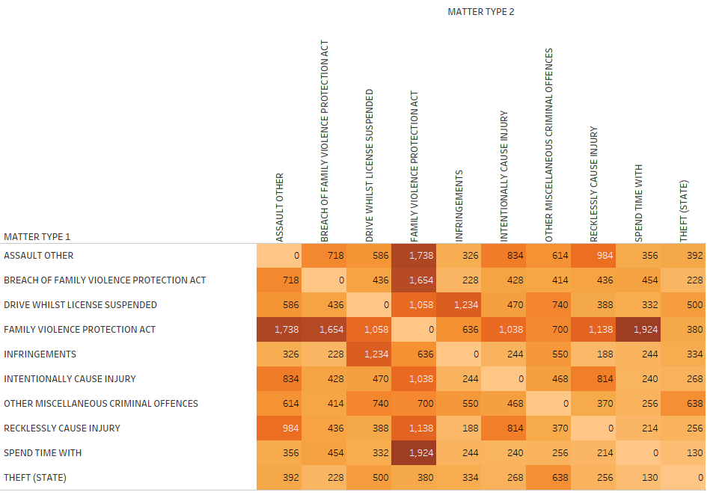

Figure : Heat map for crossover between top matter types for culturally and linguistically diverse clients

# Priority Clients

VLA provides services to diverse customers and for the purposes of this project, has defined the following groups as priority clients groups for data analysis:

* Aboriginal and Torres Strait Islander
* Culturally and Linguistically Diverse
* Youth (10-17 yo) at the time of first service Crossover clients
* High cost clients

The first three groups (Aboriginal and Torres Strait Islander, Culturally and Linguistically Diverse and Young) are most likely to have indicators of disadvantage and to access multiple VLA services. There are significant differences between the general client population and the identified groups above that will be explored in the following sections.

Additionally, the cost analysis was done following the following weights for the different service types:

* Grant of Aid: 15
* Minor Work: 2
* Duty Lawyer: 1
* Legal Advice: 0.5

## Interpreting this report

The analysis was done focusing on the **services provided**, which means that all percentages in the following client profiles are **the percentage of services** allocated to clients that belong to the segment that is being discussed. So for instance, Aboriginal and Torres Strait Islander clients may make up 2 percent of our total client population, but have received 3 of total services.

## Aboriginal and Torres Strait Islander

There is a total of 48,082 VLA services allocated to clients who identify themselves as Aboriginal or Torres Strait Islander which represents 3 percent of VLA’s services. These clients have been identified as a group that is more likely to have signs of disadvantage. The following analysis shows the differences between this group and the general clients to understand their interaction with VLA.

### Demographics

The demographics of the Aboriginal and Torres Strait Islander clients were analysed to see how they differ from the general population.

##### Gender

Services provided to Aboriginal and Torres Strait Islander clients are slightly less likely to be for males and more likely to be for females than the general population. Although very slight, there is a difference of about 3 percent in the split between two genders for Aboriginal and Torres Strait Islander compared to the general clients. However, in both cases, more services have been provided to male clients.

Table : Gender of general clients compared to Aboriginal and Torres Strait Islander clients

|  |  |
| --- | --- |
| **ALL VLA clients** | **ABORIGINAL AND TORRES STRAIT ISLANDER clients** |
|  |  |

##### Location

Most Aboriginal and Torres Strait Islander clients that received a service from VLA come from Greater Shepparton, East Gippsland and Darebin. The percentages allocated to the top three locations for Aboriginal and Torres Strait Islander clients are greater than the top three locations for general clients.

Table : Location of general clients compared to Aboriginal And Torres Strait Islander clients

|  |  |
| --- | --- |
| **ALL VLA clients** | **ABORIGINAL AND TORRES STRAIT ISLANDER clients** |
|  |  |

##### Age of contact

The median age of contact of Aboriginal and Torres Strait Islander clients is 29 years old, which is 15 percent less than 34 years old of the general clients. The range is wider for general clients compared to Aboriginal and Torres Strait Islander clients.

All VLA clients

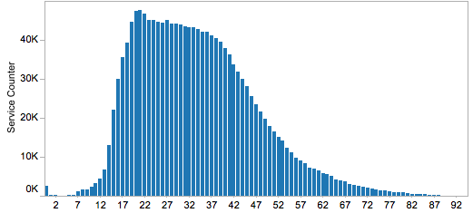

Figure : Age of contact of general clients

Aboriginal And Torres Strait Islander clients

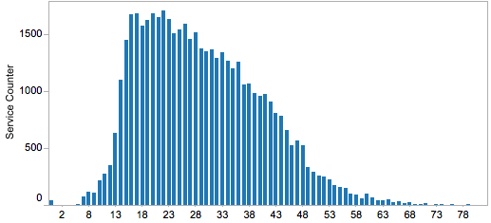

Figure : Age of contact of aboriginal and Torres strait islanders

##### Disability

The percentage of services provided to Aboriginal and Torres Strait Islander clients with a disability (30.60%) is higher than the percentage allocated to general clients (20.54%).

Table : Disability status of general clients compared to Aboriginal And Torres Strait Islander clients

|  |  |
| --- | --- |
| **ALL VLA clients** | **ABORIGINAL AND TORRES STRAIT ISLANDER clients** |
|  |  |

The percentage of services provided to Aboriginal and Torres Strait Islander clients with a disability that have mental health issues is slightly lower than general clients, however this disability is still the most common in both groups.

Table : Disability description of general clients compared to Aboriginal And Torres Strait Islander clients

|  |  |
| --- | --- |
| **ALL VLA clients** | **ABORIGINAL AND TORRES STRAIT ISLANDER clients** |
|  |  |

##### Benefit status

The percentage of services provided to Aboriginal and Torres Strait Islander who receive benefits is higher compared to the general clients with a difference of almost 5 percent.

Table : Benefit status of general clients compared to Aboriginal and Torres strait islander clients

|  |  |
| --- | --- |
| **ALL VLA clients** | **ABORIGINAL AND TORRES STRAIT ISLANDER clients** |
|  |  |

The percentage of services for Aboriginal and Torres Strait Islander clients that receive Newstart allowance is around 2% less that for general clients, yet this type of benefit is the most common for both groups. The percentage of services for Aboriginal and Torres Strait Islander clients who receive a Disability Support Pension is 5 percent more than general clients.

Table : Benefit type of general clients compared to Aboriginal and Torres Strait Islander clients

|  |  |
| --- | --- |
| ALL VLA clients | ABORIGINAL AND TORRES STRAIT ISLANDER clients |
|  |  |

##### Employment

The percentage of services provided to non-employed Aboriginal And Torres Strait Islander clients (84.42%) is considerably higher than the one for general clients (52.53%). This represents a difference of almost 32 percent.

Table : Employment status of general clients compared to Aboriginal and Torres Strait islander clients

|  |  |
| --- | --- |
| **ALL VLA clients** | **ABORIGINAL AND TORRES STRAIT ISLANDER clients** |
|  |  |

##### Living arrangements

Although the most common living arrangement for services provided to both general clients and Aboriginal and Torres Strait Islander clients is single, there is a higher percentage for Aboriginal and Torres Strait Islander clients. In this case 78 % percent of the services were given to single Aboriginal And Torres Strait Islander clients compared to 61.67 percent for single general clients.

*Note limitations of data:* Living arrangements are subject to frequent change, so the data is likely reflect living arrangements at time of first service unless records were updated for each service.

Table : Living arrangements of general clients compared to Aboriginal and Torres Strait Islander clients

|  |  |
| --- | --- |
| VLA ALL clients | ABORIGINAL AND TORRES STRAIT ISLANDER clients |
|  |  |

##### Dependents

For both services allocated to general clients and Aboriginal and Torres Strait Islander clients, the most common number of dependents is 0, and this number decreases as the number of dependents increase.

Figure 2.1.10. Number of dependents of general clients compared to Aboriginal and Torres Strait Islander clients

ALL VLA Clients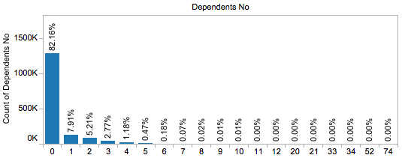

Figure : Number of dependents of general clients

Aboriginal And Torres Strait Islander clients

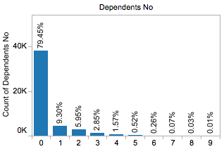

Figure : Number of dependents of Aboriginal and Torres Strait Islander clients

### Services

The services that Aboriginal and Torres Strait Islander clients utilised were analysed with a focus on the different matter types. Differences between Aboriginal and Torres Strait Islander clients and general clients are outlined below.

##### Top 10 Matter Types

The most frequent matter types for Aboriginal and Torres Strait Islander clients is child protection applications, followed by family violence protection, burglary, and assault (other). The rankings by frequency of the top matter types differ across the general and the Aboriginal and Torres Strait Islander group.

Table : Matter type of general clients compared to Aboriginal and Torres Strait Islander clients

|  |  |
| --- | --- |
| ALL VLA clients | ABORIGINAL AND TORRES STRAIT ISLANDER clients |
|  |  |

##### Top Most Costly Matter Types

The costliest matter type for Aboriginal and Torres Strait Islander clients include protection applications (which is also the costliest for general clients), followed by burglary, spend time with children, recklessly cause injury, and assault other.

Table : Matter type cost of general clients compared to Aboriginal and Torres Strait Islander clients

|  |  |
| --- | --- |
| ALL VLA clients | ABORIGINAL AND TORRES STRAIT ISLANDER clients |
|  |  |

For both general and Aboriginal and Torres Strait Islander clients, the most costly matter type are child protection applications. Compared to general clients, Aboriginal and Torres Strait Islander clients tended to have higher costs for burglary.

##### Law type

The ordering of frequency for both groups are similar, but it must be noted that for Aboriginal and Torres Strait Islander clients, there was a slight increase in the percentage of criminal law, and a slight decrease in the percentage of civil law, compared to general clients.

Table : Law type of general clients compared to Aboriginal And Torres Strait Islander clients

|  |  |
| --- | --- |
| **VLA ALL Clients** | **ABORIGINAL AND TORRES STRAIT ISLANDER clients** |
|  |  |

##### Service type

For general clients, the most frequent service type is duty lawyer, but for Aboriginal and Torres Strait Islander clients, it is grant of aid.

Table : Service type of general clients compared to Aboriginal and Torres Strait Islander clients

|  |  |
| --- | --- |
| VLA ALL Clients | ABORIGINAL AND TORRES STRAIT ISLANDER clients |
|  |  |

For service type, general and Aboriginal and Torres Strait Islander clients generally have a similar pattern, but there is a slight upward movement for duty lawyer for Aboriginal and Torres Strait Islander clients by the end of 2015.

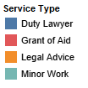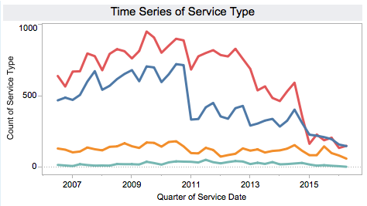

Figure : Time series of service type of general clients

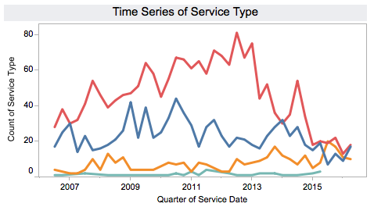

Figure : Time series of service type of Aboriginal And Torres Strait Islander clients

## Culturally and Linguistically Diverse

The total number of VLA services provided to clients who speak a language other than English at home is 184,643, which is about 12 percent of VLA’s services. The following analysis shows the differences between this group and the general clients to understand their interaction with VLA.

### Demographics

The demographics of the Culturally and Linguistically Diverse clients were analysed to see how they differ from the general population.

##### Gender

The percentage of services allocated to Culturally and Linguistically Diverse males is higher than that of general clients, with a difference of about 7 percent.

Table : Gender of general clients compared to Culturally And Linguistically Diverse clients

|  |  |
| --- | --- |
| **VLA ALL Clients** | **CULTURALLY AND LINGUISTICALLY DIVERSE clients** |
|  |  |

##### Location

The top 10 most frequent geographical areas are similar, while the ordering differs. For Culturally and Linguistically Diverse clients, the Hume area is the most frequent local government area, closely followed by Brimbank.

Table : Location of general clients compared to Culturally And Linguistically Diverse clients

|  |  |
| --- | --- |
| **VLA ALL Clients** | **CULTURALLY AND LINGUISTICALLY DIVERSE clients** |
|  |  |

##### Age of contact

The most common age of contact for general clients is around 19 to 22, this is lower than the usual age for Culturally And Linguistically Diverse clients, which is 25 to 29 with an average of 37, 9 percent higher compared to average for the general clients (34).

Age of contact of general clients compared to Culturally And Linguistically Diverse clients

ALL VLA clients

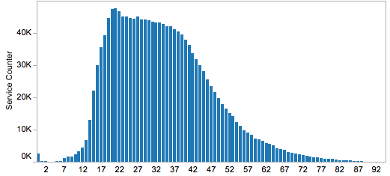

Figure : Age of contact of general clients

Culturally And Linguistically Diverse clients

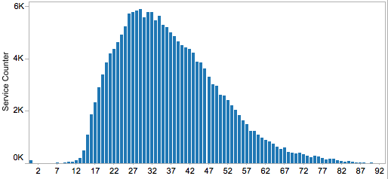

Figure : Age of contact of Culturally And Linguistically Diverse clients

##### Disability status

Compared to general clients there is a higher percentage of services provided to Culturally and Linguistically Diverse clients that are classified as not having a disability. This percentage is around three times as much as those that are classified as having a disability. Interestingly fewer Culturally and Linguistically Diverse clients are recorded as having been not asked about disability status at time of service.

Table : Disability status of general clients compared to Culturally And Linguistically Diverse clients

|  |  |
| --- | --- |
| **ALL VLA clients** | **CULTURALLY AND LINGUISTICALLY DIVERSE clients** |
|  |  |

##### Disability description

Similar to general clients, more than half of services allocated to Culturally And Linguistically Diverse clients that had “yes” as a disability status classified their disability under mental health. Also, for Culturally and Linguistically Diverse clients, there is a higher percentage with a physical disability.

Table : Disability description of general clients compared to Culturally And Linguistically Diverse clients

|  |  |
| --- | --- |
| **ALL VLA clients** | **CULTURALLY AND LINGUISTICALLY DIVERSE clients** |
|  |  |

##### Benefit Status

Compared to general clients, the percentage of services for Culturally and Linguistically Diverse clients who receive a benefit is slightly lower.

Table : Benefit status of general clients compared to Culturally and Linguistically Diverse clients

|  |  |
| --- | --- |
| **ALL VLA clients** | **CULTURALLY AND LINGUISTICALLY DIVERSE clients** |
|  |  |

##### Benefit Type

For general clients and Culturally And Linguistically Diverse clients, around 75 percent of the top benefit types are similar.

Table : Benefit type of general clients compared to Culturally and Linguistically Diverse clients

|  |  |
| --- | --- |
| **ALL VLA clients** | **CULTURALLY AND LINGUISTICALLY DIVERSE clients** |
|  |  |

##### Employment

Most Culturally and Linguistically Diverse clients are not employed (66%) while almost 11 percent are employed.

Table : Employment status of general clients compared to Culturally and Linguistically Diverse clients

|  |  |
| --- | --- |
| **ALL VLA clients** | **CULTURALLY AND LINGUISTICALLY DIVERSE clients** |
|  |  |

##### Living Arrangements

It is interesting to note that although the most common living arrangement for Culturally and Linguistically Diverse clients is single, this is followed by married at 12 percent, compared to only 4 percent for general clients.

*Note limitations of data:* Living arrangements are subject to frequent change, so the data is likely reflect living arrangements at time of first service unless records were updated for each service.

Table : Living arrangements of general clients compared to Culturally And Linguistically Diverse clients

|  |  |
| --- | --- |
| **ALL VLA clients** | **CULTURALLY AND LINGUISTICALLY DIVERSE clients** |
|  |  |
|  |  |

#### Dependents

For services provided to Culturally And Linguistically Diverse clients, zero dependents is the most common scenario.

Number of dependents of general clients compared to Culturally and Linguistically Diverse clients

ALL VLA clients



Figure : Number of dependents of general clients

Culturally and Linguistically Diverse clients

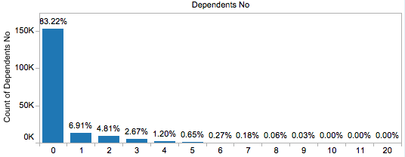

Figure : Number of dependents of Culturally And Linguistically Diverse

#### Country of origin other than Australia

For general clients (the majority of who speak English at home), the most frequent country of origin is New Zealand, with a percentage of 10.33 percent. This is followed by Vietnam (8.16%), and England (5.64%). However, for Culturally And Linguistically Diverse clients, the most frequent country of origin is Vietnam (12.42%), followed by Sudan (7.81%) and India (6%).

Country of origin of general clients compared to Culturally and Linguistically Diverse clients

ALL VLA clients

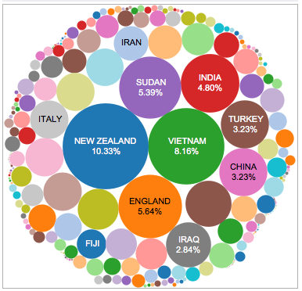

Figure : Country of origin of general clients

Culturally and Linguistically Diverse clients

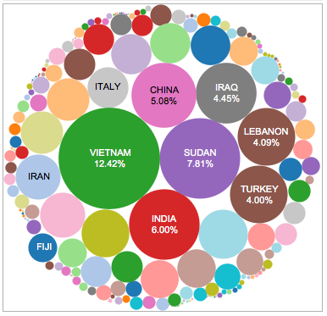

Figure : Country of origin of Culturally and Linguistically Diverse

##### Language other than English (LOTE)

For Culturally and Linguistically Diverse clients, the most frequent language other than English spoken at home is Arabic (13.65%), followed closely by Vietnamese (11.34%). Other common languages include Greek and Turkish.

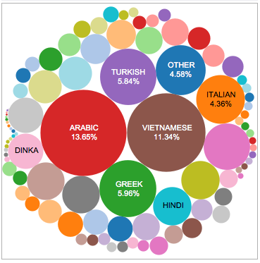

Figure : Most frequent spoken language (excluding English)

### Services

The services data was analysed to find differences between the Culturally and Linguistically Diverse clients and general clients.

##### Top Matter Types

Family violence protection is the top matter type for both groups, but for Culturally and Linguistically Diverse clients, it is followed by driving with a suspended license and infringements.

Table : Matter type of general clients compared to Culturally and Linguistically Diverse clients

|  |  |
| --- | --- |
| **ALL VLA clients** | **CULTURALLY AND LINGUISTICALLY DIVERSE clients** |
|  |  |

Figure : Time series of matter type of Culturally and Linguistically Diverse clients

##### Top most costly matter types

The most costly matter type for Culturally and Linguistically Diverse clients are child protection applications and applications to spend time with children, but this is followed by family violence protection (as opposed to being followed by burglary, for general clients).

Table : Matter type cost of origin of general clients compared to Culturally And Linguistically Diverse clients

|  |  |
| --- | --- |
| VLA All clients | CULTURALLY AND LINGUISTICALLY DIVERSE clients |
|  |  |

##### Law type

The percentage of services provided in civil law is slightly higher for Culturally and Linguistically Diverse clients. For criminal law and family law, it only differs by around 2 percent.

Table : Law type of origin of general clients compared to Culturally And Linguistically Diverse clients

|  |  |
| --- | --- |
| ALL VLA clients | CULTURALLY AND LINGUISTICALLY DIVERSE clients |
|  |  |

##### Service type

Duty lawyer is the most frequent service type for general clients, but for Culturally and Linguistically Diverse clients it is followed by Legal Advice.

Table : SERVICE type of general clients compared to Culturally And Linguistically Diverse clients

|  |  |
| --- | --- |
| **VLA ALL clients** | **CULTURALLY AND LINGUISTICALLY DIVERSE clients** |
|  |  |

For service type, before the year 2011, while more Culturally and Linguistically Diverse clients used the duty lawyer service rather than a grant of aid; the opposite is true for general clients.

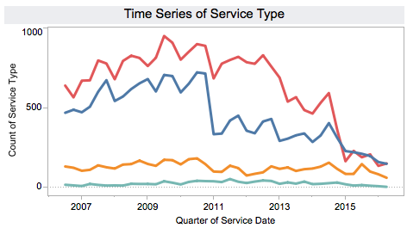

Figure : Time series of service type of general clients

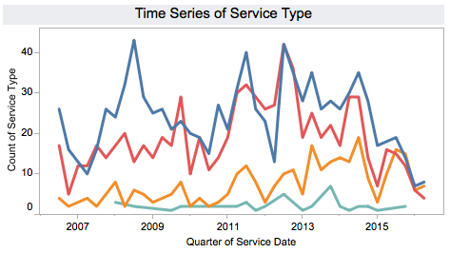

Figure : Time series of service type of Culturally And Linguistically Diverse clients

## Youth (10-17) at time of first service

There are a total of 31,923 VLA clients who were between 10-17 years old at the time of first service. This segment has been identified as a group that is more likely to have further legal problems throughout their lives. The following analysis shows the characteristics of this group and the general clients to understand their interaction with VLA.

### Demographics

The following points will describe how the demographics change between client groups.

##### Gender

Clients in this segment are slightly less likely to be male and more likely to be female than the general population. Although very slight, there is a difference of about 3 percent in the split between two genders for Young compared to the services given to general clients. However, in both cases, clients are still more likely to be male.

Table : Gender of general clients compared to Young

|  |  |
| --- | --- |
| ALL VLA clients | YOUNG clients |
|  |  |

##### Location

Most Young clients come from Casey, Greater Geelong and Hume. The top geographical locations for general clients and Young clients vary.

Table : Location of general clients compared to Young clients

|  |  |
| --- | --- |
| **ALL VLA clients** | **YOUNG clients** |
|  |  |

##### Age of first contact

The median age of first contact of Young clients is 15 years old.

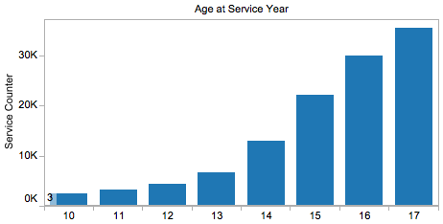

Figure : Age of first contact of Young clients

##### Disability

The percentage of Young clients with a disability (9.16%) is considerably lower than of the services allocated to general clients with a disability (20.54%).

Table : Disability status of general clients compared to Young clients

|  |  |
| --- | --- |
| **ALL VLA clients** | **YOUNG clients** |
|  |  |

Most of the Young clients with a disability present mental health issues and intellectual disability.

Table : Disability description of general clients compared to Young clients

|  |  |
| --- | --- |
| **ALL VLA clients** | **YOUNG clients** |
|  |  |

##### Benefit status

The percentage of Young clients who receive benefits is considerably lower compared to the general clients with a difference of almost 40 percent.

Table : Benefit status of general clients compared to Young clients

|  |  |
| --- | --- |
| **ALL VLA clients** | **YOUNG clients** |
|  |  |

Most Young clients who receive a benefit get youth allowance, followed by Newstart allowance.

Table : Benefit type of general clients compared to Young clients

|  |  |
| --- | --- |
| **ALL VLA clients** | **YOUNG clients** |
|  |  |

##### Employment

The percentage of non-employed clients is higher for Young clients at 61.11%, compared to 52.53 percent for general clients.

Table : Employment status of general clients compared to Young clients

|  |  |
| --- | --- |
| **ALL VLA clients** | **YOUNG clients** |
|  |  |

##### Living arrangements

Although the most common living arrangement for both general clients and Young clients is single, there is a higher percentage for Young clients which considering their age is unsurprising.

*Note limitations of data:* Living arrangements are subject to frequent change, so the data is likely reflect living arrangements at time of first service unless records were updated for each service

Table : Living arrangements of general clients compared to Young clients

|  |  |
| --- | --- |
| **VLA ALL clients** | **YOUNG clients** |
|  |  |

##### Dependents

For both general clients and Young clients, the most common number of dependents is 0 and the maximum number of dependents is 10 although with a very low percentage.

**Number of dependents of general clients compared to YOUNG clients**

ALL VLA clients



Figure : Number of dependents of general clients

YOUNG clients

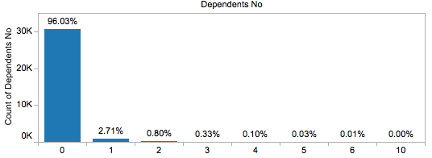

Figure : Number of dependents of Young clients

### Services

The services that Young clients utilised were analysed, with a focus on the different matter types. Differences between Young clients and general clients will be discussed.

##### Top 10 Matter Types

The most frequent matter types for Young clients are child protection applications with 22.05 percent, followed by family violence (6.53%), burglary (4.45%), and theft (4.5%).

Table : Matter type of general clients compared to Young clients

|  |  |
| --- | --- |
| **ALL VLA clients** | **YOUNG clients** |
|  |  |

Compared to general clients, Young clients have higher counts for child protection applications. The difference between Protection Applications and the rest of the matter types for both general clients and Young clients is the most evident.

##### Top 10 Most Costly Matter Types

The most costly matter type for Young clients include child protection applications (which are also the most costly for general clients), followed by protection application by emergency care, family violence and burglary.

Table : Matter type cost of general clients compared to Young clients

|  |  |
| --- | --- |
| **VLA ALL clients** | **YOUNG clients** |
|  |  |

##### Law type

The ordering of frequency of Law Type for both groups is similar, but it must be noted that for Young clients, there was a slight decrease in the percentage of criminal law, and a slight increase in the percentage of family law, compared to general clients.

Table : Law type of general clients compared to Young clients

|  |  |
| --- | --- |
| **VLA ALL clients** | **YOUNG clients** |
|  |  |

##### Service type

For Young clients, the most frequent service is Grant of Aid, followed by Duty Lawyer, with only a very small percentage of Minor Work.

Table : Service type of general clients compared to Young clients

|  |  |
| --- | --- |
| **VLA ALL clients** | **YOUNG clients** |
|  |  |

Before the year 2015, general clients and Young clients follow a similar pattern for service type counts. However, just right before the start of 2015 onwards, the count for the grant of aid for Young clients is lower than the counts of duty lawyer.



Figure : Time series of service type of general clients

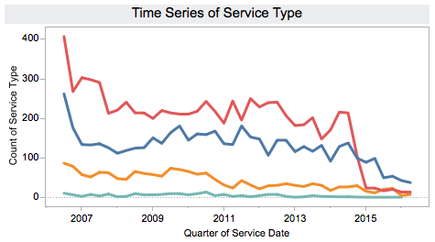

Figure : Time series of service type of Young clients

## Crossover Clients

Our study included the analysis of services utilised by clients across more than one Law Type. These clients are defined as crossover clients.

In order to identify crossover clients, then number of services accessed by each client for every law type was calculated. Where a client had accessed at least one service from at least two Law Types, they were considered a crossover client. The number of different law types accessed was calculated. In addition, the law services crossed between were assigned to each client from one of “Civil-Criminal”, “Civil-Family”, “Criminal-Family” or “All”.

In the analysis, 89,670 clients were found to be crossover clients. This accounts for approximately 20 percent of VLA’s clients. The table below depicts the percentage of crossover clients for each crossover category (of the total crossover clients).

Table : Percent of crossover clients by program areas

|  |  |  |  |  |
| --- | --- | --- | --- | --- |
| Crossover Category | Civil – Criminal | Civil – Family | Criminal – Family | All programs |
| Percentage of Crossover Clients | 26.7% | 13.7% | 42.7% | 16.9% |

From the crossover clients, the majority (42.7%) utilised Criminal and Family law services. The second most prevalent scenario are services allocated to clients who utilised Civil and Criminal services (26.7%), followed by clients accessing every law type service (16.9%) and clients who access both Civil and Family law (13.7%).

From the 89,670 cross-over clients, 45.01 percent of services utilised by those clients are Criminal Law, 34.15 percent are Family Law, and 20.84 percent are Civil Law.

## High Cost Clients

This section aims to find demographical patterns for high cost clients. High cost clients are those in the top 10 percent of their average cost to service per year they are active (i.e. for the years they receive VLA services). The total cost to service are made up of relative weightings of the services they consume (Grant of Aid: 15, Minor Work: 2, Duty Lawyer: 1, Legal Advice: 0.5). The 90th percentile of “Cost per Active Year” was 68 cost units, a client that consumes higher than 68 units per active year is classified as “high cost”.

For robust comparison, we create multiple segments of the dataset as described in the table below:

##### Interpreting the data

Percentages referred to in the tables refers to unique clients.

Table : Client segments according to cost, age and Aboriginal And Torres Strait Islander status

| Client Segments | Counts | Description |
| --- | --- | --- |
| All clients | 442,679 | All clients in the VLA database |
| Aboriginal and Torres Strait Islander Clients | 8,461 | Clients in the VLA database that are identified as either Aboriginal or Torres Strait Islander |
| Young Clients | 31,923 | Clients whose first age of service was between 10 to 17 years, inclusive |
| High Cost Clients | 41,824 | Clients whose “Cost Per Active Year” was above 68 units. |
| High Cost Aboriginal and Torres Strait Islander Clients | 2,744 | High Cost Clients who are also identified as Aboriginal and Torres Strait Islander |
| High Cost Young Clients | 10,535 | High Cost Clients who are also identified as Young.. |

##### Customer Acquisition by Year

Table : Cost acquisition by year

|  | All Clients | Aboriginal and Torres Strait Islander Clients | Young Clients | High Cost Clients | High Cost Aboriginal and Torres Strait Islander clients | High Cost Young Clients |
| --- | --- | --- | --- | --- | --- | --- |
| 2006* | 8% | 7% | 7% | 15% | 14% | 8% |
| 2007 | 13% | 9% | 11% | 14% | 12% | 9% |
| 2008 | 12% | 8% | 10% | 9% | 9% | 7% |
| 2009 | 11% | 7% | 10% | 7% | 8% | 7% |
| 2010 | 10% | 8% | 10% | 6% | 6% | 7% |
| 2011 | 10% | 12% | 10% | 6% | 7% | 7% |
| 2012 | 9% | 13% | 10% | 6% | 7% | 7% |
| 2013 | 8% | 10% | 8% | 7% | 6% | 8% |
| 2014 | 8% | 10% | 9% | 6% | 6% | 8% |
| 2015 | 7% | 11% | 10% | 18% | 17% | 22% |
| 2016* | 4% | 6% | 5% | 8% | 7% | 10% |

*2006 and 2016 volumes only represented 6 months’ worth of data. The actual volume could be assumed to be double.

The table above shows the volume of clients acquired per year as a proportion of the entire population of each segment. From here, we can see that high Cost clients tended to be acquired in 2006, 2007, and then in 2015 and 2016 – this trend was proportional to the numbers of HC Aboriginal and Torres Strait Islander Clients acquired and numbers of HC youth clients acquired. The increase in high cost clients in those years was proportional to the percentage increase in high cost Indigenous clients. By contrast, the increase in high cost young clients were disproportionately higher than the increase in high cost clients in general, signalling an active strategy to acquire and provide services to high-risk youths in 2015-2016 (32% of HC young clients were acquired in this 18-month period).

##### Customer Acquisition by Age

The largest segment of clients (27% of all clients) get introduced to VLA services between the ages of 20 – 29. In contrast, the largest segment of high cost clients were introduced to VLA within the 10-19 age range.

Aboriginal and Torres Strait Islander clients get introduced to VLA a younger age than the general client population (54% get introduced to VLA before the age of 30, as opposed to 37% in general). Of this, Aboriginal and Torres Strait Islander high cost clients are even more significant in proportion with 69 percent being introduced to VLA before the age of 30.

Table : Client cost acquisition by age

| Acquired at the ages | All clients | All Aboriginal and Torres Strait Islander Clients | High Cost Clients | High Cost Aboriginal and Torres Strait Islander Clients |
| --- | --- | --- | --- | --- |
| 10-19 | 10% | 25% | 32% | 39% |
| 20 – 29 | 27% | 29% | 28% | 30% |
| 30 – 39 | 25% | 22% | 23% | 18% |
| 40 – 49 | 19% | 15% | 11% | 8% |
| above 50 | 16% | 7% | 4% | 2% |

Table : Client cost acquisition by age (percent of total)

|  |  |  |
| --- | --- | --- |
| Acquired at the ages | All Youth Clients | High Cost Young Clients |
| 10 | 4% | 5% |
| 11 | 5% | 6% |
| 12 | 5% | 6% |
| 13 | 7% | 10% |
| 14 | 12% | 16% |
| 15 | 17% | 20% |
| 16 | 22% | 20% |
| 17 | 27% | 17% |

##### Aboriginal and Torres Strait Islander clients

Aboriginal and Torres Strait Islander clients are over-represented in the high cost client segments. While 2 percent of the client database are identified as Aboriginal and Torres Strait Islander, 7 percent of high cost clients and 8 percent of high cost young clients, respectively, are identified as Aboriginal and Torres Strait Islander. Aboriginal and Torres Strait Islanders are also disproportionately represented in the clients’ youth database – 5 percent of youth are also Aboriginal and Torres Strait Islander.

Table : Aboriginal and Torres Strait Islander client percent representation according to cost

|  |  |  |  |  |
| --- | --- | --- | --- | --- |
|  | All Clients | Young Clients | High Cost Clients | High Cost Young Clients |
| Indigenous Australians | 2% | 5% | 7% | 8% |

##### Spread of services across LGAs

The spread of high cost clients and high cost youths follow the spread of volume of clients in LGAs like Casey, Greater Geelong, Greater Bendigo, Ballarat, and Hume. However, Aboriginal and Torres Strait Islander clients and high cost Aboriginal and Torres Strait Islander clients tend to be in other LGAs e.g. Greater Shepparton, Mildura, East Gippsland, La Trobe, and Darebin.

##### Gender

Gender split for clients in the whole dataset is 61 percent male, 39 percent female. However, for Aboriginal and Torres Strait Islander clients, the proportion of female is higher at 43 percent. High cost clients are considerably more represented by males than females, with males making up 65 percent of high cost clients, 60 percent of high cost Aboriginal and Torres Strait Islander clients, and 68 percent of high cost youths.

Table : Client percent gender distribution

|  |  |  |  |  |  |  |
| --- | --- | --- | --- | --- | --- | --- |
|  | All Clients | Aboriginal and Torres Strait Islander Clients | Young Clients | High Cost Clients | High Cost Aboriginal and Torres Strait Islander clients | High Cost Young clients |
| Male | 61% | 57% | 61% | 65% | 60% | 68% |
| Female | 39% | 43% | 39% | 35% | 40% | 32% |

##### Benefits

40 percent of all clients receive some form of government benefit. Newstart Allowance is the most popular (24%) type of benefit received. The proportion of high cost clients receiving government benefits is lower than the general clientele – 37 percent of high cost clients and high cost Aboriginal and Torres Strait Islander clients are government benefit recipients.

Young clients and high-cost young clients receive significantly less benefits, proportionally, than other segments. 28 percent of high cost young clients receive benefits, in contrast to 24 percent of youths in general. This signals that High Cost Young clients seem to have higher access to government benefits. The most popular benefits received by youth are Youth Allowance, followed by Newstart allowance.

Table : Client percentage according to types of benefits

|  | All Clients | Aboriginal and Torres Strait Islander Clients | Young Clients | High Cost Clients | High Cost Aboriginal and Torres Strait Islander clients | High Cost Young Clients |
| --- | --- | --- | --- | --- | --- | --- |
| Benefits Recipients | 40% | 34% | 24% | 37% | 37% | 28% |
|  | **Benefit Types** | | | | | |
| Newstart allowance | 24% | 33% | 26% | 25% | 35% | 31% |
| Parenting payment | 14% | 25% | 12% | 18% | 31% | 11% |
| Disability support pension | 13% | 22% | 10% | 11% | 19% | 18% |
| Youth allowance | 3% | 7% | 33% | 4% | 9% | 36% |

##### Living Arrangements

Table : Client living arrangement in percent

|  |  |  |  |  |  |  |
| --- | --- | --- | --- | --- | --- | --- |
|  | All Clients | Aboriginal and Torres Strait Islander  Clients | Young Clients | High Cost Clients | High Cost Aboriginal and Torres Strait Islander clients | High Cost Young Clients |
| Single (%) | 49% | 74% | 70% | 77% | 78% | 74% |

High cost clients have a higher tendency to be single compared to the general clients. 49 percent of clients in the database are identified as Single. This is significantly lower than the proportion of Singles in High cost clients (77%), High cost Aboriginal and Torres Strait Islander clients (78%), and High Cost Young Clients (74%) These statistics should be taken together with the fact that 74 percent of Aboriginal and Torres Strait Islander clients, and 70 percent of young clients are identified as Single to begin with.

##### Disability

A greater proportion (23%) of high cost clients have disabilities compared to the general clients (13%). The proportion of Aboriginal and Torres Strait Islander clients with disabilities is also higher than the general clients at 25 percent, and even higher still for high cost Aboriginal and Torres Strait Islander clients, at 27 percent. Youths and high cost youths record proportionately less instances of disability. In all cases, mental health is the most prevalent form of disability (applicable to about 50% of disabled clients), followed by physical disability, and then intellectual disability.

Table : Percentage of client disability and types

|  |  |  |  |  |  |  |
| --- | --- | --- | --- | --- | --- | --- |
|  | All Clients | Aboriginal and Torres Strait Islander Clients | Young Clients | High Cost Clients | High Cost Aboriginal and Torres Strait Islander Clients | High Cost Young Clients |
| Disability | 13% | 25% | 8% | 23% | 27% | 13% |
|  | Disability Types | | | | | |
| MENTAL HEALTH | 54% | 52% | 47% | 56% | 49% | 48% |
| PHYSICAL | 23% | 18% | 30% | 13% | 20% | 4% |
| INTELLECTUAL | 6% | 12% | 10% | 13% | 10% | 34% |
| ACQUIRED BRAIN INJURY | 3% | 6% | 2% | 7% | 11% | 4% |

##### Employment

The biggest segment of clients did not state their employment status with VLA – possibly indicating that most clients interact with VLA only at a touch level, making it unnecessary for VLA to record their employment status. However, for Aboriginal and Torres Strait Islander Clients, and High Cost clients, High Cost Aboriginal and Torres Strait Islander clients, and High Cost Young clients, their employment status are well recorded – and most clients in these segments are unemployed. This is especially true for all high cost segments, where about 90 percent of clients are unemployed.

Table : Client employment status

|  | All Clients | Aboriginal and Torres Strait Islander Clients | Young Clients | High Cost Clients | High Cost Aboriginal and Torres Strait Islander clients | High Cost Young Clients |
| --- | --- | --- | --- | --- | --- | --- |
| NOT EMPLOYED | 33% | 74% | 58% | 87% | 94% | 90% |
| NOT STATED | 46% | 12% | 34% | 6% | 3% | 4% |
| FULL-TIME EMPLOYMENT | 10% | 7% | 2% | 2% | 1% | 1% |
| PART-TIME EMPLOYMENT | 5% | 3% | 2% | 2% | 1% | 2% |
| CASUAL | 5% | 4% | 3% | 3% | 1% | 2% |
| SELF EMPLOYED | 1% | 0% | 0% | 0% | 0% | 0% |

##### Dependents and Child Support Dependents

Most VLA clients (85%) have no dependents at first time of service. Proportionally, Aboriginal and Torres Strait Islander clients and high cost clients are more likely to have one or more dependents than the general clients. High cost young clients are also more likely to have one or more dependents compared to youths, but high cost Aboriginal and Torres Strait Islander clients are less likely to have dependents than the general client population.

Table : Clients with dependants

| Dependents | All Clients | Aboriginal and Torres Strait Islander Clients | Young Clients | High Cost Clients | High Cost Aboriginal and Torres Strait Islander clients | High Cost Young Clients |
| --- | --- | --- | --- | --- | --- | --- |
| 0 | 85% | 76% | 97% | 79% | 80% | 95% |
| 1 | 7% | 10% | 2% | 9% | 9% | 3% |
| 2 | 5% | 7% | 1% | 6% | 6% | 1% |
| 3 | 2% | 3% | 0% | 3% | 3% | 0% |
| 4 | 1% | 2% | 0% | 1% | 1% | 0% |
| 5 | 0% | 1% | 0% | 1% | 0% | 0% |

Just like number of dependents above, the statistics on child support dependents show that Aboriginal and Torres Strait Islander clients and high cost clients are more likely to have child-dependents than the general clients. However, in contrast to the dependents statistics, high cost young clients are not less likely to have dependents compared to the whole youth client population.

Table : Clients on child support

|  |  |  |  |  |  |  |
| --- | --- | --- | --- | --- | --- | --- |
| Child Support Dependents | All Clients | Aboriginal and Torres Strait Islander Clients | Youth Clients | High Cost Clients | High Cost Aboriginal and Torres Strait Islander Clients | High Cost Youth |
| 0 | 96% | 93% | 100% | 93% | 93% | 99% |
| 1 | 2% | 3% | 0% | 4% | 3% | 1% |
| 2 | 1% | 2% | 0% | 2% | 2% | 0% |
| 3 | 1% | 1% | 0% | 1% | 1% | 0% |

##### Conclusion

This analysis has provided for insight into not only crossover between top matter types, but also priority clients. Priority clients are those clients who are of Aboriginal or Torres Strait Islander descent, who are culturally and/or linguistically diverse, who were between 10 and 17 years of age at the time of their first service, who utilise services across more than one Law Type, and/or who are of high cost to the VLA.

Overall, VLA’s clients are diverse and as such have different needs and present different levels of disadvantage. This analysis shows the differences between each interest group for VLA and the general client population, and aims to broaden the understanding of how these segments utilise VLA’s services.

1. List of tables

Table 1: Gender of general clients compared to Aboriginal and Torres Strait Islander clients 7

Table 2: Location of general clients compared to Aboriginal And Torres Strait Islander clients 8

Table 3: Disability status of general clients compared to Aboriginal And Torres Strait Islander clients 10

Table 4: Disability description of general clients compared to Aboriginal And Torres Strait Islander clients 11

Table 5: Benefit status of general clients compared to Aboriginal and Torres strait islander clients 11

Table 6: Benefit type of general clients compared to Aboriginal and Torres Strait Islander clients 12

Table 7: Employment status of general clients compared to Aboriginal and Torres Strait islander clients 12

Table 8: Living arrangements of general clients compared to Aboriginal and Torres Strait Islander clients 13

Table 9: Matter type of general clients compared to Aboriginal and Torres Strait Islander clients 15

Table 10: Matter type cost of general clients compared to Aboriginal and Torres Strait Islander clients 15

Table 11: Law type of general clients compared to Aboriginal And Torres Strait Islander clients 16

Table 12: Service type of general clients compared to Aboriginal and Torres Strait Islander clients 16

Table 13: Gender of general clients compared to Culturally And Linguistically Diverse clients 18

Table 14: Location of general clients compared to Culturally And Linguistically Diverse clients 19

Table 15: Disability status of general clients compared to Culturally And Linguistically Diverse clients 20

Table 16: Disability description of general clients compared to Culturally And Linguistically Diverse clients 21

Table 17: Benefit status of general clients compared to Culturally and Linguistically Diverse clients 22

Table 18: Benefit type of general clients compared to Culturally and Linguistically Diverse clients 22

Table 19: Employment status of general clients compared to Culturally and Linguistically Diverse clients 23

Table 20: Living arrangements of general clients compared to Culturally And Linguistically Diverse clients 23

Table 21: Matter type of general clients compared to Culturally and Linguistically Diverse clients 28

Table 22: Matter type cost of origin of general clients compared to Culturally And Linguistically Diverse clients 28

Table 23: Law type of origin of general clients compared to Culturally And Linguistically Diverse clients 29

Table 24: SERVICE type of general clients compared to Culturally And Linguistically Diverse clients 29

Table 25: Gender of general clients compared to Young 31

Table 26: Location of general clients compared to Young clients 32

Table 27: Disability status of general clients compared to Young clients 33

Table 28: Disability description of general clients compared to Young clients 33

Table 29: Benefit status of general clients compared to Young clients 34

Table 30: Benefit type of general clients compared to Young clients 34

Table 31: Employment status of general clients compared to Young clients 35

Table 32: Living arrangements of general clients compared to Young clients 36

Table 33: Matter type of general clients compared to Young clients 37

Table 34: Matter type cost of general clients compared to Young clients 38

Table 35: Law type of general clients compared to Young clients 38

Table 36: Service type of general clients compared to Young clients 39

Table 37: Percent of crossover clients by program areas 41

Table 38: Client segments according to cost, age and Aboriginal And Torres Strait Islander status 42

Table 39: Cost acquisition by year 42

Table 40: Client cost acquisition by age 43

Table 41: Client cost acquisition by age (percent of total) 44

Table 42: Aboriginal and Torres Strait Islander client percent representation according to cost 45

Table 43: Client percent gender distribution 45

Table 44: Client percentage according to types of benefits 46

Table 45: Client living arrangement in percent 46

Table 46: Percentage of client disability and types 47

Table 47: Client employment status 48

Table 48: Clients with dependants 48

Table 49: Clients on child support 49

1. List of figures

Figure 1: Heat map for crossover between top matter types (service numbers) 2

Figure 2: Heat map for crossover between top matter types for Aboriginal and Torres Strait Islander clients 3

Figure 3: Heat map for crossover between top matter types for 10-17 years of age at time of first service clients 4

Figure 4: Heat map for crossover between top matter types for culturally and linguistically diverse clients 5

Figure 5: Age of contact of general clients 9

Figure 6: Age of contact of aboriginal and Torres strait islanders 9

Figure 7: Number of dependents of general clients 14

Figure 8: Number of dependents of Aboriginal and Torres Strait Islander clients 14

Figure 15: Time series of service type of general clients 17

Figure 16: Time series of service type of Aboriginal And Torres Strait Islander clients 17

Figure 17: Age of contact of general clients 19

Figure 18: Age of contact of Culturally And Linguistically Diverse clients 20

Figure 19: Number of dependents of general clients 24

Figure 20: Number of dependents of Culturally And Linguistically Diverse 24

Figure 21: Country of origin of general clients 25

Figure 22: Country of origin of Culturally and Linguistically Diverse 26

Figure 23: Most frequent spoken language (excluding English) 27

Figure 25: Time series of matter type of Culturally and Linguistically Diverse clients 28

Figure 30: Time series of service type of general clients 30

Figure 31: Time series of service type of Culturally And Linguistically Diverse clients 30

Figure 32: Age of first contact of Young clients 32

Figure 33: Number of dependents of general clients 36

Figure 34: Number of dependents of Young clients 37

Figure 41: Time series of service type of general clients 39

Figure 42: Time series of service type of Young clients 40