Victoria Legal Aid client profiles – high-contact users of legal aid services

Summary
Client data over a ten year period from 2003 to 2013 was analysed to map the frequency with which clients used our services. The top one per cent of our users were identified as ‘frequent’ or ‘high-contact’ users, and their demographic characteristics were examined to see if and how they differed from standard, infrequent users (the remainder of our client group).
While all users of Victoria Legal Aid (VLA) services, particularly those who receive grants of legal assistance, are relatively disadvantaged, we found that high-contact users were more likely to exhibit certain demographic characteristics. The characteristics that stood out amongst this cohort were they:
- had early contact with VLA (prior to 18 years of age)
- started criminal offending at a young age, specifically between 10 and 17 years of age
- identified as having a psychiatric issue, acquired brain injury or a cognitive disability
- identified as an Aboriginal or Torres Strait Islander.
This has implications for how we predict who may be likely to continue to use our services and how we deliver services to this group.

Contents
Victoria Legal Aid client profiles – high-contact users of legal aid services 1
Summary 1
Contents 1
Figures 1
Executive summary 3
Key findings 3
Recommendations 3
Introduction 5
Methodology 6
Characteristics of high-contact users 6
First contact with VLA 9
Legal matters 9
Location 11
Discussion 12
Implications for VLA 12
The importance of systemic advocacy 14
Conclusion 15
References 17

Figures
Figure 1 – Rates of disability amongst VLA clients 7
Figure 2 – Types of disability amongst standard and high contact VLA clients 8
Figure 3 – Age of first contact with VLA 9
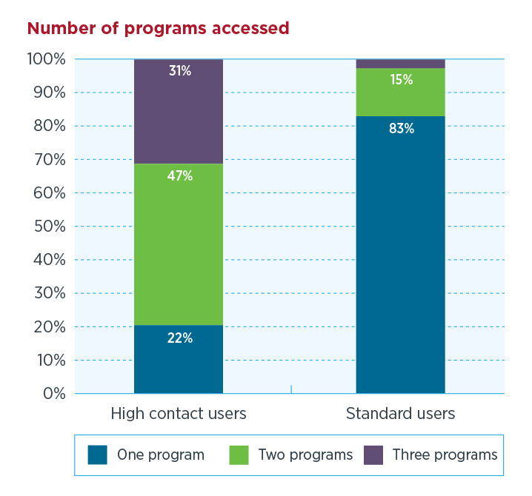 Figure 4 – Number of programs accessed by standard and high contact VLA clients 10
Figure 5 – VLA clients and prior involvement with child protection/family violence 11

Executive summary
Client data over a ten year period (2003–2013) was analysed to map the frequency with which clients used our services.
6471 users were identified as high-contact users. These users had an average of 34 services from VLA over a 10-year period. While these users represent 1.2 per cent of our total clients, they have used 12 per cent of our services during that period.
Further demographic and legal matter type data was analysed to see what similarities or differences they may share with the larger client population.

Key findings
High-contact users are more likely to be male, younger, Australian born, have a disability or be on a Disability Services Pension and have approached VLA for a criminal issue.
High-contact users were also more likely to have sought help from VLA across multiple law areas (criminal, civil and family) and were more likely to have seen us for a child protection or family violence issue before the age of 18.
Key risk factors for a client who may become a high-contact user appear to be one or more of the following indicators:
- early contact with VLA (prior to 18 years of age)
- criminal offending at a young age, specifically between 10–17 years of age
- having a psychiatric issue, acquired brain injury or a cognitive disability
- identifying as an Aboriginal or Torres Strait Islander.
These findings have implications on the delivery of legal services, as we can identify the particular characteristics that are likely to indicate vulnerability to future, chronic legal problems and contact with the criminal justice system.

Recommendations
VLA should consider either introducing and/or enhancing the following approaches:
- providing more intensive service delivery when the person has initial contact with VLA, including careful case management and provision of a single contact point within the organisation for that client
- providing more holistic services, with a focus on appropriate referrals to non-legal service providers
- embracing a multi-disciplinary approach, where VLA lawyers work actively with social workers, teachers, doctors and police to address the problems of the individual that is contributing to or causing their legal problem(s)
- advocating for systemic change, where current practice or policies may contribute to criminalisation, particularly of vulnerable people, such as young children or people with mental health issues or cognitive disabilities.
It is worth noting that VLA does prioritise vulnerable clients, such as children or people with disabilities, for intensive service delivery and aims to provide holistic legal services for its vulnerable clients. Our services in the child protection area are particularly focused on linking them to other practice areas (such as Youth Crime) and to provide continuity of representation where possible.
It is suggested that this approach could further benefit from additional resources to provide even more intensive case management and advocacy. Any outcomes from other similar projects, such as the NSW Children’s Civil Law Service Pilot, will provide useful insights for VLA in improving outcomes for high-contact users.
Any changes to service delivery would need to be evaluated to determine the effectiveness of these approaches, and whether they do in fact, reduce further contact with the criminal justice system or the risk of additional legal problems. VLA would also need to evaluate whether the provision of intensive services early in an individual’s contact with VLA provides other tangible benefits for that person.

Introduction
The National Partnership Agreement on Legal Assistance Services tasks legal assistance agencies with trying to prevent legal problems. They are required to target disadvantaged Australians through early resolution of their legal problem and by delivering holistic legal services in an efficient and cost-effective way. This is in an environment where it is increasingly difficult for legal assistance providers to keep up with the demand for legal services.
Recent research on legal need has found that while experiencing legal problems (and subsequently needing legal help) is relatively common, a small sub-set of the population seem to be at risk of experiencing multiple and serious legal problems. This group is also distinguished by experiencing other indicators of disadvantage, such as disability, unemployment, lone parent status, Indigenous status and living in disadvantaged housing. The implications of this research are that legal assistance agencies should provide more intensive assistance to those who are at risk of experiencing high legal need, while also providing lower intensity services to the rest of the community.
If those people experiencing high legal need share similar characteristics then it’s likely that the clients of legal aid agencies who are high users of our services also share common characteristics. Legal Aid NSW created profiles of their 50 highest users between 2005–2010 and found a number of commonalities, including the fact that they had first contact with legal aid at a very young age, and had backgrounds that included involvement with child protection, out of home care, homelessness and school suspension or expulsion. A high number also had mental health and cognitive impairment issues. Most were being provided assistance for criminal matters. The research outlines the service implications for identifying and managing these users, including more intensive casework and collaboration with other agencies when trying to address the other problems that may be leading to, or exacerbating the offending.
VLA has undertaken a similar exercise using a different methodology. Rather than focusing on the top 50, we’ve chosen a larger group of clients who have used our services multiple times over a ten year period. We looked at the data we had already collected from these clients with the aim of seeing if and how they differ from a ‘standard’ user of our legal services, and what implications that may have for how VLA targets and delivers our services. Unlike Legal Aid NSW, we have not examined their case files in detail, rather we focused on the information available to us from our client database, which captures demographic information and information about the nature of their legal problem.

Methodology
We mapped frequency of usage for all clients (where we have recorded their details) over a ten year period (2003–2013). This represents almost half a million clients who have received approximately 1.8 million legal services between them. ‘Services’ include legal advice, minor assistance, duty lawyer and legal representation through a grant of legal assistance. They also cover all VLA program areas – criminal, family and civil law. It is worth noting that the majority of clients accessing VLA services (62 per cent) do not receive a grant of legal assistance.
We separated the top 1.2 per cent of clients who had used the most services and classified them as ‘high-contact users’. This represents 6,471 individual clients. On average each client received 34 services from VLA across all programs.
While this group represents 1.2 per cent of our total client group, they have received 12 per cent of total services during that period. Also, while representing 3 per cent of the total number of clients who have received a grant of legal assistance, they receive 16 per cent of the total grants during that ten year period.
A ‘high-contact user’ will fall into one or more of these categories. They will have received more than:
- 12 grants of legal assistance
- 12 legal advice sessions
- 16 duty lawyer services, or
- 32 services across all categories.
The remainder were classified as ‘standard’ users, who represent the bulk of our client group. This group receive on average, 3.2 services from VLA, across all service types (excluding information services). This represents 492,715 clients.
We examined if there were any differences between these two groups.

Characteristics of high-contact users
A high-contact user of our services is more likely to:
- be male (76 per cent of our high-contact users were male, compared with 61 per cent of standard users)
- first come in contact with VLA at 16 years of age. The age range where the majority of high-contact users first come into contact with us is between 14–34 year of ages, with the highest number at 16 years of age. For standard users, first time contact seems to be more evenly spread, and starts at an older age, most commonly ranging in age from 19–52. So for high-contact users, the profile is younger (the average age of a high-contact user is 28 compared to 35 for standard users).
While the age profile of standard and high-contact users is very similar between the ages of 18–35, (i.e. there are similar numbers from both groups who first contact us between those ages) there are three times as many high-contact users whose first contact with VLA is between 10–17 compared to standard users. This is even more prevalent with our top 100 users, where almost a third had their first encounter with VLA between the ages of 12–14, and where 41 per cent had their first encounter with VLA at 16 years or less. Standard users are much more likely to have had their first contact with us at older ages (35+ years of age) than high-contact users.
High-contact users were also more likely to:
- have been born in Australia – 80 per cent of high-contact users were born in Australia. This is slightly higher than standard users, (76 per cent). The next most common country of origin for high-contact users is New Zealand
- have a disability (30 per cent compared with 21 per cent of standard users) – see Figure 1.
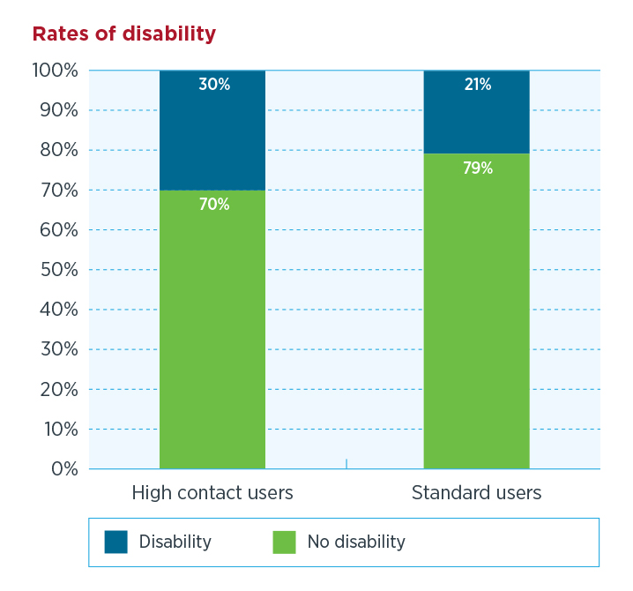
Figure 1 – Rates of disability amongst VLA clients
High- contact users were also more likely to have either a mental, intellectual, psychiatric disability or acquired brain injury compared with a standard user. A standard user is more likely to have a physical disability, including a hearing, visual or speech impairment – see Figure 2.
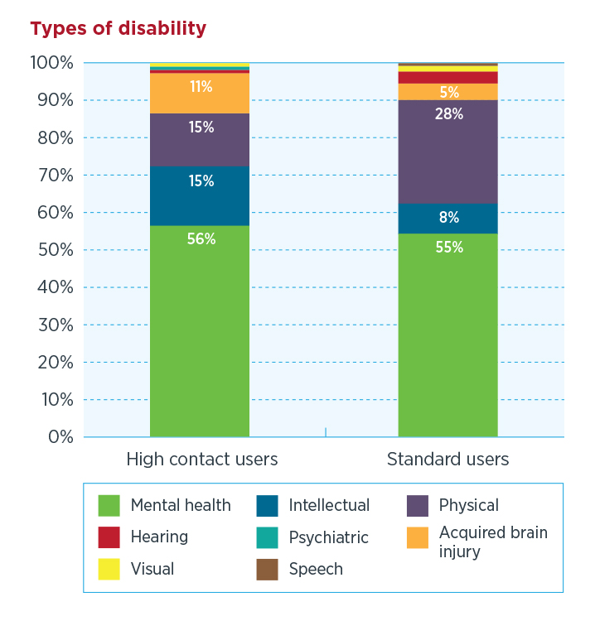
Figure 2 – Types of disability amongst standard and high contact VLA clients
High-contact users were also more likely to:
- be on a Disability Support Pension (DSP) – 41 per cent of high-contact users who are on a government benefit/pension are on the DSP, compared with 15 per cent of the standard users who are on a benefit/pension.
- identify as Aboriginal and Torres Strait Islander. While still a relatively small number of our standard client group (1.3 per cent), they make up a larger subset of the high-contact users group (4.2 per cent).

First contact with VLA
The majority of clients have their first contact with VLA for a criminal law matter, however for high-contact users, this is even more likely (67 per cent for high-contact users compared to 47 per cent for standard users). Therefore, high-contact users are less likely than standard users to contact us for a family or civil matter in the first instance, though some may go on to receive those family and civil services later.
As per the age profile above, the first contact with VLA for high-contact users tends to be at younger ages (10–17, peaking at 16 years of age), though they are also contacting us frequently between 18–34. See Figure 3.
When looking at just the top 100 users, their age profile is even younger, with the most common age of first contact at 13 years of age, with the average age overall at 21 years of age.
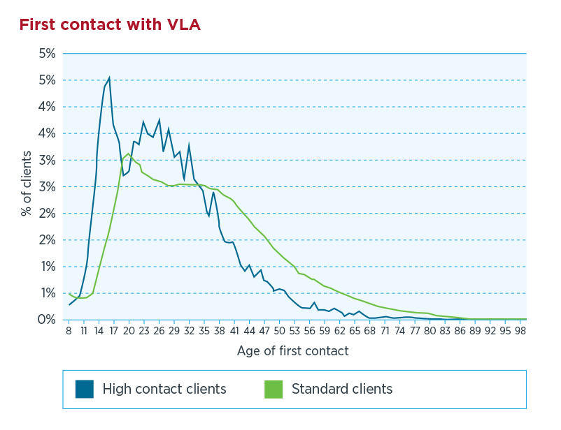
Figure 3 – Age of first contact with VLA

Legal matters

Grants of legal assistance
We provide grants of legal assistance to people who cannot afford a lawyer. Grants are usually for criminal or family matters, but they can also be given in some other civil matters, such as immigration, social security, mental health or discrimination cases.
High-contact users were more likely to have received a grant of legal assistance for a criminal matter (91 per cent compared to 54 per cent standard users) and civil law matters than standard users. Similar numbers had received a family law grant (51 per cent for high-contact users, 53 per cent for standard users). However, they were more likely to require multiple grants of legal assistance for all matters, including family law.
From our top 100 users, all 100 had received at least one grant of legal assistance for criminal matters, however 70 of them also had a grant for a family matter during the ten year period.
Criminal issues are more likely to generate multiple contacts with VLA for high-contact users. High-contact users receiving criminal law services average 27.2 services over 10 years, compared with 7.7 for family law services and 7.9 for civil services.
Across all services, the most common single matter group for high-contact users was theft and miscellaneous offences, while for standard users, family matters relating to children was the most common.
Legal aid services are managed by three program areas: Criminal Law Program, Family Law Program and the Civil Law Program.
Figure 4 – Number of programs accessed by standard and high contact VLA clients
High-contact users are more likely to have accessed multiple programs at VLA, with the majority accessing two programs (47 per cent), with 31 per cent having accessed three programs and 22 per cent only having accessed one program. Standard clients are more likely to have accessed only one program (83 per cent), while 15 per cent accessed two programs, and only two per cent accessed three programs – see Figure 4.
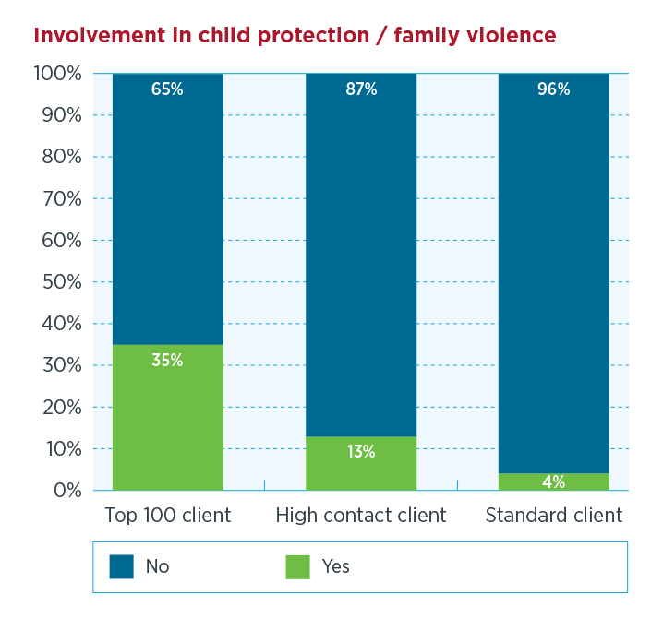
Figure 5 – VLA clients and prior involvement with child protection/family violence
High-contact users were three times more likely to have been involved in a child protection or family violence issue prior to the age of 18, than standard users – 13 per cent for high-contact user clients compared with four per cent for standard clients. These numbers increase when isolating our top 100 users. 35 per cent of that cohort had come to VLA for a child protection of family violence matter before the age of 18 – see Figure 5.

Location
Both high-contact users and standard users come from locations that are classified as relatively disadvantaged (with a Socio-Economic Index of Advantage – SEIFA – score lower than the median Melbourne or Victorian score).
The top five local government areas where high-contact users come from are Greater Geelong, Greater Dandenong, Casey, Brimbank and Hume. The top five local government areas for standard users are not too dissimilar, they are Casey, Hume, Greater Geelong, Brimbank and Greater Dandenong. Some of these are located in ’interface’ areas – areas that are have high population growth, on the edge of growth corridors and with often inadequate infrastructure and services to cope with the population growth.
The top five suburbs where high-contact users come from are Dandenong, Reservoir, St Albans, Frankston and Sale. For standard users, St Albans, Frankston, Dandenong, Reservoir and Shepparton are the top suburbs.

Discussion
These findings align with research about legal need where indicators of disadvantage (such as disability, unemployment, Indigenous status) may lead to a greater vulnerability to experiencing multiple and serious legal problems. The profile of our high-contact users as being more likely to be male, involved in the criminal justice or child protection system at a young age, and with high numbers having a mental health issue or cognitive disability is consistent with research about risk of involvement in the criminal justice system. It is also similar with the profile of NSW Legal Aid high-contact users.

Implications for VLA
From the profile it would appear that some of the key risk factors for clients who may become future high-contact users are those who:
- have early contact with VLA (prior to 18 years of age) for child protection or family violence matters
- start criminal offending at a young age, specifically between 10–17
- have a mental health issue, psychiatric issue or a cognitive disability, including acquired brain injury.
- identify as Aboriginal or Torres Strait Islander.
Having identified these as risk factors, is there value in providing a different kind of service for these users?
The purpose of doing so would be to help prevent future offending and associated other legal problems, and subsequently the need for future VLA services or more costly legal interventions. The other advantage of identifying clients at risk of becoming high-contact users is to better manage the organisation’s relationship with these clients by making appropriate, early referrals and by focusing on the client and not just on the legal problem. (As the VLA data shows, high-contact user clients are more likely to have problems that extend beyond one program area, and have a combination of criminal/civil/family legal problems). This would align well with VLA’s business plan priority of delivering holistic services.
The Legal Aid NSW research recommends a number of different approaches that may be appropriate for Victoria’s high contact clients. These include providing more intensive and holistic legal services aimed specifically at young people using a case management approach, linking to other services, including non-legal services and working with courts, community services (DHS) and police to identify and assist these young users.
As a consequence of this report, NSW has set up a pilot Children’s Civil Law Service, that will provide casework services to child clients identified as having complex needs. The service partners with Legal Aid NSW’s Children's Legal Service and Shopfront Youth Legal Centre (a community legal centre) to deal with criminal issues, at the same time as it deals with the civil legal problems that may or may not be associated with the criminal matters. The service will also identify systemic issues that lead to the criminalisation of this group of children, particularly those who have a history of placement in out of home care. Lawyers also directly assist clients with their negotiations with the Department of Family and Community Services. The Legal Australia-Wide (LAW) Survey also identified the need for intensive, case-managed services for vulnerable or disadvantaged groups.
The fact that high-contact users have an overall younger age profile, and appear to be more likely to first have contact with us prior to 18 years of age provides a strong argument to target these clients for intensive, holistic services in the first instance. As in NSW, VLA has accredited specialists in children’s law, who already have expertise in working with this client group. The Child Protection team and the Youth Crime team work closely with each other to identify young children with child protection/criminal issues and try to ensure, where possible, continuity of representation. The teams could potentially be resourced to continue to provide more holistic services to this group including case management, advocacy and linking in to other supports or services. Another high risk indicator for clients, (where holistic services could be targeted) is where the client has been identified as having a mental illness, intellectual, cognitive or psychiatric disability. Finally, Aboriginal and Torres Strait Islander status also stands out as a significant risk indicator – Aboriginal Australians are over-represented in both the child protection area, juvenile justice and adult criminal justice areas. While they are a small proportion of our overall client population, they are overrepresented in our high-contact user group and in the proportion of our clients who are in custody.
The Legal Aid NSW High service users at Legal Aid NSW study also recommends continuity of representation to be provided for high-risk clients, providing the same legal representative for all/most of the matters involving the client. The paper also suggests a more flexible grants process for this type of client, rather than applying for grants for each separate legal incident.
The Legal Aid NSW high-service user study suggests that this case management approach is delivered by a highly qualified lawyer who is able to work across jurisdictions and has the skills to devise innovative approaches to the client’s issues and link the client to other services, both legal and non-legal.
Another approach may be to provide multi-disciplinary services to this group, and employing a social worker or a case worker to work with lawyers, service providers and the client. Health-legal multidisciplinary partnerships have existed in the US for some time as have some law and social work multi-disciplinary legal clinics. Since 2010, Monash University has participated in a program where social work students are placed alongside law students in a community legal centre (Monash Oakleigh Legal Service). The purpose of working in this way is to enable the legal service to assist clients with the various non-legal issues (homelessness, drug abuse, health issues, housing etc.) that may be contributing to their legal problem. The advantage of bringing in specialist social workers or case workers would be to utilise their expertise in accessing the support the client needs, and being a consistent point of contact with the client. This would allow the use of different legal representatives who are specialists in different areas of the law.

The importance of systemic advocacy
While legal aid agencies can improve their own approaches to dealing more effectively with high-contact users, it is important to remember that there are limits to what an individual agency can do. The structural disadvantage and systemic issues that contribute to chronic offending need to be addressed before we would see a real decline in the continued need for legal aid services in the future.
The common trajectory of involvement in the child protection system, and then subsequent involvement in the criminal justice system is already well established. Specific problems, for example, in the management of behavioural issues for children in residential or out-of-home care which criminalises such behaviour and leads to early involvement in the criminal justice system, becomes a risk in itself for continued involvement in the system.
Also well known is the disproportionate number of people with mental health, cognitive disability (including acquired brain injury ) who become involved in the criminal justice system. People with mental health issues are also vulnerable to civil problems, such as debt and housing, escalating to become criminal problems. An example of this in Victoria, is in the area of infringements, where the management of fines, means that vulnerable people can find themselves facing prison, for what may initially appear to be a relatively minor legal issue. VLA has advocated for changes to the infringements process in order to minimise the negative impacts on vulnerable people, and has run test cases to uphold the right to have cases reviewed, which take into account a person’s disability.
This example reinforces that whatever changes we may make to our internal processes, it’s important that through its work with clients, VLA remains actively involved in identifying systemic issues that contribute to the experience of legal problems by its most vulnerable clients. VLA should be prepared to draw attention to these issues, and propose solutions.

Conclusion
The Legal Australia-Wide Legal Needs Survey proposes a ‘”two speed system” of legal service delivery – a heavily targeted and even case managed approach to meeting the complex needs of the small minority of the community that experience the large majority of legal problems, and a much lighter model for the rest”. Clients of legal aid are some of the most disadvantaged in the state, yet our services reflect the two speed system, where the majority of clients receive less intensive services, or even if they do have a grant of legal assistance, they may approach us on average once or twice over the course of a decade.
In the meantime, there is a small group of clients who access our services multiple times, including obtaining multiple grants of assistance and needing help with legal problems beyond criminal matters. These clients have complex problems that either reoccur or their personal circumstances exacerbate their risk of experiencing a legal problem. An analysis of data collected from these clients show high rates of disability and disadvantage. Providing distinct, stand-alone services for this client group may not be as effective as providing intensive, additional holistic support (legal and non-legal) when these clients first approach VLA. This support may be in the form of:
- providing more intensive service delivery when the person has initial contact with VLA, including careful case management and provision of a single, contact point within the organisation for that client
- providing more holistic services, with a focus on appropriate referrals to non-legal service providers
- embracing a multi-disciplinary approach, where VLA lawyers work actively with social workers, teachers, doctors and police to address the problems of the individual that is contributing to or causing their legal problem(s). This may involve directly employing case workers or liaison officers (especially in relation to Aboriginal clients) to help connect with ancillary services in addition to legal assistance
- advocating for systemic change that would contribute to reducing the likelihood that vulnerable people become involved in criminal offending or experiencing serious legal problems.
To some extent, VLA has already identified priority clients (such as children) who may qualify for intensive legal help including appropriate referrals to other support and where possible, continuity of representation. However, we would need to provide additional resources to facilitate providing a single contact point, or in employing caseworkers. Further research would be needed to examine whether this investment would reduce costs for legal aid, or free up resources to help a greater number of people.
We would need further research and consultation with VLA lawyers, on whether these approaches would be practical and whether they would minimise the reoccurrence of future legal problems. We also need to further examine the costs of providing standard services to these users, and whether they could be redirected towards services that may lead to more lasting change.

References
Allard, T., Chrzanowski, A. & Stewart, A. 2013 Targeting crime prevention: identifying communities that generate costly and chronic offenders, Australian Institute of Criminology, Research and Public Policy Series no.123, Canberra. Available at: http://www.aic.gov.au/publications/currentper cent20series/rpp/121-140/rpp123.html
Australian Council of Social Service, 2013 Australian Community Sector Survey 2013 : national report (ACOSS Paper 202), ACOSS, Strawberry Hills. Available at: http://acoss.org.au/images/uploads/Australian_Community_Sector_Survey_2013_ACOSS.pdf
Australia. House of Representatives. Standing Committee on Aboriginal and Torres Strait Islander Affairs, 2011 Doing time: time for doing: Indigenous Youth in the Criminal Justice System Canberra, 2011. Available at: http://www.aph.gov.au/parliamentary_business/committees/house_of_representatives_committees?url=atsia/sentencing/report.htm
Cashmore, J. 2011 “The link between child maltreatment and adolescent offending: systems neglect of adolescents” Family Matters, 89. Available at: http://www.aifs.gov.au/institute/pubs/fm2011/fm89/fm89d.html
Co-operative Legal Service Delivery Program, 2013 CLSD Update, December 2013, CLSD, NSW Legal Aid.
Coumarelos, C, et al, 2012 Legal Australia-Wide Survey: legal need in Australia, Law and Justice Foundation of NSW, Sydney. Available at: http://www.lawfoundation.net.au/ljf/app/&id=FC6F890AA7D0835ACA257A90008300DB
Council of Australian Governments. 2010 National Partnership Agreement on Legal Assistance Services, Canberra. Available at: http://www.ag.gov.au/LegalSystem/Legalaidprograms/Documents/Nationalpercent20Partnershippercent20Agreementpercent20onpercent20Legalpercent20Assistancepercent20Services.pdf
Essential Economics, One Melbourne or two? Implications of population growth for infrastructure and services in interface areas: updated report, Carlton, 2013 Available at:
http://apo.org.au/sites/default/files/docs/EssentialEconomics_One_Melbourne_or_Two_2013.pdf
Farrell, J. & Noble, P.2012 “How doctors and lawyers can help vulnerable patients”, The Conversation, 15 November 2012. Available at: http://theconversation.com/how-doctors-and-lawyers-can-help-vulnerable-patients-9999
Forsyth, L & Gaffney, A. 2012 “Mental disorder prevalence at the gateway to the criminal justice system”, Trends & Issues in Crime and Criminal Justice, 438. Available at: http://www.aic.gov.au/publications/currentper cent20series/tandi/421-440/tandi438.html
Gough, E. 2011 The Drift from care to crime: a Legal Aid NSW Issues Paper Legal Aid NSW, Sydney. Available at:
http://www.legalaid.nsw.gov.au/__data/assets/pdf_file/0019/18118/The-Drift-from-Care-to-Crime-a-Legal-Aid-NSW-issues-paper.pdf
Hyams, R.2012 ” Multidisciplinary clinical legal education : the future of the profession.” Alternative Law Journal; 37 (2) 2012: 103. Available at (subscriber access only): http://search.informit.com.au/fullText;dn=20122848;res=AGISPT
Saunders, B.J et al, 2013 An Examination of the impact of unpaid infringement notices on disadvantaged groups and the criminal justice system – towards a best practice model, Monash University, Melbourne. Available at: http://www.cjrc.monash.org/unpaidfines/unpaid_infringements_final_report.pdf
Trubeck, L & Farnham, J. 2000 “Social justice collaboratives: multidisciplinary practices for people” Clinical Law Review, Fall. Available at: https://media.law.wisc.edu/m/mtbyz/social_justice_collab.rtf
Van de Zandt, P. & Webb, T. 2013, High service users at Legal Aid NSW: profiling the 50 highest users of legal aid services, Legal Aid NSW, Sydney. Available at: http://www.legalaid.nsw.gov.au/__data/assets/pdf_file/0004/16537/Legal-Aid-NSW-Study-on-high-service-users-June-2013.pdf
Victoria Legal Aid. Strategic Plan 2011-14, VLA, 2011. Available at: http://intranet.vla.vic.gov.au/xwf/vlanet/dir_strat_plan_11_14.pdf
Victoria Legal Aid.2013 (Media release), “Court of appeal decision supports fairer fine laws”, 4 March. Available at: http://www.legalaid.vic.gov.au/about-us/news/court-of-appeal-decision-supports-fairer-fines-laws
Victoria. Parliament. Law Reform Committee. 2013 Inquiry into access to and interaction with the justice system by people with an intellectual disability and their families and carers, The Committee.. Available at: http://www.parliament.vic.gov.au/images/stories/committees/lawrefrom/iaijspidtfc/2013-03-05_Access_to_justice_intellectually_disabled_-_Final_Report.pdf

Council of Australian Governments. National Partnership Agreement on Legal Assistance Services, Canberra, 2010.
63 per cent of legal assistance service providers were unable to meet demand for services in 2011-12. Australian Council of Social Service, Australian Community Sector Survey 2013 : national report (ACOSS Paper 202), ACOSS, Strawberry Hills, 2013
In a national survey about legal need, 50 per cent of respondents experienced at least one or more legal problems within the previous 12 months. Coumarelos, C, et al , Legal Australia-Wide Survey: legal need in Australia, Law and Justice Foundation of NSW, Sydney, 2012.
ibid
Van de Zandt, P. & Webb, T. High service users at Legal Aid NSW: profiling the 50 highest users of legal aid services, Legal Aid NSW, Sydney, 2013
In this instance, services did not include legal information or website usage, as we do not record the names/details of clients who use these services
In terms of costs to the organisation, we estimate that each client would have received on average $18,000 in direct service delivery costs, however this is a conservative estimate and doesn’t factor in other administrative or overhead costs, including costs of staff time spent on these client matters. We suspect high-contact users would have more complex cases, so would likely have higher than average costs.
Note that VLA changed its client database in 2011. Client records were transferred into the new system, however the collection of demographic data may not have been consistently recorded. As an example, since 2011, data relating to disability is a mandatory field in the database, so the collection of data regarding disability prior to 2011 is not as robust.
Out of those users who reported a disability, high-contact users and standard users had similar rates of mental health issues (57 per cent to 55 per cent respectively), however high users were twice as likely to report an intellectual disability (15 per cent compared with 8 per cent for standard users) and an Acquired Brain Injury (11 per cent compared with 5 per cent).
Standard users who reported a disability were more likely to have a physical disability (30 per cent compared with only 14.5 per cent for high users).
Miscellaneous offences includes defamation and libel, offences against privacy, public health and safety and illicit drug offences
Programs at VLA fall into three jurisdictions – criminal, family (including children’s matters) and civil (including discrimination, social security, veteran’s affairs, refugee/migration, fines/infringements, credit and debt).
Essential Economics, One Melbourne or two? Implications of population growth for infrastructure and services in interface areas: updated report, Carlton, 2013
Cashmore, J. “The link between child maltreatment and adolescent offending: systems neglect of adolescents” Family Matters, 89, 2011
Forsyth, L & Gaffney, A. “Mental disorder prevalence at the gateway to the criminal justice system”, Trends & Issues in Crime and Criminal Justice, 438, 2012. This study found that at the time of arrest, almost half of all detainees had some form of mental health disorder. See also; Victoria. Parliament. Law Reform Committee. Inquiry into access to and interaction with the justice system by people with an intellectual disability and their families and carers, The Committee, 2013.
Van de Zandt & Webb
Ibid p. 23
Co-operative Legal Service Delivery Program, CLSD Update, December 2013, CLSD, NSW Legal Aid, p.2. The service also works with the Shopfront Youth Legal Centre and is working Parramatta Children’s court in relation to establishing a specialist list for children who have been identified as having complex needs.
Coumerelos et al p.xxi
Australia. House of Representatives. Standing Committee on Aboriginal and Torres Strait Islander Affairs. Doing time: time for doing: Indigenous Youth in the Criminal Justice System: Canberra, 2011.
In 2012/13, VLA data shows that approximately 5 per cent of our clients not in custody identified as Aboriginal and Torres Strait Islander (ATSI), however, 8 per cent of our clients in custody identified as ATSI. The number of VLA Aboriginal clients in custody has been trending upwards over the last few years.
Note this is also a commitment in the Victoria Legal Aid, Strategic Plan, 2011–14, VLA 2011.
Van de Zandt & Webb, p. 24
Ibid p.25. As an example, the authors advocate for additional funding to be available for urgent specialist, expert reports, and for a case service advocate function, that will support the client between court appearances and help with obtaining access to other services.
ibid
Farrell, J. & Noble, P. “How doctors and lawyers can help vulnerable patients”, The Conversation, 15 November 2012 <http://theconversation.com/how-doctors-and-lawyers-can-help-vulnerable-patients-9999>
Trubeck, L & Farnham, J. “Social justice collaboratives: multidisciplinary practices for people” Clinical Law Review, Fall, 2000 <https://media.law.wisc.edu/m/mtbyz/social_justice_collab.rtf>
Hyams, R.” Multidisciplinary clinical legal education : the future of the profession.” Alternative Law Journal; 37 (2) 2012: 103.
Cashmore, 2011
Gough, E. The Drift from care to crime: a Legal Aid NSW Issues Paper Legal Aid NSW, Sydney, 2011 p. 3
Forsyth & Gaffney
Saunders, B.J et al, An Examination of the impact of unpaid infringement notices on disadvantaged groups and the criminal justice system – towards a best practice model, Monash University, Melbourne, 2013.
Victoria Legal Aid. Infringements Working Group. Vulnerable people and fines: position paper, Melbourne 2013
Victoria Legal Aid. (Media release), “Court of appeal decision supports fairer fine laws”, 4 March 2013
Coumerelos et al, xi

