Space Invaders Evaluation
A legal education theatre project

August 2012

© 2026 Victoria Legal Aid. Reproduction without express written permission is prohibited. Written requests should be directed to Victoria Legal Aid, Research and Communications, 350 Queen Street, Melbourne Vic 3000.
Disclaimer. The material in this publication is intended as a general guide only has been prepared for Victoria Legal Aid staff and community legal centre staff and volunteers for study purposes only. The information contained should not be relied upon as legal advice, and should be checked carefully before being relied upon in any context. Victoria Legal Aid expressly disclaims any liability howsoever caused to any person in respect of any legal advice given or any action taken in reliance on the contents of the publication.
Contents
Space Invaders Evaluation 1
August 2012 1
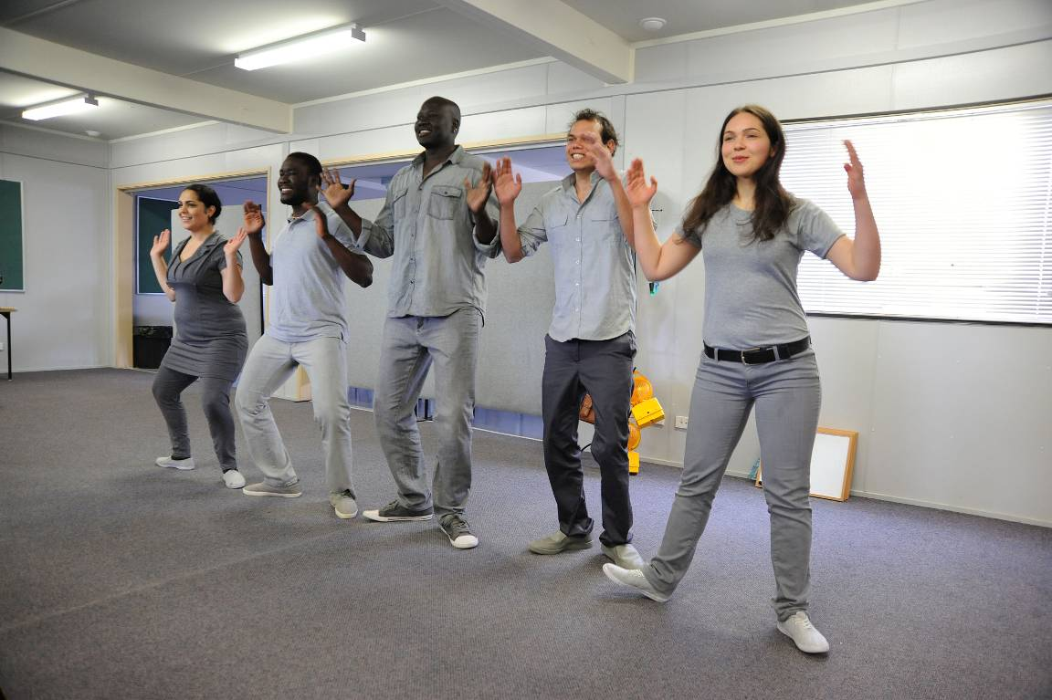 1
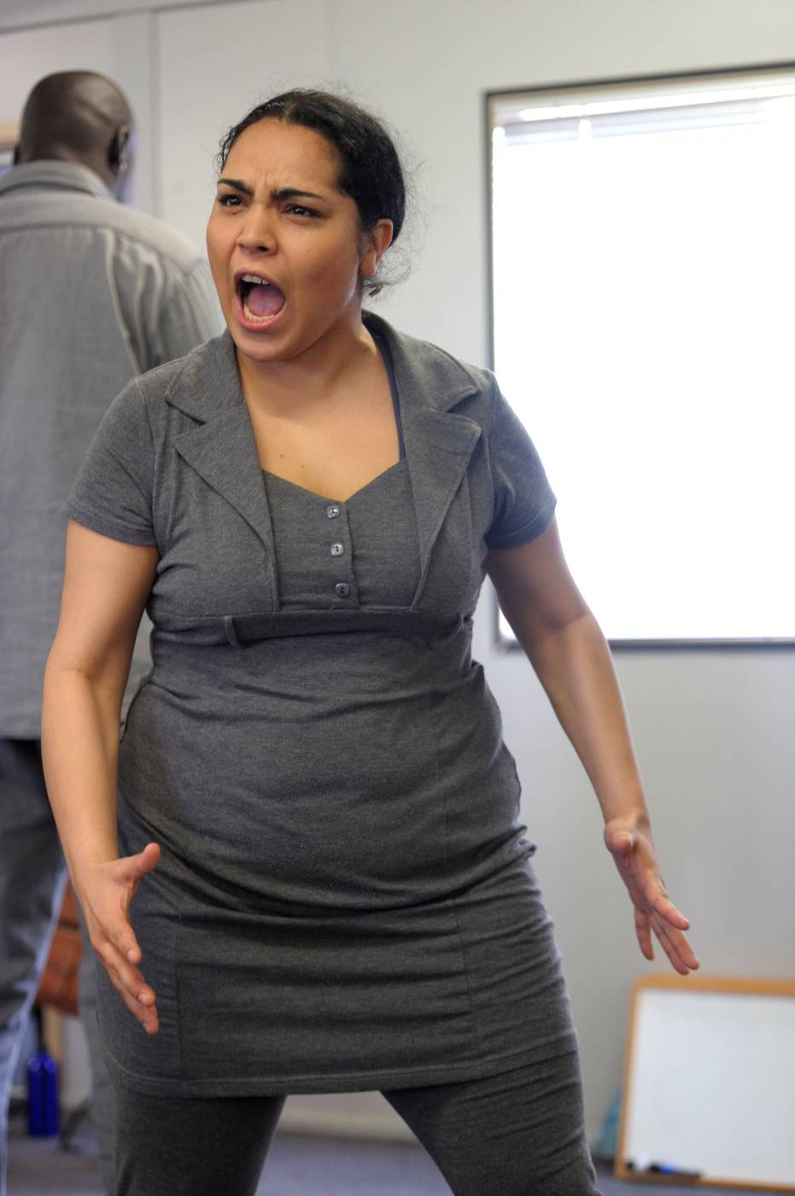 2
Acknowledgements 2
Executive summary 2
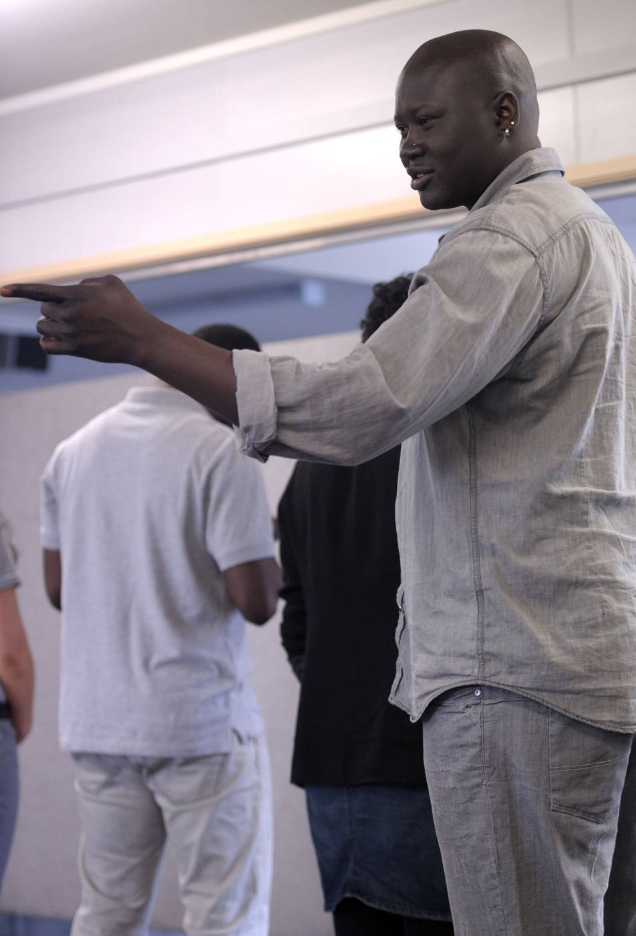 4
Background 4
Young people and police 4
About the organisations 6
The role of community legal education 7
Section one: What was the project? 8
Background 8
The concept 9
The show we made 9
Objectives and outcomes 9
Project timeline 10
Young experts 10
Schools 10
Personnel 11
Governance 11
Budget 11
Educational resources 12
Communications 12
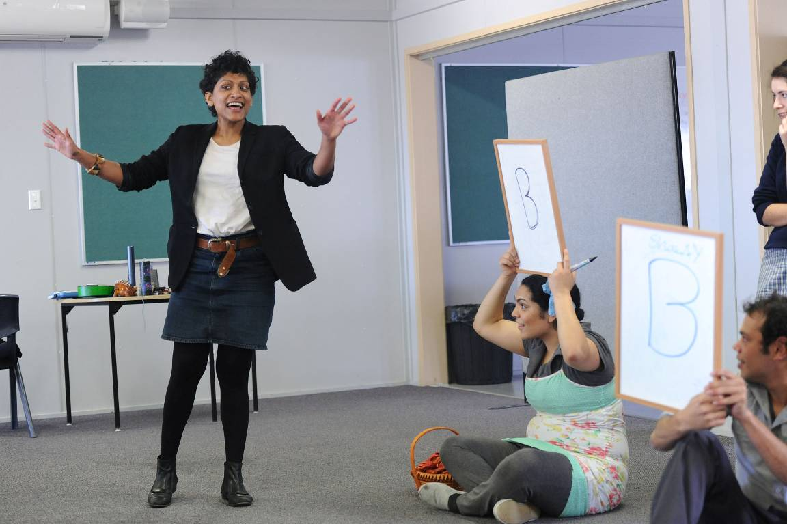 13
Section two: What did we learn about the impact of the project? 13
Methodology 13
What students said 14
What teachers and workers said 17
What the artists said 18
What we said at Victoria Legal Aid 19
Recommendations 19
Section three: What did we learn about the process? 20
Methodology 20
The things we did well 20
The things we could have done better 21
Recommendations 22
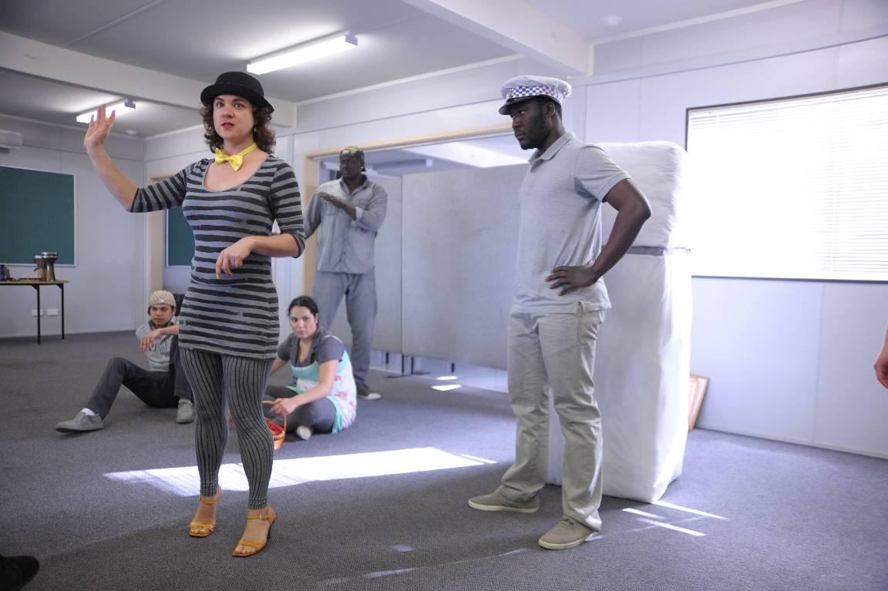 23
Conclusion 23
Appendice one: Script 25
Appendice two: Students’ ‘your rights’ card 44

Acknowledgements
Victoria Legal Aid greatly acknowledges the input of the project partners: Cymbeline Buhler, Western Edge Youth Arts, and Tamar Hopkins, Flemington Kensington Community Legal Centre. We also acknowledge the support of law student Rachael D’Rozario for sorting the survey data, and the many others who helped bring this big project to life. Thanks to photographers Carla Gottgens and Kim Daly for the photos used through this evaluation report.

Executive summary
Space Invaders was a new legal education theatre project, a joint project between Victoria Legal Aid, Flemington Kensington Community Legal Centre and Western Edge Youth Arts. With funding from Arts Victoria and the Australia Council, the project used theatre to educate year 9 and 10 students about their rights when dealing with police, a pertinent issue to young clients and participants from across our three organisations. We conceived and developed the project in 2010, and then implemented it in 2011.
The project involved an artistic team of seven key artists (director/facilitator, writer and five performers) and three ‘lawyers-in-residence’, who helped develop the show and performed in it too.
We presented to seven schools over eight performances reaching approximately 600 students. We targeted schools in areas which were ethnically diverse: south eastern Melbourne, inner Northern suburbs and inner-Western and far Western suburbs.
We evaluated the impact of the project through student surveys, teacher surveys, reflective statements and a project debrief. We evaluated the process through ongoing reflection, and also through the project debrief.
In surveying students, we learnt that:
- students responded well to the format
- students found the content and the stories relevant
- students learnt more about key legal rights.
In evaluating the process, we learnt that:
- we did a good job of bringing in the right expertise to the project
- we could improve on defining who is best to lead a cross-agency project and who supports it.
The project has future opportunities for all three agencies involved. This report offers recommendations for what Victoria Legal Aid should do. The recommendations are:
- re-purpose the script into a ‘police powers kit’. The kit should have tools that staff and other youth educators can use to support them in delivering information sessions about police powers to young people
- re-visit schools from the project where there was a demand for more information and for returning to the school. Use the re-purposed materials or encourage the teachers to do so
- re-purpose the script so it can be used in police training. This recommendation is about being organisationally responsive to the first recommendation of the 2011 Coroner’s Court of Victoria inquiry into the shooting of Tyler Cassidy, where it is recommended that the Victoria Police Operational Safety and Tactics Training be improved where it relates to dealing with vulnerable young people
- continue to build relationships with other legal and non-legal educators, by sharing the learnings of this project.

Background

Young people and police

Usage of space and racialised treatment
In parks, on the streets, at the shopping centre, on the steps of Flinders Street station: young people spend time socialising in public spaces.
Legislatively, police officers play a role in monitoring young people within public spaces. Recent amendments to Victorian law provide police with increased authority in maintaining ‘order’:
- the Graffiti Prevention Bill 2007 allows for police officers to search anyone that they reasonably believe to be 14 or older and who is near a graffitied property, for example, a train station
- the Summary Offences and Control of Weapons Acts Amendment Bill 2009 allows for Victoria Police to declare public areas as ‘designated’ search spots where police officers can randomly search a person for weapons
- the Justice Legislation Amendment (Protective Services Officers) Act 2011 allows for new Protective Service Officers (PSOs) to work at train stations. PSOs have similar powers and weapons to police officers.
For young people from culturally and linguistically diverse backgrounds, the relationship with police can be even more heightened, as policing can often be racialised.
The 2010 report, Boys, you wanna give me some action: interventions into policing of racialised communities in Melbourne, by community legal centres Fitzroy Legal Service, Springvale Monash Legal Service and Western Suburbs Legal Service, was an extensive enquiry into relationships between young African people in the City of Greater Dandenong, Flemington and Braybrook. This report was part of the centres’ ‘Racism Project’, about racism in the community. Two key findings from the report showed that “African young people are over-policed in the regions of the study” and “Police enforce particular notions of acceptable usage of public space. This results in police-youth conflict.“
This is not a unique African problem. Murphy and Cherney in Policing ethnic minority groups with procedural justice: an empirical study Australian studies (2010) cite various Australian studies examining the relationship between police and ethnic communities, which all show that ethnic minority groups living in Australia have particularly problematic and poor relationships with police.

The impact of policing
Police interactions can have a serious impact on young people’s sense of safety and well-being. Moonee Valley City Council Youth Services’ 2006 report about young people’s safety concerns in the Flemington region noted the two most significant safety concerns for young people were drugs and crime, and police officers.
Individuals and witnesses of violent crimes who were surveyed reported feeling intense paranoia, fear, helplessness, scarring and deep distress at being in Australia.
Casework experience from the Flemington Kensington Community Legal Centre – a legal centre committed to issues of police accountability – and our Youth Crime sub-program continually corroborate these sorts of findings.

Demand for information and format of information
Young people want information about their rights. Am I old enough?, a Victoria Legal Aid publication about young people and their legal rights, is one of Victoria Legal Aid’s most popular publications. We distribute nearly 50,000 copies per year. We also distribute over 17,000 copies of the publication Police powers. Our youth issues pages on our website continue to be the most frequently visited pages.
Mission Australia’s 2010 nation survey into the needs of young people found that “the top three sources of advice and support for young people in 2010 were friends, parents and relative/family friend and this was true for all age groups and both genders.” Creating a theatre show is another opportunity to communicate to young people information that they want. And as the research suggests, the young people in attendance will pass the information they learn onto others.

About the organisations

Victoria Legal Aid
We are a state-wide organisation that helps people with their legal problems in criminal, family, and civil and administrative law. Our 2011-14 strategic plan identifies our priority clients are people who:
- face detention by the state or having decisions made for them
- are exposed to risk of violence or harm
- are marginalised or vulnerable to exploitation or unfair treatment.
Our Youth Crime sub-program represents more than half of all children (people aged under 18) in Victoria facing criminal charges.
As well as providing legal advice and representation, the Legal Aid Act 1978 mandates that we provide community legal education to the Victorian public. We have produced free legal education material for over 30 years, materials used by our lawyers and many workers and advocates, as well individuals. We also provide community legal education through other mediums: digital media, community events, information seminars, and community engagement projects.

Flemington Kensington Community Legal Centre
Flemington Kensington Community Legal Centre is one of more than 50 community legal centre in Victoria. The centre’s purpose is to provide free and confidential legal advice to people in the Flemington and Kensington area. Like many community legal centres, Flemington Kensington Community Legal Centre delivers community legal education and conducts law reform and social justice campaigns. The centre is committed to the principles of human rights, social justice, equity and community participation.
Flemington Kensington Community Legal Centre employs a part-time solicitor, Tamar Hopkins, on a long-term police accountability project.
For many years Victoria Legal Aid has partnered with Flemington Kensington Community Legal Centre in the ongoing production of the Police powers publication.

Western Edge Youth Arts
Western Edge Youth Arts is a youth arts organisation that works with culturally and linguistically diverse and economically disadvantaged communities to create unique arts and arts education experiences for young people under 26. Western Edge’s work is founded on long-term relationships with participants, a strong commitment to the professional development of young artists and a dedication to the production of excellent, culturally diverse art with an authentic youth voice. Western Edge works in both school and community contexts. Cymbeline Buhler is the Artistic Director at Western Edge Youth Arts, working on community programs. She has extensive background in community arts and in forum and playback theatre.

The role of community legal education

Minimising the impact of the law
The law can empower a person with rights and remedies to resolve a legal issue but can also create experiences of stress, injustice and mistreatment. To this extent, the role of community legal education can be to prevent legal issues escalating. The flow-on effect for an organisation like Victoria Legal Aid is decreased demand on our other service areas. The earlier the problem can be addressed, the less likelihood the individual’s need for the more complex and more resource-intensive services. In this way community legal education can reduce stress for clients and costs to the justice system and community.
Regarding police powers and young people, the more equipped and empowered a young person feels in asserting their rights when dealing with police, the greater their chance of avoiding contact with the criminal justice system.

Funding and policy frameworks
The Commonwealth government recognises the value of preventative legal aid work. In the current funding agreement, the National Partnership Agreement on Legal Assistance Services 2011-14, the Commonwealth government has increased funding for preventative programs. The Community Legal Education sub-program at Victoria Legal Aid has grown and so has the expectation across the organisation that other subprograms and regional offices increase community legal education activities. A project like Space Invaders fits into broader justice sector priorities and Victoria Legal Aid’s organisational direction.
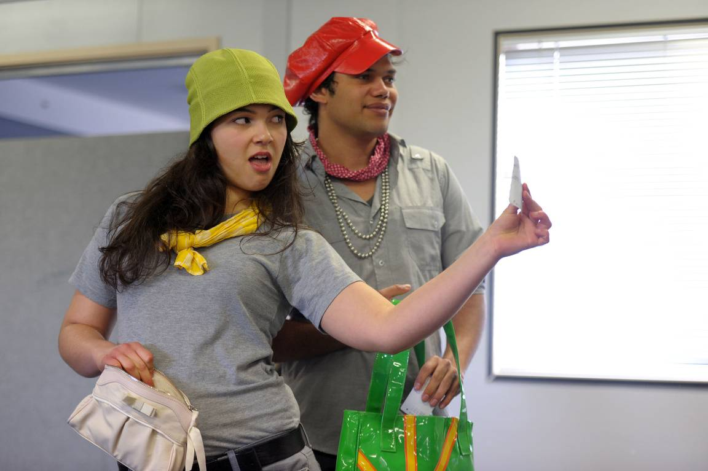

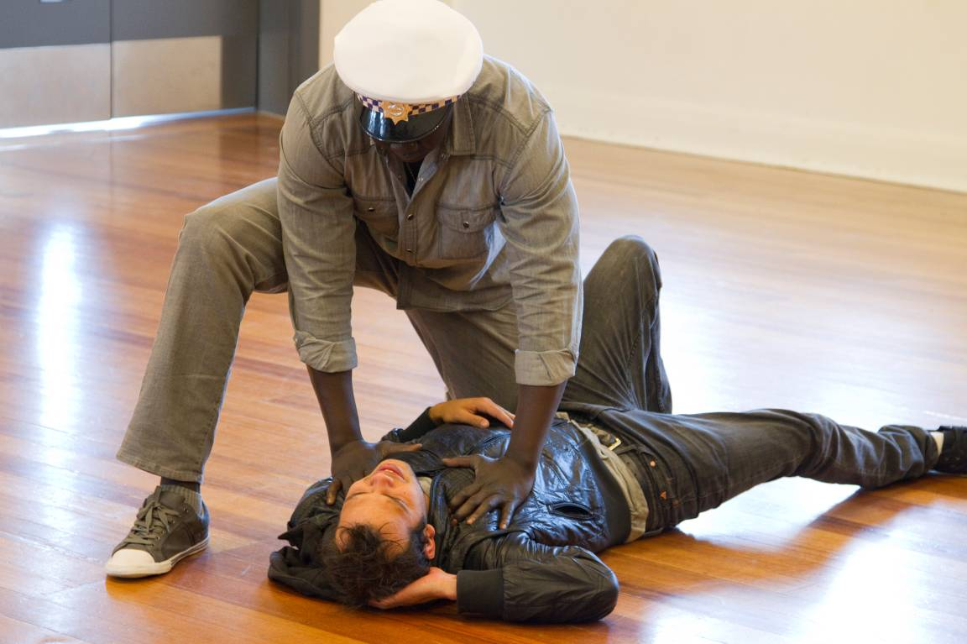

Section one: What was the project?

Background
In early 2010, Sam Lawry and Michele Lee from the Community Legal Education subprogram met with Tamar Hopkins at Flemington Kensington Community Legal Centre for a general catch-up. In talking about new project ideas, Tamar suggested a ‘know your rights’ theatre performance for high school students about police powers. She suggested using forum theatre or playback theatre, as she had seen examples of these in a youth setting in Canberra. This was the initial seed that triggered the deeper, creative conceptualisation of the project that Western Edge led when they came onto the project.

The concept
The three agencies work together to develop and present a legal education theatre show for year 9 and 10 students on the topic of police powers. We work with professional and emerging artists, and begin our theatre-making process with a week-long workshop for the artists – the Expert’s Week – with young people who’ve already had extensive contact with police. We include youth lawyers in making and performing the show.

The show we made
Space Invaders was an hour-long interactive theatre show using scripted performance and improvised playback performance.
The show began with the facilitator, Cymbeline, presenting a humourous introduction – the performers and the lawyer danced, and then assembled in a line-up where they struck poses that represented a concerned parent and then a concerned police officer.
The bulk of the ensuing show was made up of three fictional scenarios:
- a group of young girls are at a train station. Ticket inspectors and police officers approach them and question them about their presence and conduct at the train station, the police officers take a phone off one of the young girls
- police officers stop, question and search two young boys on the street, suspecting the boys of having stolen a fridge. The situation gets violent
- a young man sees a lawyer after being roughly arrested by a police officer for a crime of theft.
Cymbeline hosted a question and answer section after each scripted scenario. This was played as a quiz show. The performers selected students from the crowd and brought them up as quiz show contestants to answer the questions. The lawyer provided the correct legal answer.
Halfway through the show, Cymbeline guided a playback theatre segment to encourage students to share personal stories of encounters with authority.
The script is provided in the appendix.

Objectives and outcomes

Objectives
The objectives for Space Invaders were that students would:
- better understand their rights when dealing with police
- be more confident in asserting their rights
- know when and where to seek legal help.

Outcomes
The immediate outcome we aimed for was that the students who watched the performance would learn key rights and be equipped with tools for de-escalating situations of conflicts when dealing with police. In the long-term, these young people would be less likely to have ongoing interaction with the criminal justice system.

Project timeline
Project development occurred all throughout 2010. Project implementation occurred from February to August 2011, with shows happening July and August. Project implementation included casting performers, writing the script, rehearsing and performance.

Young experts
We began the development phase of the project in April 2011 with a week-long workshop for the artists – the Experts’ Week. This was a week with young African people from the Western suburbs who had had contact with police and who shared their stories with the artists to help us develop the content for the show.
There were approximately 15 young people involved in the Experts’ Week. We recruited these young people through Western Edge’s networks.
For most days of the Experts’ Week, we dedicated time to the young people sharing stories, and then the performers and young people using playback theatre to explore the stories. One afternoon, two people who had been through the prison system spoke to the artists about their experiences. Another day was dedicated to conflict resolution training. At the end of each day, the artists spent a couple of hours reflecting on what they had learnt that day and started to flesh out the content for the show.
Tamar and two Victoria Legal Aid workers (Joni Gear and Annie Davis) also attended the Experts’ Week and provided some answers to legal queries that arose.

Schools
We presented to seven schools over eight performances, and presented to about 600 students, mainly in year 9 and 10. Workers within our networks referred the schools to the project on the basis of the cultural diversity of the student population, given the research shows that culturally diverse young people are over-represented in police targeting. We selected schools in south eastern Melbourne, Northern suburbs and Western suburbs.
We visited:
- Debney Park Secondary College
- Endeavour Hills Secondary College
- Keysborough College
- Northlands Secondary College
- Northcote High School
- NMIT Heidelberg
- Deer Park Secondary College (Victoria University Secondary College).

Personnel

Artists
Key artists were:
- Cymbeline Buhler (director, facilitator, performer and key creator of the show)
- Adam Cass (writer)
- Justin Grant, Deng Makeui, Uraine Mastrosavas, Joana Pires and Saliah Siryon (performers)
- Laura Harris (props and costume designer)
- Rob Jordan (sound designer).

Production support
Towards the end of the project, we engaged Ally Pryor as the tour manager and sound operator.

Lawyers
Three lawyers were ‘lawyers-in-residence’ on the project:
- Tamar Hopkins, Flemington Kensington Community Legal Centre
- Joni Gear, Victoria Legal Aid
- Anoushka Jeronimus, Victoria Legal Aid.
The lawyers provided input into the script and, on a rotating basis, were in the performance and answered legal questions.

Project management
Project management was shared by:
- Cat Sweeney, February-June 2011, paid contractor
- Michele Lee, February-September 2011, in-kind Victoria Legal Aid staff.
Cymbeline also contributed greatly to project management decisions.

Other personnel
We also engaged other artists and workers to provide extra support. This included playback training, non-violence training, filming and photography.

Governance
We established a memorandum of understanding to guide our working relationship. We also established a steering committee. However, the committee was only able to meet once at the start of the project.
The steering committee comprised Cymbeline Buhler; Michele Lee; Tamar Hopkins; Chantelle Higgs, YMCA; Bec Smith, Springvale Monash Legal Service; Jody Ebinger, Footscray Police; and Moses Lado, Brimbank Police.

Budget
Our budget was $82, 385. This was made up of:
- $30,000 from Arts Victoria
- $10,000 from the Australia Council
- $24, 4357 from Victoria Legal Aid’s Community Legal Education budget
- significant in-kind support from the three partner agencies.

Educational resources

Teachers’ resources
To support the performance, we gave teachers the ‘authority module’ from Victoria Legal Aid’s Young people and the law. The publication is a kit for teachers and educators, and has tools for running class-room activities. The authority module has content about police powers. We also provided teachers with a list of local service providers.

Youth resources
For the students, to reinforce key messages from the show, we designed and printed a Space Invaders ‘your rights’ wallet-card, which listed key rights talked about in the show:
- You have the right to remain silent.
- When you are arrested, you have the right to know why. You can ask the police officer ‘What am I under arrest for?’
- If you are under 18 you have the right to an independent person or a parent to be with you in an interview
- The police can search you if you’re under arrest or if they have a warrant. They can only search you without a warrant if they reasonably think you have things on you like illegal drugs, weapons or graffiti tools, or if you’re in a ‘designated’ area for searches. You can always ask the police officer ‘What a I being searched for?’.
The performers handed the cards to all students at the show. See the appendix for a copy of the card.

Communications
Victoria Legal Aid planned and implemented a communications strategy. Where appropriate Victoria Legal Aid involved the two other partner agencies in the implementation of the strategy. Some of the communications highlights included:
- regular articles in Comet, an internal Victoria Legal Aid newsletter
- articles in Moonee Valley Leader and it the City Weekly magazine.
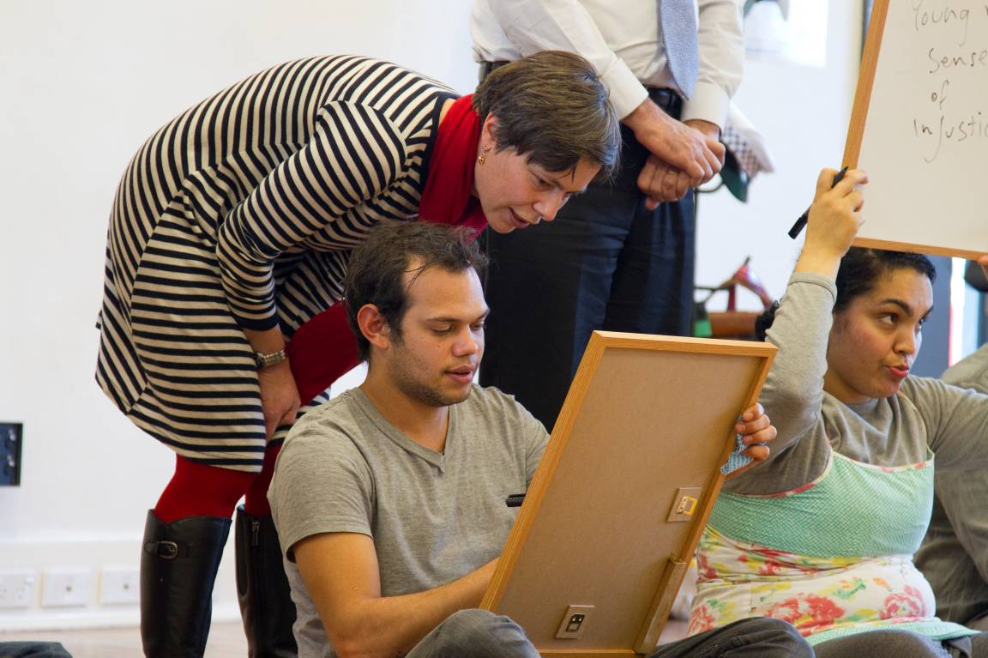

Section two: What did we learn about the impact of the project?

Methodology

Students
We evaluated the impact of the show on students through a survey where we asked:
- What did you like best about the show?
- What didn’t work so well?
- What were two legal things you learnt that you didn't know before?
- What bits in the show that would give you confidence in dealing with difficult situations in the future?
- Do you think the police were portrayed negatively? Was this realistic?
- Did you enjoy the interactive bits of the show? If so, why? If not, why?
- Did you like watching your classmates’ stories played out on stage? If so, why? If not, why?
We received 199 completed student surveys.

Teachers and workers
For teachers at each school, we asked them similar questions to the students. Only one teacher returned a survey.
We also received anecdotal feedback from three teachers, and anecdotal feedback from three workers who saw the show.

Artists
We evaluated the impact of the show on the artists through:
- reflections during and after the Experts’ Week
- project debrief.
All artists in the Experts’ Week provided ongoing verbal feedback, and one performer provided written feedback.
Most artists came to the debrief, as well as the production manager. The sound designer was unable to attend, and the props designer was overseas and provided email feedback.

Organisation
We evaluated the impact of the project on the organisation through:
- written and verbal reflections from the two lawyers who attended the Experts’ Week
- project debrief with the two lawyers who were in the show. One lawyer attended and the other gave email feedback
- regular reflections within the Community Legal Education sub-program.

What students said

What did they like best about the show?
One hundred and ninety seven of 199 students answered this question. Some students specified more than one thing they liked:
- 55 students liked the acting
- 34 students liked the interactivity of the performance, which included things such as the game show and questions being asked to the lawyers
- 27 students liked the humorous/comedic nature of the play and its actors
- 25 students liked ‘other’ qualities of Space Invaders. This included receiving chocolate, skipping class and ‘the end’ of the play
- 20 students liked the dancing best
- 18 students liked the legal information
- 17 students liked the whole performance
- 5 students liked the music the best.

Analysis: Many students responded well to the aesthetic choices of the show – commenting on the ‘fun’, ‘entertaining’ or ‘funny’ nature of the show. They responded well to the performers and to the interactive nature. Some students singled out individual performers as being highlights: this suggests that students identified with the performers, whom we purposely cast to represent a range of cultural backgrounds. Some commented on liking the chocolates that we handed out to reward interaction.

What didn’t work so well?
One hundred and eight six of 199 students answered this question. Again, students specified more than one thing they thought didn’t work so well:
- 102 students gave responses that were hard to categorise or were very succinct. For example, students used words like ‘weird’ and ‘confusing’ and some said they didn’t know what was going on in the show
- 70 students actually then responded by saying ‘everything’ worked and thus there wasn’t anything that didn’t work
- 46 students felt that the dancing didn’t work
- 40 students felt that the interactivity didn’t work
- About 15 students felt that the music and the acting didn’t work so well.

Analysis: Students at Northcote High School provided most of the negative feedback, skewing the results. We got anecdotal feedback that the performance actually went really well yet those who responded from this school spoke in negative terms. Students may also have felt confronted by the high energy and un-self conscious performance. Given the weighting of negative feedback at one location and the lack of consistency or specificity in the answers, it is un-useful to draw broad negative conclusions.

What were two legal things that they learnt that they didn’t know before?
One hundred and eighty two of 199 students answered this question. Student responses were sorted into four main categories:
- 116 students learnt something about ‘police/ticket inspector rights’. This includes taking photos of inspectors, inspectors and police officers asking for young people’s ID and whether police officers can remove your possessions
- 71 students learnt something about ‘arrest/interview information’. This includes having the right to see a lawyer and the right to know what you are being arrested for
- 62 students learnt something about the ‘right to remain silent’
- 32 students had responses that did not fit into the first three groups. Responses contained answers such as ‘I didn’t learn anything’ and non-serious answers.

Analysis: It was affirming to see that most students could recall one or two things from the show in terms of their rights. Rights about dealing with the police officers and ticket inspectors had high recall, suggesting that the train station scenario had relevance and recall. Rights in an interview and when to give your name and address had reasonably good recall too. We covered rights in an interview in the third scenario, and name and address in the second. It was affirming to see that students recalled information from across the whole show, not just the last thing that was presented. This suggests that all the scenarios presented relevant information in an engaging way.

However, it’s interesting to note that students’ interpretation or expression of what they learnt wasn’t always accurate. “That the cops can’t take your stuff.” Or “That if the police are using too much force on you, you could resist with self defence.” It’s fair to expect that after a 60-minute show, the students wouldn’t be able to repeat the legal content verbatim.

What bits in the show would give the students confidence in dealing with difficult situations in the future?
One hundred and forty eight of 199 students answered this question:
- 21 students felt more confident because of knowing their legal rights. And 46 students commented on the police or ticket inspector information being helpful
- 20 students commented on knowing more about handling conflict
- 15 students felt more confident by knowing lawyers’ contacts
- 4 students felt the ‘whole show’ helped but 24 said none of the show would increase their confidence.

Analysis: Most students talked about the legal information giving them confidence. The information about ticket inspectors ranked highly, most likely because of the common experience of young people interacting with ticket inspectors. Students didn’t seem to respond to or reference the tips we gave about staying calm and not escalating a situation.

Did the students think the police were portrayed negatively? Was this realistic?
One hundred and eighty four of 199 students answered this first question, and 193 answered the second part of the question. Ninety eight people agreed that the police were portrayed negatively and most felt that this was realistic. Fifty eight students said the police were not portrayed negatively but most said that this wasn’t realistic. Twenty nine students gave ‘other’ answers.

Analysis: Students felt that the police are negative and that it is realistic to portray them this way. It was inaccurate when police were portrayed positively.

Did the students enjoy the interactive bits of the show?
One hundred and seventy six of 199 students answered this question:
- 142 students enjoyed this. They enjoyed it because it was fun and entertaining (49), because they got to be involved (42), the lollies (13) and the realism (7)
- 30 students did not enjoy the interactivity. They felt it was boring or stupid (9), they didn’t like the physical contact (2), they preferred to watch others interacting (1), they didn’t like student interaction (2).

Analysis: Most students enjoyed the interactive nature of the show.

Did the students enjoy their classmates’ stories played out on stage?
One hundred and eighty six of 199 students answered this question:
- 115 students enjoyed this because of the humour (30), the realism or relevance (28) or because it was interesting (22)
- 41 students didn’t enjoy this but didn’t give too many reasons. Some said it was ‘embarrassing’ or ‘un-necessary’.

Analysis: Most students enjoyed the stories, that is, the playback theatre aspects. This suggested that drawing on real-life content from the audience was an effective tactic for creating an engaging show that students listened to.

Outcomes
In the short-term, we wanted the students to learn their rights and be equipped with tools for de-escalating conflict when dealing with police.
The responses from the surveys showed that the dramatic nature of a theatre show engaged students. Students learnt legal rights. However, not as many students mentioned the conflict-resolution skills as something they had learned.
Overall, the show contributed to an immediately to increased legal knowledge of 600 students. Given that young people often turn to each other for information, the project was able to contribute towards these audience members being more informed if their peers ask them for advice.
Our long-term outcome was that students would be less likely to have any ongoing interaction with the criminal justice system. This is beyond the capacity of this evaluation to assess. It would require longitudinal work to determine this and to be able to attribute the show as the contributing factor to the student’s reduced interaction with crime and policing.

What teachers and workers said
Overall, the teachers and workers were supportive of the project and of its impacts on young people.
The following feedback is from teachers and workers who attended.
I write to thank you and the all team from Space Invaders for your performance at Victoria University Secondary College on Friday 19th August.
Among staff and students in attendance there was unanimous praise for the educational and pedagogical validity of the work, in content and structure.
The spirit and professionalism with which your company and legal experts delivered the performance was commendable and the connection forged between performers and students was testament to the integrity of your performers and the egalitarian underpinnings of the work.
I wish to extend my thanks to Michele and Anoushka of Victoria Legal Aid for providing context and links to the students' experience with police and the criminal justice system.
On all accounts, Space Invaders was an excellent educational opportunity for our students who are excluded from many Theatre in Education programs due to cultural underrepresentation and socio-economic disadvantage. (Casey Nicholls, Deer Park Secondary College)
I did see the show and thought it was fantastic; I was really impressed by how well the performers managed to engage the kids. The format and the content were great. (Cameron Shilton, CLE worker, Darebin Community Legal Centre, attended the Northcote High School show)
Please keep us in mind for the future VCAL project - I believe it is something our students can benefit from, as they did with Friday's show. The students who attended have been giving raving feedback - great work and congratulations to all.
(Pierina Sassella, teacher, NMIT Heidelberg)
CONGRATULATIONS! What a performance ! The Year 10 students were a fantastic audience and got a lot out of the show. It was superbly organised and all actors were fantastic. I really highly recommend for this show to continue performing next year as it is a wonderful tool for providing relevant and useful information to as many students as possible. I am aware that the Year 11 students were not as actively involved but certainly the Year 10 were. So the performance may be more suited to a Year 10 and possibly Year 9 audience. The idea of a lawyer coming in to answer any questions raised was great as well. Thank you for choosing Keysborough College Coomoora campus as one of the schools to perform. (Laurence Dreyfuss, teacher, Keysborough Secondary College)
In particular, NMIT were particularly interested in having us return to present to students who missed the one show. They were also keen for us to present to other campuses.

What the artists said
The young artists involved, particularly the performers, all reported that the project helped them to better understand their legal rights, making them more confident young people and performers. After the Experts’ Week, one performer commented:
By getting to know the young experts and listening to their stories I was able to better understand their individual worlds and the range of prejudices they are confronted with when dealing with police and security.
I gained a lot from watching the young experts creating playback theatre themselves. They played great three dimensional police characters and a rich detailed portrayal of an African mother.
Meeting with the speakers who had spent time in prison was very inspiring and gave me a fuller picture of the personal circumstances and events that can lead people to commit unlawful behaviour which is destructive to themselves and others. Both of the speakers voiced that seeking education and working for a cause that they are passionate about is the key to empowering themselves to living a better lives.
The lawyer’s presence and legal advice relating to the stories was crucial and informative.

What we said at Victoria Legal Aid
Space Invaders was well-received by staff involved in the project and staff who saw performances of the show. It was clear that Victoria Legal Aid was ready and supportive of an innovative approach to delivering community legal education.
Relationships is a key theme of the Victoria Legal Aid’s 2011-14 Strategic Plan, and the project was an example of deep relationship building. The Community Legal Education sub-program strengthened its relationship with the Youth Crime sub-program and, externally, with Flemington Kensington Community Legal Centre. Tamar expressed strong positive feedback about the partnership, as it amplified the reach of her local work. Space Invaders was showcased in the Federation of Community Legal Centre’s 2010-11 annual report.
Being organisationally responsive to our external environment is another theme for Victoria Legal Aid’s strategic direction. Victoria Legal Aid contributed to the coronial inquest into the 2008 police shooting of 15-year-old Tyler Cassidy in Northcote. We made recommendations for improving police training. In November 2011, after the Space Invaders project had ended, the Coroner handed down the recommendations. Her first recommendation was that Victoria Police ‘develop and incorporate a youth specific component to the Operational Safety Tactics Training with a particular focus on youth specific skills for risk assessment and tactical communications and conflict resolution’.
There are more opportunities for Space Invaders to support Victoria Legal Aid’s strategic direction. We can continue to build relationships, particularly with other legal and non-legal educators who would like to inform their practice by hearing about our experiences with this project. We can contribute to organisational responsiveness by using content from Space Invaders as part of police training.

Recommendations

Re-purpose the play into a police powers kit
The scenes in Space Invaders were funny yet complex and they connected with audiences. In short, they worked. The Community Legal Education sub-program should adapt these scenes to create a ‘police powers’ presentation kit to support workers to deliver information sessions. We should target Victoria Legal Aid regional office staff, Flemington Kensington Community Legal Centre and other community legal centres like Youthlaw, and youth workers. The kit should include visual presentation materials, simplified scripts of Space Invaders scenes for use as role plays, handouts like the Space Invaders wallet cards and speakers’ notes. We should create content by drawing on existing Victoria Legal Aid resources like Young people and the law, Police powers and Am I old enough?

Re-connect with schools from the project
NMIT enquired about more presentations of Space Invaders, and in 2012 has recontacted us again. So has Endeavour Hills. The Community Legal Education subprogram should return to these schools and use the re-purposed education tools to deliver education sessions, or encourage the teachers to.

Be organisationally responsive, incorporate the content from Space Invaders into police training
Victoria Legal Aid should adapt the Space Invaders scenarios for police training, where it relates to dealing with young people.

Build relationships, share the learnings from the project
The Community Legal Education sub-program should discuss and promote the learnings from Space Invaders with other legal and non-legal educators.

Section three: What did we learn about the process?

Methodology
We evaluated the process via:
- ongoing reflections between the three agencies
- project debrief.

The things we did well

We had a good mix of organisations
Our three agencies brought specialist expertise to the project, and without this mix we wouldn’t have been able to create such a dynamic show. The Community Legal Education sub-program at Victoria Legal Aid has created smaller theatre events before and staff within the team are from theatre and community development backgrounds. Working with a professional arts organisation like Western Edge Youth Arts added extra quality and experience to the project. Flemington Kensington Community Legal Centre also brought expertise in knowledge about young people and police. Similarly, Victoria Legal Aid also brought this technical expertise through the Youth Crime sub-program.

We worked with excellent artists
All of the artists were skilled and passionate about the project. The young performers brought a warmth and likeability to the show and built rapport with audiences, sometimes even instantly.

We approached the project with an open mind
To approach a project with an open mind meant that we were supportive of how the project unravelled. The main barriers to the project were some of the issues identified on the next page, rather than the project team being resistant to ideas and trying new things.

We worked well across the organisation
The Community Legal Education sub-program strengthened its internal relationship with the Youth Crime sub-program, who regarded Space Invaders as an important project for 2011 and dedicated lawyers at all stages, as much as they could. This mutually respectful relationship has built better inroads for ongoing work between the subprograms.

We managed expectations of workload for lawyers
The Victoria Legal Aid lawyers and Tamar from Flemington Kensington Community Legal Centre were very involved with the development of the work. They provided technical advice about legal accuracy of the content but they also performed and consequently rehearsed their role as well. They helped devise questions and answers in the question and answer segments following the fictionalised scenes. They also participated in the project debrief.
We did a good job managing expectations and were fortunate that Victoria Legal Aid and Flemington Kensington Community Legal Centre lawyers were so committed to the project and supported by dedicated managers. For future projects, we should continue to manage the work expectations to accommodate for those already dedicated to community legal education and those new to the demands of the work.

The things we could have done better

Clarify who the project sponsor is
The project was a legal project that used theatre. It needed to be better led by either Flemington Kensington Community Legal Centre or by Victoria Legal Aid. That is, the project needed a clear ‘sponsor’. The sponsor’s role would be to provide overall direction and ‘sign off’ on major decisions. Without this clear leadership, at times the purpose of the project and the roles got confused.
Throughout 2010, we approached the project as though it should be an equal partnership between three agencies. In the project debrief, key artists such as Cymbeline and Adam reported at times being unclear about what the expectations were for their role. Cymbeline, in particular, was tasked with being a project partner but also employed to lead the artistic team. We agreed that the legal agencies could have played a role in carving out the education aims and from this the arts organisation could have carved out the artistic aims that supported the education aims.

Dedicate a project manager who is not the project sponsor
Victoria Legal Aid was a de facto project sponsor with Flemington Kensington Community Legal Centre. Specifically, the Community Legal Education sub-program provided most of the project management but at times Western Edge also took on a more central role in project management decision-making. Sharing the project management had its advantages because it placed Victoria Legal Aid quite close to the operations of the project. However, sharing day-to-day project management decision-making was made more difficult by not being co-located.
What could have worked better is that the legal agencies developed the brief and then tendered out the project to arts organisations to manage budget and personnel.

Develop content for the show from across all the communities we presented in
The show was presented to students in three different parts of Melbourne, but the making of the show was informed by stories only from young people from only the Western suburbs. In the project planning we had talked about engaging with young people from the three areas. In the end we worked with young people only from the Western suburbs and only from African backgrounds, as these were young people from Western Edge’s networks. We felt that it would be more manageable to work within our networks and to assemble young people with a level of trust amongst each other. This is not to say that Space Invaders lacked fundamental relevance in the stories we presented in the show but had we engaged with young people across the communities, we would have had a chance to hear and choose from a broader array of stories.

Develop strategies for sustaining contact with teachers
The project spanned two calendar years and while we were able to connect with schools to gain support for the project in 2010 and to schedule shows in 2011, it was difficult following up things such as teacher feedback and permission to use photographed images.
For future projects where we engage with teachers over the course of long-term projects, we should engage with relationship-building strategies such as meeting them regularly and agreeing early on expectations around for evaluation and things like permission slips.

Recommendations
Continue to do the things we did well:
- involve a good mix of organisations
- work with excellent artists
- approach the project with an open mind
- work across the organisation
- manage expectations of workloads for lawyers involved with community legal education projects.
Improve on the things we could have done better:
- in cross-agency projects, clarify who the project sponsor is and clearly define project roles, and dedicate a project manager who is not the project sponsor
- where content – whether theatrical or not – is presented across various regions and settings, try to ensure that the content is developed by drawing upon experiences of people in those various regions
- develop relationship-building strategies for sustaining contact with teachers to ensure buy-in over the course of a long-term project.
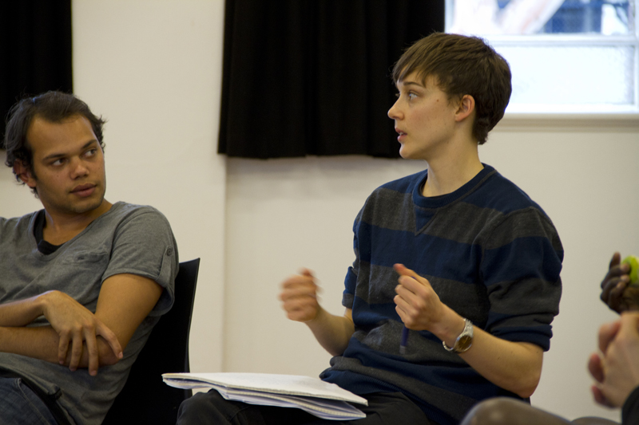

Conclusion
The Space Invaders project was a large-scale community project. We demonstrated strengths in how we collaborate across agencies but also learnt how we could better conceptualise and resource a new project.
Importantly, the show worked. The feedback from students , teachers and workers who saw the show confirmed for us the value and effectiveness of a highly interactive and educational show.
The journey for Space Invaders is not yet over, and there are plenty of opportunities for Victoria Legal Aid to adapt the content from the project and extend the impact of this work.

Appendice one: Script
Written by Adam Cass, 2011
SPACE INVADERS – THE GAME SHOW!
Very loud and very scratchy retro Space Invaders arcade game sounds play and the performers come in making ‘piew-piew’ laser beam noises and shooting their fingers off in random directions. It’s very silly, they are together in a line, side by side. They move from one edge of the stage to the other, in time with the Space Invaders track. When they get to the extreme edge, they move slightly forward, and then head back in the other direction (á la the arcade game). After not too long the Space Invaders sounds are drowned out by an approaching police siren which gets louder and louder. The cast scatter, and Cymbeline comes in. The cast surrounds her and turns out to the audience ---
CAST: LADIES AND GENTLEMEN, BOYS AND GIRLS IT’S SPACE INVADERS THE GAME SHOW! PLEASE WELCOME YOUR HOST CCCCCCCCCCCCCCCCCCCYMEBLINE!!!
Cheesy canned applause plays over the sound system and Cymbeline motions for silence –
CYMBELINE: Thank you! Thank you!
The cast crowds around Cymbeline and applauds loudly...
CYMBELINE: No need, no need for that –
The cast crowds even closer to Cymbeline and cheers her and keeps clapping...
CYMBELINE: Guys, give me some room –
The cast gets even closer. They virtually swallow Cymbeline up and really get in her face, clapping and cheering and paying no attention to her discomfort.
CYMBELINE: ENOUGH! GET OUT OF MY SPACE!
She pushes the cast away and they tumble to the floor.
PERFORMER ONE: Cymbeline, we were just trying to help you!
PERFORMER TWO: Yeah, man, don’t be so violent!
Cymbeline takes a breath.
CYMBELINE: Look, I’m sorry, all right, but you were in my space, you were in my face. Who asked you to get up in my face like that?
PERFORMER THREE: It really hurt. This floor is hard!
CYMBELINE: I didn’t mean to hurt you. Please, can we just get on with the game show?
The cast gets up off the floor shakily. Cymbeline waits for them all to be standing up, and for each of them to go to their position. One of them goes to a large easel which has a whole bunch of gigantic white cards sitting on it (the topmost card has a question mark drawn on it). Another performer goes to a big basket full of goodies, which is labelled ‘Prizes’. Another makes their way to a large gong (or something similar), and picks up something to strike it with (which they don’t do yet). A fourth performer goes over to some musical instruments, getting ready to play.
CYMBELINE: Is everybody ready?
The performer by the easel removes the topmost card, revealing the word ‘Yes’ on the one underneath. The performer by the prizes puts their hands in the basket and tosses some of the goodies up in the air playfully. The gong performer strikes the gong, the musician plays a bit of music. For just a second the Space Invaders soundtrack, mixed with the police siren, plays again. Cymbeline holds up a hand and shakes her head and moves a little closer to the audience. The soundtrack stops dead.
CYMBELINE: Look, before we begin it’s probably important that I say something about what we’re doing here today. Things are going to get a little silly, in good ways and silly ways, and sometimes maybe in really bad ways, too. This show is about things that go wrong between people who share spaces with each other, or between people who invade spaces that belong to other people, and those people whose space it is that’s been invaded. It’s about things that go wrong between young people and people like tram inspectors and security guards and it’s especially about things that go wrong between young people and the police. Things go wrong between young people and police far too often. We’ve heard some stories and read some stories, and some of us have lived some stories, and I’m sure a lot of you have too, which are just so awful. They’re so incredibly awful that we can’t begin to really get to the truth of them in the little time we have. Sometimes things go wrong because kids are kids and they get out of control and do things that they shouldn’t, but sometimes they go wrong because some police and others in positions of authority just aren’t very good at their jobs. Sometimes they aren’t very good at being people, either, and sometimes they do things which nobody should ever, ever do. And if anyone in the audience has got a story about times when police have done those kinds of things, please tell somebody, your mum or dad or teacher or a lawyer, as long as it’s somebody. You might even tell us about it today, and maybe by the end of the show you’ll all have heard some stuff you didn’t know before and maybe you won’t let those kinds of situations ever happen to you again, because you’ll know your rights and you won’t ever again let anybody in a position of power treat you in those awful ways.
CAST: ON WITH THE SHOW!
CYMBELINE: Yes, on with the show!
The gong performer strikes the gong. The easel performer reveals another card which says ‘At The Train Station. The whole cast calls –
CAST: GAME ONE – AT THE TRAIN STATION!
All of the performers rush into position. Cymbeline invites the audience –
CYMBELINE: So now just look and listen and think and find all the silly wrong turns our characters take. For each one you uncover A Pretty Nice Prize, chocolates or lollies or something healthier if you prefer it (you get to choose!), might just be yours!

At The Train Station
Characters.
- 3 main girls (ONE, TWO & THREE), all African.
- 2 other African girls, FATIMAH and SAIESHA.
- Two ticket inspectors.
- Two police officers.
The three main girls are waiting on a train platform. A train is coming...
ONE: So are we going to catch this train or not?
TWO: Let’s go, we’re late.
THREE: No, we can’t go yet, we’re still waiting for Mariam
TWO: Mariam can get there by herself she’s not a little baby. We’ll text her when we’re there.
ONE: But we’re waiting for Lala, too.
TWO: Lala doesn’t have a phone.
THREE: How can she not have a phone?
ONE: Here comes Fatimah.
TWO: I didn’t even know she was coming!
THREE: She’s not. Who invited you?
FATIMAH: Saiesha did. Is she here yet?
THREE: Is Saiesha coming??!
Saiesha arrives.
ALL: SAIESHA!
SAIESHA: Here I am!
TWO: I thought you were in Adelaide?
THREE: You should have Facebooked me!
SAIESHA: I just got home, chill!
TWO: The train’s about to go!
The train pulls away from the station.
ONE: We missed it!
THREE: We’ll get the next one. Don’t wet yourself!
TWO: Here comes Yamilé, with Setona and Favor.
FATIMAH: I thought it was just going to be a few of us.
SAIESHA: No, man, we’re all coming.
Saiesha sees a few girls in the distance and calls out and waves to them –
SAIESHA: Hey! Alek, Josephine, Juliet, Zeneb, Subin, we’re going into the city. Come!
FATIMAH: Woo, there’s going to be a lot of us!
TWO: Don’t look now, here come the ticket inspectors...
Some ticket inspectors arrive on the platform –
ONE: Look at that, the way they prowl, they think they’re Tasmanian tigers come back from the dead. They think they’re so important –
TWO: They’re looking at us.
ONE: We’re little bilby babies. The Tasmanian tigers are stalking us.
TWO: We’re not even on a train yet.
THREE: Here they come.
TWO: We’re not even on a train yet!
TICKET INSPECTOR A: Tickets please, ladies.
TICKET INSPECTOR B: You ladies got your tickets?
One goes to take out a ticket, but Two stops her.
TWO: No we don’t have any tickets.
THREE: That’s right, we don’t. What you going to do about it Mr. Tassie Tiger?
Two points in the direction that the inspectors have come from.
TWO: Why didn’t you ask those people for tickets?
TICKET INSPECTOR B: This is a ticketed area, ladies.
TICKET INSPECTOR B: I’m afraid I’ll need to see some ID.
TWO: You walked straight by those people. You didn’t ask them for tickets.
ONE: Yeah, man, why didn’t you ask them for tickets?
TICKET INSPECTOR A: We just need to see your tickets.
ONE: It’s just so unfair.
TWO: You aren’t going to see them.
TICKET INSPECTOR B: Please, just make it easy.
THREE: We aren’t going to show you our tickets until you ask those white people over there for their tickets.
TWO: You’re racist, man.
TICKET INSPECTOR A: Come on girls –
ONE: You’re a racist.
Three takes out her ticket and shows it to the inspector –
THREE: We have tickets racist, just move along –
One & Two take out their tickets, too –
ONE: Yeah, just move along you white tigers –
TWO: You’re late for your apartheid party!
TICKET INSPECTOR B: All right, all right ladies –
TICKET INSPECTOR B: I’m not a racist. I wish you wouldn’t say that.
TRIO: SAY SORRY! JUST SAY SORRY!
THREE: Say sorry you racists!
The girls all start yelling at once, telling the ticket inspectors to go, laughing and congratulating each other. The inspectors leave, but almost as soon as they disappear a couple of police officers arrive.
THREE: Who called the cops?
ONE: What did they have to call the cops for?
TWO: We had tickets! We’re not even on the train yet!
The police make their way over to the girls.
POLICE OFFICER A: Got your tickets there, ladies?
The girls, extremely frustrated take out their tickets in silence. The police look around and see how many of them are there.
POLICE OFFICER B: About time you all moved along, ladies.
ONE: What?
TWO: What do you mean, move along?
POLICE OFFICER A: Probably just best you all leave the station.
TWO: We’re waiting for a train, man!
THREE: We have tickets!!
POLICE OFFICER B: You’re making some of the other passengers nervous.
ONE: What passengers? We’re not even on a train yet, we’re just all standing still? You crazy?
POLICE OFFICER B: No need for the attitude, Miss.
TWO: It’s not attitude, cop, that’s our SWAG.
THREE: Yeah, Somethin’ We Africans Got.
The girls laugh and bump fists.
POLICE OFFICER B: Well whatever you call it, it’s probably time to move on. We don’t want to have to arrest you.
Angry now, One takes out her phone and starts to film what’s going on –
ONE: This is just harassment. I’m recording this, officers, so make sure you don’t harass us too much.
POLICE OFFICER B: Put the camera away please, Miss.
TWO: It’s not a camera you big strong smart powerful policeman, it’s a phone!
THREE: Ooh, you’re so big and strong! Hey girls, look how big and powerful and important and smart and strong he is!
The girls laugh...
POLICE OFFICER A: Probably best to put the phone away, girls. You’re not doing yourselves any favours.
POLICE OFFICER B: I am instructing you to put the phone down.
ONE: Make me.
THREE: Yeah, she doesn’t have to, she’s protecting her rights.
TWO: You’re harassing us, strong man, we’re protecting our rights.
POLICE OFFICER A: I’d ask you to leave the station, girls.
THREE: We’re waiting for our friends!
TWO: When they get here we’ll catch a train –
ONE: Which we all have tickets for!
POLICE OFFICER B: You’re all the same.
THREE: Who? Who are all the same?
POLICE OFFICER B: I am instructing you again to put down the telephone.
ONE: Not doing it.
TWO: She’s not doing it, Strong.
Officer B swipes at One quite violently and takes her phone away from her.
ONE: That’s theft! You stole my phone!
TWO: That’s assault! You hit her!
THREE: Another train is coming.
A train is on its way, it toots its horn, breaking the spell of violence that is on the edges of spilling over.
POLICE OFFICER A: Train’s coming girls. Best just get on it. Nobody wants more trouble here.
ONE: Give me my phone back!
TWO: We’re getting the train! Don’t worry we’re leaving!
POLICE OFFICER A: It’s all okay now. Everything’s going to be okay.
THREE: You horrible cops. Now Lala won’t be able to find us.
POLICE OFFICER A: This looks like your train, girls.
The train gets closer.
ONE: Give me my phone Back!!
Begrudgingly, the officer gives One her phone back. The girls hop on the train, and as they’re disappearing they stick up their fingers and yell in a sing-song chorus –

DISCUSSION
Immediate question:
What problems did you see in this story?

Contestants up

Question 1 (y/n): Did the police have the right to ask the girls to leave the train station, even though they had a valid ticket?
Question 2 (multiple choice): When is it okay for the police to take your possession away from you?
(A)
(B)
(C)
Question 3 (open): Do you think it was okay for the girls to film the policemen? And can you think of any times when it might not be okay to film people?
Playback questions:

The New Fridge
Characters.
- Two boys.
- Their little sister.
- Two police officers.
Two boys are pushing a very large fridge along on a very wonky trolley on a very hot day. Their little sister is skipping around them, mocking them –
BOY ONE: Oh this fridge is so heavy!
BOY TWO: It’s so hot today! But we’ve got a new fridge!
BOY ONE: This bloody trolley won’t go straight!
BOY TWO: My back hurts! But I’ve never had a new fridge before!
BOY ONE: My legs hurt!
LITTLE SISTER: Oh come on boys, push harder! Push harder!
BOY TWO: You shut up, it’s heavy.
BOY ONE: You want to push it, sister?
BOY TWO: You can push it by yourself if you want.
LITTLE SISTER: Poor little babies can’t even push a tiny little fridge!
She laughs. She skips around in front of the fridge and pushes against it.
BOY ONE: Hey!
BOY TWO: You idiot, you get away from there.
BOY ONE: You’re a bad sister, we’ll get mum to whip you!
LITTLE SISTER: Ohhhhh, poor widdle babies! Need mummy to fight for them!
She giggles and skips and is loving this. Just at that moment some police drive by on the other side of the road. The little sister sees them and jokingly calls out to them –
LITTLE SISTER: Hey cops! You gonna arrest my brothers for being such babies?
BOY TWO: Shut up, you idiot.
She giggles. The boys keep pushing the fridge, but they notice that the police car has turned around. It drives past them and pulls up just a little bit ahead of them.
The boys realise what is about to happen, and Boy One rushes to the car before the police can even open a door.
BOY ONE: NO! Stay in there! It’s our fridge! We didn’t steal it.
POLICE OFFICER ONE: Let me out of the car, son.
BOY ONE: NO! Don’t call me son! You’ve only stopped because you think we stole the fridge!
BOY TWO: Calm down, man.
POLICE OFFICER TWO: (getting out of the other side of the car) Just settle down. Nobody said you stole anything.
BOY ONE: WELL THEN WHY DID YOU STOP?! You think we stole it!
Police Officer One forces the door open and climbs out of the car.
POLICE OFFICER ONE: Where did you get that fridge, boys?
BOY TWO: We have a receipt!
POLICE OFFICER ONE: Step away from the car, please.
LITTLE SISTER: I’m going to go and get mum...
BOY ONE: No!
LITTLE SISTER: I really think I should tell mum what’s happening.
BOY TWO: Don’t you dare. You just go and sit over there.
LITTLE SISTER: I’m scared!
BOY TWO: GO!
The sister slinks away, but not very far. She’s very upset.
BOY TWO: Look how scared you made her. Look how you ruined our day!
POLICE OFFICER ONE: You really need to comply.
BOY ONE: I won’t! I don’t! If two businessmen wearing suits were pushing this fridge you wouldn’t have even looked at them.
Police Officer One pushes the boy away from the car.
POLICE OFFICER ONE: Step away from the car!
The push is harder than intended, and Boy One stumbles and falls. Boy One rages –
BOY ONE: I’m going to SMASH YOU, YOU STUPID COP!
The little sister screams and cowers away, but suddenly everything slows right, right, right down and the world turns gluey (this next section might work best if the lines overlap each other) –
BOY ONE: My heart is thumping, my chest is tight, my brain is fuzzy, my gut feels like there is a basketball in it, my bowels are going all funny, I feel like I need to poo and wee, my knees are shaking, my fingers are tingling, my ears are hot, my toes are cold, my limbs are floppy and weak, my eyes are blurry.
POLICE OFFICER ONE: I feel lightheaded, I have wobbly knees, tingly fingers and toes, I have sweaty fingers and a tight chest, I have butterflies in my stomach, my brain feels like it is shrinking and expanding at the same time, I feel adrenaline and testosterone flowing through me. My head feels like it’s going to explode.
LITTLE SISTER: I want to scream.
BOY ONE: I want to cry.
BOY TWO: My mouth is dry.
POLICE OFFICER TWO: I need to poo.
BOY ONE: I’m thinking really fast. My muscles are contracting and starting to twitch.
POLICE OFFICER ONE: My jaw is locked. My temples are tense.
LITTLE SISTER: I am not in my body. I’m slightly out of my body.
BOY TWO: I’ve got cramps all over me.
POLICE OFFICER TWO: My vision is narrowing.
BOY ONE: I feel like a robot.
POLICE OFFICER ONE: I can’t remember anything.
Cymbeline comes over and puts herself between the antagonists. She holds up her hands.
CYMBELINE: Everybody stop!
The cast freezes, they don’t move a muscle. Cymbeline turns to the audience.
CYMBELINE: Okay! Now it’s time to see what happens next.... Who here thinks there’s a way out of this situation without it getting any more violent or out of control? Put up your hands...
She waits for a show of hands.
CYMBELINE: And who here thinks things have gone too far and it’s definitely going to get pretty ugly now?
She waits for the hands again.
CYMBELINE: Ooh, that’s interesting. Well, I want to believe that it’s possible to avoid the worst of it, so I think I’ll show you what I mean... after I do that, though, I’m going to ask you again, and you’ll get to come up with your own ending if you don’t like ours. The person who suggests the one you all agree is the most realistic will win a whole handful of prizes!
The cast members are having a hard time staying frozen and they call out, doing their best to not move –
CAST: HURRY UP CYMBELINE!
Cymbeline nods and backs away.
CYMBELINE: So first, the fairly peaceful solution...
The cast members jolt back into life. For them time hasn’t passed since Cymbeline froze the scene.
BOY ONE: I should take a deep breath.
POLICE OFFICER ONE: I should just take a deep breath.
POLICE OFFICER TWO: Everybody needs to take a deep breath.
All of them take a very deep, very deliberate breath, and the world spins back into normal time.
LITTLE SISTER: I’m going to tell mum!
The little sister starts to run away. Boy Two throws himself on top of Boy One and holds him down.
BOY TWO: Just calm down, bro! Calm down!
BOY ONE: It’s OUR fridge! We PAID for it!
LITTLE SISTER: Oh I can’t get mum. She’ll be too angry –
The little sister stops in her tracks, not knowing what to do. She’s confused and upset.
POLICE OFFICER TWO: It’s all right, it’s all right. We just wanted to see a receipt.
BOY ONE: You stupid cops you never should have stopped us. We’re allowed to use the street. We’re allowed to push a fridge.
Boy Two digs in his trouser pockets and finds the receipt.
BOY TWO: Here it is! Now do you believe us?
BOY ONE: You go. Just get back into your car before I get really angry.
POLICE OFFICER ONE: No need for threats, son. We’re going to need to get some ID. Names and addresses, please?
That’s too much for Boy One. He tries to struggle to his feet, but his brother holds him down.
BOY ONE: No! You can’t have our names and addresses. You’ve got no right to ask for them! We didn’t steal anything!
BOY TWO: He’s right. We didn’t do anything wrong, there’s no reason to think that we did, so we’re not going to tell you. We don’t have to. That’s our right!
LITTLE SISTER: Don’t we have to tell them our names?
BOYS: NO!
The two police officers pause and think about things. They walk away for a moment and talk quietly among themselves. Police Officer One puts a hand on Police Officer Two’s arm, a calming gesture. They come back.
POLICE OFFICER TWO: Just get home as quick as you can with that thing.
POLICE OFFICER ONE: You need to control that temper, boy.
BOY ONE: GO AWAY!
The police get back into their car and drive away. The little sister comes back close to them. She’s crying, but she’s very proud. The two boys start pushing the fridge again, sweating, but neither of them say a word for some time.
BOY TWO: You idiot.
BOY ONE: I should have punched them.
LITTLE SISTER: My brothers stood up to them!
BOY ONE: You’re just lucky you didn’t go and get mum. I would have punched you.
BOY TWO: You idiot.
BOY ONE: They never should have stopped us.
They keep pushing the fridge. It’s still very heavy. Cymbeline calls out to them –
CYMBELINE: Right! That’s that. Who thinks that was a realistic way for that scene to end?
She waits for a show of hands.
CYMBELINE: Who still thinks it would most likely go another way?
She waits, and asks for different opinions. If it is suggested that the scene would have most likely ended much more violently, she’ll shake her head sadly and decide who the prize should go to...
CYMBELINE: You get the prize, but I wish so many of you didn’t agree that this scene could only end badly. Oh well. Come back in guys!
The cast comes back to the positions they were in when Cymbeline first froze the scene.
CYMBELINE: The violent ending! But I don’t want to glorify it so don’t make it seem cool.
A couple of the cast members, including Boy One nod their heads. The movements are acted out not brutally or in real time, but matter-of-factly, as if demonstrating to a class.
BOY ONE: So that stupid copper pushed me over and I hit my head and my heart was thumping and I felt weak and invincible all at the same time and I wanted to cry and even though I was so scared I yelled out to him I’M GOING TO SMASH YOU! And then I tried to stand up –
POLICE OFFICER ONE: But my own skin was tingling and I was out of my body and I wasn’t thinking so I kicked him back down and I yelled at him Get on your knees and put your hands behind your back NOW!
POLICE OFFICER TWO: I tried to calm things down. I said to the boy, I pleaded with him Stay down!
BOY ONE: I tried to jump up again, but –
LITTLE SISTER: But I got in his way and I screamed I’m going to tell mum! I started to run away, but –
BOY ONE: But I lunged at her and grabbed her and even though she screamed I held on to her and shouted You aren’t going to get mum!
BOY TWO: And I begged him Just calm down, bro! Calm down!
BOY ONE: But I was so crazy angry It’s OUR fridge I said! We PAID for it I said!
LITTLE SISTER: He was hurting me Ow! I tried to get away from him –
POLICE OFFICER TWO: He didn’t even know he was hurting his little sister. I swooped in and I pulled her out of his arms, I couldn’t think what else to do. Everything happened so quickly.
BOY ONE: I screamed at them YOU STUPID COPS WE’VE GOT A RECEIPT! And I dug in my pockets and I found the receipt and I threw it in the face of the stupid copper –
POLICE OFFICER ONE: And it was only a tiny little bit of screwed up paper but it seemed at the time like he’d thrown a rock at me and so I grabbed the little runt by the arm and twisted it behind his back –
BOY TWO: I was crying now, I felt like a little boy again I said He was just showing you the receipt!
BOY ONE: I was crying out in pain –
POLICE OFFICER ONE: I pushed the little runt into the concrete, hard –
BOY ONE: Hard –
POLICE OFFICER ONE: I held his face down, I searched him as roughly as I could and I asked him You got a weapon there? Thinking for all the world like he was going to stab me with a concealed knife or something –
BOY ONE: I don’t have a weapon! You stupid copper!
BOY TWO: My brother was crying out, screeching in pain. I said Hey! Hey, stop now, you’re hurting him.
POLICE OFFICER ONE: I said Too right I’m hurting him! And I pulled back my fist and I was going to hit him in the back of the head, I was going to knock the sod unconscious –
LITTLE SISTER: I screamed –
POLICE OFFICER TWO: I yelled out. I don’t know what I yelled out –
CYMBELINE: OKAY!
The cast stops in their tracks.
CYMBELINE: That’s enough. We’ve seen enough of that for now. We all know where it’s going.

DISCUSSION
Immediate questions:
What stopped the violence in the first scenario?
How did the violence begin? - why did the boy get angry?
- why were the police suspicious?

Contestants up
Question 1 (y/n): Did the boys have to give their names and addresses?
Question 2 (open): Did anyone break the law? Who?

Playback questions:
can you think of a time when you were in a dangerous situation?

The Lawyer.
Characters.
- A boy.
- A lawyer.
- A police officer.
A boy is speaking to a lawyer in the lawyer’s office.
LAWYER: So, let’s start at the beginning. This charge sheet shows that you’ve been charged with several offences, assaulting police in the execution of duty, theft of council property, and possession of an illicit substance. I need you to tell me whether you agree with what they say you did or not, and then we’ll have a chat about where we go from here.
The boy doesn’t answer.
LAWYER: It’s all right, you can speak to me. I promise everything you say in this office is absolutely confidential.
The boy pauses, but then says –
BOY: Nah, you’re one of them.
LAWYER: One of who?
BOY: You’re part of the system, aren’t you?
The lawyer draws a little closer.
LAWYER: I’m your lawyer. That means I’m here for you, my only role is to act on your behalf. I am not allowed to say anything you tell me to anyone unless you authorise me to. I don’t act for the police. My job is to help you to work out what you want to do with these charges. I need to hear what you say happened so that I can try to help you.
BOY: But if I say it all I’ll get into more trouble.
LAWYER: I don’t want to get you into more trouble. I want to help you sort out the trouble you’re already in. Unless you tell me that you’re going to go out and kill someone, I am not allowed to speak to the police, or to anybody else. Not unless you tell me to. I’m here to make sure your rights are protected, that you get treated fairly, that you get proper advice and that you get to decide what to do.
The boy thinks about it.
BOY: I don’t really remember. I hit my head and things were kind of fuzzy.
The lawyer nods, and makes a note in a pad.
BOY: You’re writing this down! Who you going to show?
LAWYER: Nobody. I really do promise that. It’s just for me.
The boy pauses again, but –
BOY: I was out the front, smoking.
LAWYER: The officer arrived while you were smoking some marijuana?
BOY: Nah man, cigarettes.
LAWYER: In the officer’s report it says –
BOY: It was a cigarette. I hate that drug stuff. I don’t even usually smoke. It was a party. I didn’t even really think about it. It was noisy. The music was loud. People were shouting and running about and that.
LAWYER: The people at the party were drinking?
BOY: I dunno.
LAWYER: And you?
BOY: I was sitting out the front by myself. Just sitting there.
LAWYER: Did the officer speak to you?
The boy laughs.
BOY: Yeah.
LAWYER: What did he say?
BOY: He asked me where I got the hazard light.
LAWYER: What do you mean by hazard light?
BOY: You know, the flashing thing they put near holes in the road so cars won’t fall into them.
LAWYER: And what did you say to him?
The boy laughs again. A police officer appears in the distance and says –
OFFICER: Where’d you get the hazard light, boy?
BOY: Nothing.
LAWYER: Where were you at the time?
BOY: I told you, I was sitting out the front of the house.
LAWYER: The officer was alone?
BOY: Yeah, just him.
LAWYER: Did he say why?
BOY: I dunno. I was woozy afterwards, like I said.
LAWYER: And you were alone?
BOY: I TOLD YOU!
LAWYER: I just want to get it right, it’s okay...
BOY: Everybody else was out the back singing or something.
OFFICER: Where’d you get the hazard light, boy?
LAWYER: And you didn’t answer the officer?
BOY: I blew smoke in his face.
LAWYER: Marijuana smoke?
BOY: No. Jeez! Listen to me. It was a cigarette.
The police officer coughs and waves the smoke out of his face.
LAWYER: And what did the officer do?
The officer turns and jumps on top of the boy.
BOY: Hey!
OFFICER: You black terror!
BOY: Hey, that hurts! Ow, my head!
LAWYER: He jumped on top of you?
BOY: Yeah, he hurt me.
OFFICER: Give me that!
LAWYER: He pulled the cigarette out of your hand?
BOY: Yeah.
LAWYER: What did you do, then?
BOY: Nothing.
LAWYER: Did you push him away?
BOY: I hit my head when he jumped on top of me, I didn’t have any muscles, I was woozy.
OFFICER: You assaulted me!
BOY: I did not!
LAWYER: He meant blowing the smoke in his face?
BOY: Yeah. Probably.
The police officer turns the boy around on to his belly and twists his arm behind his back. He handcuffs the boy.
OFFICER: That hazard light is council property –
BOY: But I didn’t have anything to do with the light! It was already here!
LAWYER: Was that true?
BOY: Nah, I took it.
The boy laughs.
LAWYER: And what did you say he called you?
BOY: He called me a black terror.
LAWYER: After you blew the smoke in his face?
BOY: Yeah.
LAWYER: Okay.
OFFICER: I am arresting you. You have the right to remain silent, everything you say may be used as evidence against you, if you are not an Australian citizen you may communicate or attempt to communicate with a person from the consulate office of the country of which you are a citizen, you may communication or attempt to communication with a legal practitioner and a friend or a relative. You’re coming down the station right now –
LAWYER: Did he say why he was arresting you?
BOY: Nah. He just arrested me. He spat on me, man.
The police officer spits in the boy’s face.
OFFICER: You’re dirt. You’re a drugged up abo and you should be rotting in a cell.
LAWYER: He said that?
BOY: Yeah. And I’m not. He’s wrong.
The police officer hauls the boy to his feet, very roughly.
BOY: You’re wrong, man! I don’t touch drugs!
The police officer pushes the boy down again to his knees.
BOY: Ow! My head really hurts!
The officer pulls the boy up again.
BOY: Up or down, jeez?!
LAWYER: What happened then?
BOY: He put me in the back of his car and drove me to the police station.
The police officer disappears.
LAWYER: Did you make a complaint at the police station?
BOY: Yeah of course I did.
LAWYER: Did the police interview you there?
BOY: They wanted to call my mum to be there while they did it but I didn’t want her to come, so some other chick came who said she was a Responsible Person or something. I don’t really know what that was all about.
LAWYER: That would have been what they call an Independent Person. Did you get released or have to go before a Magistrate to get released?
BOY: The police released me and gave me papers and a DVD thing with the interview they did of me.
LAWYER: The papers were the sheets that you gave me?
BOY: Yeah, I guess.
The lawyer takes a deep breath.
LAWYER: Okay. Well. I’m sorry he said those things to you.
The boy looks down and doesn’t say anything.
LAWYER: He shouldn’t have treated you that way.
BOY: Ah, it’s all right.
LAWYER: No, it’s not, not at all, but you need to make a decision about whether to plead “guilty or not guilty” to the three offences. Before you make your mind up, though, you need to know whether the police have any evidence that you have committed these offences and the strength of that evidence. We also need to watch the DVD of the interview to know what you said to the police and whether your rights were respected. For example, you have the right to be told you can speak to a lawyer before you are interviewed and to be told you have the right to silence. You also need to make a decision about whether you want to make a complaint about the force that the police officer used on you and the words he used when he was arresting you, because it sounds like he didn’t tell you why you were being arrested. You may also be able to take legal action against the police officer for assaulting you or even for false imprisonment. You could also make a race discrimination complaint to the Australian Human Rights Commission. Each of these steps is complicated and there could be risks involved with them. Before you make a decision about what to do you need to collect as much information about what happened as possible.
BOY: Jeez.
LAWYER: You hit your head. Did you see a doctor straight after the incident?
BOY: No, I wasn’t too bad, I guess. I was pretty sore, but.
LAWYER: Did you tell you parents about what happened? Did you complain about it in the interview?
BOY: No...
LAWYER: Did you have any bruises or bleeding? Did you take any photos of any injuries? Are you certain no one at the party saw or heard anything that happened?
BOY: You ask a lot of questions, hey?
LAWYER: Because you made a complaint at the police station, there should be a record there. We will need to get a copy of these records.
The boy is shaking is head and smiling.
BOY: You’re really taking this seriously, aren’t you? You really want to help me?
LAWYER: Before I can properly advise you about what to do, I need to obtain the police brief, because that’s their evidence against you, obtain records from the police station, and listen to the interview. I will also need to take a statement from the Independent Person and anyone at the party who might have seen what happened.
BOY: Okay.
LAWYER: This will all take a bit of time and you need to be patient and stay in contact with me. We might have to adjourn the first court date while we wait for the information to arrive. First of all, I need you to give me authority to gather this information and collect witness statements. If you are happy for me to do this, I will need you to sign this authority. When I have everything, I will get you back in to go through it all, advise you on your options and get you to tell me about what you want to do.
BOY: Thank you so much for this, hey.
They both stand, ready to part.
LAWYER: Good to meet you and speak soon.
Cymbeline comes forward...

DISCUSSION
No immediate questions – straight to contestants

Contestants up

Question 1 (y/n): If you get arrested, you have to give your name and address. Do you have to answer any other questions?

Question 2 (multiple choice): If you’re arrested
(A) You can choose to be interviewed by yourself if you prefer
(B) You have to call your parent or guardian to be there with you
(C) There might be a reason why your parent isn’t the best person to have there, in which case you have a trained independent person instead

Question 3 (open):
- The young person in the story didn’t call a lawyer. Why do you think a young person in that situation wouldn’t’ call a lawyer?
- Can you think of any reasons why it might be good to call a lawyer?

Playback question:

Appendice two: Students’ ‘your rights’ card
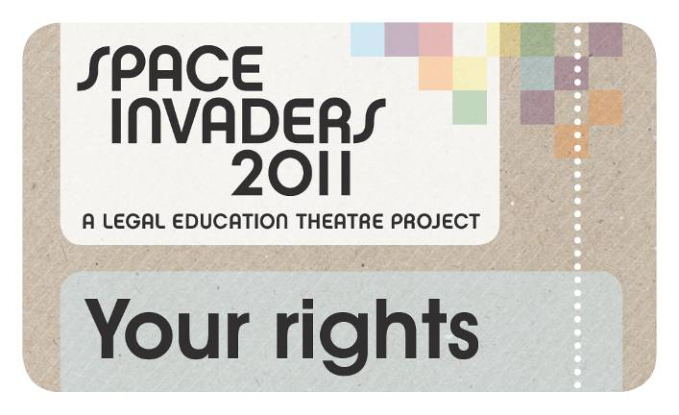
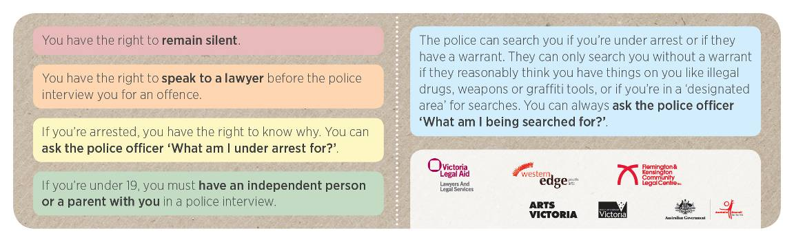
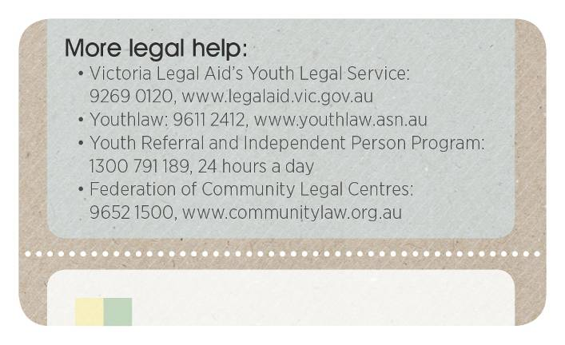

Boys you wanna give me some action: interventions into policing of racialised communities in Melbourne, Bec Smith and Shane Reside, support from Fitzroy Legal Service, Springvale Monash Legal Service and Western Suburbs Legal Service, 2010
Creating a Better City for Young People: The needs of young people living in Flemington, North Melbourne, Kensington and Ascot Vale, Final Report, Anna Duff, Simone Perkin, Ahmed Dini, Daniel Hale-Michel et al, 2006
We worked with Victoria Legal Aid’s Youth Legal Service; Youth Legal Service staff work across the Youth Crime and Child Protection sub-programs. This report will refer to the Youth Crime sub-program rather than the Youth Legal Service.
National survey of young Australians 2010, Mission Australia
This is the states and territories’ current funding agreement with the Commonwealth government.
This is a style of theatre where the audience is invited to share personal stories and the performers ‘play back’ this story but using theatrical methods. This theatre developed from the a style of theatre called ‘theatre of the oppressed’.
Formerly known as What’s the deal: a kit to educate young people about legal issues.
The ex-prisoners who attended the Experts Week.
Finding – Inquest into the Death of Tyler Cassidy, Coroners Court of Victoria, Melbourne, November 2011

