Changes to the ‘Submit Claims’ screen

This factsheet provides information about completing the new ‘Practitioner who performed work’ and ‘Counsel briefed’ fields when submitting claims for payment.

Capturing who performed the work
From 24 February 2014, all practitioners will be required to provide details of who undertook the work for each stage of a matter when submitting a claim for payment. This is done by completing the mandatory ‘Practitioner who performed work’ field on each claim.
This requirement will:
- enable VLA to effectively monitor and enforce panels requirements and quality measures
- allow individual practitioners to demonstrate the work they have completed on a file. This will be particularly useful to individual practitioners when applying for Panel Certifier status on a section 29A panel.
Each item of work must be claimed separately to accurately capture who did the work for that item. Practitioners who already interim bill will notice very little change to the way they claim payment from VLA.

What does ‘Practitioner who performed work’ mean?
The practitioner who performed the work is the solicitor practitioner who
- prepared the item of work being claimed
- appeared as a solicitor advocate
- authorised the expenditure of funds for that disbursement.

How to complete the ‘Practitioner who performed work’ field when claim is made for fees payable to the solicitor practitioner.
- In the ‘Submit Payment Claim’ field, click on the pick list (magnifying glass icon) next to the ‘Practitioner who performed work’ field. The ‘Select a person’ field will be displayed.
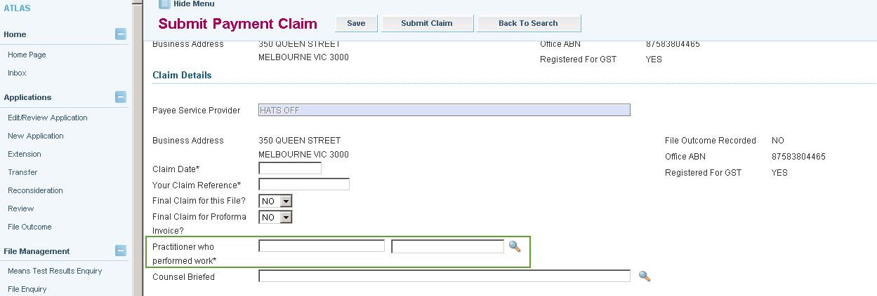

- Click ‘Search’ on the ‘Select a person’ field. A list of practitioners in your office will be displayed.
- Select the practitioner who did the work from that list by clicking on the red ‘Person ID’ field next to the practitioner’s name. The name of the practitioner who performed the work will now be displayed on the claim for payment.
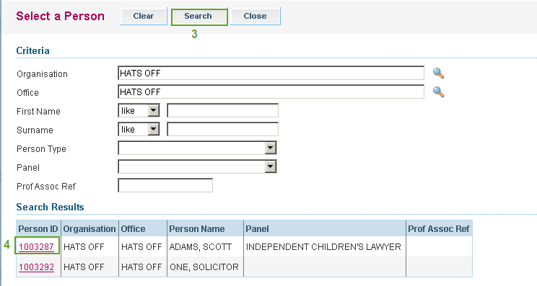
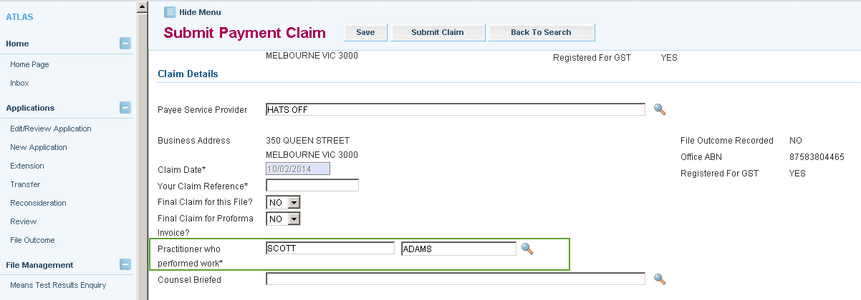
- Proceed to claim the relevant items, and certify as usual.

How to complete the ‘Counsel briefed’ field when paying a barrister directly from ATLAS web.
If an instructor is claiming fees on behalf of a barrister who performed the work or appeared, the barrister’s name must be included in the ‘Counsel briefed’ field.
Follow steps 1 to 8 inclusive of the procedure outlined in ‘ATLAS Direct payments to barristers’.
To complete the ‘Counsel briefed’ field:
- Proceed to the 'Counsel briefed’ field, and select the magnifying glass.

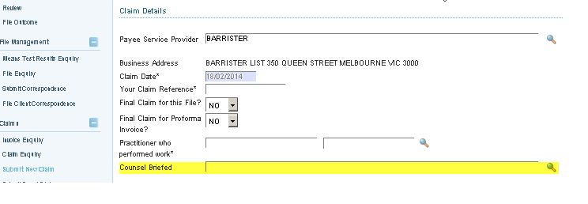
- Select ‘Barrister’ from the ‘Service Type’ dropdown list.
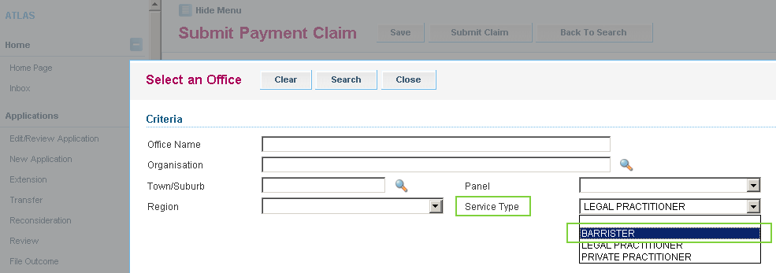
- Enter in the name of the barrister to be paid in the ‘Office’ field and click ‘Search’.
- Select the barrister to be paid.
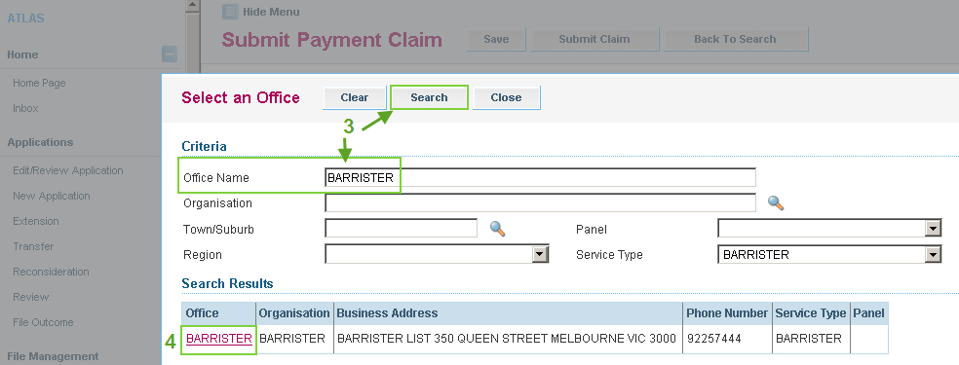
- Complete rest of the claim form and certify as usual.

