When a new application for assistance is submitted, a client may choose to have all correspondence from Victoria Legal Aid relating to the grant of assistance sent to their practitioner instead of to their own address.
The client may seek to change their correspondence option while the file is ongoing.
Use File Client Correspondence to:
- request that all client correspondence from Victoria Legal Aid relating to the grant of assistance is sent to the practitioner only
- remove a request for all client correspondence to be sent to the practitioner
It is usually appropriate to remove the request upon file finalisation. If you fail to do so, grants or contribution letters from Victoria Legal Aid will continue to be sent to the practitioner, who is required to notify their client.

File Client Correspondence

- Select File Client Correspondence from the left hand menu under File Management.

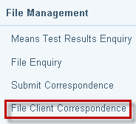

- The Search for File screen displays. Enter File ID and select Search.

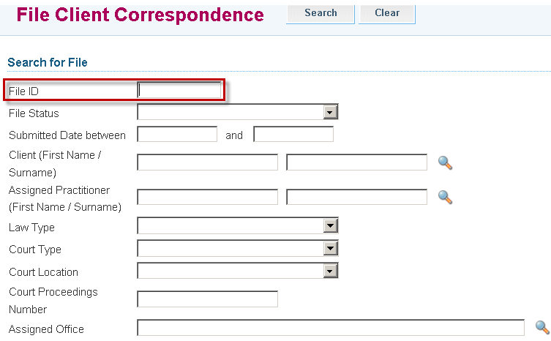

- Search Results will display. Click on the File ID link to retrieve the file.

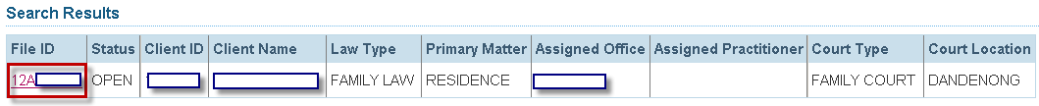

- The File Client Correspondence screen will display.

- Check the box for all client correspondence to be sent to the lawyer only
- Uncheck the box for client correspondence to be sent to the client.

Note: Ensure that you update the client’s address. Go to ‘Update Client Details’.

