Use File Enquiry to:
- check details of a specific file such as the status of the grant of assistance and the scope of aid
- obtain a list of approved ATLAS grants files assigned to your office

File Enquiry - for a specific file

- Select File Enquiry from the left hand menu.

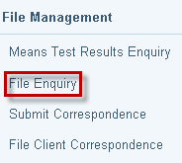

- The Search for File screen will display. Enter the File ID and click on Search.

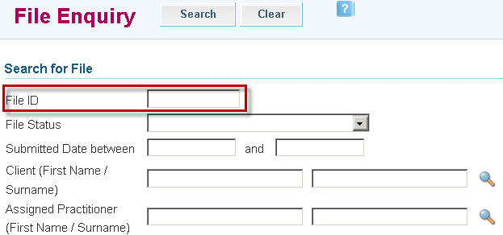

- Search Results will display. Click on the File ID link to retrieve the file.

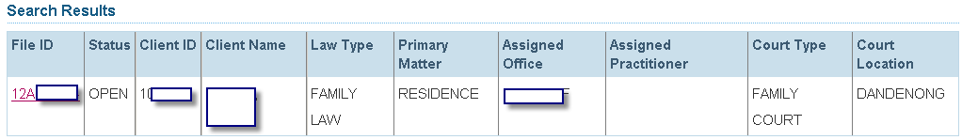

- The File Enquiry screen will display information regarding the grant of assistance such as decision, date aid is effective and the scope of aid.

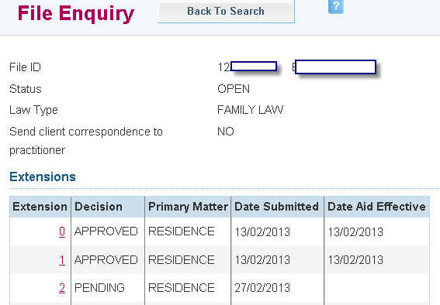

- Click on the relevant Invoice ID link to see the list of work items covered by the scope of aid.

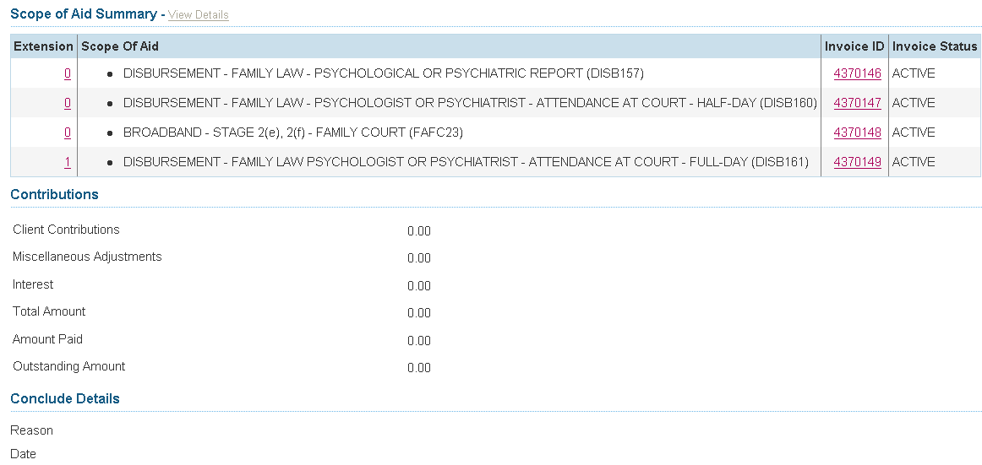

File Enquiry – for list of approved ATLAS grants files

- Select File Enquiry from the left hand menu.

- The Search for File screen appears. Click on the magnifying-glass icon beside the Assigned Office box.

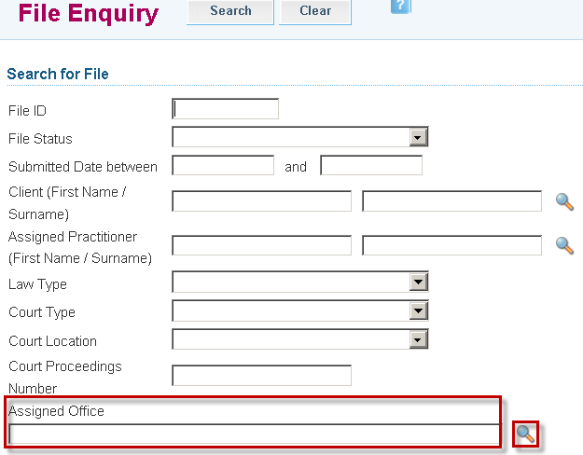

- The Select an Office screen will display. Enter the name of your firm in the Office Name box. Select Search.

Note: The name must be entered exactly as it is recorded with Victoria Legal Aid or there will be no search results returned. For example if you type in ‘ABC solicitors and barristers’, you may get no results as it is recorded in ATLAS as ‘ABC solicitors & barristers’.

Use the wildcard operator to help you search for a name. The wildcard operator can only be used in a box with no magnifying-glass icon beside it.
The wildcard operator is the % sign.
Type in a part of your office name and insert % either before or after what you have entered.

If you inserted the wildcard operator before the part of the name you entered, the search will return all names that end with the part of the name you entered and have either nothing or additional characters in front of it.
If you inserted the wildcard operator after the part of the name you entered, the search will return all names that begin with the part you entered and have either nothing or additional characters following it.
If you inserted the wildcard operator both before and after the part of the name you entered, the search will return all names that contain the part entered and have either nothing or additional characters appearing before or after it.

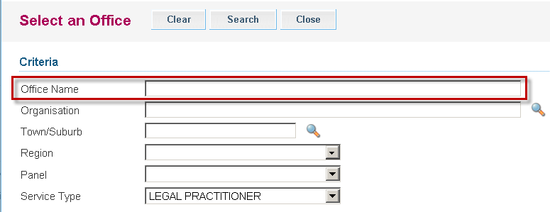

- Search results will display. If more than one name appears, check the information beside each one to identify the correct office. Click on the selected Office link.

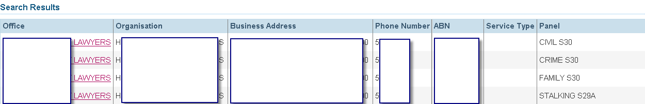

- The Search for File screen with your office name entered in the Assigned Office box will display. To refine your search enter relevant details, such as submitted date range, law type or court type, and click Search.

- Search results will display a list of ATLAS grants files that match your search criteria.

