Invoice Enquiry displays details of an invoice such as status of the invoice, amounts available and claimed. The information is displayed as a summary view of an invoice.

Claims Enquiry displays details of a claim that has been submitted and payment details. The information is displayed in the form of a tax invoice.

Invoice Enquiry

- Select Invoice Enquiry from the left hand menu.

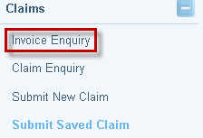

- The Search for a Proforma Invoice screen will display. Enter the File ID and click on Search to find the pro forma invoice.

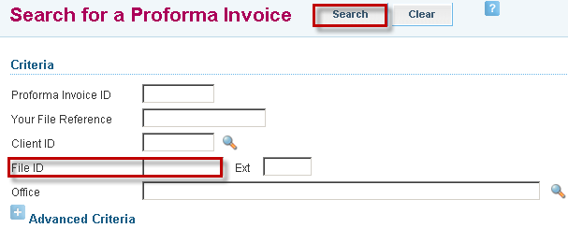

- Search results will be displayed. Click on the Invoice hyperlink.

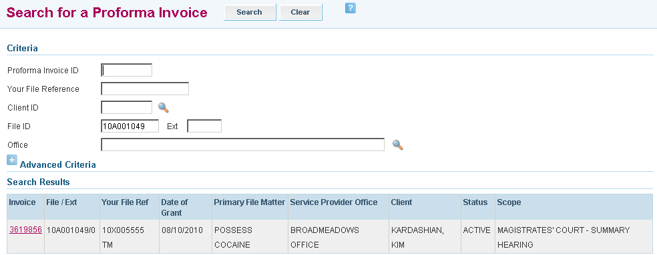

- The Proforma Invoice Enquiry sets out details such as status of the invoice, amount available and claimed to date.

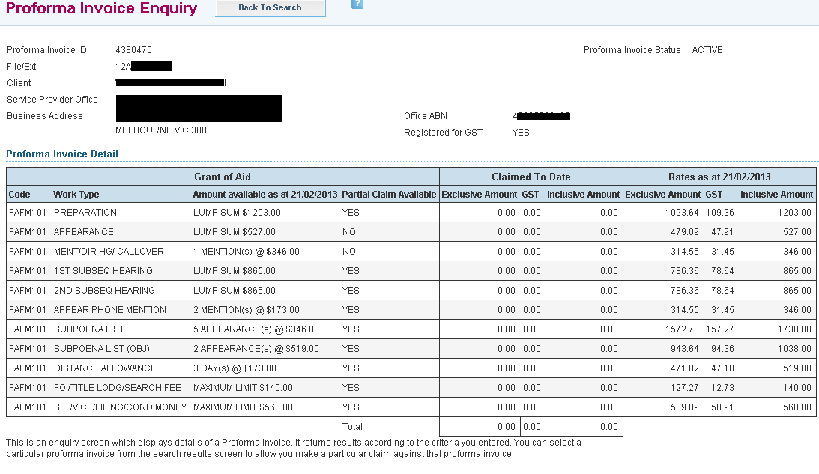

Claim Enquiry

- Select Claim Enquiry from the left hand menu.
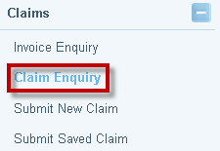

- The Claim Tax Invoice Enquiry screen will display. Enter the File ID and click on Search to find the submitted claim.
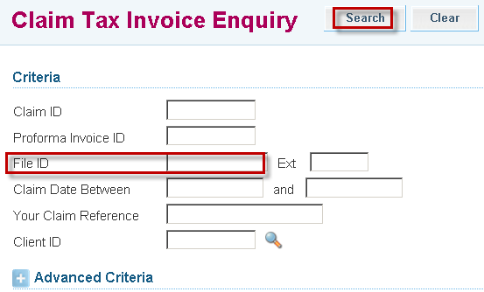

- Search results will be displayed. Select the Claim to view by clicking on the Claim hyperlink
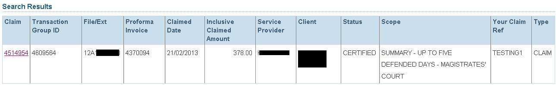

- A copy of the Recipient Created Tax Invoice is displayed. Details of the claim and payment method including bank details will be displayed.

