A requisition is a request from Victoria Legal Aid for further information regarding an application for assistance. The practitioner needs to respond to the requisitions within the time frame set by the Assignments Officer.

These requisitions will be received via the ATLAS Inbox. The ATLAS Inbox is like your email inbox.

How to view the Requisition

- Requisitions can be easily identified within the ATLAS Inbox. They will appear as follows:
You may be unable to open a Requisition if you do not have an upgrade to the latest Adobe version as well as the latest Firefox and IE7 or IE8 versions
- Click on the Document link to view the requisition.

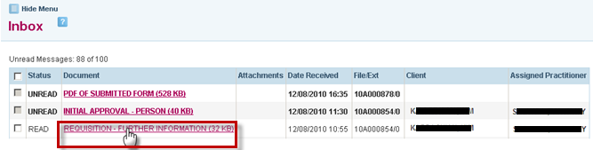

- The Respond to Requisition screen will open:

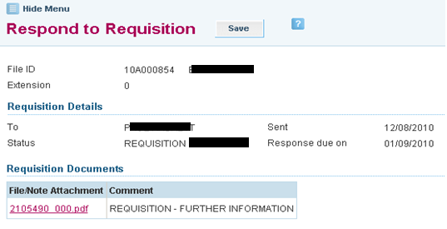

- The requisition can be viewed by clicking on the File/Note Attachment link.
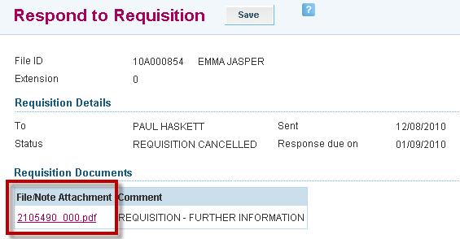

- A File Download dialog box appears. Select the Save button in that box if you want to save a copy of the requisitions on your computer system. Select the Open button to open the requisition letter from Victoria Legal Aid on your screen.

How to respond to the Requisition

- Close or minimise the screen displaying the letter referred to in the previous step. The Respond to Requisition screen is once again visible.
- Enter a Response in the Response section. You may enter ‘Refer to attached document(s)’.
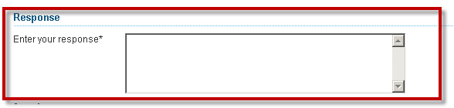
Click in the box to position your cursor

- Upload supporting documentation (e.g. letter to VLA, copy of Centrelink Card) by clicking the Show File Upload Area link within the Attachments screen.
The supporting document must be a file that is saved in your computer system cursor
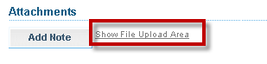

- The following screen will appear: Click on the Browse button to select your file.

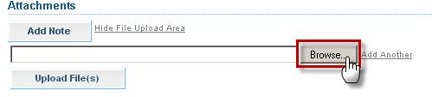

- The Choose file dialogue box will appear, displaying the file system on your computer. Navigate through this box until you locate the file you want to attach. Select that file by clicking on it, then click the Open button.

- To attach another document to your response, click the Add Another link beside the Browse button. A second box and Browse button appear below the first. Click the second Browse button and follow the previous step to select a second file from your computer's file system.
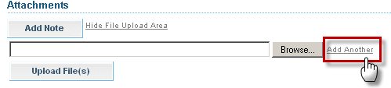

- When you have finished selecting documents to be attached, click on the Upload File(s) button.

- A new box appears below the Attachments heading, with the name(s) of your selected file(s) displaying as red, underlined links in the File/Note Attachment column of that box. You can remove a file from the box by clicking the X in the Action column beside the file name.

How to submit the Requisition

- When you have finished entering text and attached all supporting documents, submit your response to Victoria Legal Aid by clicking the Submit button in the Respond to Requisition screen.

- A message appears at the top of the Respond to Requisition screen, confirming that your response has been submitted successfully.

Frequently asked questions:
- What if the Requisition has a status of “Response Overdue”?
The requisition can still be responded to if the status is Response Overdue

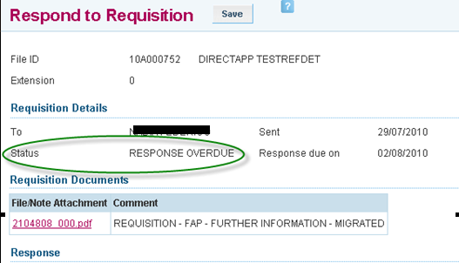

- What if the Requisition has a status of “Requisition Cancelled”?

The requisition has been cancelled and does not need to be responded to. An error message will appear.

