Use Submit Correspondence to provide relevant information to Victoria Legal Aid about the grant of assistance, for example, to notify that an error has been made on a submitted claim.
Do not send a copy of the same correspondence to Victoria Legal Aid via post , DX or facsimile.
If a client is required to provide a signed Equitable Charge, the original Charge signed by the client is required to be posted to VLA.
All other correspondence should be submitted through ATLAS.
To notify changes to client details, use the ‘Update Client Details’ function.

Submit Correspondence

- Select Submit Correspondence from the left hand menu under File Management.

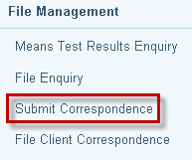

- The Search for File screen displays. Enter File ID and select Search.

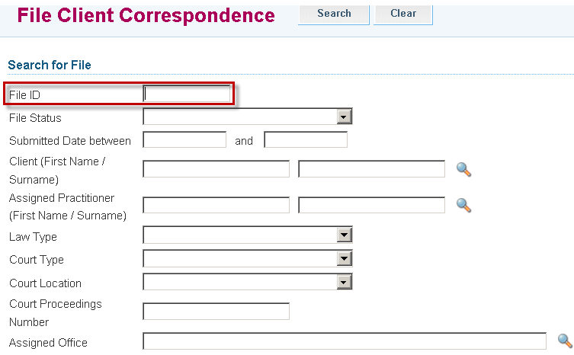

- Search Results will display. Click on the File ID link to retrieve the file.

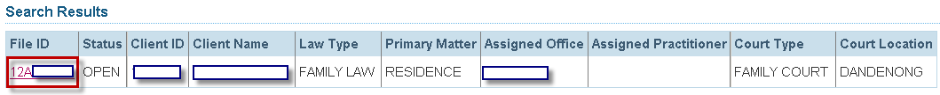

- The Submit Correspondence screen will display.
- Enter the Extension number

Complete Correspondence Details:
- Select the Type of correspondence (Excel, PDF or Word)
- Enter the Subject heading
- Provide Details
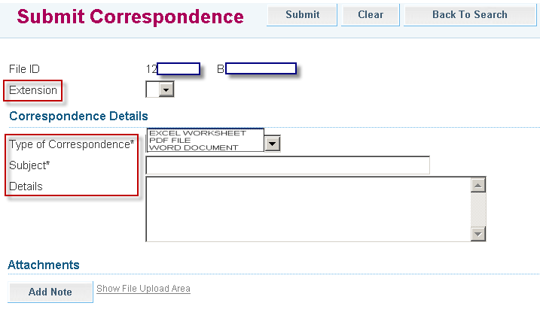

- To attach a document, click on Show File Upload Area.
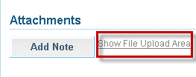

- The File Upload area will display. Click Browse and the Choose File dialogue box appears. Locate the file or document you wish to attach, click on Open to select it. The title of the selected document will populate in the field.
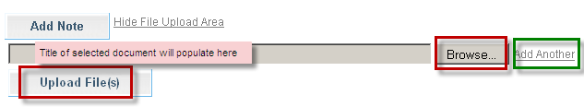

- Click Add Another if there are additional documents to be attached.

- Select Upload File.

- The File/Note Attachment grid will display with the relevant document(s).
To delete your attachment (if incorrectly attached) click the icon in the Action column.

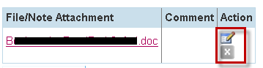

- To add or edit a Comment to describe the attachment, click the icon in the Action column.
Enter the comment, then click to save the comment. Click to delete the comment.

ATLAS has a 10 MB limit on the size of file attachments.

To avoid an error, split large attachments into two or more parts before attaching.

- To add a Note only, click Add Note.
Enter your Note and click to save the note or comment.
Click to delete the note or comment.
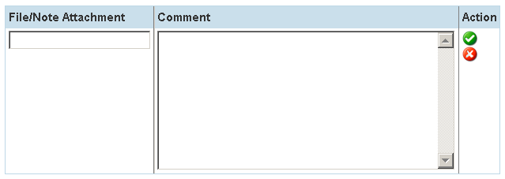

- Click to submit the application. A message will display to confirm the record or correspondence has been submitted successfully.

