If a client’s details change after an application for assistance has been submitted, use Update Client Details to notify Victoria Legal Aid of the changes. There is no need to send correspondence to Victoria Legal Aid about these changes.

Update Client Details

- Select Update Client Details from the left hand menu under Client.

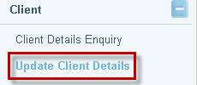

- The Client Update screen displays. Enter Client first name and Surname and select Search.

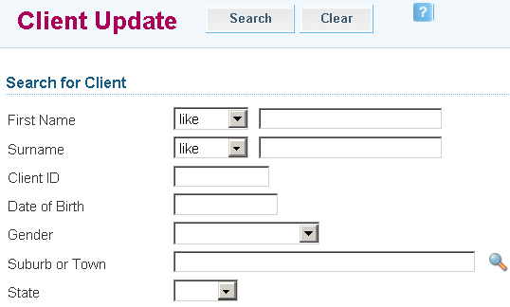

- Search Results will display. Click on the Client Name to retrieve the client.

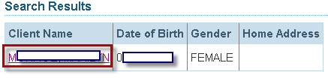

- The Update Client Details screen will display. Update changes as required:

- Contact details such as address or telephone number
- Additional details such as Centrelink benefit details
- Income, expenses and asset details if the client’s financial circumstances have changed
- Living arrangements

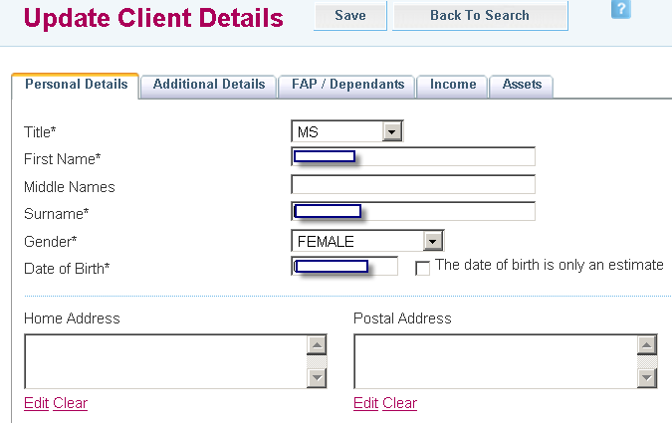

- Select Save. A message will display that the record has been saved successfully.



- If there were changes relating to the client’s financial circumstances, a warning notification states that ATLAS will recalculate the means test for the client based on the new financial information provided. Victoria Legal Aid will notify the client and their lawyer in writing if the grant of assistance is affected by the changes.


