Victoria Legal Aid
Client Experience Survey 2025
Summary report (accessible version)

Quality and Compliance Statement
This project was conducted in accordance with the international quality standard ISO 20252, the international information security standard ISO 27001, as well as the Australian Privacy Principles contained in the Privacy Act 1988 (Cth). ORIMA Research also adheres to the Privacy (Market and Social Research) Code 2021 administered by the Australian Data and Insights Association (ADIA).
Acknowledgments
ORIMA pays respect to Aboriginal and Torres Strait Islander Peoples past and present, their cultures and traditions and acknowledges their continuing connection to land, sea and community.
We would also like to acknowledge and thank all the participants who were involved in our research for their valuable contribution.
Contents
Project overview 1
Background 1
Research approach 1
Respondent profile 2
Summary of key results 5
Summary of key indicators 2022-25 6
Key takeouts for the 2025 survey 7
Access 8
Experience 9
Expertise 9
Communication 10
Person-centred 11
Personal and cultural needs 12
Client feedback on meeting personal or cultural needs 14
Legal capability 15
Resolution 16
Resolution status 16
Resolution – fully resolved 16
Resolution – partly or unresolved 17
Next steps after Legal Advice service 19
Wellbeing 20
Stress 20
Overall Wellbeing 21
Mental health 21
Overall client satisfaction 23
Results and trends 23
Overall satisfaction comparisons by cohorts 24
Program and service type trends 26

Project overview

Background
Victoria Legal Aid (VLA) is an independent statutory authority established under the Legal Aid Act 1978. VLA provides legal information, advice and representation to members of the Victorian community who are most disadvantaged and in need of support. Services provided by VLA and private practitioners are intended to be accessible, tailored to clients' needs and capabilities, and help people to address legal problems.
VLA has sought feedback through client surveys since 2011, to assess the extent to which it meets clients’ needs. In 2022, VLA adopted an outcomes approach with the development of VLA’s Outcomes Framework 2022-30 and the Outcomes and Evidence Agenda 2022-26. The first outcome, ‘clients have increased access to justice’ is directly related to the client journey with VLA. This outcome has been further broken down to better understand the client journey along with the impact of VLA’s services.
These client outcome areas are:
- Access to VLA services;
- Experience of VLA services;
- Impact on client legal capability,
- Resolution of clients’ legal problems; and
- Impact on client wellbeing.
In 2025, VLA commissioned ORIMA Research to conduct the survey. This report presents a summary of the findings from the research.

Research approach
The research approach had five stages:
- Project establishment, which included:
  - Project inception and planning
- Establishment of survey tools and processes
  - Questionnaire refinement and finalisation
  - Sample preparation and validation
  - Online survey programming
- Fieldwork (27 February – 2 May 2025)
  - Online survey invitations and reminders distributed via email and SMS
  - Computer Assisted Telephone Interviewing (CATI)
- Data analysis and reporting
  - Data cleaning and analysis
  - Survey data weighted by service offering, service type and law type
  - Preparation of a summary report and data tables

Respondent profile

Sampling approach
The survey was sent to all n=23,153 VLA clients who received services between 1 June – 30 November 2024. Survey invitations were sent via email or SMS to all records (except for n=1,000 that were retained for computer-assisted telephone interviewing (CATI)). CATI was then used to top-up under-filled strata to ensure the sample was representative by service offering, service type, and law type (see table below). Certain groups were oversampled to allow for more robust analysis and reporting. The survey data was then weighted by known population proportions. The sample did not include clients aged under 18, or any client who had received a FYCL service for a family violence issue where the risk level of seeking their feedback was deemed to be too high.

Response rate
Response rates achieved via each survey distribution method are outlined below.
Total: 3.9% (926/ 23,153)
  - Email distribution (via research supplier): 2.8% (389/ 14,043)
  - Email distribution (via VLA): 2.9% (29/ 1,000)
  - SMS distribution (via research supplier): 2.9% (208/ 7,110)
  - CATI (via research supplier): 18.5% (300/ 1,625*)

Profile of responding sample compared to the in-scope population
A summary of the responding sample compared to the in-scope population is provided in Table 1.

Table 1: Profile of responding sample compared to the in-scope population
Service offering | Target number of responses  (# minimum) | Actual number of survey responses  (#) | Proportion within survey responses  (% unweighted) | Population  (count of clients who had received VLA services between 1 June to 30 November 2024) (#) | Proportion within population  (%)
In-house practitioner | 300 | 802 | 87% | 20,529 | 89%
Private practitioner | 100 | 125 | 13% | 2,632 | 11%

Service type | Target number of responses  (# minimum) | Actual number of survey responses  (#) | Proportion within survey responses  (% unweighted) | Population  (count of clients who had received VLA services between 1 June to 30 November 2024) (#) | Proportion within population  (%)
Duty lawyer | 300 | 504 | 54% | 12,318 | 53%
Legal advice | 200 | 295 | 32% | 8,072 | 35%
Casework | 80 | 143 | 15% | 3,027 | 13%

Law type | Target number of responses  (# minimum) | Actual number of survey responses  (#) | Proportion within survey responses  (% unweighted) | Population  (count of clients who had received VLA services between 1 June to 30 November 2024) (#) | Proportion within population  (%)
Criminal law | 200 | 480 | 52% | 13,365 | 58%
Family law | 200 | 238 | 26% | 6,005 | 26%
Civil law | 200 | 208 | 22% | 3,817 | 16%
Total number of unique client records | 800 | 926 | 100% | 23,153 | -

Demographic profile
Almost half of the sample were middle-aged: 35-44 years (27%) and 45-54 years (22%). Two in five were female (40%) and 59% were male. Fourteen percent of respondents speak a language other than English and 6% were of Aboriginal and / or Torres Strait Islander descent. Sixty percent of respondents indicated they live with disability - the most common conditions were mental health issues (37% overall), complex mental illness (22%) and those who are neurodiverse or have learning difficulties (13%). Forty-one percent of respondents indicated that their highest level of education was high school or below.

Summary of key results

Access
- 78% of respondents agreed it was easy to contact VLA when they first needed help.

Experience
- 83% of respondents agreed that the lawyer treated them with respect.
- 83% of respondents agreed that the lawyer listened to their legal problem.
- 73% of respondents agreed that the lawyer took their circumstances into account.

Resolution
- 52% had their legal problem fully resolved.
- 16% had their legal problem partially resolved.
- 26% had an unresolved legal problem.
- 79% of respondents agreed that VLA’s help had a positive impact on their legal outcome.
- 78% of respondents agreed that VLA helped fix their legal problem.

Wellbeing
- 65% of respondents agreed they were less stressed after talking to the lawyer.
- 66% of the respondents with a fully resolved matter agreed that their overall wellbeing was improved.
- 37% of the respondents with an unresolved matter agreed that their overall wellbeing was improved.

Legal capability
- 79% of respondents agreed they know where to get help for future legal problems.
- 76% of respondents agreed that they feel more confident to get legal help in the future.
- 76% of respondents agreed that the lawyer helped them understand how to deal with their legal problems.

Satisfaction
- 68% of respondents were satisfied with the help they got from VLA.
- 79% of respondents agreed that they would recommend VLA to others.

Summary of key indicators 2022-25
Table 2 highlights the results for key indicators, including those used for reporting to Federal and State Governments for the 2022-25 period.
Table 2. Summary of key indicators for 2022-25 period
Question/ indicator | 2022 | 2023 | 2024 | 2025
ACCESS: It was easy to contact VLA when you first needed help. (NLAP) | 77% | 81% | 80% | 78%
EXPERIENCE: The legal aid lawyer understood my legal problem. | 77% | 73% | 77% | 77%
EXPERIENCE: The lawyer treated me with respect. | 81% | 80% | 85% | 83%
EXPERIENCE: The lawyer listened to my legal problem. (NLAP) | 83% | 76% | 77% | 83%
RESOLUTION: The help I got from VLA had a positive impact on the outcome of my legal problem. | 85% | 76% | 84% | 79%
RESOLUTION: Legal Aid helped me fix my legal problem. | 84% | 75% | 80% | 78%
RESOLUTION: Proportion of clients who had their legal problem resolved. | 42% | 50% | 48% | 52%
LEGAL CAPABILTY: You know where to get help if you have another legal problem in the future. | 78% | 80% | 77% | 79%
LEGAL CAPABILTY: You feel more confident to get legal help in the future if you need it. (NLAP) | 75% | 76% | 75% | 76%
LEGAL CAPABILTY: The lawyer helped you understand how to deal with your legal problem. (NLAP) | 77% | 70% | 74% | 76%
WELLBEING: I was less stressed after talking to the lawyer. | 65% | 59% | 63% | 65%
SATISFACTION: Overall client satisfaction. (DPS) | 67% | 62% | 65% | 68%
SATISFACTION: I would recommend VLA to other people. (NLAP) | 78% | 76% | 76% | 79%

Key takeouts for the 2025 survey
- VLA continues to perform well at an overall level.
At an overall level, Victoria Legal Aid (VLA) continues to perform well, as the majority of clients were satisfied with the services they received (68%). Since 2015, client satisfaction had been following a trajectory of decline, however this has now reversed, as client satisfaction has increased consistently in the past two annual surveys. In the 2025 survey, most clients felt it was easy to contact VLA when they first needed help, that lawyers used a person-centred approach, and that the service strengthened their legal capability. Almost four in five would recommend VLA to others (79%), reflecting strong service advocacy, another outcome indicator of positive client experience.
- Almost half of clients had personal or cultural needs.
The proportion of VLA clients with personal or cultural needs was high, with almost half reporting they had a specific need. The most common support needs were a disability, mental health issue, or other health concerns (26%), and experience of violence (17%). Only around two in five of those clients felt that VLA fully met those specific needs. Catering for the needs of VLA’s heterogenous client-base continues to be of importance.
- VLA helped strengthen client’s legal capability.
The experience of interacting with VLA left most respondents feeling more capable of dealing with legal problems in the future. For example, almost four in five respondents agreed they would know where to get help with future legal problems (79%), and three quarters felt the lawyer gave them the confidence to take the next steps to address their legal problem (74%).
- Clients with unresolved legal problems and unfavourable outcomes had lower satisfaction.
The resolution status and outcome of clients’ legal problems continues to have a significant influence on service satisfaction, with clients who had unresolved problems and clients who had unfavourable outcomes reporting poorer service satisfaction and poorer wellbeing.
- Legal advice clients and those who had sought support for a family law matter continue to have lower satisfaction
Clients who had received Legal Advice services had lower overall satisfaction than those who had received Duty Lawyer or Casework services. This may in part be due to the lower service intensity and the lower rate of case resolution among Legal Advice clients. Similarly, those seeking support for family law matters also had a lower rate of case resolution, which would have contributed to the lower service satisfaction rating. Additional support for these client cohorts may be needed.

Access
This section of the report focuses on clients’ initial contact with VLA and any difficulties they had when contacting VLA when they first needed help.
Most respondents found accessing VLA’s service straightforward.
Almost 8 in 10 agreed it was easy to contact VLA when they first needed help (78%). 22% felt that it was not easy to contact VLA when they first needed help. Of these clients, 85% reported difficulty in making initial contact with VLA, and a much smaller proportion (11%) had difficulties communicating with the VLA staff member when they were able to make contact (see Figure 1).
Figure 1: Ease of accessing Victoria Legal Aid
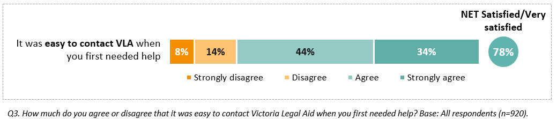
Twenty-two percent (22%) felt that it was not easy to contact VLA when they first needed help. Of these 129 clients, 85% of them reported difficulty in making initial contact with VLA, and a much smaller proportion (11%) had difficulties communicating with the VLA staff member when they were able to make contact. See Figure 2 for more detail.
Figure 2: Why was it difficult to contact Victoria Legal Aid? (129 respondents)
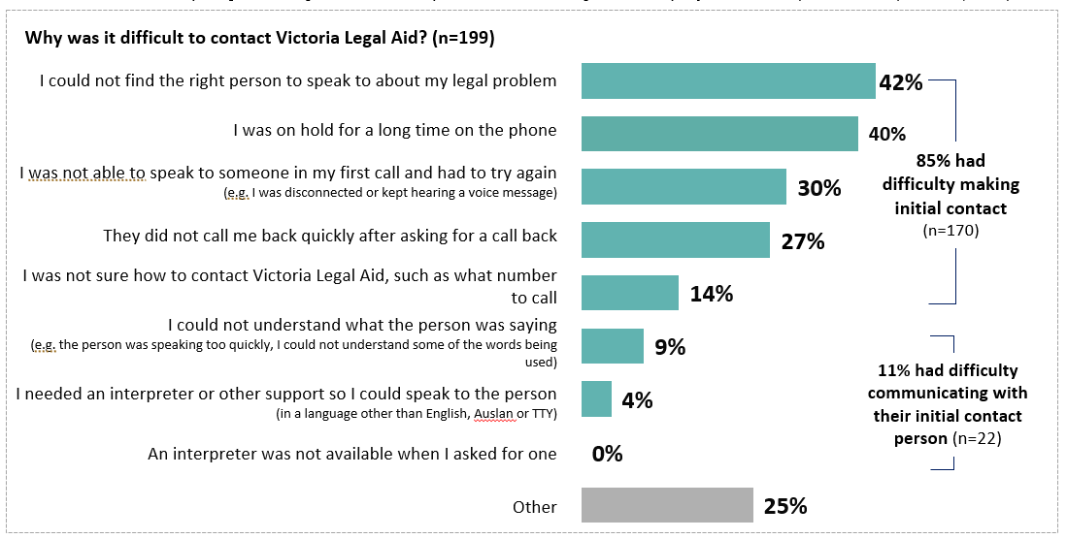
Question: Why was it difficult to contact Victoria Legal Aid? Base: All those who disagreed or strongly disagreed with the statement “It was easy to contact Victoria Legal Aid when you first needed help” (n=129)

Experience
This section of the report focuses on the various factors influencing the quality of the experience clients have while interacting with VLA. These can be summarised as:
perceived expertise of the legal advisors,
quality of communication between clients and legal advisors,
the extent to which services are person-centered and tailored to individual circumstances, and
support needs and considerations of clients, and whether these were adequately met.

Expertise
Respondents generally felt positive about the expertise of the lawyer.
Around three quarters of respondents (77%) agreed that the lawyer understood their legal problem and 71% felt confident that the advice provided would help them. Fifteen percent (15%) did not think that their lawyer understood their problem and 19% had not been confident that the lawyer’s advice would help them, disagreeing or strongly disagreeing with these statements. More details can be found in Figure 3.
Figure 3: Expertise of Legal Aid lawyer
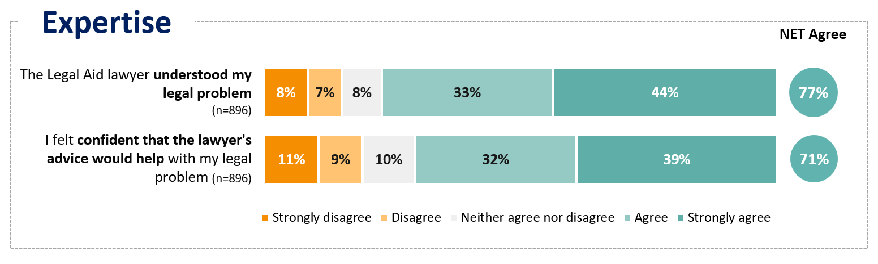
Question: How much do you agree or disagree with the following statements about the Legal Aid lawyer? – the Legal Aid lawyer understood my legal problem. Question: How much do you agree or disagree with the following statements about how you felt? – I felt confident that the lawyer’s advice would help with my legal problem. Base: All respondents (n=920). Excludes ‘not sure / I can’t remember’ responses.
Some respondents praised the capability of their lawyer and felt this resulted in a better legal outcome.
“They have got results for you. Feeling confident moving forward in July.”
“My lawyer was methodical, organised, well versed in the law and got me a good outcome.”
“Because the person I spoke with understood the difficulty with my case and suggested how to challenge that to try and get a different outcome to make my case clearer.”
Some respondents felt that their lawyer did not provide helpful advice or information, as it wasn’t specific to their matter or they felt the lawyer had lower capability.
“The lawyers are not helpful and I had chance to speak to two lawyers and both were very unhelpful and seems very less knowledgeable.”
“Advice was vague and generalised. I have since received a second opinion from a private lawyer that contained far more useful information for decision making and future planning.”

Communication
Communication between lawyers and clients was viewed positively.
Four in five (80%) agreed it was easy to understand the lawyer and 76% said they were able to ask all the questions they wanted. More information can be found in Figure 4.
Figure 4: Ease of communication with the legal aid lawyer
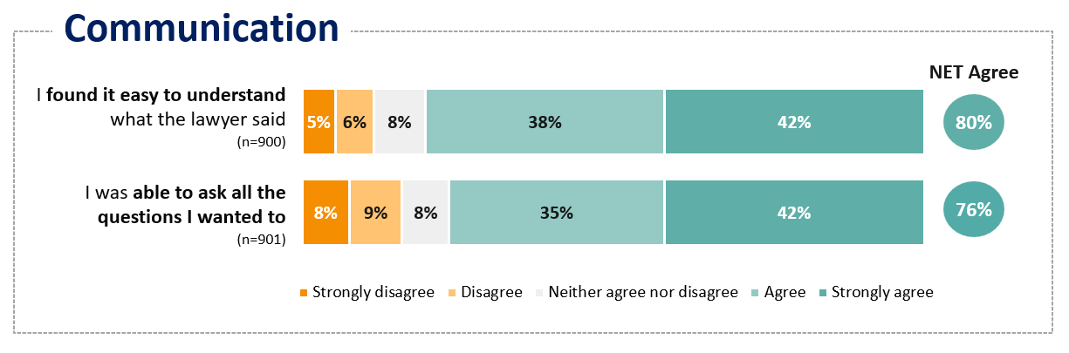
Q8d,b. How much do you agree or disagree with the following statements about how you felt? – The last time I got help from the Legal Aid lawyer… I found it easy to understand what the lawyer said. The last time I got help from the Legal Aid lawyer… I was able to ask all the questions I wanted to. Base: All respondents (base sizes shown above). Excludes ‘not sure / I can’t remember’ responses.
.
Some respondents praised the ability of lawyers to explain complex information and processes related to their case:
“The communication / Being able to understand everything.”
“It was explained really well, it solved part of the case / They explained more about how the process will be going, what I need to do, and how to improve my case, overall.”
“The lawyer I spoke with provided the information I required, in a warm and intelligent way. Any questions I had, were answered promptly and professionally.”
Fewer respondents held negative sentiment in relation to communications. Those with negative sentiment mentioned poor listening skills and unanswered questions.
“He just didn't listen to what I had to say, basically even the police that were there said it was a misunderstanding and the lawyer didn't care at the time "just plead guilty.“”
“I am dissatisfied because I haven't had my questions answered, I was not advised on what I should do to make the outcome of my case better and things were left till last minute instead of being dealt with in a suitable time frame.”

Person-centred
Respondents perceived the service to be person-centred.
Eighty-three percent (83%) of respondents agreed or strongly agreed that their lawyer treated them with respect and listened to their legal problem. Seventy-four percent (74%) agreed and strongly agreed that the lawyer did not rush them and wanted the best result or them. Seventy-three percent (73%) said that the lawyer took their circumstances into account. More information can be found in Figure 5.
Figure 5: Perception of the service as person-centred
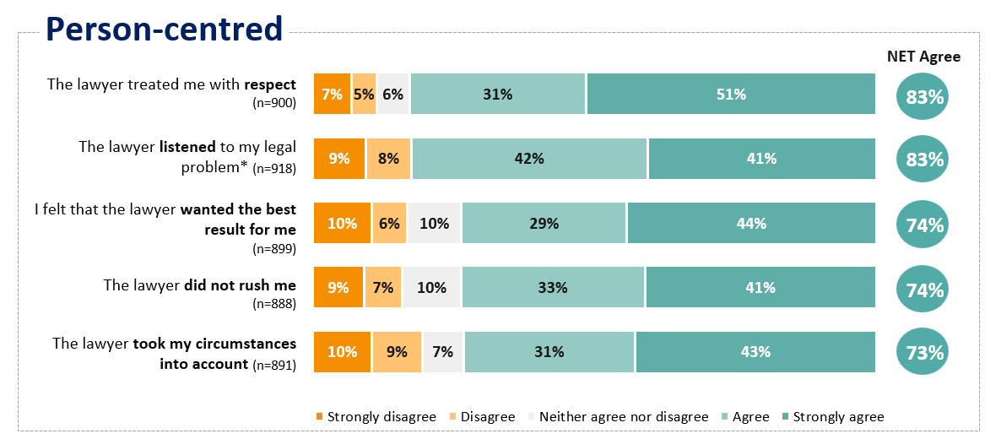
Question: How much do you agree or disagree with the following statements about the Legal Aid lawyer? Question: How much do you agree or disagree that the lawyer listened to your legal problem? Base: All respondents (base sizes ranged from n=888 to 918). Excludes ‘not sure / I can’t remember’ responses. *This question about the lawyer listening to their legal problem was asked on a 4-point agreement scale without a mid-point (e.g. ‘neither agree nor disagree’).

Many respondents felt they were respected, empathised with, and that their personal circumstances were taken into account.
“Great empathetic lawyers who treated me and my family with respect and had a strong duty for charge and justice.”
“The lawyer was emphatic kind, considered and completely dedicated to resolving the matter.”
A smaller number of clients felt they weren’t listened to, and that the lawyer lacked understanding of their personal circumstances.
“I felt that the legal aid lawyers were there as a token gesture. I felt like a number and was rushed through so they could get to next client.”
“Felt like just another number in the system. Didn’t listen to issue or have any understanding of what it was like to be a victim in a dv situation. Seemed like just wanted the day to end.”
“They didn't listen to me / They didn't care about me.”

Personal and cultural needs
Among 892 respondents, 49% had specific personal or cultural needs or considerations when using VLA’s services (see Figure 6).
Figure 6: Support needs and considerations
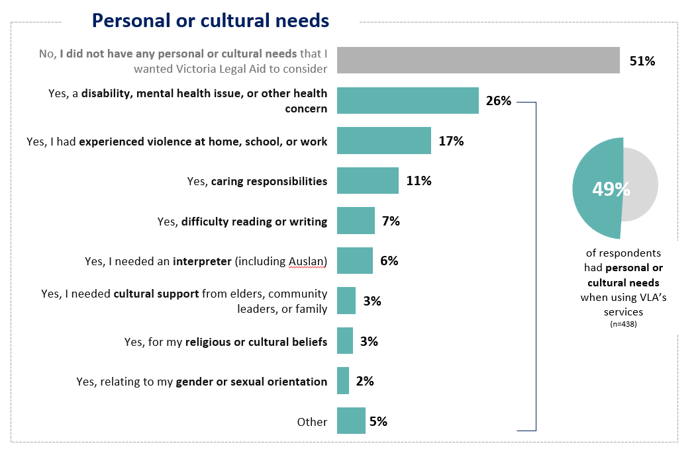
Question: Regardless of whether you asked for any additional help, did you have any support needs when you used Victoria Legal Aid’s services? If so, what were they? Base: All respondents (n=892).
Of the 49% of respondents who had a personal and/or cultural need, 26% had a disability, mental health issue, or other health concern, 17% had experienced violence at home, school, or work and 11% had caring responsibilities. These were the top three areas. And of this proportion of clients with personal or cultural needs, approximately 35% had more than one need they wanted VLA to consider.

Extent to which personal and cultural needs were met
Of those who had personal or cultural needs when accessing VLA services, feedback on whether these needs were met was mixed.
Feedback from respondents on whether their needs were met were mixed (as shown in Figure 7). Respondents requiring interpreter services were the most likely to say that their needs were fully met (51%).
Although respondents’ disability, mental health or other health concerns and previous experience with violence were the most commonly identified needs people wanted VLA to consider, only a minority of these respondents indicated their needs were fully met (43% and 39% respectively). Cultural support from Elders, community leader or family was the need least likely to be met with 36% of the fifty respondents saying their needs were not met at all.

Figure 7: Degree to which personal or cultural needs were met
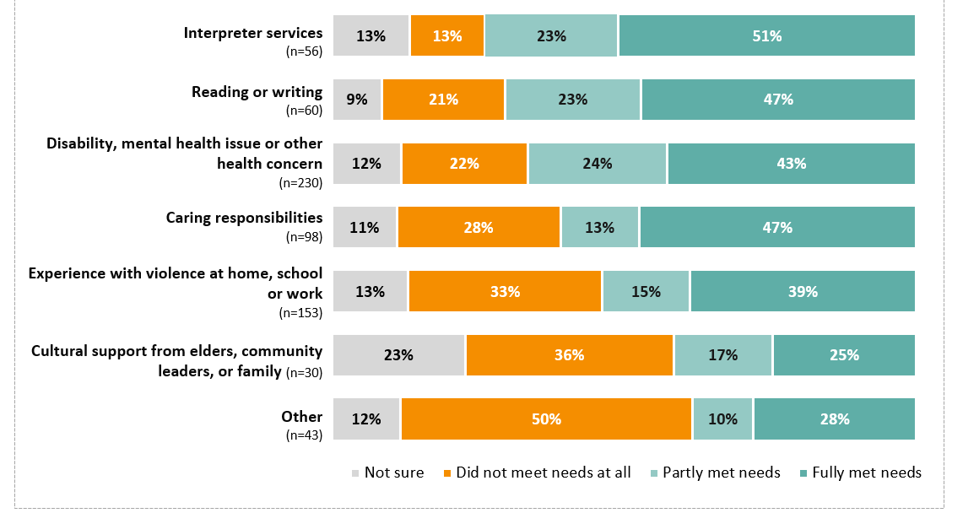
Question: How well did Victoria Legal Aid support these needs? Base: Respondents who indicated supports were needed, (base sizes ranged from 33 to 123). Excludes ‘not sure’ responses. Note: Results relating gender or sexual orientation, and religious or cultural beliefs are not shown due to small response numbers (n=17-27)

Client feedback on meeting personal or cultural needs
When respondents were asked why their personal or cultural needs were not fully or only partially met, many explained that it was because they felt VLA did not understand or ask questions about their situation.
“Because they didn't ask if I needed any assistance due to these disabilities and experiences.”
“Did not consider my disability or pension to even take on my case.”
“I don’t have the knowledge to understand advanced English words as I have a learning disability (SLD) they were very aware of that but still didn’t take any consideration to work on a easy pass.”
“I had difficulty understanding the lawyer at times. I wasn’t always sure that my experience of violence was being taken into account. My sexual orientation and gender identity are highly relevant to my case and whilst acknowledged I haven’t felt entirely understood.”
“It was never asked or taken into consideration.”
Respondents whose personal or cultural needs were not fully met were asked how VLA could better meet their needs. Asking whether clients have these needs in the first instance was mentioned by some. Improved listening skills, the need for a trauma-informed approach, and better training for lawyers in working with people from diverse backgrounds was also mentioned.
“Slow down. Listen carefully. Listen completely, talking isn't a competition. Allow processing time and allow us to talk when we have something to say instead of talking straight over the top.”
“Carry my concerns into the court room.”
“Need trauma-informed approach across VLA.”
“They could be more patient, listen and treat me with some dignity, respect and empathise with my situation.”
“If I have a social worker from Victoria Legal Aid who listens to and understands me, and works together with the lawyers supporting me, I believe the outcome will be more effective. Additionally, if the lawyer has specific training in working with people form diverse backgrounds, I believe Victoria Legal Aid will be able to support me better.”

Legal capability
This section describes the impact of VLA’s assistance on clients’ ability to understand their most recent legal problem, how to deal with it, as well as their impact on building client capability in dealing with future legal problems.
The experience of interacting with VLA left most respondents feeling more capable of dealing with legal problems in the future.
Almost four in five respondents (79%) agreed they would know where to get help with future legal problems and 76% felt more confident in getting legal help should they need to do so in the future. Other feedback on capability showed that 74% felt that the lawyer gave them the confidence to take the next steps in addressing their legal problem. See Figure 8 for details.
Figure 8. Capability of respondents
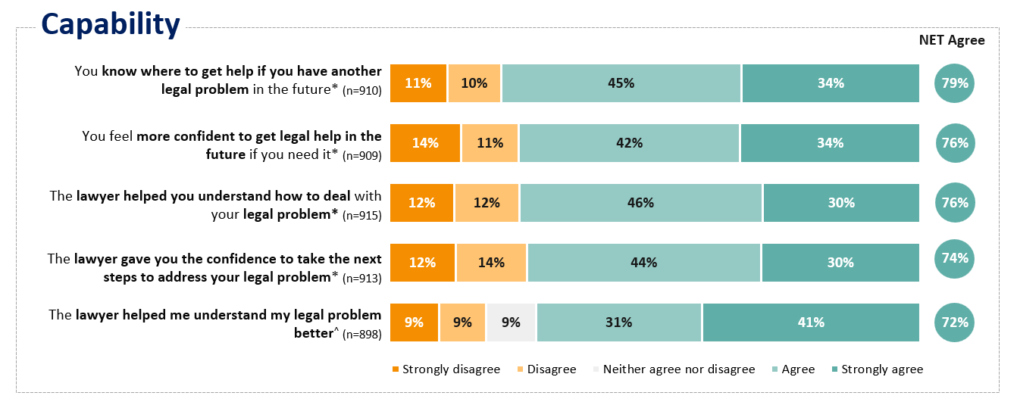
*These questions were asked on a 4-point agreement scale without a neutral mid-point (e.g., ‘neither agree nor disagree’). ^Excludes ‘not sure / I can’t remember’ responses. Question: Q25a. How much do you agree or disagree with the following statements? – You know where to get help if you have another legal problem in the future. Q25b. How much do you agree or disagree with the following statements? – You feel more confident to get legal help in the future if you need it. Q10. How much do you agree or disagree with the following statements? – The lawyer helped you understand how to deal with your legal problem. Q7d. How much do you agree or disagree with the following statements about the Legal Aid lawyer? The last time I got help, the Legal Aid lawyer… helped me understand my legal problem better. Q36a. How much do you agree or disagree with the following statements? The lawyer gave you the confidence to take the next steps to address your legal problem. Base: All respondents (base sizes noted above).

Resolution
This section focuses on client perceptions of VLA’s impact on their legal matters. In the survey there was a separate set of questions for those who had a fully resolved legal matter to those whose legal matter was yet to be resolved. The former focused on the perceived impact of VLA assistance on the outcome, and the latter focused on the perceived impact of VLA assistance on the progress of their case or anticipated outcome.

Resolution status
One in two respondents’ (52%) legal problem had been fully resolved at the time of surveying. Of those, half (52%) indicated the problem was resolved completely in their favour. For more details see Figure 9.
Figure 9. Resolution status

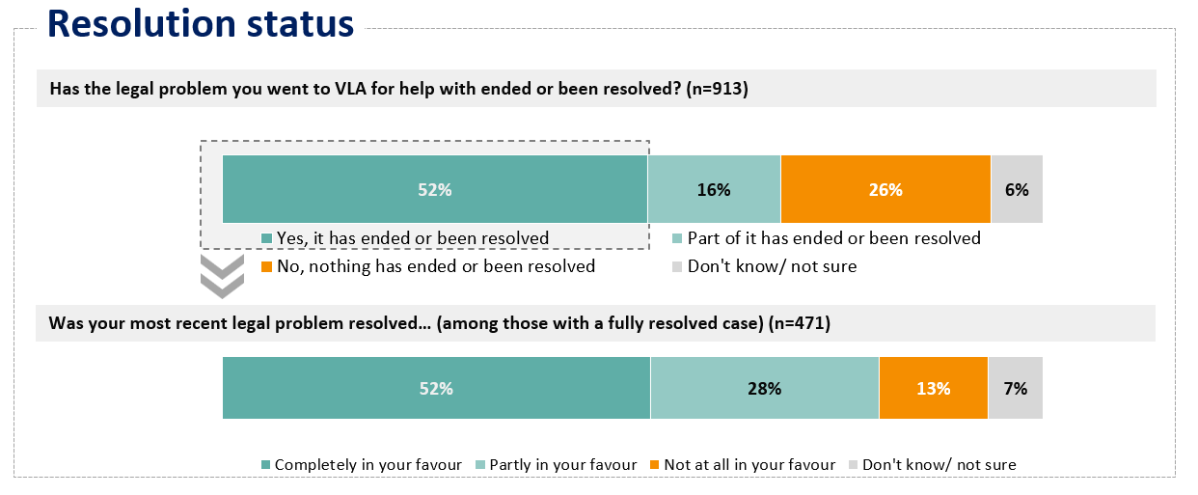
Q16. Has the legal problem you went to VLA for help with ended or been resolved? Base: All respondents (base size noted above). Q17. Was your most recent legal problem resolved…? Base: All respondents with a fully resolved legal problem (base size noted above).

Resolution – fully resolved

VLA’s involvement was perceived to have had a positive impact on the outcomes of 79% of those respondents’ legal problems where their legal problem had been resolved. Four in five agreed that legal aid gave them enough help for their legal problem (81%) and fixed their legal problem (78%).Seventy-eight percent of those with a resolved legal problem felt that the outcome was fair and 80% were satisfied with the outcome. See more details in Figure 10.

Figure 10. Resolution - Fully resolved matter

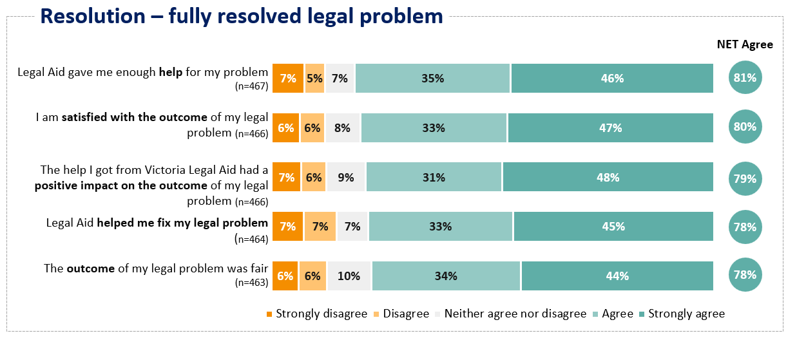Q20. Thinking about the resolution of your legal problem, how much do you agree or disagree with the following? Q18a. Thinking about the resolution of your legal problem, how much do you agree or disagree with the following? – The help I got from Legal Aid had a positive impact on my legal problem. Base: All respondents with a fully resolved legal problem (base size noted above). Excludes ‘not sure / I can’t remember’ responses
Respondents who perceived VLA to have had a positive impact on their legal problem spoke highly of VLA’s support and the skills of the lawyers:
“My lawyer was methodical, organised, well versed in the law and got me a good outcome.”
“I was able to get all the correct advice to fight my case with a great outcome, was thoroughly happy with the results.”

Resolution – partly or unresolved
Views were less positive among those with a partly or unresolved legal problem.
For the respondents with an unresolved or only partly resolved legal matter, 56% reported that the help from Legal Aid helped them to get to the next step(s) in their legal problem; 51% thought Legal Aid gave them enough help for their problem. 47% of respondents reported that the help they have got from VLA so far will have a positive impact on the outcome of their legal problem and 39% of respondents felt satisfied with how their case was going (as shown in Figure 11.). These are all slightly up from the previous year’s results.

Figure 11. Resolution partly/unresolved matter
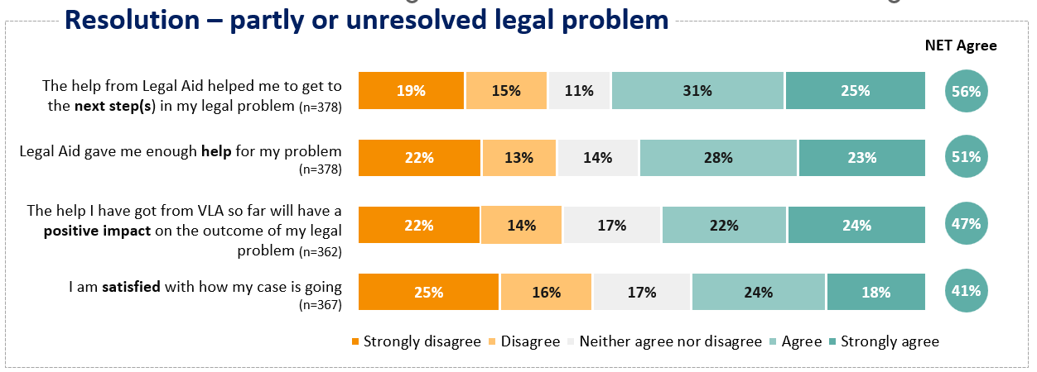
Q21. How much do you agree or disagree with the following? Q19a. How much do you agree or disagree with the following? – The help I got from Victoria Legal Aid so far will have a positive impact on the outcome of my legal problem. Base: All respondents with a partly resolved or unresolved legal problem, excluding those who did not know if their legal problem was resolved (base size noted above). Excludes ‘not sure / I can’t remember’ responses.

Respondents who were not satisfied with their overall experience and whose legal problem had not been resolved described disappointment with the quality of the service or felt that they weren’t helped.
“Was given incorrect advice totally irresponsible.”
“They were very quick and rushed me/Couldn't help and told me to find someone else in private practice but gave no referrals.”
“They didn't help with my situation.”
“The legal help I received before ended in a fiasco. The last time I called for legal aid, I was told that Legal Aid would pick me up with an interpreter, but I never received the call.”
However, some clients expressed satisfaction with VLA despite their case not being resolved. In many cases this was because they felt their lawyer had helped them, had been empathetic, and had reduced their stress levels.
“Because I'm shown care in their tone and understanding.”
“I was at the lowest in my life with no direction or idea on how to until I spoke to [name] from Victorian legal aid, she actually listened and understood where we could fight for my right to be a parent. She is an angel thank you.”
“They helped a lot with stress.”
“Just helpful and related easily to my issue.”

Next steps after Legal Advice service
Clients were asked what they actually did after their legal advice service.
After their service with VLA was completed, Legal Advice clients most commonly looked for legal help from private lawyers outside of VLA (19%) or followed up the referral(s) provide by VLA (18%). For more detail see Figure 12.
Figure 12. Steps taken after legal advice service
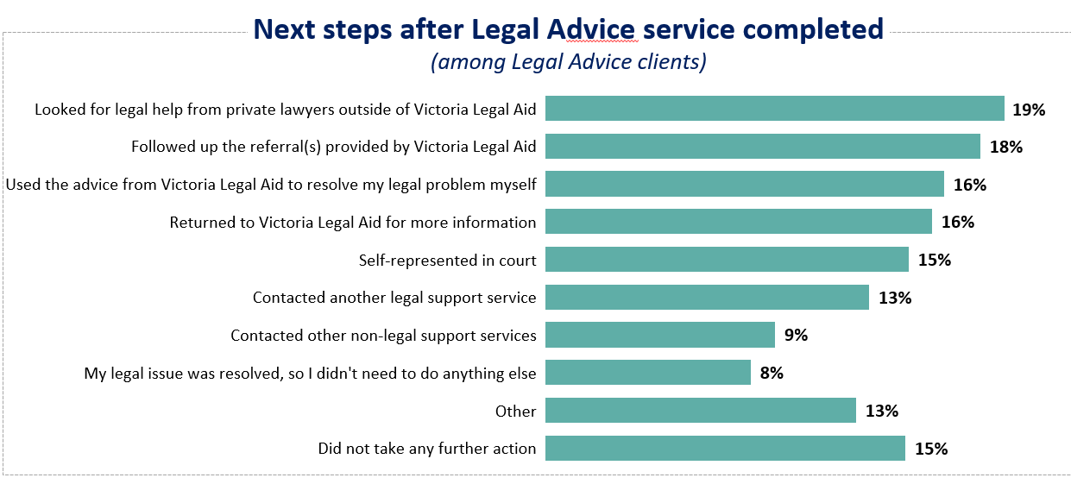
Q35. After your legal advice service with Victoria Legal Aid was completed, what did you do next? Base: Respondents who had received Legal Advice services (n=279).

Of those who self-represented in court (n=40):
- 25% Looked for legal help from private lawyers outside of VLA
- 18% Followed up the referral(s) provided by Victoria Legal Aid
- 8% Contacted another legal support service
In terms of how many steps people took after their legal advice service, 51% took just the one step while 24% took between 2-4 steps and 2% took more than 5 steps.
Many respondents who selected ‘Other’ as their next step mentioned that their case was still ongoing.
“Need more follow up as matters with [other organisation] not resolved.”
“Still ongoing.“
“Has not been resolved.“

Wellbeing
This section discusses VLA’s impact on the wellbeing of clients, including stress levels, overall wellbeing and mental health.

Stress
Almost three in four respondents whose legal problem was resolved generally indicated that VLA’s services had a positive impact on their stress levels. In contrast, just over half of respondents whose problems were partially or entirely unresolved agreed that VLA’s services had a positive impact on stress levels (54%).
Overall, three in five (65%) respondents agreed that they were less stressed after talking to the lawyer. Three quarters of respondents (74%) with a resolved legal matter agreed they were less stressed after talking to the lawyer, but this was slightly over half (54%) for those without a resolved matter (as shown in Figure 13.).
Figure 13. Wellbeing – stress levels
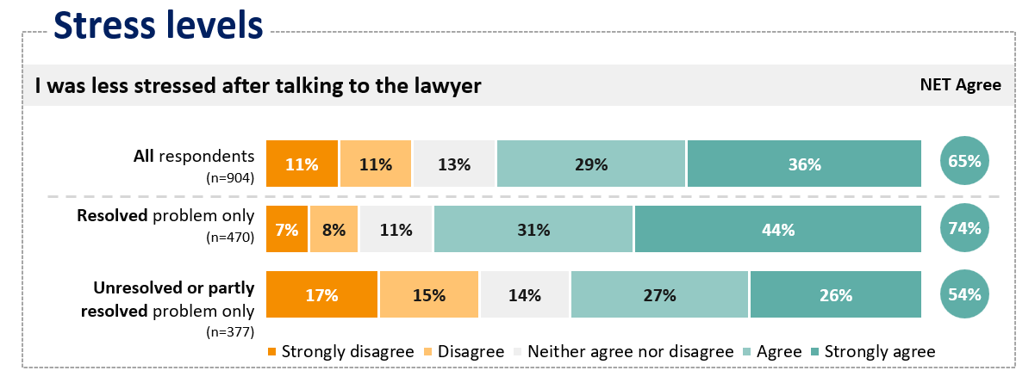
Q8a. How much do you agree or disagree with the following statements about how you felt? – I was less stressed after talking to the lawyer. Base: All respondents, respondents with a fully resolved legal problem, and respondents with a partly resolved or unresolved legal problem excluding those who did not know if their legal problem was resolved (base size noted above). Excludes ‘not sure / I can’t remember’ responses.

Some of those with unresolved problems indicated that their involvement with VLA may have been detrimental to their wellbeing, and caused them emotional distress.
“They have destroyed our life, collected a paycheck and left my child and myself to fend for ourselves.”
“The lady I spoke to did not listen and I felt very judged and dictated to. I was emotional by the end of the call and very confused.”

Overall Wellbeing
Similarly, respondents whose legal problem was resolved generally indicated that VLA’s services had a positive impact on their wellbeing
Half (53%) of all respondents agreed that the help they got from VLA improved their overall wellbeing. Two in three (66%) respondents with a fully resolved matter agreed that the help they got from VLA improved their overall wellbeing and 37% of respondents with an unresolved or partly resolved matter agreed that the help they got from VLA improved their overall wellbeing (as shown in Figure 14).
Figure 14. Overall wellbeing
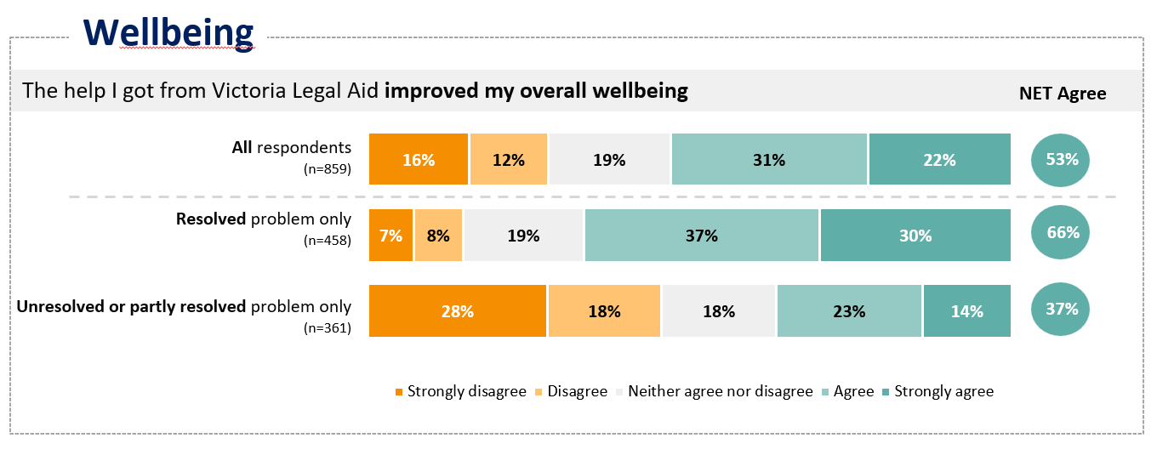
Q18. How much do you agree or disagree with the following statements? Q19. How much do you agree or disagree with the following statements? Base: All respondents, respondents with a fully resolved legal problem, and respondents with a partly resolved or unresolved legal problem excluding those who did not know if their legal problem was resolved (base sizes noted above). Excludes ‘not sure / not applicable’ responses.

Mental health
Similarly, respondents whose legal problem was resolved generally indicated that VLA’s services had a positive impact on their mental health. In contrast, a minority of respondents whose problems were partially or entirely unresolved agreed VLA’s services had a positive impact on their mental health.
Half (50%) of all respondents agreed the help they got from VLA improved their mental health. Sixty-two percent (62%) of respondents with a fully resolved matter thought the help they got from VLA improved their mental health. Thirty-six percent (36%) of respondents with an unresolved or partly resolved matter thought the help they got from VLA improved their mental health (as shown in Figure 15).

Figure 15. Wellbeing – mental health
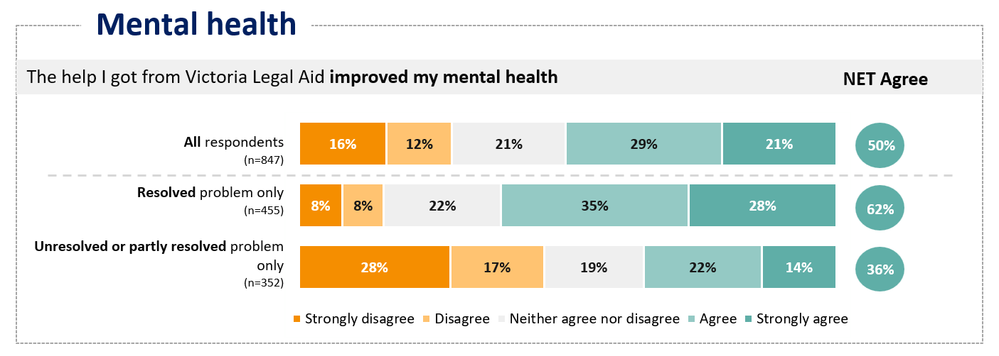
Q18. How much do you agree or disagree with the following statements? Excludes ‘not sure / not applicable’ responses.
Q19. How much do you agree or disagree with the following statements? Excludes ‘not sure / not applicable’ responses.
Base: All respondents, respondents with a fully resolved legal problem, and respondents with a partly resolved or unresolved legal problem excluding those who did not know if their legal problem was resolved (base sizes noted above).

Respondents who felt that they had good mental health outcomes, praised VLA’s assistance:
“It was daunting in the extreme and very stressful when trying to handle my legal problems, so having Vic Legal Aid represent me has saved my wellbeing and allowed me look to the future...without that help my life would have been very bleak indeed.”
“The legal problem was quite distressing and the lawyer who provided my advice was able to reduce my distress and give me clear guidance.”

Overall client satisfaction

Results and trends
Between 2015 and 2023, client satisfaction followed a trajectory of decline. In 2024 this trend reversed, and satisfaction has continued to increase into 2025.
Sixty-eight percent of respondents were either very satisfied or satisfied with the overall help they received from VLA. This is an increase from 65% in 2024 and 62% in 2023. Longer term trends are shown in Figure 16.
Figure 16. Overall satisfaction in 2024 and time series comparison
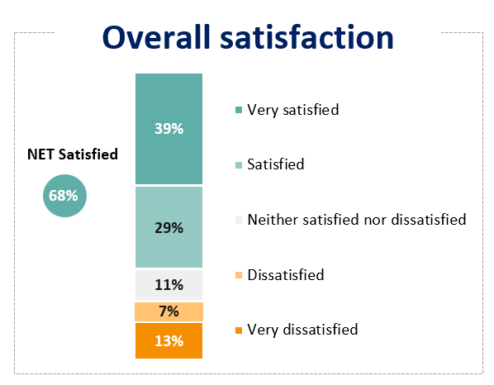
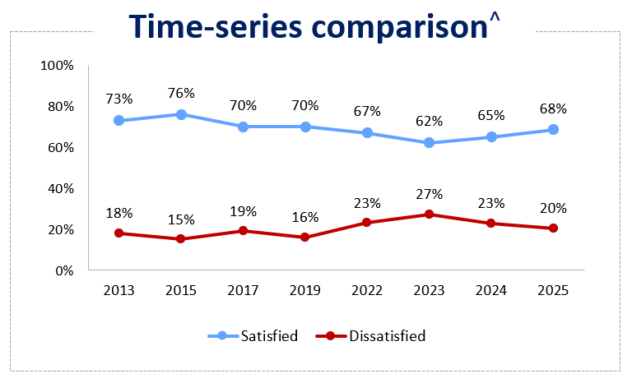
Q23. Overall, how do you feel about the help you got from Victoria Legal Aid? ^ Base sizes are not available for 2013-2022 results. Base size for 2023 is n=783, base size for 2024 is n=802 and base size for 2025 is n=926. 2023, 2024 and 2025 results are weighted. Any trends described are indicative only.
Respondents were asked the reason for their level of satisfaction. The main reason among those satisfied was that their request for services was fulfilled or they were satisfied due to the outcome of their legal problem:
“I was happy with out the outcome / He did a good job.”
“They understood me and got the case sorted.”
Another common reason for satisfaction was the character or conduct of the lawyer, including mentions of empathy, patience, professionalism, understanding, care/support, work ethic and use of a trauma-informed approach.
“Because the lawyer I had was very respectful and understood my problem and supported me in my rough patch at that time.”
“They fought hard for the result and were very competent lawyers that treated me well.”
“I really appreciate that the lawyers I have interacted with are highly sensitive in their approach to working with victims of trauma, which has made a significant difference in how supported and secure we feel.”

Overall satisfaction comparisons by cohorts
Regarding the rate of overall satisfaction by the outcome of respondents’ legal problem, the rates of satisfaction are:
- 92% for clients whose legal problem was resolved completely in their favour,
- 86% for clients whose legal problem was resolved partly in their favour, and
- 36% for clients whose legal problem was resolved not at all in their favour.
Regarding the rate of overall satisfaction by resolution status of legal problem, 85% of respondents with a fully resolved matter were satisfied, 74% of respondents with a partially resolved matter were satisfied, and 32% of respondents with an unresolved matter were satisfied.
Regarding the rate of overall satisfaction by service type, 74% of respondents that received case work services were satisfied, 69% of respondents that received duty lawyer services were satisfied, and 56% of respondents that received legal advice services were satisfied.
Regarding the rate of overall satisfaction by problem type, 71% of respondents that had a criminal law matter were satisfied, 59% of respondents that had a civil matter were satisfied, and 55% of respondents that had a family law matter were satisfied.

Details can be found in Figure 17.
Figure 17. Overall satisfaction comparisons by cohorts
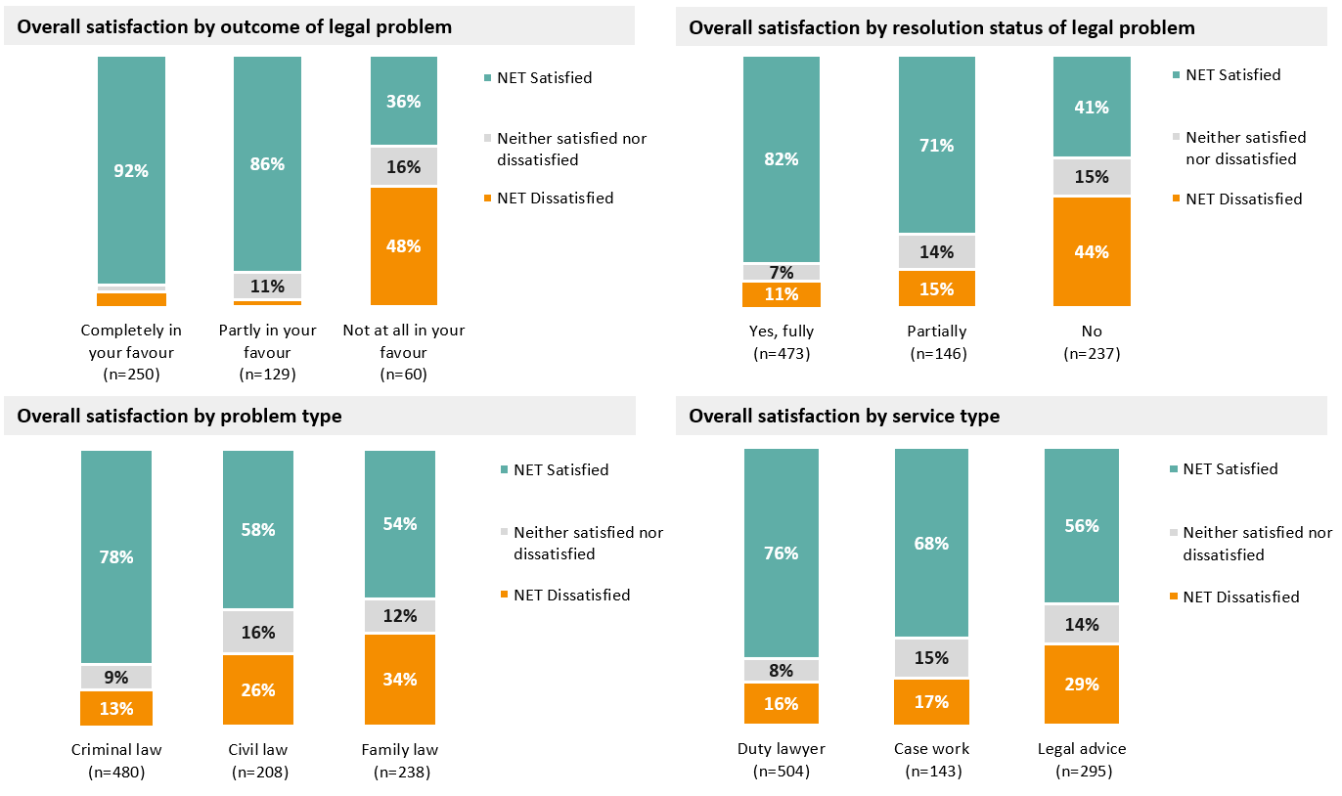
Base: All respondents (base sizes noted above).
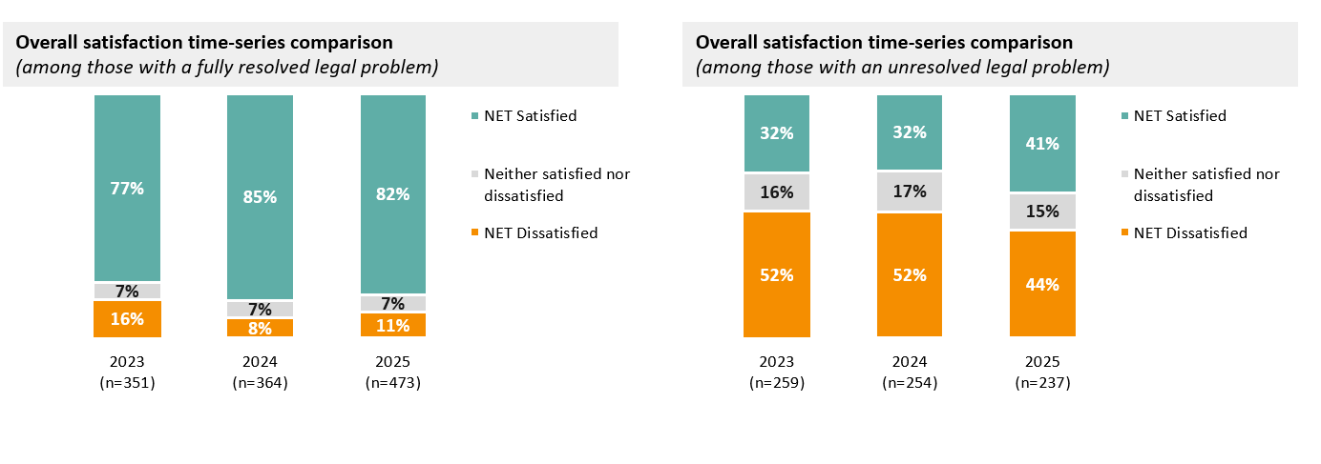
Base: Respondents with a fully resolved legal problem, and those with an unresolved legal problem (base sizes noted above).

Program and service type trends
Overall satisfaction ratings have generally followed a gradual trajectory of decline across all program areas between 2015 and 2023. In 2024 and 2025, ratings have stabilised across all program areas and shown some movement upwards. although are still lower than those recorded in 2015 (as shown in Figure 18). Criminal law clients tend to be more satisfied with VLA services than civil and FVCL clients and this gap is increasing.
Figure 18. Overall satisfaction by program area and time series comparison

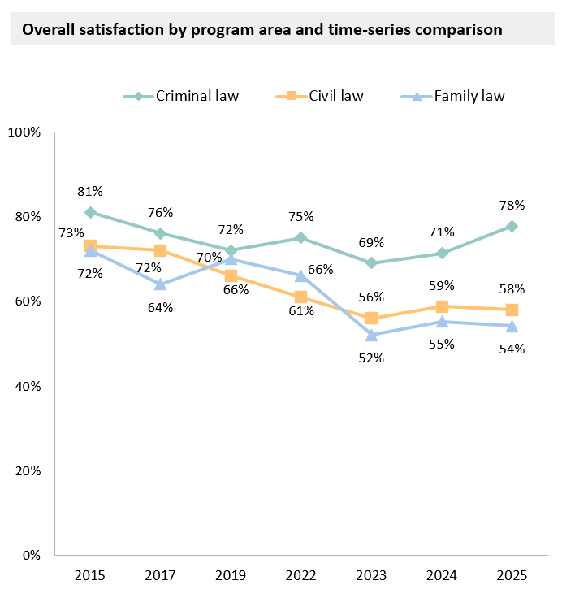
Base: All respondents by program area (2023 to 2025 results are weighted). 2023 (weighted): Criminal Law (n=269), Civil Law (n=189), Family Law (n=326). 2024 (weighted): Criminal Law (n=385), Civil Law (n=199), Family Law (n=221). 2025 (weighted): Criminal Law (n=480), Civil Law (n=208), Family Law (n=238).
Figure 19 shows that overall satisfaction ratings have also been gradually declining in each service area between 2015 and 2023. In 2025, ratings continue to improve for duty lawyers services, decline for casework services (first time this has occurred) and remain relatively steady (but substantially lower) for legal advice services.
Figure 19: Overall satisfaction by service area and time-series comparison
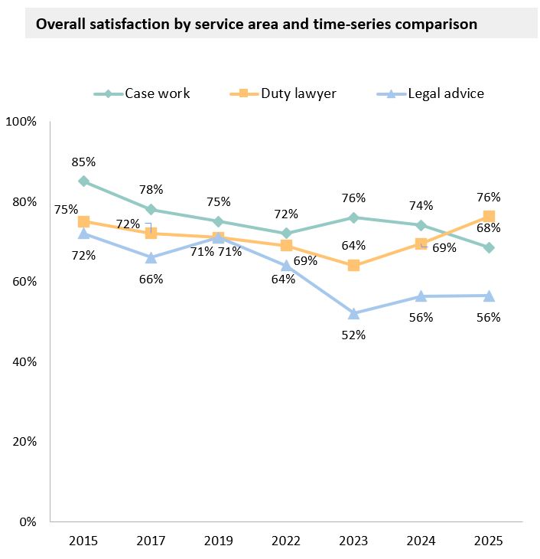
Base: All respondents by service area. 2023 (weighted): Case work (n=127), Duty Lawyer (n=334), Legal advice (n=329). 2024 (weighted): Case work (n=113), Duty Lawyer (n=384), Legal advice (n=308). 2025 (weighted): Case work (n=143), Duty Lawyer (n=504), Legal advice (n=295).

Family law in this report is used to refer to Family, Youth and Children’s law.

