Impact report: Three years of Victoria’s Victims Legal Service
A joint report from partners in Victoria’s Victims Legal Service

Acknowledgement of Country
This report was written on the lands of the Wurundjeri and Bunurong peoples of the Kulin Nation. We acknowledge and pay our respects to Aboriginal and Torres Strait Islander peoples and Traditional Custodians throughout Victoria, including Elders past and present.
We also acknowledge the strength and resilience of all First Nations people who continue to be victims of abuse, family violence and crime at disproportionate rates, which should be understood as both a cause and effect of intergenerational trauma, social disadvantage and racism.
We recognise many First Nations people are less likely to report crime given past and collective experiences of discrimination and institutional racism from police and government services, and the impact this has on awareness of options for financial, legal and health assistance. We acknowledge the strength and resilience of all First Nations people who face barriers to access and knowledge of rights, as well as distrust and fear of government service provision due to historical mistreatment, discrimination and racism.

Contents
Executive summary 2
Victoria’s Victims Legal Service – How we assist victims 5
Over 12,000 services for victim-survivors in Victoria 8
Outcomes for victims: moving towards healing and recovery 10
Meeting victim-survivors’ individual and intersecting needs 11
Partnering to better meet the needs of victim survivors 13
Culturally safe and accessible services for First Nations victims 16
A coordinated approach to training, engagement and systemic advocacy 17
The future for specialist legal assistance for victim-survivors in Victoria 19

Executive summary
Without your assistance I would not have been able to move forward and try to heal from my past. I will never fully recover and I will always have triggers however with today’s outcome I will be able to access some much needed support to stay safe physically and emotionally. You are truly a valuable asset to all the survivors of these crimes and I am extremely grateful that you were a part of my healing journey.
Selma (name has been changed), South-East Monash Legal Service and VLS client
In March 2023, the Victims Legal Service (VLS) became Victoria’s first dedicated, statewide, specialist legal service for victims of crime. The VLS is a coordinated and collaborative service partnership, which was designed together with victim-survivors. It includes a specialist VLS Helpline, together with a network of VLS partners who provide more intensive legal assistance. Service partners include Victoria Legal Aid (VLA), Victorian Aboriginal Legal Service (VALS), Djirra, Women’s Legal Service Victoria (Women’s Legal) and seven local community legal centres (CLCs) across the state: Eastern CLC, Northern CLC, Inner Melbourne Community Legal, South-East Monash Legal Service (SMLS), Allied Justice (formerly Ballarat & Grampians Community Legal Service), Mallee Family Care CLC and Gippsland Community Legal Service.
This three-year impact report shares data on VLS services, feedback from partners and stories of 11 VLS clients – Phillip and Charlie, Jasmine, Lida, Juniper, Jay, Lucille, Melanie, Sarah, George and Mia. Together, these highlight the role the VLS has played in improving the experience of the justice system and delivering tangible outcomes for victim-survivors in Victoria.
From its commencement in March 2023 until 31 January 2026, the VLS has provided 12,097 services to Victorian victim-survivors, including information and referrals, advice, minor assistance and ongoing legal casework including representation. The VLS has provided information and legal advice in response to a total of 10,513 enquiries to the VLS Helpline. The VLS Helpline has successfully referred 802 victims to VLS partners who have been able to provide intensive legal assistance. Over 2000 individual victim-survivors have received legal advice and/or ongoing legal assistance.
Of the victims we have supported, 44% reported having a disability, 35% reported experiencing mental health issues, 24% reported having experienced or being at risk of experiencing family violence and 23% lived in a region, rural and remote area.
In a snapshot analysis of 25 finalised outcomes achieved by the VLS since the commencement of the Financial Assistance Scheme (FAS) in November 2024, the VLS had helped obtain over $380,000 in financial assistance for victim-survivors. This financial assistance is a crucial part of recovery for many victim-survivors, including through supporting safety (such as lock changes, alarms and lighting), access to mental and physical health services, support for children and housing, education and wellbeing supports, alongside non-financial assistance in the form of victim recognition statements.
In its first three years of operation, the VLS has provided victims of crime with specialist trauma-informed legal information, advice and ongoing legal casework services resulting in:
- Victims of crime better understanding their options in relation to financial assistance and compensation, helping to minimise the trauma of the justice process
- Accessible and tailored pathways for victims to legal assistance, reducing the need to re-tell their stories
- Significant amounts of financial assistance to support victim-survivors’ recovery, and
- A more collaborative and stronger legal assistance sector response to victims’ needs, including strong partnerships with non-legal service providers and a coordinated approach to systemic reform.
Informed by our direct work with victim-survivors, this report also shares the VLS’s findings regarding ongoing need for system and service reform, including:
- There remains significant unmet legal need for victims of crime. Within the existing resourcing of the VLS, VLS partners cannot keep up with demand for ongoing assistance for victims of crime seeking help to claim financial compensation.
  - Demand for assistance from the VLS Helpline has steadily increased year on year since commencement of the service in March 2023. In 2023, the VLS Helpline responded to 1,850 enquiries, in 2024 to 3,734 enquiries and in 2025 to 4,876.
  - Over 727 victim-survivors who would otherwise have been eligible for intensive assistance from VLS partners have had to be turned away due to lack of capacity in VLS partners to accept referrals.
- Persistent need for legal assistance. Even with the introduction of the FAS in Victoria in November 2024, which aims to be a more accessible victim-centred scheme for victims to access financial assistance, it is clear there is a persistent need for legal assistance to support victim-survivors to understand their rights and options and effectively navigate access to financial assistance.

- The importance of funding certainty to embed the VLS as part of Victoria’s service landscape for victim-survivors. The VLS is currently only funded until June 2026, with no certainty that this will continue. Short term funding has affected the VLS’s ability to provide certainty to victim-survivors, community partners and specialist VLS staff. Funding certainty is needed to ensure the VLS becomes an embedded part of Victoria’s service landscape for victim-survivors, helping to understand and navigate their rights and entitlements and support recovery.

- The role for more comprehensive specialist legal services for victim-survivors. The current scope of the VLS does not meet a range of other needs victim-survivors have to understand and exercise their rights. The VLS provides a model that can be built upon to provide a comprehensive, specialist legal service that would better support victim-survivors through the justice system.
- The systemic role of the VLS. In addition to delivering individual outcomes to victim-survivors, the VLS has played a crucial role in supporting implementation of government’s commitment to improve the experiences of victim-survivors. The VLS is the primary referral pathway for victims to the FAS and ensures that victims, especially those with complex matters, have access to free, consistent and quality legal assistance to support them to understand and effectively navigate the scheme. The VLS also plays an important role in providing coordinated insights informed by direct practice on system operation, improvements and reform.
This report draws together the experiences of victim-survivors and the collective evidence of VLS partners. It sets out the VLS service model, which was designed with victim-survivors, and outlines the outcomes and impact of the VLS to date. Collectively, we highlight the crucial role of specialist legal assistance in promoting just outcomes and improving the experiences of the justice system for victim-survivors across Victoria.

Victoria’s Victims Legal Service – How we assist victims

Background to the VLS
The establishment of a statewide specialist and comprehensive legal service for victim-survivors, which focuses on their substantive legal entitlements and addresses unmet legal need of victim-survivors, has been a key recommendation of multiple inquiries and research focused on the experiences of the justice system by victim-survivors.
In the 2021/22 budget, the Victorian Government announced $7.3 million over three years to establish a new, dedicated VLS. This funding was extended for 12 months in the 2025/26 state budget and is currently due to end in June 2026.
Building on the strength of the state-funded VLS service model, in 2023, Victoria was successful in receiving funding from the Commonwealth Government to implement a pilot initiative to improve access to legal assistance for victims of sexual offences (Commonwealth pilot).

Our scope
The VLS provides free legal advice and support to people who have suffered injury or loss because of a violent crime and need help to access financial assistance through the FAS, and/or compensation from the person who committed the crime through a Restitution and Compensation Order (RACO) under the Sentencing Act 1991 (Vic) (the Sentencing Act). Since March 2024, a limited expansion under the Commonwealth pilot, has also enabled the VLS to provide legal assistance to sexual violence victim-survivors regarding their options and rights in relation to confidential communications and health information, such as medical or counselling records, during criminal court proceedings.
The VLS assists victims of crime through the VLS Helpline and specialist legal casework services.
A state-wide specialist advice line
The Victims Legal Service Helpline (1800 531 566), delivered by VLA (both by phone and webchat), is the primary entry point for the VLS. The VLS Helpline is staffed by a specialist team of lawyers who provide triage, information, advice and referrals, both legal and non-legal. All VLS Helpline staff have received specific training in trauma-informed practice to support warm referrals to VLS partners, minimising the need for a victim-survivor to repeat their story. VLS Helpline staff are also trained to identify when a victim-survivor may benefit from an appropriate referral to a non-legal support service.
The model also includes a ‘no wrong door’ approach so victims of crime can also enter the service via different entry points, including through place-based services, health justice and other partnerships with VLS service partners (eg, with victim support services, family violence or sexual assault service providers, Aboriginal Community Controlled Organisations, and community organisations).
Specialist legal case work services
For victims of crime who meet eligibility for further assistance with financial assistance claims, VLS lawyers at Djirra, VALS, VLA and other CLC partners provide more intensive assistance to support victims to understand their rights and legal options and to navigate legal processes. This includes taking instructions from the client, working with the client to identify what they are entitled to access to assist recovery, liaising with police, health and other support professionals to obtain documentation, drafting statutory declarations and responding to requests from FAS for further documentation and information.
VLS partners also work to intentionally provide wrap around support, including for ancillary legal issues and access to non-legal support including social work (although this is not currently funded as part of the VLS).

Commonwealth pilot
Services under the Commonwealth Pilot are provided by three VLS partners, VLA, Women’s Legal and Djirra, and include:
- Legal information, procedural advice, and referrals for victim-survivors of sexual violence through the existing VLS Helpline
- Targeted advice, ongoing legal casework and representation for victim-survivors seeking to protect confidential communications made to health and counselling professionals (under Division 2A – Confidential communications and protected health information of the Evidence (Miscellaneous Provisions) Act 1958 (Vic) s 32CE), and
- Tailored support for First Nations victim-survivors through funding to Djirra, to provide direct support to First Nations women seeking to report sexual violence to police and secondary consultations to other VLS providers in confidential communications applications made in relation to First Nations women.
For victims of sexual violence who have been informed that an application has been made to subpoena their confidential communications, medical and counselling records, a specialist lawyer under the Commonwealth pilot can assist them to oppose this application by drafting a detailed confidential statement/affidavit and representing them at the hearing (and often multiple hearings), until the subpoena application is resolved. Independent legal representation enables victim-survivors to understand their options and to have a voice in the process whilst minimising the risk of re-traumatisation and disengagement from criminal proceedings.

Principles of the VLS
The design of the VLS service model was informed by the perspectives, experiences and expertise of victim-survivors, alongside organisations who work with and support victims of crime. This informed the aims of the VLS, which are to:
- provide victims of crime with trauma-informed, specialised legal advice and assistance related to Victims of Crime Assistance Tribunal (VOCAT)/FAS and RACO matters
- ensure victims of crime understand their rights, entitlements and available supports regarding state funded financial assistance and restitution and compensation from the person who committed the crime
- support victims of crime to feel validated, heard and have their experience recognised
- enable victims’ immediate legal needs to be identified and responded to in a timely manner before they escalate, and
- ensure that the model of service provision under the VLS promoted a ‘no wrong door’ approach to promote access by victims of crime.
Victim-survivors who participated in the service design process informed the development of ten principles that underpin VLS service delivery.
The 10 principles of the VLS:
- trauma-informed
- victim-led
- equitable
- culturally safe
- self-determination
- accessible
- specialised
- co-ordinated
- timely
- accountable.

Recognising structural barriers and experiences of marginalisation
The principles and model of the VLS recognise that there are key groups who often have specific needs, and/or experience structural barriers to accessing the justice system including higher rates of victimisation and discrimination. The VLS prioritises working with women experiencing gender-based violence, First Nations people, people experiencing language or cultural barriers, children and young people, older people, people experiencing homelessness, people living in regional/rural/remote locations, LGBTQIA+ clients, people with a disability, including mental health issues, people experiencing family violence, and victims of sexual assault and historical child abuse. For the Commonwealth pilot, women in prison have also been identified as a priority group.

Over 12,000 services for victim-survivors in Victoria
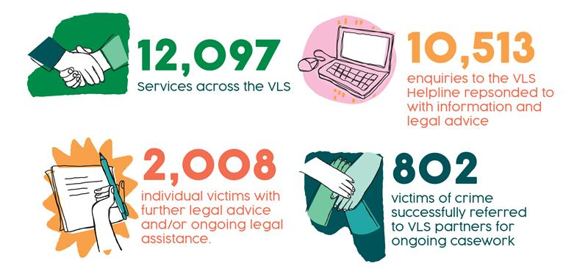

From its commencement in March 2023 until 31 January 2026, the VLS has provided 12,097 services including responding to 10,513 enquiries to the VLS Helpline with information and legal advice as well as providing 2,008 individual victims with further legal advice and/or ongoing legal assistance. This expansive reach and high volume of services have been delivered at a time of significant need for victims of crime including during a transition of Victorian schemes to enable access to financial assistance.
Through its specialist VLS Helpline and directly through VLS partners, including community legal centres, the VLS has provided over 7,000 information and/or referral services to victims of crime including warm referrals to VLS partners, other legal service providers and non-legal support organisations to victims of crime. This represents over 60% of the VLS’ services. The VLS has also provided more intensive assistance to victims of crime, including nearly 3,400 instances of detailed legal advice and over 1,000 ongoing legal casework services. Almost ten percent of the services provided by the VLS are for ongoing legal casework.

Reaching clients with the greatest barriers to access
A victim’s experience and response to crime is impacted by a range of factors including age, gender identity, ethnicity, culture, previous experiences of violence or trauma, social-economic status and social networks. Some groups within the community experience greater rates of victimisation and structural or systemic barriers to engaging with the legal system and accessing legal services. The VLS prioritises these groups for assistance. Detailed data on priority client access is recorded by each of the VLS partners and the VLS Helpline.
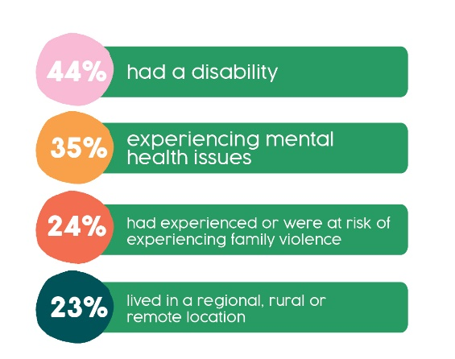
Of the victims we have supported, 44% reported having a disability, 35% reported experiencing mental health issues, 24% reported having experienced or being at risk of experiencing family violence and 23% lived in a region, rural and remote area.
Data collected by the VLS Helpline and partners demonstrates the reach of the VLS to victim-survivors who experience barriers to accessing legal assistance outlines further that 4.9% Older people (65+, 50+ Aboriginal or Torres Strait Islander), 6% Young People (18-24), 5% Children (0-17), 5.8% Language or Cultural barriers, 8% First Nations CLinets, 9% Experiencing homeslessness.
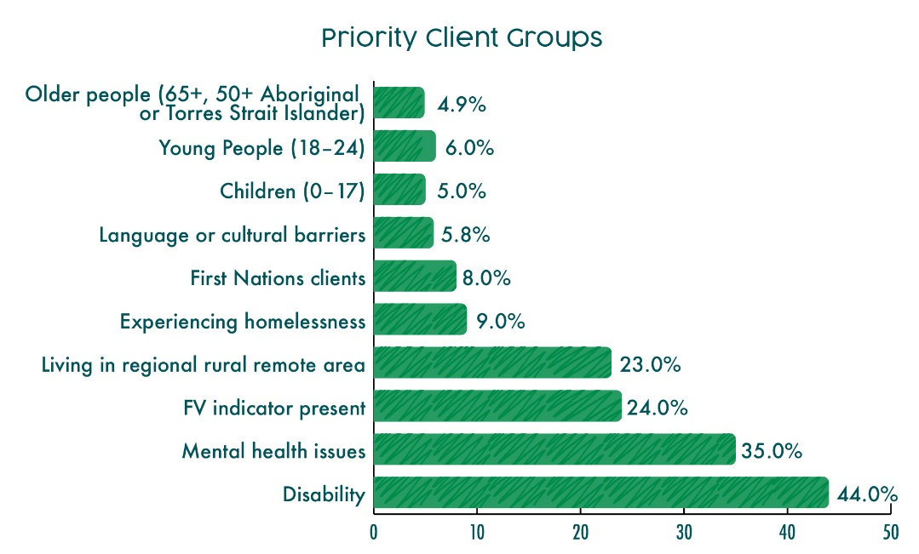

Increased demand from the community
Demand for assistance from the VLS Helpline has steadily increased year on year since commencement of the service in March 2023. In 2023, the VLS Helpline responded to 1,850 enquiries, in 2024 3,734 enquiries and 4,876 enquiries in 2025.
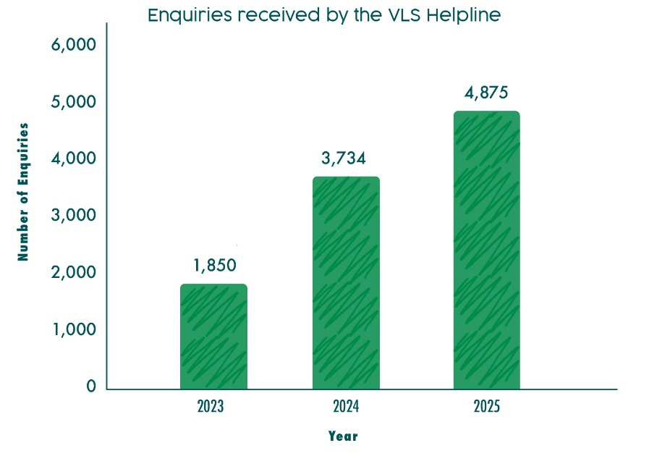
Demand for assistance has been significantly higher since the transition from the VOCAT to the FAS with the VLS recording the highest number of enquiries since the commencement of the FAS in November 2024.
The VLS Helpline received its highest average calls per month (445 calls) in the last six months from 1 July – 31 December 2025.
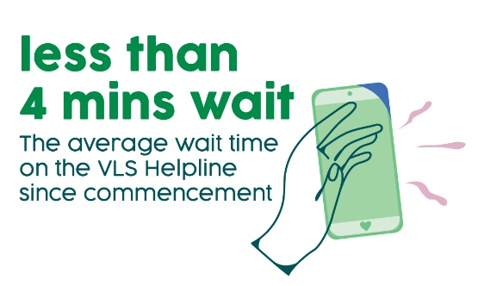
Responsive and timely for clients at time of need
The VLS Helpline is often the first point of contact a victim-survivor has with both the VLS and the legal system. As part of its trauma-informed model of service delivery, the VLS aims to keep wait times on the specialist VLS Helpline as low as possible. The average wait time on the VLS Helpline since commencement has been less than 4 mins. Help seekers who contact the VLS Helpline also have the option to seek a callback rather than wait in the queue with the callback occurring on the same day with the next available person.
VLS Helpline staff provide an in-depth triage covering the provision of legal information and advice so the victim-survivor understands their rights and options in relation to the crime, legal and non-legal referrals as appropriate and identification and referral for other legal issues if relevant. This is reflected in call length data captured by the Helpline with the average length of call between 17 and 21 minutes.

Outcomes for victims: moving towards healing and recovery
Financial assistance and compensation can be an important aspect for many victims on their path to recovery. Financial assistance can fund access to much needed health supports and provide economic security and other supports that might help a victim recover.
Victim-survivors assisted by the VLS regularly report financial assistance having helped them to find secure housing, provide care to their children, seek counselling, recover from trauma and provide them with options for their future including education and employment opportunities.
While financial outcomes provide only one measure of the impact of the VLS to support victims towards recovery, a snapshot analysis of financial assistance provided to VLS clients shows the significance of monetary outcomes.
A snapshot of 25 finalised matters shows the VLS has helped obtain over $380,000 in financial assistance for victim survivors since FAS commenced in November 2024.
This financial assistance has enabled victim-survivors access to vital supports including loss of earnings, safety related expenses, special financial assistance, counselling, medical services, psychiatry or psychology, and other expenses to support recovery and wellbeing. In addition, the receipt or offer of a victim recognition statement by FAS, acknowledging the harm done to the victim, offers validation and is often a key step towards recovery for victims of crime.

Meeting victim-survivors’ individual and intersecting needs

Through our trauma-informed processes
VLS processes are designed to ensure that victims of crime feel validated and heard, and that services are provided in a trauma informed way that is flexible and sensitive to victims’ needs. The VLS Helpline minimises the need for victim-survivors to re-tell their story or go through multiple referral pathways to find legal assistance through a ‘warm referral’ framework. At intake, the VLS Helpline undertakes a comprehensive triage process with the victim-survivor and when making a referral the VLS Helpline provides detailed information to the VLS partner (with client consent) to ensure the client doesn’t have to go over key information and keeps them informed of the progress of their referral. VLS service providers are committed to responding to referrals within 48 hours and also update a centralised database with capacity and eligibility criteria to streamline the referral process for victim-survivors.
The client story below highlights the benefits of the VLS’s specialist legal intake, advice and referral services.
Phillip and Charlie’s story: How one call can lead to multiple ways of helping
The VLS Helpline received a call from Phillip on behalf of his son Charlie (names have been changed) who had been a victim of sexual abuse. Phillip and his wife had commenced a FAS application on Charlie’s behalf without legal assistance but were struggling to gather and upload evidence of his injury onto the FAS system. Both Phillip and his wife were significantly impacted after learning of the abuse suffered by their child and his wife had since been diagnosed with Post Traumatic Stress Disorder (PTSD). During the call with the VLS Helpline, Phillip disclosed that the family had received a notice from a collection agency for unpaid bills, had gone into debt and that he had also fallen behind on a payment plan for infringements.
The VLS Helpline provided advice on FAS processes and how Phillip could provide evidence of Charlie’s injury. The VLS Helpline lawyer identified that both Phillip and his wife may be eligible for their own FAS assistance as secondary victims. Additionally, the VLS Helpline lawyer was able to give advice to Phillip about making an application for review in relation to the infringements and referred him to VLA’s Economic and Social Rights team for further assistance as well as providing him with an information email with details of financial counsellors.
Through the VLS’s warm referral process, Charlie was referred to a VLS partner CLC for specialist assistance in a way that reduced the load of both he and Phillip having to re-tell their stories at the next stage of their legal assistance journey.
All VLS lawyers undertake trauma-informed training and aim to deliver services in a culturally safe and trauma informed way. VLS lawyers aim to work in an integrated way with non-legal support services to support victim-survivors and shield them from further traumatisation. The words of VLS client, Jasmine, demonstrate the benefit of flexible, trauma informed service delivery and integrated assistance.
Jasmine’s story: VLS’s trauma-informed legal assistance
Jasmine (name has been changed) was referred by her existing VLA lawyer who was assisting her with other legal issues to a VLS lawyer within VLA. She experienced Attention-deficit Hyperactivity Disorder (ADHD) and PTSD. Her VLA VLS lawyer assisted her to apply for interim financial assistance and she was ultimately awarded approx. $59,000 to help her recovery from the impact of being a victim of family violence. She also received $3000 in special financial assistance in recognition of the significant harm she had endured.
Jasmine explained the impact of this assistance in her own words:
At the start of the process, I was completely overwhelmed. My trauma and ADHD make it really hard for me to deal with formal processes – they feel confusing and stressful. But my VLS lawyer made everything so much easier. She was really easy to talk to and helped me understand that what I had been through wasn’t okay – and that I was actually entitled to support.
She took the time to explain everything slowly, in a way that worked for me. I was able to ask questions and go at my own pace, which made a huge difference. I really appreciated that she was flexible and happy to do appointments over the phone – that made it so much more manageable for me.
The fact that my lawyer worked alongside my support worker was a game changer.
I felt truly supported, and it helped having someone else who understood the process and could remind me what steps I needed to take, especially on days when my ADHD or PTSD made it hard to concentrate. It also really helped that my VLS lawyer could collaborate with the other VLA lawyer I was working with on another matter. With my permission, they shared information, which made both processes smoother and less stressful for me.
The VOCAT award has had a big impact on my healing. I now have a car, less debt, and a home that actually works for me. I have funding for counselling and psychiatry in place, and for the first time in a long time, I feel optimistic about the future.
This journey has helped me get my life back on track. I’m now in a really good place to work towards getting my kids back.

Meeting our clients where their legal needs intersect
Victims of crime can experience clusters of intersecting legal needs which may be caused or exacerbated by their experience of crime. These legal needs can impact their safety, financial stability and ability to recover and can extend into areas of civil law, family law and other justice systems. While the VLS is only resourced to provide advice and assistance with FAS (and not other intersecting issues or wrap around support), victim-survivors accessing the VLS have been able to benefit from more wrap-around support as VLS partners, including CLCs and VLA, work in an integrated way with victim survivors.
Lida’s story highlights the often-interconnected legal issues experienced by victim-survivors.
Lida’s story: Being assisted with family violence, tenancy, fines, parenting arrangements and NDIS supports
Lida (name has been changed) is a 22-year-old woman who was referred to VLS partner, Northern CLC, by Safe Steps. Lida has a daughter in her care who has a disability and is on the NDIS.
Lida’s relationship with the other party commenced at the age of 16. He told her that he was 23 years old but was actually in his 30s. Throughout the relationship, Lida experienced significant family violence, including sexual abuse against her and her daughter and assaults causing injuries. There was also significant financial abuse. Lida was not able to have her own bank account, and he gambled away money from the NDIS account for the daughter. Lida also had significant fines in her name which he had forced her to take from him.
Following police taking out an IVO on her behalf, Lida had been accommodated by Safe Steps. Her legal needs include finalising the family violence intervention order, removing her name from the lease agreement of the rental property, getting the utilities out of her name which were in arrears, resolving the fines in her name that were accrued by him, addressing parenting arrangements, making a complaint to police in relation to the sexual assault, preventing him from accessing her daughter’s NDIS account, and accessing the Victims of Crime Financial Assistance Scheme.
Our assistance to victim-survivors through the VLS focuses on ensuring that clients are guided and supported to get help not just for their VLS related legal need. Our clients are also provided with clear referral pathways to wrap around legal assistance within the expertise of the VLS partners.

Partnering to better meet the needs of victim survivors

Strong relationships with Centres Against Sexual Assault (CASAs) and Victims Assistance Programs
All victims of crime have a range of needs in the aftermath of a crime and during the judicial process that follows, including the need to be supported, the need to access justice and the need for compensation and restoration. From our work with victim-survivors, we know that victims’ needs include the need for non-legal support, health supports and that victim needs can change over time. The VLS partners’ strong relationships with services that can support victims with their non legal and non-justice needs are a strength of our integrated way of practice. Not only does the VLS provide victim-survivors with specialist legal help so they can navigate complex legal systems and access financial assistance to heal, we also work closely with victim assistance programs and CASAs to ensure victims are linked in with other supports needed and available to them. Collaboration ensures clients receive specialised support and enables clients to receive the right type of assistance at the right time.
Juniper’s story shows the clear benefit to a client where their support partners are working closely together to provide wrap around support, through a relationship VLS partner, SMLS, has built with the South Eastern Centre Against Sexual Assault (SECASA) over almost 30 years, including through a health justice partnership.
Juniper’s story: Supported every step of the way
Juniper (name has been changed) is a young mother who had endured years of abuse from her husband, often in front of her children. She wanted the abuse to stop, fearing for her and her children’s lives should it escalate further. She decided to seek help and made several police reports. She wanted safety and a chance to rebuild her life.
She reached out to SECASA for support overcoming her trauma. SECASA identified that she could be eligible for financial assistance to help her recovery. SECASA referred Juniper to VLS partner, SMLS for specialist legal help.
When SMLS lawyers first spoke to Juniper, she was overwhelmed, exhausted and determined to create a safer future for herself and her children. Juniper said she needed support to recover from the trauma, regain her independence and feel stable again. She also wanted her experience to be recognised for its seriousness.
SMLS supported Juniper through the VOCAT process, including working with her to tell her story clearly and safely, gathering the evidence she needed, preparing her for the hearing and advocating strongly for the supports that would make the biggest difference to her recovery. This included help with living costs, counselling and practical tools that would let her move around safely with her children.
Juniper’s application was successful. She received almost $20,000 in assistance, including $10,000 in special financial assistance and funding for specialised transport so she could travel independently and keep her children safe. The Tribunal Member praised her courage and reminded Juniper that she does not carry the responsibility for the harm she endured at the hands of her husband.
Although the process felt heavy at times, Juniper said she felt supported every step of the way. The outcome gave her relief, validation and the resources she needed to begin rebuilding a safer, more stable life for her family.
In delivering the VLS, VALS works closely with Aboriginal Engagement Workers assisting victims in other support services to ensure referrals to VALS’ VLS program are straightforward, easy and reduce victims’ experiences of stress and anxiety. In the words of an Aboriginal Engagement Worker:
‘As an Aboriginal Engagement Worker who provides a culturally appropriate service, the VLS is the only culturally appropriate option I have. It’s a service I can vouch for with community and have never received a complaint about the VLS. It would be disappointing to lose this extremely useful service and would be a detriment to community and victims of crime in general.’

In community – providing place-based and statewide services
‘As a place-based service we often see people at their most vulnerable. They’re disconnected from government services and can often get lost in bigger systems. Instead, they look for the support they need within their immediate community. Integrated, localised assistance is vital for supporting these people when they need us most.’
Ashleigh Newman, Interim CEO, SMLS, VLS partner
Across the seven generalist CLCs that are VLS partners, and the statewide offering of VALS, Women’s Legal, Djirra and VLA, the VLS provides significant coverage for victims of crime seeking legal assistance. We see the tangible benefits of community legal centres within the VLS delivering place-based services through strong relationships with local organisations and networks, deep understanding of the needs of local communities and the ability to respond to dynamic changes in these communities. This is of particular importance for victim-survivors located in outer metropolitan and regional areas within Victoria, who have sought assistance from CLCs located in those areas. When considered alongside the statewide offering through VLA, Women’s Legal, VALS and Djirra, this model helps deliver tailored and accessible services to victims of crime.

Collaborative referrals that ensure greater access
As Jay and Lucille’s stories demonstrate, the ‘no wrong door’ approach of the VLS is crucial in ensuring victims do not fall through the ‘gaps’ and ensure coordination of wrap around support to victims through victim support services, specialist family violence or sexual assault service providers, Aboriginal Community Controlled Organisations, and community organisations.
Jay’s story: Referral through a health justice partnership
In late 2024 Jay (name has been changed) was referred from a Health Justice Partner, where VLS partner, Inner Melbourne Community Legal Centre (IMCL), has an existing weekly on site presence. Jay was the victim of sexual assault by an unknown offender. IMCL worked with Jay to ensure appropriate adjustments were made to our service delivery for communication.
Jay required legal assistance to engage with the FAS application system, including engagement with the police and other third parties on their behalf. This prevented Jay from being re-traumatised by any unscheduled contact from FAS directly, and allowed the lawyer to assist with further information requests.
Following the successful submission of Jay’s FAS application, Jay also had criminal charges on foot. The same lawyer who assisted with the FAS application, was skilled in criminal representation. The lawyer successfully advocated for the withdrawal of those criminal charges, using the information already provided by Jay to IMCL for the FAS application. Jay was spared re-telling their story to a different lawyer for their criminal matter.
IMCL was able to support Jay throughout the full FAS process, covering advice, information gathering, and third-party engagement.
This client’s journey would not have been possible without the existing partnerships, made strong by the ongoing training and engagement by IMCL to its partners. Further, Jay was able to provide evidence of their injuries and disabilities to just one lawyer, and this was used across both the FAS and criminal matters.
Lucille’s story: Integrated support between youth organisation and VLS partner enabled Lucille to engage with the FAS process
Lucille (name has been changed) was a warm referral to VLS partner, Women's Legal, from a youth organisation who supported her through a criminal matter regarding police misconduct.
The youth organisation and Women's Legal stayed in contact with Lucille throughout to facilitate a warm referral once the criminal matter was complete. This approach also meant that Lucille’s youth social worker could debrief with Women's Legal on Lucille’s ongoing non-legal needs, which were impacting her trauma presentation and capacity for self-advocacy.
Lucille’s age also factors into her ability to deal with her own legal matters. The integrated approach between the youth organisation and Women's Legal allowed substantive instructions to be shared, and relevant documents provided readily to assist with the drafting of Lucille’s FAS application.

Culturally safe and accessible services for First Nations victims
‘I don’t think I would have been able to navigate it [the FAS] without a lawyer, and I would have just never done it.’
Hannah (name has been changed), Djirra and VLS client
First Nations people are dramatically overrepresented as victims of crime yet under-represented as recipients of victim services. In 2024-2025, there was a 10% increase in Aboriginal victims of crime with 2,578 Aboriginal women in Victoria recorded as victims of crime in the last 12 months. These figures are likely to be a significant underestimation, with data suggesting that around 90% of violence against Aboriginal women and most cases of sexual abuse of Aboriginal children are undisclosed, due to barriers in reporting.
The VLS recognises the unique needs and experiences of First Nations victim-survivors, and in particular Aboriginal women, as a priority client group who face disproportionately high rates of violence alongside systemic barriers to reporting to police and accessing justice. In our first three years of operation, 898 services have been provided to clients across the VLS who identified as First Nations.
With VLS partners, Aboriginal Legal Service, VALS, and Aboriginal Family Violence and Prevention Legal Service, Djirra, First Nations victim-survivors are provided choice to access legal Aboriginal community-controlled legal services to assist them. VALS’s client, Melanie shares in her own words the importance of the trust-based relationship she experienced in being provided legal assistance by VALS.
Melanie’s story: ‘The VALS lawyer helping is one less stress on my journey’ (name has been changed)
The VALS lawyer helping is one less stress on my journey. It has really helped me not have to worry about my FAS application.
I have experienced so many years of family violence and I have also been homeless due to family violence. On my journey I need support, I know I can rely on VALS to guide me in this process, VALS is always there for me.
So, when I had other issues such as intervention orders, eviction notice, bond issues and license suspension I knew I could ask VALS for help.
Things are slowly getting better. I am now participating in some community panels, I have part time employment, I am finally securing housing in the next few weeks and also, I am beginning a university diploma course in March and I am still on my journey.
Djirra’s client Sarah’s story highlights the dual assistance that Djirra was able to provide her with navigating a claim for financial assistance as a victim of crime and obtaining a Family Violence Intervention Order, through its holistic and culturally safe service provision.
Sarah’s story: Djirra’s holistic and culturally safe support was critical
Sarah (name has been changed) first sought Djirra’s assistance with applying to the VOCAT for extreme and extensive family violence perpetrated against her by her former partner. This included threats to kill, physical abuse including non-fatal strangulation, property damage, financial, verbal and emotional abuse. Djirra supported Sarah to receive interim awards from VOCAT for counselling and safety expenses.
When the initial offer from VOCAT did not reflect the severity of her experiences, Sarah, supported by a Djirra lawyer, decided to withdraw her VOCAT application and instead apply under FAS.
Djirra submitted her application on Sarah’s behalf to FAS in April 2025, and a final outcome was received February 2026. At the same time, Djirra’s lawyer also assisted Sarah with a Family Violence Intervention Order against her former partner, ensuring she was not retraumatised by having to retell her story.
The final outcome Sarah received from FAS was for the maximum amount of special financial assistance available ($25,000), which was much greater than the award VOCAT offered her.
Sarah used the special financial assistance money to make necessary repairs to the house she still lived in with her children, so that her and her family no longer had the daily visual reminders of the significant damage caused by her former partner and the violence they suffered.
Sarah shared that she would not have been able to make the application without Djirra’s holistic, culturally safe support, particularly as she finds navigating technology and online systems – such as the FAS portal – difficult on her own.

A coordinated approach to training, engagement and systemic advocacy
The collaborative and coordinated model of the VLS is underpinned by a Working Group convened by the DJCS with VLS partners to oversee the implementation of the service, and a Community of Practice that brings together all VLS partner organisations.

Community of Practice
‘The Community of Practice has been an absolute godsend to lawyers within the VLS. Lawyers are incredibly stressed trying to navigate the FAS portal due to its constant glitches...The sheer workload is enormously stressful and having the Community of Practice makes all the difference, knowing we are all in the same position. Even as a very experienced VOCAT lawyer, who has found the transition to FAS much easier as a result than others, I absolutely love having the Community of Practice and look forward to our meetings. It is so good to brainstorm, share experiences and handy hints – as well as the sheer overwhelm of a very problematic system.’
Danielle Wisniak, Victims Legal Service Co-Ordinator
Northern CLC (VLS partner)
The Community of Practice brings together all VLS partners on a monthly basis and provides a forum to develop and share best practice in relation to service delivery, case management and trauma informed practice and facilitate opportunities for further learning and development through de-identified casework examples. Coordinated responses through the Community of Practice help identify and address emerging needs of victim-survivors and ensure clients do not fall through the service gaps. This kind of regular interaction ensures training needs are identified, new approaches can be discussed, and problem-solving is tackled collectively – ultimately creating a more cohesive and responsive service for victim survivors in Victoria.
The Community of Practice has been well placed to monitor the implementation of the FAS, identify emerging issues and trends and collaborate to formulate practical solutions for clients whilst also advocating for improvements to the scheme.
‘The Community of Practice meetings encourage open dialogue about specific issues that participants are facing. If someone is unsure about the legal implications of a case or needs guidance on dealing with complex trauma-related situations, they can bring it to the group. By openly discussing these challenges, everyone benefits from the collective expertise of the group. It’s a collaborative learning environment that helps ensure that clients’ needs are met with well-rounded, informed solutions.’
Leanne Bosman & Shivana Rajendran, Mallee Family Care (VLS partner)

Benefit of collaborative advocacy and engagement
The VLS has an important role to play in informing and embedding cultural change across legal services and the justice system. Drawing on their considerable practice experience, in 2024 the VLS partners made a joint submission to the Australian Law Reform Commission’s (ALRC) Inquiry into Justice Responses to Sexual Violence, emphasising the role of trauma-informed, specialist legal assistance in promoting just outcomes and improving the experience of the justice system for victim-survivors of sexual violence and advocating for improved court processes, systemic reforms and targeted support.
The Commonwealth pilot of the VLS was recognised in the ALRC’s Final Report as a program making meaningful strides to address key causes of secondary victimisation of victim survivors of sexual assault by the justice system.
Through the collaborative partnership model, the VLS has advocated for improvements to the operation of the FAS. From June to December 2025, the Community of Practice highlighted issues with FAS and identified opportunities for improvement with regular reporting from the Community of Practice to the VLS Working Group. The VLS has also had collective input and engagement through membership of the FAS Advisory Group, including a joint submission in October 2025 identifying issues with the FAS portal and offering potential solutions. VLS representation on the FAS Advisory Group, along with other key stakeholders, continues to help guide improvements to the new scheme. The VLS Community of Practice will be making submissions to the Independent Review of the FAS which is due to be finalised in November 2026.
Through this collaborative advocacy, the VLS has been able to provide coordinated feedback to support continuous improvement and reform that responds to the needs and experiences of victim-survivors engaged with the scheme.

The future for specialist legal assistance for victim-survivors in Victoria

Unmet legal need
Demand for the VLS consistently exceeds VLS partner services’ capacity and forecast demand. To track unmet legal need, since February 2024, VLA has been recording the number of help seekers who sought assistance from the VLS Helpline and who would have been eligible for a referral to a VLS partner for more intensive assistance, but who were unable to be referred due to lack of capacity.
In total, since we commenced recording this data in February 2024 to January 2026, 727 victim survivors who would otherwise have been eligible for more intensive legal assistance have been unable to receive it due to limited capacity within the VLS. For these clients, after the VLS Helpline has provided information or advice, the only option is to provide contact information for non-VLS CLCs or private practitioners. Both of these alternative service options are also struggling to keep up with demand, including a number of CLCs who are not currently funded to provide assistance with FAS matters. A number of private practitioners who previously undertook this work are also stepping back from this service provision since the commencement of FAS due to processing delays and a reduction in legal costs. In the absence of adequate government funding for specialist legal services, many victims of crime cannot access critical services because of limited program scope and capacity. This impacts the most disadvantaged in the community, and risks leaving them without support to navigate an overwhelming criminal justice system and recover from the devastating impacts of crime.
Resourcing for the VLS is limited, with most VLS service partners only funded for a part-time lawyer dedicated to this work and no confirmation of funding beyond the current funding period (currently due to end June 2026). The uncertainty and short-term nature of this funding can constrain the legal assistance sector’s capacity to engage in important, long-term planning. Due to our experience in providing services in uncertain funding environments, we know uncertainty leads to service disruption, loss of key staff and reduces the critical reach of services to communities, resulting in people being unable to rely on crucial services from year to year.
Due to the resourcing constraints, VLS partners are frequently at capacity and unable to accept new referrals for ongoing legal casework. For victim-survivors having to navigate complex legal processes alone, this may mean they give-up pursuing their rights. VLS service partners have managed capacity constraints through pausing referrals for periods of time or limiting the number of referrals they can accept from the VLS Helpline each week while demand for the VLS Helpline has been steadily increasing since commencement of the service.
In addition to continuing the funding for the VLS in Victoria, the high demand for current services should be considered in informing decisions about adequately meeting the legal needs of victim-survivors across the state. In terms of local presence, there is only funding for part-time lawyers required to service large catchment areas, such as the Gippsland region, Melbourne's East (including Boroondara, Knox, Manningham, Maroondah, Whitehorse and Yarra Ranges) and Northern suburbs (including Hume City Council, Merri-bek City Council, Banyule Council, Nillumbik Shire Council, City of Whittlesea, Yarra City Council and Mitchell Shire Council). CLC VLS partners beyond these geographical regions are also stretched with current demand and other geographical regions in Victoria have very limited dedicated coverage (eg, Melbourne’s West).

Need for more comprehensive legal assistance for victims’ needs
The establishment of a specialist and comprehensive victims legal service that focuses on the substantive legal entitlements of victim-survivors has been a key recommendation of multiple inquiries and research focused on the experiences of the justice system by victim-survivors.
The VLS is a collaborative, whole of legal sector service model, the design of which was informed by victim-survivors, including key groups who have specific needs and/or experience structural barriers to accessing the justice system. However, the scope of the funded services remains narrow, and we see directly the need to invest in more comprehensive and ongoing legal services for victim-survivors to support them to understand and exercise their rights and options. Inquiries have found that victim-survivors of sexual violence need legal advice and assistance to ensure they can exercise their rights and protect their interests including rights and privileges in relation to evidence, their rights to privacy in relation to disclosures of personal information in criminal proceedings and implications of taking part in restorative justice.
We also see the need for non-legal advocates or allied professionals, as recommended by the Victorian Law Reform Commission (VLRC), to provide support for victim-survivors across services and legal systems, including to provide information about justice options, help victim-survivors understand and exercise their rights, facilitate referrals and advocate for victim-survivors in services and across legal systems.
Additional funding for both frontline staff and enhanced co-ordination are vital to equip the VLS to meet the existing and future legal need of victim-survivors.

Continued investment in the VLS is critical for the ongoing success of the FAS
The FAS represents the most significant investment in victim services in decades and was a highly anticipated reform by both stakeholders and victims.
VLS partners have long advocated for a more victim-centric model of financial assistance and continue to work closely with government to support FAS to function at its best. The VLS is the primary referral pathway for victims to the FAS and ensures that victims, especially those with complex matters, are given access to free, consistent and quality advice on accessing the scheme.
Through our work with victim-survivors, we know that, even once FAS is working effectively, there will always be victim-survivors who need specialist legal assistance to understand and navigate their rights and entitlements.
Victim-survivors assisted through the VLS face a range of barriers and complexity in navigating the application process. Examples include: victim-survivors whose application is out of time, who have a prior criminal history or character considerations, who have experienced multiple acts of violence over a period of time (eg, family violence), who have not reported to the police and/or who are experiencing systemic barriers including language or cultural barriers, low literacy and/or low tech literacy, complex trauma, disability and mental health issues.
Throughout the transition to FAS, demand for assistance from the VLS Helpline has been significantly higher than it was under VOCAT. Enquiries to the VLS Helpline often come from victim-survivors who have attempted to engage with the FAS process themselves but have been unable to progress or complete their applications. VLS lawyers report that they frequently assist victim-survivors who have given up on the FAS process, preferring to forego the support they may be eligible for rather than jeopardise their mental health.
One of the biggest barriers to accessing FAS is that the system is completely online via a portal with no translation available. It also requires the capacity to set up online accounts, have an email address and have access to ID documentation. Many VLS clients do not have these capacities, including those who are fleeing family violence and do not have access to ID documents, those who speak English as a second language, have low literacy or tech literacy and have no or limited access to a computer or internet connection. These barriers are insurmountable without legal assistance.
Further, the high evidentiary threshold under FAS puts clients who have already experienced trauma in a position where it is highly likely they will be re-traumatised by engaging with the FAS application process. For example, victim-survivors must deal directly with police to obtain their own statements, which for some victim-survivors can be re-traumatising, or they may be required to go through a Freedom of Information process which is both confusing and time consuming. As has been clear through the stories shared in this report, clients are often dealing with a FAS application whilst navigating multiple other legal issues and court processes, leaving them at high risk of disengaging both with the FAS and with the justice system.
Dr Andrew Clarke illustrates how this plays out for many clients at Allied Justice, a place-based CLC in regional Victoria:
‘Our clients are vulnerable in a number of respects – elderly, isolated, and low socio-economic status being among the factors. FAS pre-supposes a high degree of literacy – in terms of understanding legal and technical terms; competent use of the computer, and so forth.
The FAS application process is complex and tricky for well-educated members of the public to navigate. For vulnerable clients it is impossible.
These are people who are traumatised and suffering; there is a jarring effect for a person who is the victim of a violent crime to be expected to engage with a complex, wordy, technical, closed loop application process. These are the very people who require assistance and advocacy to make their cases fully and robustly.’
Dr Andrew Clarke, Senior Lawyer
Allied Justice (VLS partner)
The VLS supports victim-survivors whose applications have merit and who require additional assistance to complete the application process. For these clients, receiving victims’ assistance has the potential to prevent homelessness, further exposure to violence, financial destitution and/or further health issues. Timely access to financial assistance reduces the compounding effects of financial stress and supports clients during critical periods following victimisation, allowing them to focus on recovery and long-term stability.
George and Mia’s stories below highlight the importance of legal assistance for clients with FAS applications.
George’s story: Legal assistance crucial to overcome barriers linked to ABI, literacy and a lack of technology
George (name has been changed), a Mallee Family Care client, is a man in his 50s who suffered significant trauma from an assault. Due to an acquired brain injury (ABI), literacy challenges, and lack of access to technology, legal assistance was crucial for him to complete and submit his online FAS application.
Without this support, he would not have been able to navigate the process on his own. Additionally, he sought legal advice regarding a tenancy issue and a civil matter related to an unpaid loan. He received assistance with these general legal concerns. The application has been submitted and is currently in the ‘submitted’ phase.
Mia’s story in her own words (name has been changed)
I remember calling VOCAT back in 2024 to ask about making an application. But I felt really intimidated and was not able to complete that application and so it lapsed. Now that I have been able to get assistance from VALS [the VLS lawyer] I have someone to help me with the process.
Without the VALS [VLS] lawyer calling me regularly to help with the steps I would not be able to manage to make an application. I feel like I developed at a slower rate than other people my age due to trauma and this makes it really hard for me to do this type of thing on my own.
If victims with complex needs are unable to access support through the VLS to make comprehensive, quality applications, in addition to the impacts for victim-survivors and their families, this will likely result in processing delays, creating additional pressures for the FAS, as it will be required to seek further information directly from victims. It risks undermining the effectiveness of FAS and of the government’s commitment to delivering a more victim-centric FAS for Victorian victims of crime.

Justice system needs to better respond to victims’ experiences in a trauma informed and culturally safe manner
Victim-survivors continue to experience re-traumatisation and a lack of cultural safety in their experiences with justice and related systems following their experiences of crime.
Ensuring that reforms to justice responses are trauma-informed can support access and engagement with the justice system. On the other hand, if justice responses are not trauma-informed, they may cause further harm. We see victim-survivors through the VLS who have had other traumatising experiences in their interactions with the justice system and related agencies, including in reporting crimes, that often limit their ability to participate with the proactive steps needed to seek financial assistance or respond to a confidential communications related matter.
Victims of crime continue to experience significant barriers to accessing and engaging with the justice system including caused by past experiences, a lack of information and support, a lack of trust and concerns about further harm. By addressing these barriers including through making sure there is meaningful opportunity to engage with the justice system, more support, better treatment if someone chooses to engage and more pathways for seeking a justice outcome, victim-survivors could be supported to better engage with the justice system and their access to justice could be significantly increased.
These reforms have been long advocated for by our partners in the sexual assault services sector and directly by victim-survivor advocates. We join their call for reforms to the justice system that make it safer, more trauma-informed, more able to meet the diverse justice needs of victims and more culturally safe. These reforms are crucial for improving victims’ experiences of the justice system and supporting them in their recovery.

Opportunity and promise provided by the VLS
Through the VLS, we have seen the strengths of a coordinated service model as outlined in this report. This service model has a role to play in informing and embedding cultural change across legal services and the justice system.
In contemplating future funding and service models for victim-survivors, governments should invest in both frontline staff and service coordination to continue and extend the benefits observed through Victoria’s VLS.

$7.3 million was announced in the 2021/22 Victorian budget to establish a new, dedicated VLS up until June 2025. A further $3.2 million was announced in the 2025/26 Victorian budget to extend the operation of the VLS for a further 12 months. This funding currently ends in June 2026.
Victims Legal Service | victimsofcrime.vic.gov.au.
$381,558 over 25 finalised matters. We note that due to the manual nature of the process, this analysis was limited to 25 finalised matters (i.e. not all matters finalised through the VLS), so it is not an exhaustive account of the amounts of financial assistance achieved through the VLS, which would be significantly higher.
A total of 20.1 FTE (staff) funded in 2025/2026 to deliver services across the VLS Helpline and VLS partners.
To track unmet legal need, since February 2024, VLA has been recording the number of help seekers who sought assistance from the VLS Helpline and who would have been eligible for a referral to a VLS partner for more intensive assistance, but who were unable to be referred due to lack of capacity. This has included where there were no alternative VLS partners who had capacity or the client did not meet the eligibility criteria where a VLS partner did have capacity (for example, the help seeker was not a victim of family violence or they were not women or non-binary where these were eligibility criteria). Data is February 2024 – January 2026 (noting a gap in manual data collection for four months, from July – October 2025 due to resourcing constraints).
As considered and recommended by a series of reports and inquiries (see page 24 below). We note that the VLS also includes a Commonwealth funded pilot assisting victim-survivors of sexual assault with confidential communications matters (discussed below).
See, eg, Victorian Law Reform Commission, The Role of Victims of Crime in the Criminal Trial Process (Report No.34), August 2016, recommendation 34; Sentencing Advisory Council, Restitution and Compensation Orders: Report (October 2018) 99, recommendation 8; Centre for Innovative Justice, Strengthening Victoria’s Victim Support System: Victim Services Review (Final Report, November 2020), 149; Victorian Law Reform Commission, Improving the Justice System Responses to Sexual Offences, (Report No. 42) September 2021, recommendation 46; Victims of Crime Commissioner, Silenced and Sidelined: Systemic inquiry into victims participation in the justice system, November 2023, recommendation 21.
When the VLS first commenced, assistance was provided through the Victims of Crime Assistance Tribunal (VOCAT) when it operated until its transition to the FAS in November 2024.
The protections for victim-survivors in relation to confidential communications made to health and counselling professionals were strengthened in response to the VLRC Sexual Offences Report. These stronger protections commenced in July 2023, including an expanded definition of confidential communications to include health information, a positive obligation on the prosecuting party to provide notice of an application to a victim-survivor and a right for victim-survivors to appear and make submissions. In the 2022-23 Budget, the Australian Government announced $8.4 million in funding over three years to pilot specialised and trauma-informed legal services for victims of sexual offences in three locations across Australia. Victoria, alongside Western Australia and the Australian Capital Territory, was selected as one of three jurisdictions for the pilots. From 2026, these pilots will be extended and expanded across Australia. See Supporting victims and survivors of sexual violence - piloting new legal services models | Our ministers – Attorney-General’s portfolio (ag.gov.au). Until the funding for the Commonwealth pilot, there was no access to legal assistance to support victim-survivors to understand or exercise their rights under these strengthened provisions. See also Albanese Government strengthening support for victims and survivors in the justice system | Department of Social Services Ministers.
See Victims Legal Service | victimsofcrime.vic.gov.au.
We also assist victims to oppose applications under s 32C of the Evidence (Miscellaneous Provisions) Act 1958 (Vic) to adduce evidence (compared to applications for leave to issue a subpoena regarding records).
The design process coordinated by the Department of Justice and Community Safety (DJCS) included representatives from the Victims of Crime Consultative Committee (VOCC).
From commencement of the service on 14 March 2023 up until 31 January 2026.
7131 Information or Referral Services from March 2023 and up to 30 June 2025.
3,365 Discrete Assistance Services and 1,079 ongoing legal casework services from March 2023 until 30 June 2025.
We note that that an individual victim-survivor may experience multiple barriers and therefore may fall into multiple priority client groups.
Percentages in the graph represent the percentage of the overall service count where a client has advised that they are part of a priority client group rather than a percentage of the overall individual client count. It should be noted that an individual client may fall into a number of priority client groups and may also receive a number of services. Further, the VLS aims to keep robust data on clients accessing the service but in keeping with trauma informed principles balances this with consideration of how much information the victim may feel comfortable providing.
2161 enquires just before and post FAS commencement (1 July-31 December 2024), 2511 enquiries (1 January – 30 June 2025) and 2365 enquiries (1 July – 31 December 2025) post FAS commencement compared to 1573 enquiries (1 January – 30 June 2024), 1168 enquiries (1 July – 31 December 2024).
$381,558 from 25 finalised matters. We note that due to the manual nature of the process, this analysis was limited to 25 finalised matters (i.e. not all matters finalised through the VLS), so it is not an exhaustive account of the amounts of financial assistance achieved through the VLS, which would be significantly higher.
A lump sum payment made to a primary victim who has experienced a significant adverse effect as a direct result of an act of violence. The amount awarded is determined by the criminal charges (or what they would have been if the offender hasn’t been charged) which determines into which category (A, B, C or D) the act of violence falls. There is a minimum and maximum amount for each category and FAS determines the amount within this band. Sometimes FAS will uplift the special financial assistance into a higher category, for example if the victim was a child or if the injuries are very severe, e.g. permanent disfigurement.
See Victorian Law Reform Commission, Review of the Victims of Crime Assistance Act 1996: supplementary Consultation Paper (2017), Chapter 13: The needs of victims of crime
Centre for Innovative Justice, Strengthening Victoria’s Victim Support System: Victim Services Review (Final Report, November 2020) 11, 73. Centre for Innovative Justice in partnership with Djirra, Elizabeth Morgan House Aboriginal Women’s Service and Dadi Munwurro, Ensuring that Aboriginal perspectives inform responses to Aboriginal victims (Final Report, November 2024).
See Aboriginal Justice Indicators Dashboard 2024-2025 produced by the Crime Statistics Agency (CSA): https://www.crimestatistics.vic.gov.au/crime-statistics/latest -aboriginal-crime-data/aboriginal-justice-indicators-dashboard.
Australian Institute of Health and Welfare, Aboriginal and Torres Strait Islander people - Australian Institute of Health and Welfare (Webpage, 2024)
See ‘A joint submission from partners in Victoria’s Victims Legal Service to the 2024 ALRC inquiry into justice responses to sexual violence’ (2024).
Australian Law Reform Commission, Safe, Informed, Supported: Reforming Justice Responses to Sexual Violence, ALRC Final Report 143, January 2025, 129.
This has included where there were no alternative VLS partners who had capacity or the client did not meet the eligibility criteria where a VLS partner did have capacity (for example, the help seeker was not a victim of family violence or they were not female where these were eligibility criteria).
We note a gap in data collection occurred for four months, from July – October 2025 due to staff turnover in the VLS Helpline and the manual requirements of recording this data.
Both VOCAT and now FAS have experienced delays in progressing applications, which has also affected capacity of the VLS to take on new referrals (because existing files remain open and unresolved for long periods of time).
Victorian Law Reform Commission, The Role of Victims of Crime in the Criminal Trial Process (Report No.34), August 2016, recommendation 34. Sentencing Advisory Council, Restitution and Compensation Orders: Report (October 2018) 99, recommendation 8; Centre for Innovative Justice, Strengthening Victoria’s Victim Support System: Victim Services Review (Final Report, November 2020), 149; Victorian Law Reform Commission, Improving the Justice System Responses to Sexual Offences, (Report No. 42) September 2021, recommendation 46; Victims of Crime Commissioner, Silenced and Sidelined: Systemic inquiry into victims participation in the justice system, November 2023, recommendation 21.
See VLRC Improving the Justice System Response to Sexual Offences (2021), Chapter 12: Supporting people who have experienced sexual violence for further discussion, including regarding legal assistance in relation to confidential communications, access to intermediaries, options for compensation and restorative justice.
As above, we note that the Confidential Communications reforms in Victoria which commenced in July 2023, including an expanded definition of confidential communications to include health information, a positive obligation on the prosecuting party to provide notice of an application to a victim-survivor and a right for victim-survivors to appear and make submissions
See VLRC Improving the Justice System Response to Sexual Offences (2021), Chapter 12: Supporting people who have experienced sexual violence for further discussion
Ibid, recommendation 45. See also Sexual Assault Services Victoria, Justice Navigator Pilot (Justice Navigator pilot — Sexual Assault Services Victoria).
When deciding whether to pay assistance to an applicant, or how much to pay, the FAS must take into account an applicant's character, behaviour and attitude (including primary, secondary or related victims or applicants in funeral application) and the criminal history of primary, secondary, related and deceased primary victims.
Australian Law Reform Commission, Safe, Informed, Supported: Reforming Justice Responses to Sexual Violence, ALRC Summary Report 143, January 2025, 11.
Ibid.

