Family Law Legal Aid Services Review
Consultation and Options Paper

January 2015

© 2026 Victoria Legal Aid. Reproduction without express written permission is prohibited. Written requests should be directed to Victoria Legal Aid, Research and Communications, 350 Queen Street, Melbourne Vic 3000.
Disclaimer. The material in this publication should not be relied upon as legal advice, and should be checked carefully before being relied upon in any context. Victoria Legal Aid expressly disclaims any liability howsoever caused to any person in respect of any legal advice given or any action taken in reliance on the contents of the publication.
Contents

Family Law Legal Aid Services Review 2
January 2015 2
© 2021 Victoria Legal Aid. Reproduction without express written permission is prohibited. Written requests should be directed to Victoria Legal Aid, Research and Communications, 350 Queen Street, Melbourne Vic 3000. 3
Executive summary 4
About Victoria Legal Aid 9
About this consultation 9
About this paper 11
How to make a submission 12
Abbreviations 14
Issues and options for reform 15
Appendix 1 49

Executive summary
Victoria Legal Aid (VLA) is undertaking a Family Law Legal Aid Services Review (the Review) to ensure that family law legal aid services are fair, as widely available as possible, and sustainable. The focus of the Review is to consider how VLA can consolidate what it is getting right in its approach to family law legal aid services, and to identify and address areas where service delivery is not efficient, of a high enough standard, or targeted to the right clients. It is not an objective to reduce the overall amount spent on family law matters but rather to utilise the available funds in the most effective and efficient manner. The Review is primarily concerned with legal aid services provided for legal problems that are dealt with in the Commonwealth family law jurisdiction.
This Consultation and Options Paper is the second stage of an ongoing review process. The first stage of the Review involved mapping VLA family law services, identifying opportunities for improvement, and undertaking preliminary discussions with key stakeholders to elicit their insights about how services might work better. Key issues identified in this first stage are detailed in this paper, and are accompanied by a number of options for reform. Key issues and options are summarised below.
Members of the public and other stakeholders are invited to make written submissions in response to this Consultation and Options Paper. Your feedback in relation to some or all of the options will help shape our thinking about what changes to progress.
This paper is structured around themes that were identified as important as part of the consultation process. These themes take you through a client’s journey in the family law system from access and intake and the nature of legal aid clients to early intervention and litigation. The paper then also addresses issues around self-represented litigants and specific areas of family law such as child support, financial and property matters and the representation of children’s interests through Independent Children’s Lawyers.
Submissions are due by Monday 16 February 2015.

Access and intake
There are a number of ways that members of the community can access family law legal aid services. Preliminary consultations with various stakeholders indicate that:
- some existing access points are not as widely known about as they could be
- non-legal service providers could be better supported to identify their clients’ legal issues and make appropriate referrals into legal services
- high client intake locations, such as the Magistrates’ Courts family violence jurisdiction, could be better utilised to ensure pathways into legal help for broader family law issues.
Option 1: Better promote existing Legal Help and duty lawyer services and actively expand outreach.
Option 2: Develop a family law screening tool for community and support workers.
Option 3: Develop referral or other tools for lawyers to support better identification of relevant non-legal services for clients and better referral of clients to these services where appropriate.
Option 4: Enhance intake opportunities at Magistrates’ Courts for clients with family law legal need.

Vulnerable clients
It is now well documented that some members of the community are particularly vulnerable to experiencing multiple legal problems, and face the most significant barriers to accessing legal services. Stakeholders consulted for this Review agreed that it is important to target legal services to the most vulnerable. Stakeholders emphasised the importance of warm referrals to and from other service providers and outreach for vulnerable clients, and support for culturally appropriate provision of legal services.
Option 5: Develop closer partnerships with the Victorian Aboriginal and Torres Strait Islander legal services to meet unmet demand for family law services in Aboriginal communities.
Option 6: Undertake a ‘continuity of service delivery’ pilot for high needs clients, in partnership with community legal centres.
Option 7: Expand VLA’s Settled and Safe program across Victoria.
Option 8: Deliver training on related areas of law to family law practitioners, so that they can better assist clients and provide appropriate advice and referrals.

Early intervention
A key theme that emerged during stage 1 of this Review was the importance of networked relationships across legal and non-legal support services to ensure that clients with family law issues can access the right kind of help at the earliest possible opportunity. In addition to supporting non-legal service providers to make appropriate referrals, and providing place-based service delivery, stakeholders identified greater use of technology to expand the reach of legal information and education, and grant funding for early advice and negotiation to resolve some family law disputes, as possible early intervention strategies.
Option 9: Develop and deliver an education program for non-legal support workers to assist clients to identify pathways for resolution of family law matters.
Option 10: Expand and diversify family law legal information.
Option 11: Provide more outreach services at points of early contact for clients.
Option 12: Re-introduce an advice and negotiation grant for limited matters.

Family dispute resolution
There was consensus among stakeholders that VLA’s legally-assisted family dispute resolution (FDR) service, Roundtable Dispute Management (RDM), is a valuable service. Issues were raised about:
- eligibility for the RDM service
- intake into RDM
- the timing of RDM
- some lawyers’ approach to RDM conferences
- ensuring culturally responsive RDM services
- the relationship between RDM and legal services provided for parties undertaking family mediation at other FDR services such as Family Relationship Centres (FRCs).
Option 13: Require parties to exchange a short summary of the issues in dispute prior to a Roundtable Dispute Management conference.
Option 14: Make payment of the preparation component of the family law dispute resolution grant contingent on proof of preparation.
Option 15: Conduct a thorough examination of the value of VLA trialling a new legal service at one or more Family Relationship Centres, including an evaluation of previous pilots of legal assistance to clients of FRCs and review of current new service arrangements.
Option 16: Expand eligibility for the Roundtable Dispute Management service to include:
- matters in which there has been or is a risk of family violence (ie. both victims and perpetrators could be eligible)
- where a party is not seeing their child.
Option 17: Pilot an expanded duty lawyer (or Family Law Legal Service-type) scheme to represent clients at Roundtable Dispute Management (including clients currently eligible for a grant of aid) to determine if such a scheme is effective and economic, and enables greater numbers of clients to access RDM (and/or frees up legal aid resources to fund other options canvassed elsewhere in this paper).
Option 18: Develop and implement a culturally responsive framework for family dispute resolution provision at Roundtable Dispute Management, in collaboration with community-based and academic partners.

Litigation
A number of stakeholders raised concerns relevant to legal assistance for parties to initiate, respond to and conduct family law court proceedings, in particular:
- eligibility restrictions on legal aid funding in relation to responding to court applications, contravention of orders and representation at final hearings
- the complexity of some of the family law eligibility guidelines
- the quality of some of the legal work completed under litigation grants of aid.
Option 19: Priority for litigation funding be given to matters where:
- The client has a particular vulnerability, such as a mental health issue, cognitive impairment, language barrier, literacy issues, drug and alcohol issues, or an acquired brain injury;
- The matter involves allegations of family violence and/or child abuse, where the outcome of the matter would significantly impact the relationship between a parent and the child/ren because one parent is likely to have limited or no time with the child/ren or there is likely to be a change in residence; and/or
- The proposal or conduct of a party substantially prejudices the ability of a child to maintain a meaningful relationship with one or both parents.
Option 20: Remove the guideline restricting funding for representation at final hearing for clients otherwise eligible for litigation funding.
Option 21: Establish a reference group that includes private practitioners, community legal centres and VLA staff lawyers to review grant guidelines related to family law dispute resolution and litigation and make recommendations about:
- Re-drafting the guidelines so that they are easier to understand and apply.
- Re-drafting the guidelines to reflect the case management and hearing models of the Family Law Courts.
- Developing checklists to assist practitioners in applying for grants of aid and assessment of the merits of a matter.
Option 22: Conduct a court ordered mediation pilot.
Option 23: Remove the funding requirement that respondents to a court application may only be granted aid to seek an adjournment.
Option 24: Amend the guideline removing eligibility for aid, so that it does not exclude funding on the basis of breaches of Victorian family violence safety notices or intervention orders.
Option 25: Establish a working group that includes private practitioners, community legal centres and VLA staff lawyers to develop a suite of quality tools to assist practitioners in the preparation of matters for hearing.
Option 26: Divide the current preparation fee into two components:
- An evidence analysis, merits assessment and case strategy fee ($534 being three hours at $178.00) to cover the work involved for a lawyer or barrister undertaking this assessment;
- The remainder of the fee to be a general lump sum fee to cover the other general preparation undertaken by a lawyer.
Option 27: Introduce a certificate of readiness for final hearing.
Option 28: Establish a preferred list of barristers to be briefed in legally aided family law matters.

Duty lawyers
Feedback from stakeholders during preliminary consultations suggests that the work of duty lawyers is highly valued. Adjustments to the duty lawyer service could make it more strategic and efficient.
Option 29: Pilot a duty lawyer service modelled on the Legal Aid NSW Early Intervention Unit.
Option 30: Pilot an expanded duty lawyer service modelled on the QPILCH Self Representation Service (Courts) model.
Option 31: Maintain the current duty lawyer service model, with the addition of Information and Referral Officers at Court to triage matters before the duty lawyer sees the client and/or make referrals for clients after seeing the duty lawyer.

Self-represented litigants
Self-represented litigants (SRLs) are often stated to present an efficiency issue for the courts and a risk of unjust outcomes in family law matters. Stakeholders generally agreed that services should be available to assist SRLs and that the current service response to SRLs could be better coordinated.
Option 32: Review information and resources provided by VLA, other Legal Aid Commissions, community legal centres and the Family Law Courts to support self-represented litigants, to identify and address gaps.
Option 33: Pilot a QPILCH-type service model for providing additional discrete task assistance to self-represented litigants.
Option 34: Consider establishing a student clinic model for providing discrete task assistance to self-represented litigants.

Child support, financial and property matters
The general consensus among stakeholders consulted for this Review was that current child support legal services operate effectively and do not need to be changed. Stakeholders contributed a mix of views about whether other financial and property matters should be more broadly funded and in what circumstances, and in relation to the availability of Roundtable Dispute Management for property matters.
Option 35: Re-introduce litigation grants for property matters when the dispute also involves children and where the only asset is superannuation.
Option 36: Re-introduce litigation grants for property matters when the dispute also involves children, where the parent is seeking to retain the family home and will receive no payment, and/or where the matter involves a superannuation split or a pool of equity less than $50,000 (including superannuation).
Option 37: Remove the current limited grant funding available for property matters at Roundtable Dispute Management.

Independent children’s lawyers
Feedback received about Independent Children’s Lawyers (ICLs) during preliminary consultations was generally positive, particularly in relation to the quality of ICLs’ work. Some concerns were expressed about the guideline that requires ICLs to appear as solicitor advocates in final hearings. ICLs provided feedback that a fee for instructing in complicated matters, and grants for disbursements, should be considered.
Option 38: Introduce a limited grant for Independent Children’s Lawyers to instruct in proceedings.
Option 39: Amend the current guideline to continue to allow for, but no longer require, Independent Children’s Lawyers to appear at final hearing as solicitor advocates.
Option 40: Introduce a grant for disbursements for Independent Children’s Lawyers seeking assessment reports, applicable where legally aided parties or self-represented litigants are unable to pay the cost of the report.

About Victoria Legal Aid
Victoria Legal Aid (VLA) is an independent statutory authority established to:
- provide legal aid in the most effective, economic and efficient manner
- manage our resources to make legal aid available at a reasonable cost to the community and on an equitable basis throughout the state
- provide improved access to justice and legal remedies
- pursue innovative means of providing legal aid to minimise the need for individual legal services in the community.
VLA helps people with legal problems involving family breakdown, child protection, family violence, criminal matters, social security, mental health, discrimination, guardianship and administration, fines, immigration, tenancy and debt. We provide:
- free legal information through our website, our Legal Help telephone service, community legal education (CLE), publications and other resources
- legal advice and minor assistance through our Legal Help telephone service, duty lawyer service and advice appointments on specific legal issues
- grants of legal aid to pay for legal representation by a lawyer in private practice or a VLA staff lawyer.
Our clients are people who are socially and economically disadvantaged, people with a disability or mental illness, children, the elderly, people from culturally and linguistically diverse (CALD) backgrounds and those who live in remote areas.
In addition to helping people resolve their legal problems, VLA works to address the barriers that prevent people from accessing the justice system. We contribute to law reform, influence the efficient running of the justice system, and ensure the actions of government agencies are held to account. We take on important cases and campaigns that aim to improve the law and make it fairer for all Victorians.

About this consultation
VLA is committed to delivering high quality legal services and to making the most economic use of a limited legal aid fund. This requires regular review of our service delivery models to ensure the appropriate mix of services targeted to the right people, at the right intensity and at the right time.
VLA is undertaking a review of family law legal aid services to ensure that they are fair, as widely available as possible and sustainable.
Family law legal aid services in Victoria have historically been subject to regular expansions and contractions in eligibility due to changes in funding levels, costs of services and legislation, and processes in the family law system. As a result, there has often been a lack of consistency and certainty for legal aid clients and practitioners who help them. Today we have a large mix of different family law services being offered, including under legal aid grant guidelines that have become quite complex.
In early 2013, VLA made a broad suite of changes to its eligibility guidelines across the criminal, civil, and family and children’s law areas to ensure services remained financially sustainable in the face of record demand and increased costs. This included changes to family law guidelines covering assistance for family mediation and family law court proceedings.
We acknowledge that these changes have been difficult for many people and we have recently taken action to reduce the effect of these on some of our most vulnerable clients. However, this has also highlighted that a more comprehensive review of our family law service approach would be a valuable exercise.
The focus of this review of family law legal aid services is to consider how we can consolidate what we are getting right, and make necessary changes where legal aid service delivery is not efficient, of a high enough standard of quality, or targeted to the right clients. It is not an objective to reduce the overall amount spent on family law matters but rather to utilise the available funds in the most effective and efficient manner.
Well designed family law services will help us prevent legal problems, resolve disputes quickly and effectively and play a vital role in keeping families safe.

What the Review covers
The Family Law Legal Aid Services Review (the Review) is looking primarily at legal aid services provided for legal problems that are dealt with in the Commonwealth family law jurisdiction. This includes disputes about family separation and ongoing parenting arrangements for children, child support and independent children’s lawyers.
The Review covers a range of legal aid services in this area, including legal information, advice, duty lawyering and ongoing assistance under a grant of aid. It is considering services provided by VLA’s staff practice, private practitioners and community legal centres.
The overall service model for state-based family law services related to family violence intervention orders and child protection matters will not be covered by this Review. However, the interrelationship of these issues with other family law problems is very important, as recognised by joint Commonwealth/State strategies to tackle family violence and child abuse and neglect under the National Plan to Reduce Violence against Women and their Children and the National Framework for Protecting Australia’s Children. This interrelationship is therefore within the scope of the Review.

The Review process
During the first stage of this Review, VLA has mapped its existing services, identified opportunities for improvement, and held preliminary discussions with a large number of key stakeholders to elicit their insights about what is working well and what could be improved.
These stakeholders included:
- Family Court of Australia
- Federal Circuit Court of Australia
- selected Magistrates’ Courts of Victoria
- Law Institute of Victoria
- representatives of the largest private practitioner suppliers of family law legal aid services in metropolitan Melbourne and regional Victoria
- Victorian Bar
- Federation of Community Legal Centres
- selected community legal centres (CLCs)
- Aboriginal and Torres Strait Islander legal services
- Family violence prevention legal services
- Victorian Department of Human Services
- Commonwealth Attorney-General’s Department
- Family Law Council
- Victoria Legal Aid staff
- Family Relationships Centres
- Aboriginal and Torres Strait Islander support services
- Family violence support services
- Family support services and community agencies
Stakeholders were selected on the basis of the experience they could draw on to contribute to the Review and to ensure that there was coverage across the State.
A discussion guide was prepared to structure consultations with stakeholders. This guide included key issues identified through mapping and considering VLA services.
This Consultation and Options Paper is the second stage of the Review process. The views expressed in the preliminary discussions with key stakeholders have significantly informed this paper, including the options for reform.
Responses provided to this Consultation and Options Paper will be considered at the completion of the consultation period. VLA will then endorse a number of strategies and actions to improve family law legal aid services. These strategies will be made publicly available in mid 2015.

About this paper
A key theme that emerged during discussions with stakeholders was the importance of relationship building and integrated service delivery across all agencies that work with families. Many stakeholders acknowledged that more work needs to be done in this area.
A related theme that emerged during discussions with stakeholders was the importance of clear referral pathways for clients so that they can navigate the legal system. This was raised particularly in the context of clients who have multiple legal matters and experience issues with family violence and child protection as well as their family law dispute.
The importance of place-based service planning and outreach to make services more accessible to clients, was also emphasised during stakeholder discussions.
The Courts and the Victorian Bar emphasised the importance of providing quality legal work to legally aided clients and suggested options for improvements in this area. Private practitioners contributed their insights about VLA eligibility guidelines for grants of assistance (for family dispute resolution and court litigation) and the process and requirements for obtaining grant funding.
Overall, the options in this paper reflect some key directions for family law legal aid services that emerged as a result of the consultations.
A key direction identified during the first stage of this Review is the importance of timely intervention so that parents can resolve matters as early as possible in the best interests of their children, and in a manner that makes more efficient use of legal aid funds. There is thus an emphasis in this paper on options that canvas possible improvements to early intervention services that would target more resources to the ‘front end’ of legal help, in an attempt to avoid the need for protracted litigation.
Another key direction that has taken shape over the first stage of this Review is that in cases involving very vulnerable clients and complex issues, assistance should be provided to the full extent necessary to resolve the matter. This may mean increasing the intensity of legal help provided to some clients but that fewer people are provided with such assistance, with better targeting of discrete legal help to most clients.
A further and related key direction is the need to promote high quality legal services that will better support people to identify and resolve issues in dispute and consider settlement options earlier and more often.

How to make a submission
Members of the public and other stakeholders are invited to make written submissions in response to this Consultation and Options Paper. Your feedback will help shape our thinking about which options to take forward.
Submissions are due by Monday 16 February 2015.
We are committed to a transparent consultation process that enables all interested people to access the Consultation and Options Paper as well as the submissions we receive in response. You can provide a submission:
Through the Victoria Legal Aid website: http://www.legalaid.vic.gov.au/information-for-lawyers/doing-legal-aid-work/family-law-legal-aid-services-review
By email: mailto:familylawreview@vla.vic.gov.au.
Emailed submissions must be in Word format.
All submissions will be published on the VLA website after the close of the submission period. If you do not want your submission published, please contact us on the email address above to discuss further.

The options in this paper
Options in this paper are presented as possibilities for change or reform. This means that we have not presented the status quo or ‘no change’ as a specific option for each issue. Submissions are free to address ‘no change’ as well as the stated options or any other option relevant to the issues presented.
Some options listed in this paper are stand-alone suggestions, whereas other options may be alternative possible responses to the same issue. We are interested both in feedback on the individual options and in views on the best or priority options overall given that sustainable funding parameters may require choices between options.
Submissions are welcome on any aspect(s) of this paper. Submissions can, but do not need to, address every option.

Abbreviations
AAT Administrative Appeals Tribunal
CALD Culturally and linguistically diverse
CLC Community legal centre
CLE Community Legal Education
COMP Court-Ordered Mediation Pilot
FDR Family Dispute Resolution
FLAP Family Law Assistance Program
FLLS Family Law Legal Service
FRC Family Relationship Centre
FVIO Family Violence Intervention Order
FVPLS Victoria Aboriginal Family Violence Prevention and Legal Service Victoria
ICL Independent Children’s Lawyer
QPILCH Queensland Public Interest Law Clearing House
RDM Roundtable Dispute Management
SRL Self-Represented Litigant
SSAT Social Security Appeals Tribunal
VLA Victoria Legal Aid
VALS Victorian Aboriginal Legal Service

Issues and options for reform

Access and Intake

Background and current practice
Most family law legal aid services to Victorians are currently delivered by the VLA staff practice or by private practitioners under grants of legal assistance for family dispute resolution or litigation. Legal help for family law matters takes several forms. VLA provides non-means tested legal information and referrals to clients state-wide through its Legal Help phone service and website. Legal advice and some minor assistance (assistance to complete limited or one-off tasks) is provided over the phone and in person at various VLA offices. VLA provides duty lawyer services at the Family Court in Melbourne and Federal Circuit Courts in Melbourne and Dandenong. VLA and private practitioners represent clients under grants of legal assistance, at VLA’s family dispute resolution service, Roundtable Dispute Management (RDM), and in court litigation in the Family Court and Federal Circuit Court.
The VLA staff practice accounts for over 90 per cent of family law duty lawyer services provided each year, while private practitioners are assigned around 80 per cent of family and children’s law legal assistance grants each year.
The Victorian Aboriginal Legal Service (VALS), the Aboriginal Family Violence Prevention and Legal Service Victoria (FVPLS Victoria) and some community legal centres (CLCs) also provide family law legal information, advice, and in some cases extended assistance (to complete one or more discrete tasks). VALS, FVPLS Victoria and a small number of CLCs also provide ongoing casework assistance with family dispute resolution or court litigation including under grants of legal assistance (which enable them to pay for disbursements, such as barrister’s fees).
VLA also provides family violence intervention order duty lawyer services at almost all Magistrates’ Courts across Victoria and many CLCs also provide alternate family violence duty lawyer services at a number of Magistrates’ Courts.
VLA has fourteen offices across the state, with one located in the Melbourne CBD, five in Melbourne metropolitan areas (Broadmeadows, Dandenong, Frankston, Ringwood and Sunshine) and eight in regional centres (Bairnsdale, Ballarat, Bendigo, Geelong, Horsham, Morwell, Shepparton and Warrnambool). VLA has an office in every location in Victoria that the Family or Federal Circuit Court sits, with the exception of Mildura in north-west Victoria.
For the majority of Victorians, geographic proximity to a family law service does not appear to be a barrier to accessing legal advice. 94.8 per cent of VLA clients are located within 50 kilometres of the VLA funded family law service accessed (whether this service is provided by VLA or a private practitioner under a grant of aid).
In regional Victoria the largest number of VLA’s unique family law clients live in Greater Bendigo and Ballarat. Other areas with concentrations of family law clients are Morwell in Gippsland and Cardinia in the outer south-east of Melbourne. There is a higher prevalence of family law clients in the outer suburbs of Melbourne, for example, in Casey in outer south-eastern Melbourne and Hume in outer northern Melbourne.
The maps in Appendix 1 show the delivery of family law legal aid services across Victoria.
The data on legal aid clients suggests a general trend – that where there is a family law service provider, there is a higher prevalence of clients receiving VLA-funded services. This does not necessarily mean that the current location of services indicates that all legal needs are being met. For example, awareness of a proximate service may mean that members of that community are more likely to access legal help. Identifying ‘unmet legal need’, where people require assistance but are not aware of or able to access services, is an important consideration for legal service providers.
Based on data collected by VLA emerging hotspots of family law legal need are in metropolitan Melbourne in the local government areas of Casey, Melton, Whittlesea, Wyndham, Cardinia and Hume. This reflects population growth. These areas also have a greater disadvantage index, with lower education and wage levels, than the Victorian average.
Members of the community continue to seek legal advice through traditional methods – a phone call to a legal service or presenting at court (particularly if the matter is urgent, for example a Recovery Order). VLA’s Legal Help telephone service provides information, advice and/or referral to all callers. For people who need a more intensive service and meet the relevant means test, ongoing advice and assistance may be provided. If the person does not meet the means test they may be referred to a private lawyer or a CLC. Approximately 29 per cent of calls (in the period 3 January 2011 to 31 December 2013) to Legal Help were for family law matters.
Community outreach is also an important intake method. VLA’s Child Support Legal Service, for example, operates a state-wide outreach program with regular attendance at all regional VLA offices and some remote country areas not serviced by a VLA office. Despite this broad outreach program, there continues to be areas of unmet demand, and the Child Support Legal Service has expanded its outreach to Geelong and Whittlesea this year.
There has been growing public awareness in Victoria of the issue of family violence and the introduction of more effective system wide responses. Much of this change has been led by Victoria Police, which has implemented a code of practice that supports more active policing of matters involving family violence, including making applications for Family Violence Intervention Orders (FVIOs) on behalf of affected family members, and laying criminal charges for breaches of FVIOs. This approach has had a significant impact on the number of FVIOs made and also on other areas of the justice system such as family law, child protection and summary crime.
Victoria has seen the number of FVIO applications increase significantly in recent years. The number of FVIO applications finalised state-wide increased from 23,986 in 2008-09 to 35,135 in 2013-14. The number of finalised applications in 2013-14 represented a 3 per cent increase on the previous year. The total number of intervention orders has increased by 83 per cent over the past ten years. VLA expects high demand to continue.
While FVIO legal services are outside the scope of this review, the significant increase in applications in this jurisdiction means that Magistrates’ Courts are now a first point of contact into the legal system for a large number of people in Victoria who need family law services. It is not current practice for duty lawyers at Magistrates’ Courts to systematically screen for possible family law issues and provide advice or organise warm referrals to a family lawyer.

Stakeholder feedback on access and intake
Feedback from CLCs emphasised the importance of establishing relationships with other community (non-legal) service providers, such as health services, family violence services and Centrelink, to raise awareness within the community of available legal services and ensure people who need legal help are identified and referred to legal services.
This stakeholder feedback is consistent with existing research such as the Legal Australia-wide Survey, which found that people consult a wide variety of non-legal professionals, as well as friends and family, to try to resolve their legal problems.
A networked service sector means that if a client raises the need for legal assistance with a non-legal service provider, that service provider can make an appropriate referral. Well-informed non-legal service providers can also identify a client’s need for legal help, even if their client is not aware that their problem has legal implications.
One CLC consulted as part of this review stated that its relationships with the local community centre, service providers located on housing estates, community health service providers, family violence service providers and Family Relationship Centres (FRCs), were critical to ensuring referral pathways for clients into their service.
In regional and remote areas, there are often fewer service providers. However, feedback from stakeholders suggests that the relationships between service providers in regional and remote locations may also be stronger and service providers are more likely to be co-located, providing a ‘one stop shop’ for clients needing assistance with multiple issues.
Lawyers who provide outreach services and have developed strong relationships with other service providers spoke about the importance of awareness-raising so that people, particularly the more vulnerable, are channelled by other community service providers to appropriate family law legal service providers. They noted that referral at an early stage in the family law dispute, so that assistance can be provided prior to a dispute reaching crisis, is of particular importance. Early resolution is consistent with the objectives of the National Partnership Agreement on Legal Assistance Services.
Legal Aid NSW has developed a Law Checkup document to assist community agencies to identify civil law issues. The document contains general questions to help identify legal problems earlier and provide referrals. A similar document could be created for family law matters for community workers to assist in identifying issues and making appropriate referrals.
During consultations community service providers indicated that they generally referred people to the VLA Legal Help telephone service if a family law issue was evident. Some CLCs said that they only referred people to Legal Help if a quick screening by the CLC indicated the person would be eligible for legally aided (grant) assistance. Some stakeholders were not aware of Legal Help and therefore did not refer clients to this service. This suggests a need to communicate more clearly both the existence of the Legal Help service and what services it is able to provide to clients.
Stakeholders confirmed that VLA’s duty lawyer service remains an important contact point for those clients who are unaware of the availability of legal assistance prior to arrival at court, or for those that arrive at court with an urgent matter.
Stakeholder feedback also strongly highlighted that a person’s contact with the state Magistrates’ Court jurisdiction for FVIO matters presents an important opportunity to screen for family law issues. The early detection of interrelated family law issues would enable the provision of appropriate advice and a warm referral for further legal assistance. Many stakeholders felt that not doing this may exacerbate or escalate problems for clients with ongoing family law needs, and drive further demand for more intensive family law help.
For example, if respondents to an FVIO believe that they cannot see their children due to an FVIO being in place, the provision of family law advice could inform respondents about permitted contact arrangements under the FVIO and enable a warm referral to a parenting dispute lawyer to assist with implementing longer term care arrangements. The risk of that respondent breaching the order to see their children may then be reduced. The likelihood that legal assistance will only be sought once disputes become acute or protracted may also be reduced.

Options for reform
Option 1: Better promote existing Legal Help and duty lawyer services and actively expand outreach.
VLA could identify high demand areas where outreach opportunities would facilitate access to legal services and target specific family law outreach services to those locations. This work could be done in consultation with CLCs. Such outreach could be co-located with other community service providers to maximise awareness-raising and linkages between services. Outreach could be in the form of the Child Support Legal Service model or the Early Intervention Unit model (see the Duty Lawyer and Early Intervention sections). Community legal education could complement outreach by targeting both communities and service providers in areas of high demand. This option should be read in conjunction with Option 11 in the Early Intervention section.
VLA could review current referral pathways to identify gaps and further develop relationships with key service providers so that potential clients are referred to Legal Help as early as possible

Option 2: Develop a family law screening tool for community and support workers.
VLA could develop a client screening tool for family law need designed specifically for use by non-legal service providers to enable the earlier identification of legal issues and to provide an earlier referral pathway.

Option 3: Develop referral or other tools for lawyers to support better identification of relevant non-legal services for clients and better referral of clients to these services where appropriate.

Option 4: Enhance intake opportunities at Magistrates’ Courts for clients with family law legal need.
VLA could review the way in which its FVIO duty lawyer services are provided with a view to supporting lawyers to screen more consistently for family law need.
This may include providing initial family law advice on the day and a warm referral to a family lawyer and/or to other relevant non-legal services such as family mediation. It may also include assessing eligibility for a grant of assistance for family dispute resolution and completing an application for aid.
Due to the current size of FVIO court lists and the demand for legal help currently experienced by FVIO duty lawyers, this may not be a feasible short-term goal. As a first step, VLA could develop a policy and procedure for duty lawyers that would guide basic screening for family law issues, for example, when a family law issue is identified and if time permits, the duty lawyer could provide initial advice and a warm referral; where time does not permit, the duty lawyer could provide information on parenting disputes services and Legal Help’s phone number so that the client can seek assistance for their family law matter.
To support lawyers in this practice, training on family law issue spotting could be developed and delivered so that any lawyer undertaking duty lawyer work is able to identify the indicators of a parenting dispute. This training could include private practitioners undertaking FVIO duty lawyer work and, in collaboration with the CLC sector, could also be rolled out to CLCs providing alternate FVIO duty lawyer services.

Vulnerable Clients

Background and current practice
It is well documented that disadvantaged people are particularly vulnerable to experiencing legal problems, and face the most significant barriers to accessing legal services and the civil justice system. Significantly, the Productivity Commission has found that the barriers to accessing legal assistance are not necessarily financial, so the provision of low cost remedies is not in itself a solution.
Language and cultural barriers, mental and physical health issues, and poor literacy and low education all work against capacity to access legal help. These vulnerabilities are often accompanied by a lack of awareness that help is available, difficulty communicating with service providers, greater difficulty navigating the complexity of the legal system, and a lack of resources to engage a legal service provider.
Consistent with a long history of providing services to disadvantaged members of the community, VLA focuses on priority clients – those who are poor, children and young people, women and children experiencing or at risk of family violence, culturally and linguistically diverse (CALD) communities, people in custody, people with mental health and disability issues, and Indigenous people. This commitment to priority clients is reflected in the Commonwealth Family Law Guidelines.
From 1 January 2011 to 31 December 2013, VLA assisted 34,450 family law clients through a grant of aid, legal advice, minor assistance or duty lawyer service. Various indicators, taken from this period, demonstrate that legal aid clients face particular disadvantage:
Economic vulnerability
69.3 per cent of family law clients receive a social security payment. This is higher than the average (55.7 per cent) across all of VLA’s programs (family and children’s, criminal and civil law). The most common payment received by our family law clients is a parenting payment (44.7 per cent). The second and third most common payments are Newstart Allowance (21.9 per cent) and the Disability Support Pension (14.4 per cent).
Disability or mental health issues
13.6 per cent of VLA’s family law clients have reported that they have a disability. Mental health issues (44 per cent), physical disability (28.6 per cent), intellectual disability (7 per cent), and acquired brain injury (4 per cent) were the most prevalent disability or mental health issues in this client group.
Aboriginal and Torres Strait Islander clients
2.3 per cent of legally aided clients identify as Aboriginal or Torres Strait Islander. This is higher than the percentage of people in Victoria who identify as Aboriginal or Torres Strait Islander (0.7 per cent).
This over-representation arises from the disproportionate disadvantage experienced by Indigenous Australians. However, the disproportionate disadvantage experienced by Indigenous Australians also means that the higher number of Aboriginal and Torres Strait Islander clients that VLA assists does not necessarily demonstrate that we are meeting demand for family law services in Indigenous communities. Qualitative data, in fact, suggests otherwise.
Culturally and Linguistically Diverse communities
Of VLA’s family law clients, 77 per cent were born in Australia. Of those born outside Australia, the greatest concentration of country of birth is England (1.9 per cent), New Zealand (1.9 per cent), India (1.5 per cent), Vietnam (1.2 per cent), and China (1.1 per cent).
While country of birth is not the only indicator of whether a person identifies as a member of a CALD community, when coupled with data on language spoken at home (English accounting for 87.3 per cent of VLA family law clients), VLA data is consistent with research that people from CALD backgrounds are under-represented as users of family law services. Qualitative data suggests this under-representation is not due to lower legal need in CALD communities.
Through the Settled and Safe program, VLA has worked towards increasing the awareness of laws relevant to families in new and emerging communities, including family violence, family law and child protection. In collaboration with, and following the provision of family law and family violence training to workers within settlement services to assist them with issue identification, the program uses community storytelling to facilitate an exchange of information with community members on the laws relating to family relationships, existing community strategies for responding to family violence, and the legal (and other) support services available to families. Legal literacy in these communities has increased as a result, and pathways to assistance and support have been strengthened. There are opportunities to expand the program to include legal information on family violence and family law that is relevant to adolescents.
Family Violence
Clients affected by family violence are particularly vulnerable. The experience of violence, and risk of further violence, impacts on a person’s decision to separate, and to seek care arrangements for children that minimises the risk of future harm.

Stakeholder feedback on vulnerable clients
Stakeholders consulted agree that it is important to target services to the most vulnerable. Stakeholders also recognised that the most vulnerable clients often present with multiple legal problems. One example given of multiple need was an affected family member in a FVIO matter where there was also a parenting dispute, property division issue and child protection concerns. CLCs provided feedback that migration law issues are also common when a client presents with a family law issue.
Stakeholders noted that where one lawyer addresses all the legal matters a client presents with, the process for clients is streamlined and better outcomes are achieved. An alternative approach discussed to ensure continuity of service delivery was multiple lawyers assisting a client in their area of expertise, but the service overall being coordinated and case managed by one lawyer.
It was noted that warm referrals to legal services, whether the first point of contact was a non-legal service or another legal service provider, are important to ensure vulnerable clients do not slip through the cracks. In particular, strong knowledge on the part of the referring agency of the services available, and the capacity of the legal service provider taking the referral to actually assist the client, were seen as essential to reduce the risk of a client getting lost in the system or ending up on a ‘merry-go-round’ of referrals.
Stakeholders noted that family lawyers do not always understand other relevant legal jurisdictions, particularly child protection, which could limit their ability to provide comprehensive advice and assist the client to navigate the legal system. It was also noted that those who practiced in other areas of law, for example child protection, may not have an understanding of family law matters and may not provide appropriate advice or referrals.
There was limited feedback on the interaction between child protection and family law more generally, although most stakeholders reported that there were more systematic issues that needed to be addressed between the two jurisdictions. It is noted that there is a current Family Law Council reference on the interaction between state child protection and federal family law jurisdictions. This reference will provide valuable direction in this area and proposals for reform.
The Victorian Aboriginal and Torres Strait Islander legal services consulted for this Review, VALS and FVPLS Victoria, spoke about the significant demand on their practice arising from child protection matters and fewer resources thus available for other family law assistance. While child protection is important work, and an appropriate focus, the experience of these services accords with research that there is unmet need for culturally appropriate family law services.
Consultation with other Legal Aid Commissions revealed an increased practice of employing Aboriginal Liaison Officers or support workers to assist in the delivery of culturally appropriate services, and to develop the necessary relationships with communities so that Commissions are approached to assist with family law issues.
Consultation for this review confirmed that CLCs are well placed to undertake specialised outreach to CALD communities given their close proximity to these communities, and the high regard in which CLCs are held within these communities. A number of CLCs are targeting community legal education (CLE) to CALD communities. There are opportunities for collaboration and coordination of this work.
Only a small number of CLCs currently provide family dispute resolution and litigation assistance under grants of aid but many CLCs provide FVIO duty lawyer services (see the Access and Intake section for more discussion on this interaction). CLCs expressed a strong desire to be able to provide additional family law help to their existing client base. There could be opportunities for collaboration with CLCs to expand family law service provision to disadvantaged clients.

Options for reform
Option 5: Develop closer partnerships with the Victorian Aboriginal and Torres Strait Islander legal services to meet unmet demand for family law services in Aboriginal communities.
In order for these partnerships to be effective, VLA must be cognisant of the reticence of some Aboriginal and Torres Strait Islander people to engage with the legal system, and the need to provide culturally appropriate legal services. It will be important for VLA to build trust within the community if Aboriginal and Torres Strait Islander clients are to engage with VLA. This will take time and require investment in relationship building, particularly with existing community service providers.
Following the lead of NSW and ACT Legal Aid Commissions, an option for VLA could be to employ an Aboriginal Liaison Officer or support worker. This would not negate the need to also provide cultural awareness training across practice areas to support all staff in providing culturally appropriate legal services to Aboriginal and Torres Strait Islander clients (and clients from CALD communities).

Option 6: Undertake a ‘continuity of service delivery’ pilot for high needs clients, in partnership with community legal centres.

The Magistrates’ Court is the first point of contact with the legal system for many parents (see the Access and Intake section). CLCs see a large number of clients for family violence matters at Magistrates’ Courts. Current practice is that CLCs refer these clients to a private practitioner for family law services. In limited circumstances they may refer clients to VLA where there is no conflict of interest.

A ‘continuity of service delivery’ pilot could see one or more CLCs that already undertake family law casework providing additional ongoing family law services for clients they assist with a FVIO matter. A funding model commensurate with the work could be developed to underpin the pilot and the pilot could also determine if such a model provides an effective use of resources by reducing demand for further casework services under a grant of aid. If successful, the approach could be piloted with one or more CLCs that do not currently undertake family law casework.

Option 7: Expand the Settled and Safe program across Victoria.
This option recognises the difficulties that people from CALD or new and emerging communities face in accessing legal services and their need to be provided with information about laws relating to family law and family violence.

Option 8: Deliver training on related areas of law to family law practitioners, so that they can better assist clients and provide appropriate advice and referrals.
This option recognises that family law clients often have multiple needs and that a greater general understanding of other jurisdictions might help practitioners ensure that they give appropriate and complete advice to clients, particularly acutely vulnerable clients.

Early Intervention

Background and current practice
The importance of early intervention has been identified in numerous research reports, including in an evaluation of Legal Aid NSW’s Early Intervention Unit:

An unresolved legal problem can trigger further legal problems, resulting in the experience of multiple simultaneous or sequential problems. Thus, early intervention strategies could be used to resolve legal problems before they reach crisis point, by minimising escalation, preventing flow-on effects and reducing the need for expensive court resolution.’
An objective of the National Partnership Agreement on Legal Assistance Services (NPA) is to ensure ‘earlier resolution of legal problems for disadvantaged Australians that, when appropriate, avoids the need for litigation.’ The NPA defines early intervention services as:
services provided by legal aid commissions to assist people to resolve their legal problem before it escalates, such as legal advice, minor assistance and advocacy other than advocacy provided under a grant of legal assistance.’
VLA currently provides early intervention services in the form of advice and minor assistance to parents. These services include:
- legal information, advice and referrals (both into and external to VLA) through our Legal Help telephone service
- legal advice sessions at VLA offices, which provide face to face advice for parents who are separating or have separated
- minor assistance in limited circumstances to help parents resolve matters by undertaking one-off extended assistance in the form of, for example, drafting letters or documents.
Community legal centres (CLCs) across Victoria also provide advice services for parents who are separating. Some CLCs will provide further discrete task assistance, either one-off or in a series of instances, for particular matters, for example assisting with explaining court documents and the preparation of consent orders.
VLA and CLCs also provide community legal education (CLE) relevant to family law. An example of this is VLA’s Settled and Safe program that delivers training to settlement workers on family law, family violence and child protection to enable them to provide CLE to new and emerging communities on these issues (see the Vulnerable Clients section of this paper).
Family Relationship Centres (FRCs) also conduct legal information sessions in relation to family dispute resolution processes. CLC lawyers funded by the Commonwealth deliver some of these sessions.

Stakeholder feedback on early intervention
Stakeholders consulted about early intervention strategies and approaches emphasised the importance of those working in the area of family law and related support areas being better integrated and connected. There was concern expressed that a lack of knowledge about available services makes it difficult for clients to obtain the legal advice they need and in a timely manner.
The Legal Australia-Wide Survey on legal need in Australia has identified that a sizable proportion of people take no action at all to resolve their legal problems and consequently achieve a poor outcome. Further, most people who seek advice do not consult legal advisors and resolve their legal problem outside the justice system. This suggests that if legal advice were available where clients first attempt to access help, poor legal outcomes may be avoided.
Stakeholders also emphasised the importance of legal advice being accessible where a client first accesses assistance of any kind. A family violence support worker provided feedback that training in relation to family law would benefit support workers in identifying legal issues and making appropriate referrals. It was also suggested that with appropriate training, support workers could provide assistance to clients in the early stages of a matter and then refer them to a lawyer as required.
Similarly, lawyers identified that clients often received little or no family law advice when they first made contact with non-legal support services. This was seen not only as a missed opportunity for early, good quality legal advice but could also result in the client taking action that exacerbates or further complicates the legal matter.
An example provided during consultations of a more integrated service delivery model is Mallee Family Care in Mildura. Most of the local support services in Mildura are located in the one building under this umbrella organisation. A client attending the service will see a general intake worker who will refer them to other appropriate services, such as the CLC for legal advice and a housing support worker for housing issues. This model means that the client can get access to different services for multiple problems at first point of contact. Stakeholders described this model as ‘ideal’, whilst recognising that it may not replicable across Victoria.
A private practitioner remarked that clients often only make contact with a lawyer when legal issues have escalated, at which point there is little a lawyer can do to avoid court. Arguably, a broader definition of early intervention needs to be adopted in the context of providing services to a disadvantaged client demographic. The Legal Australia-Wide Survey identifies that disadvantaged members of the community will often have multiple legal needs that they will ignore until problems reach crisis point.
In these circumstances advising or representing clients in urgent applications before the court may be the first opportunity to provide assistance. ‘Early intervention’ in these circumstances could be described as the ‘earliest intervention possible’ with the aim to prevent the dispute from escalating further, narrow the issues in dispute and/or divert the dispute away from court and into family dispute resolution if appropriate. In this regard, the legal help provided via duty lawyer services and family dispute resolution (FDR) services are often forms of earlier intervention or attempts to ensure the earlier resolution of family law disputes. The Legal Aid NSW Early Intervention Unit, described in the Duty Lawyer section of this paper, provides another example of this.
Several lawyers commented about the loss of the previous grant guideline providing funding for early advice and negotiation. This grant was limited to three hours of work to resolve a matter without the need for a further grant of aid. Feedback from practitioners was that this was a useful grant and enabled matters to be resolved early and consent orders settled. While there was strong support for early intervention via Roundtable Dispute Management (RDM), these practitioners also felt that there were many matters that could be resolved or narrowed via early negotiations or exchanges without needing to wait for RDM. This may save costs and time and potentially prevent some disputes from escalating while parties become frustrated waiting for their RDM conference.
Some stakeholders also suggested that technology could be more readily used to educate clients about basic legal matters and facilitate applications for legal aid. The consultations identified that there are gaps in the provision of legal services in regional areas, especially in the Mallee and Central Victoria. Communications technology could be one way of assisting greater numbers of clients to obtain basic legal information, legal advice and referrals for legal services in these areas. For example, the Women’s Legal Service Victoria now runs a successful legal advice outreach service to regional areas of Victoria using Skype.
There was feedback that the provision of information and education for parties in relation to family law matters and related skills, in particular conflict resolution and communication style, would be useful as an early intervention strategy. The reach of legal information and legal education sessions currently being provided by VLA and CLCs across Victoria could be increased with the use of technology.

Options for reform
Option 9: Develop and deliver an education program for non-legal support workers to assist clients to identify pathways for resolution of family law matters.
This program could be modelled on Settled and Safe and would aim to enable support workers to identify issues and provide general information and appropriate referrals. Such a program could also assist in building relationships between services and the service sector’s knowledge of available service options for their clients.
This option could be developed alongside Option 2 in the Access and Intake section.

Option 10: Expand and diversify family law legal information.
This could include an increase in online CLE provided by VLA and CLCs in relation to family law and/or a series of online videos providing basic family law information and conflict resolution options. Videos could be modelled on existing information sessions and would require minimal new content.

Option 11: Provide more outreach services at points of early contact for clients.
Place-based legal service delivery could be made available at family violence support services, community health centres, maternal health care centres and community agencies. Different outreach models could be considered. This option should be read in conjunction with Option 1 in the Access and Intake section.

Option 12: Re-introduce an advice and negotiation grant for limited matters.
The amount of the advice and negotiation grant could be taken from the preparation component of the further grant if a grant for dispute resolution or litigation is then required because the matter does not resolve. This could help to ensure the grant is used in a genuine attempt to resolve matters and where consent is likely to be achieved.

Family Dispute Resolution

Background and current practice
The Family Law Act 1975 (Cth) requires that prior to issuing court proceedings for parenting orders, all parents must complete a family dispute resolution (FDR) process. There are certain exceptions to this requirement. These exceptions generally relate to urgent matters and where the child is at risk. Once a parent has completed or attempted to complete an FDR process, a section 60(i) certificate is issued. This certificate allows a person to issue court proceedings.
VLA has its own FDR service, Roundtable Dispute Management (RDM). RDM differs from other FDR services available in that it:
- is legally-assisted (that is, parties participating in an RDM mediation conference may be, and generally are, represented by a lawyer)
- makes use of case intake, assessment and conferencing procedures that carefully screen for family violence and other risk factors and allow RDM to mediate some matters that other FDR services could not.
VLA family law grant guidelines currently require all parents who are eligible for a grant of assistance for their family law parenting dispute to first attempt FDR through the RDM service (or in some limited cases through another FDR service) prior to issuing court proceedings. The exception is some urgent matters, in which case a grant of assistance for immediate court litigation may be available.
Grants of legal assistance for a client at RDM cover both preparation for and representation at the conference. However, in practice, some practitioners only meet and discuss the matter with their client on the day of the conference and there may be little information exchanged by the parties beforehand to facilitate an understanding of respective positions.
Intake and eligibility for the RDM service is currently on the basis of one of the parents having been granted legal aid for their parenting dispute and then inviting the other parent to participate. In many cases the other parent will also be eligible for a grant of assistance but if not, the other party may have to pay their lawyers’ fees.or may be self-represented. In some cases, RDM can refer a client who is ineligible for a grant and is not otherwise represented to a lawyer under arrangements with the Family Law Legal Service (FLLS). Under this scheme, the FLLS provides an advice appointment (usually over the telephone) and legal representation on the day of the conference. FLLS currently provides this service for up to three independent conferences per week.
Most RDM conferences occur at an early stage in family law matters, avoiding the need to proceed to court. However, in appropriate matters, conferences can also occur during court proceedings (called litigation intervention conferences) to help settle the dispute before a final hearing. Last financial year just over a quarter of all RDM conferences were litigation intervention conferences.
Under VLA’s current Commonwealth family law and child support guideline 1 – early intervention and dispute resolution, a grant of aid for RDM is available where:
- there is a dispute about a substantial issue; and
- the person is a priority client.
Definitions of substantial issue and priority client are provided in the guideline.
The settlement rate for RDM conferences is currently 88 percent. Under a grant of aid for RDM, a person is entitled to two conferences but a second conference will generally only take place in situations where parties need time to assess interim parenting arrangements made at the first conference (in other words, a second conference is generally not an extended first conference). When compared with the resolution rates of other FDR services, legally-assisted FDR appears to achieve higher resolution rates.
Other FDR services are provided by a number of FDR providers, including Family Relationship Centres (FRCs) across Victoria. People participating in FDR through these services are not usually legally represented. VLA has in the past trialled projects with some FRCs to provide legal information, advice and in some instances representation but is not currently undertaking this sort of legal help. Some CLCs also work with FRCs, providing family law advice to some FRC clients and representation at mediation.

Stakeholder feedback on family dispute resolution
Stakeholder feedback about VLA’s RDM service was generally positive. The private profession praised the service, in particular the intake process, and stated that RDM enables an effective resolution of disputes.
Some stakeholders talked about delay in arranging RDM conferences and that disputes can escalate in that time period. Stakeholders provided feedback that under the guidelines, RDM generally occurs immediately following separation and this can be time of heightened emotion when matters can escalate quickly. Given these circumstances, it is not ideal that lawyers have to tell their clients to wait until an RDM conference is arranged to progress matters.
Some stakeholders said that clearer channels for providing feedback about RDM chairpersons is required, and requested a feedback mechanism in relation to the conduct of conferences.
Practitioners consulted expressed concern that they will often attend an RDM conference without being aware of the issues in dispute. Consequently, the first part of an RDM conference is taken up with determining these issues. There was feedback that this time could be better spent in discussion that progressed resolution of the dispute. There were also concerns raised that lawyers do not properly prepare their client for the RDM process, with proposals often only worked out immediately prior to the conference.
One suggestion made during consultations was that the RDM Case Manager should speak with the parties’ lawyers prior to the conference to discuss issues in dispute. There are issues of confidentiality in relation to this proposal, and permission would have to be obtained from clients.
Another suggestion was that there be an exchange of issues in dispute prior to the RDM conference so that parties are aware of the issues, can provide instructions to their lawyers prior to the conference, and are generally better prepared. However, others noted that an exchange of information prior to a conference could entrench a positional stance that is counter to the objectives of conferencing. RDM’s previous experience when there was a requirement to exchange proposals before conference tends to corroborate this concern – it could cause delays when practitioners or self-represented parties did not comply and led to people withdrawing from the process when they read the other party’s initial proposal before giving mediation a chance to work.
Some stakeholders who were not supportive of formal information exchange requirements were nevertheless supportive of better prior preparation by the lawyer before the conference, including taking proper instructions from the client. Similarly, there was feedback about the effectiveness of representation provided by the FLLS at RDM conferences, which as noted earlier includes the lawyer discussing the matter with their client in a scheduled advice appointment prior to the conference and then representing their client on the day.
In relation to eligibility for funding, the feedback during consultations was that the RDM grant is generally well targeted to clients that require the service. However, there was concern expressed that where there are allegations of family violence, the alleged perpetrator may not be eligible for aid under the current guideline (although they would be eligible for aid for court litigation) as they are not included in the list of priority clients. (In contrast, eligibility for litigation funding applies a ‘priority matter’ test and not a ‘priority client’ test.) Some stakeholders talked about the benefits of representing alleged perpetrators, including that they receive realistic advice and are more willing to engage with the process, which promotes safer and more sustainable outcomes for the other party and children.
There was concern expressed about situations where a parent is not seeing their child but there is no court application on foot. In the list of who is considered a priority client, the relevant guideline includes a person who ‘has a matter currently before the court where the proposal or conduct of a party substantially prejudices the ability of a child to maintain a meaningful relationship with one or both parents.’ On its face, the guideline precludes eligibility in situations where there are no court proceedings.
Further feedback was provided that it can be extremely difficult to resolve matters at RDM when a self-represented litigant is involved. One suggestion to improve this situation was expanding the FLLS scheme.
There was general feedback that the RDM service should be expanded overall and that a larger pool of clients should be eligible for a conference. A broader question arising from this feedback is whether client eligibility for RDM could be increased through an expansion of the guideline or through an expansion of the FLLS model with intake into RDM occurring through service guidelines rather than grant eligibility alone. Benefits of the FLLS model, which is akin to a more intensive duty lawyer service, include that it is a high quality service delivered by lawyers who specialise in family law RDM matters, and it is less expensive than work done under grants of aid. A potential disadvantage of expanding this model over other options is that it requires more clients to find their own way to RDM, instead of their lawyers providing a point of access. A pilot expanded model of FLLS could be tested to determine if it is effective and more economic.
There was some concern expressed by stakeholders during consultations that, except in limited circumstances, VLA does not accept section 60(i) certificates from FRCs as meeting the criteria for funding of court litigation. This is not a new concern and VLA has indicated in the past that the underlying reason for this policy setting is that its RDM service is able to safely and effectively mediate many matters that other FDR services cannot. However, there was a view expressed that VLA could accept a greater number of s60(i) certificates from other FDR services.
Some FRCs provided feedback that for most of their client base, the straightforward model of mediation works and settlements are achieved. One FRC identified that particularly vulnerable clients, such as those who have experienced family violence or mental health issues, would benefit from legally assisted mediation at the FRC. At present FRCs screen these people out of mediation, or attempt mediation without success. Some FRCs provided feedback that if they had the option they would prefer to conduct legally assisted mediation in these circumstances, and indicated that it would be beneficial for lawyers from CLCs and VLA to be made available to conduct these mediations. It was unclear from the feedback whether this approach would be preferred over referring clients to the existing RDM service.
Feedback was provided about the need for the RDM service to be culturally appropriate for Aboriginal and Torres Strait Islander clients and for clients from CALD backgrounds. Stakeholders who raised this issue gave positive feedback about the RDM service generally and expressed a desire for it to be expanded to more effectively help clients in these groups. They suggested options such as cultural competency training for RDM chairpersons and case managers, the hiring of chairpersons from diverse backgrounds, and a review of RDM intake processes to ensure they are conducted in culturally appropriate ways and capture additional relevant cultural information important to clients.
Several stakeholders, including private practitioners, Independent Children’s Lawyers (ICLs) and Courts, noted the effectiveness of litigation intervention RDM. It was suggested that VLA consider further ways to encourage or direct parties to undertake RDM once court proceedings are on foot, for example, once the urgent matters that prompted litigation have been resolved, but the overall dispute is awaiting hearing. It is noted that new practice standards have recently been developed by VLA as part of its Panels project, that set out required elements of quality practice for Panel practitioners (including private practitioners and staff lawyers) and are auditable. These include a family law practice standard requiring practitioners to consider whether it is appropriate to arrange for alternative dispute resolution not only at the start of a matter but to reconsider this at key stages of the matter.

Options for reform
Option 13: Require parties to exchange a short summary of the issues in dispute prior to an RDM conference.

Option 14: Make payment of the preparation component of the family law dispute resolution grant contingent on proof of preparation.

Option 15: Conduct a thorough examination of the value of VLA trialling a new legal service at one or more Family Relationship Centres, including an evaluation of previous pilots of legal assistance to clients of FRCs and review of current new service arrangements.
This examination would ascertain whether such a service model could ensure that parties who may not otherwise obtain a mediation service are able to attend for mediation, and whether the need for parties to attend a further RDM or court proceeding is therefore avoided. The examination could also consider the extent to which such a model may be more or less effective than referring parties to the RDM service.

Option 16: Expand eligibility for the Roundtable Dispute Management service to include:
- matters in which there has been or is a risk of family violence (ie. both victims and perpetrators could be eligible)
- where a party is not seeing their child.

Option 17: Pilot an expanded duty lawyer (or Family Law Legal Service-type) scheme to represent clients at Roundtable Dispute Management (including clients currently eligible for a grant of aid) to determine if such a scheme is effective and economic, and enables greater numbers of clients to access RDM (and/or frees up legal aid resources to fund other options canvassed elsewhere in this paper).

Option 18: Develop and implement a culturally responsive framework for family dispute resolution provision at Roundtable Dispute Management, in collaboration with community-based and academic partners.

Litigation

Background and current practice
VLA provides funding under grants of assistance for parents in family law disputes to initiate court proceedings in relation to arrangements for their children. A grant of assistance is subject to a client meeting the means test and the Commonwealth merits test.
The means test is based on an assessment of the income and the value of the assets of a person applying for a grant of legal assistance (and those of any financially associated person). VLA then estimates the costs of the legal services the person requires.
Depending on the person’s (and any financially associated person’s) income, the value of their assets, allowable deductions and estimated legal costs, VLA will decide:
- whether the person applying for a grant of legal assistance (or any financially associated person) can afford to pay the full cost of the legal services themselves;
- if not, whether VLA will make a grant of legal assistance and if VLA will require the person to pay a contribution towards their legal costs.
The Commonwealth merits test states that if a person is seeking a grant of assistance for a Commonwealth matter within the Commonwealth Legal Aid Guidelines (such as a family law parenting dispute), they must usually meet each of the following tests:
- reasonable prospects of success
- prudent self-funding litigant
- appropriateness of spending limited public legal aid funds.
The Commonwealth has set the merits test and it applies across all legal aid commissions. The test attempts to ensure that there is a genuine basis for assistance, that there is ongoing examination of the need for assistance and that limited funds are available for those most in need of assistance.
This general Commonwealth merits test is supplemented by specific VLA guidelines in relation to types of matters that will be funded, and the conditions of that funding. In relation to litigation, current VLA guidelines provide that there must be a substantial issue in dispute and the matter must be a 'priority matter', which is a matter where a child's wellbeing or safety is at risk, evidenced by one or more of the following factors:
- the child that is the subject of the proceedings has been or is at risk of harm from being subjected to, or exposed to, abuse, neglect or family violence
- the capacity of a party to care for the child is alleged to be affected by a physical health problem, a mental health problem or a substance abuse problem
- the proposal or conduct of a party substantially prejudices the ability of a child to maintain a meaningful relationship with one or both parents.
Funding in the above circumstances also extends to parties against whom such allegations have been made.
There are further guidelines in relation to funding for specific stages of litigation, including final hearings. The most significant of these guidelines restricts funding for representation at a final hearing (family law trial) to matters:
- in the Magellan list
- where a person has an intellectual disability, acquired brain injury or mental illness and is receiving services under relevant state laws
- cases that meet certain criteria involving family violence
- where the other party is represented either privately or through pro bono assistance.
If a client does not fit within one of these categories, funding will still be extended for preparation of the materials for trial, but will not be provided for representation at the hearing.
VLA staff lawyers and private practitioners provide family law legal services to clients under grants of assistance. VALS, FVPLS Victoria and a small number of community legal centres (CLCs) also provide family law legal services under grants of assistance.
In the period 1 January 2011 to 31 December 2013, VLA assisted 34,450 clients with family law matters through a grant of aid, legal advice, minor assistance or duty lawyer service. Of those assisted, VLA provided 17,467 grants of aid for litigation matters.
The guidelines have been the main mechanism that VLA has used to regulate and control the funding of legally aided matters. Guidelines have been adjusted many times over the years and have become increasingly complex. This has arguably led to confusion, and the inconsistent application of guidelines.

Stakeholder feedback on litigation
Funding priorities
Stakeholders were asked what they thought the priorities should be for grants of legal assistance. Responses across stakeholder groups were fairly consistent. It was generally agreed that priorities for funding should be:
- clients who have a particular vulnerability that makes self-representation difficult, such as a mental health issue, cognitive impairment, language barrier, literacy issues, drug and alcohol issues, or an acquired brain injury; and
- matters involving potentially significant outcomes for the child in which it is particularly important that relevant evidence be tested to inform the court’s decision of what is in the best interests of the child, in particular matters in which:
- there are allegations of family violence and/or child abuse where the outcome of the matter could significantly impact the relationship between a parent and the child/ren, namely, one parent will have limited or no time with the child/ren or there will be a change in residence; or
- the proposal or conduct of a party substantially prejudices the ability of a child/ren to maintain a meaningful relationship with one or both parents.
There was significant concern raised by stakeholders about the current guideline that restricts funding for representation at a final hearing. Stakeholders provided feedback that they felt it was unfair and led to injustice when a party was represented throughout a matter only to have their aid restricted for the final hearing. There was also concern expressed that some clients simply could not face the prospect of appearing at a final hearing without representation and consequently gave up prior to final hearing, or were pressured into agreeing to orders that were not appropriate. There was further concern expressed that if matters did proceed to final hearing without representation, all the evidence may not be presented and orders made may not be in the best interests of the child.
In relation to this issue, there was considerable concern expressed in particular about victims of family violence being forced to represent themselves at final hearing and being put in the position of either negotiating with, or having to cross-examine and be cross examined by, the alleged perpetrator of the family violence. Whilst it was acknowledged that there was a recent guideline change to enable representation at final hearing for cases of serious family violence, stakeholders remained concerned about matters that fall outside this guideline.
General feedback suggested that stakeholders felt it was fairer to include funding for representation at final hearing for all clients eligible for litigation funding assistance, rather than fund some clients for trial preparation but not representation, even if this meant further restricting who is eligible for litigation funding.
Guidelines generally
Stakeholders provided feedback that the guidelines are too complex, making them difficult to understand and leading to inconsistent application. Both private practitioners and VLA staff lawyers expressed frustration about what they perceived as ‘red tape’ around applying for and receiving grants of assistance. Many practitioners consulted expressed a desire to continue to undertake legal aid work, but some stated that issues with the guidelines made this more difficult. Stakeholders articulated that they felt that VLA was creating obstacles to them doing their work and that a simpler approach was warranted.
There was common feedback that it would be beneficial for the guidelines to be re-written in simpler language. Private practitioners suggested that there would be some benefit in the development of a simple checklist that could assist them in assessing the merits of a matter and the evidence that VLA requires as part of a grants application. It was emphasised that this evidence needs to be realistic and relatively easy to obtain. It was suggested that private practitioners be involved in a review of the guidelines and the development of such a checklist.
Stakeholders further suggested that it would be beneficial for VLA to provide more guidance on the interpretation of the guidelines, and provide rulings of examples of the types of matters that would qualify and those that would not.
Other issues with guidelines raised during consultations were that they do not follow the case management and hearing model of the Family Court, and that there are some hearings that are not properly covered by the fee.
Specific guidelines
Stakeholders provided feedback on specific guidelines and their impact on clients.
Stakeholders raised concern about the guideline that limits funding for people who are responding to a court application and where the parties have not attended a family dispute resolution process. This guideline only grants funding to seek an adjournment of the hearing so that parties can attend Roundtable Dispute Management (RDM).
Stakeholders said that this requirement:
- places the respondent in an unfair position as they may not have filed material and the court may not grant the adjournment
- allowed no assessment of the issues and whether the matter was in fact capable of resolution or appropriate for mediation, potentially wasting court time and the parties’ time as the matter may ultimately be assessed as not being suitable for RDM
- placed a strain on RDM’s resources as it was obliged to assess matters that may not be suitable for mediation.
Stakeholders emphasised that the above issues are amplified where matters are urgent matters and involve allegations of risk and abuse, and are therefore more likely to be ultimately screened out of RDM.
Several stakeholders suggested that VLA consider adopting a court-ordered mediation pilot (COMP) similar to that which has operated out of the Parramatta and Sydney registries of the Federal Circuit Court, and some suggested this as an alternative to the current guideline.
In 2011, Legal Aid NSW commenced COMP for family law matters at the Parramatta Family Law Courts. COMP has since been extended to the Sydney registry. Under the program a mediator, based at the Court, is employed by Legal Aid NSW and is available to conduct mediations. To access the program, parties and lawyers fill in a checklist and obtain a mediation date from a duty lawyer. The parties are then able to advise the court of the date so the matter may be adjourned until after the mediation.
COMP is available in family law matters involving children's issues, where at least one party is legally aided or an Independent Children’s Lawyer (ICL) has already been appointed, and where the court orders the parties to attend mediation or the matter is adjourned so the parties may attend mediation.
An evaluation of the program indicates that 84 per cent of COMP participants had been exempt from participating in mediation before filing. Of the 172 mediations conducted in 2012-13, 44 per cent achieved full agreement, saving 129 days of hearing time. A further 44 per cent of mediations achieved partial resolution, saving court time by narrowing the issues in dispute. Legal Aid NSW estimates that these resolutions under the COMP scheme saved it funding 253 hearing days.
Feedback was also received that the Victorian ‘litigation intervention RDM’ approach (see the Family Dispute Resolution section of this paper) has been successful in resolving matters without the need for a final hearing, especially where all relevant material, including family reports, was available. Private practioners in particular considered RDM to be beneficial at this stage, and a better option than the current requirements as it enables an assessment of the matter’s suitability for RDM.
Stakeholders also expressed concern in relation to the following guideline:
Applicants for legal assistance who are found by a court within the last 12 months to have contravened one of the following:
- a Federal Circuit Court or Family Court of Australia order without reasonable excuse
- a Family Violence Safety Notice or Conditions of Bail relating to family violence offences
- an intervention order made either under the Family Violence Protection Act 2008 or Personal Safety Intervention Orders Act 2010
- will not be eligible for a grant of legal assistance under this guideline [the litigation funding guideline] or will have their grant of legal assistance removed.
Concerns related particularly to the removal of eligibility for aid in cases of breaches of Victorian Family Violence Intervention Orders (FVIOs) or Safety Notices. Some stakeholders perceived this guideline to be unfair to respondents, or risking the unintended consequence of poorer outcomes for women and children’s safety. An example provided was that sometimes the breach of an FVIO occurs in circumstances where the respondent does not understand the terms of, or their obligations under, an order, especially where the respondent is from a non-English speaking background.
Further, in circumstances where both parties have intervention orders against the other, the less powerful party may be charged with a breach and then be denied aid for their family law matters. This concern was raised particularly in the context of Aboriginal and Torres Strait Islander clients.
Another unintended consequence of the guideline for the Magistrates’ Court has been the otherwise unnecessary adjournment of breach charges so that clients can maintain their legal aid funding.
Conversely, there was some feedback that the removal of aid where a person has contravened a federal Family Law Court order (as opposed to a breach of a Victorian FVIO) had delivered a positive impact as it had provided an incentive for some litigants to improve otherwise poor or aggressive behaviour in the way they were conducting their family law proceeding.
Quality
There was widespread concern expressed about the quality of some of the legal work completed under litigation grants of aid. In particular, concern was expressed about:
- limited analysis of evidence
- poor drafting of applications and affidavits, including failure to include relevant evidence and witnesses on affidavit
- the absence of a clear case strategy
- lack of a clear articulation of the issues in dispute
- no specification of orders sought by the parties and the basis for those orders
- limited consideration of the evidence that would be required to obtain the orders sought.
Stakeholders were also concerned that poorly prepared matters were often not ready to proceed when listed, causing delay and unnecessary costs for the court and for the client. One suggestion was that a fee be available so that barristers can provide an advice on evidence, the merits of the case, and the requirements for the matter to be prepared for final hearing.
There was also a recurring theme in the feedback about the quality of some of the advocacy provided by barristers that represent legal aid clients. Stakeholders indicated that there was some excellent advocacy work done in legally aided matters and that the standard was generally good.
However, instances of poor advocacy were leading to poor outcomes for clients, where the client may not even be aware that the outcome is poor because of their lack of knowledge of the legal system.
Stakeholders also indicated that poor advocacy may be the result of poor preparation of the matter. Early briefing of matters was advocated so that barristers had time to properly prepare.
Some stakeholders suggested that VLA should consider maintaining a list of preferred barristers as an efficient and effective way to ensure greater accountability around briefing practices, and to ensure that competent counsel represent legal aid clients in family law matters.

Options for reform
Funding priorities
Option 19: Priority for litigation funding be given to matters where:
- The client has a particular vulnerability, such as a mental health issue, cognitive impairment, language barrier, literacy issues, drug and alcohol issues, or an acquired brain injury;
- The matter involves allegations of family violence and/or child abuse, where the outcome of the matter would significantly impact the relationship between a parent and the child/ren because one parent is likely to have limited or no time with the child/ren or there is likely to be a change in residence; and/or
- The proposal or conduct of a party substantially prejudices the ability of a child to maintain a meaningful relationship with one or both parents.

Option 20: Remove the guideline restricting funding for representation at final hearing for clients otherwise eligible for litigation funding.

Guidelines generally
Option 21: Establish a reference group that includes private practitioners, community legal centres and VLA staff lawyers to review grant guidelines related to family law dispute resolution and litigation and make recommendations about:
- Re-drafting the guidelines so that they are easier to understand and apply.
- Re-drafting the guidelines to reflect the case management and hearing models of the Family Law Courts.
- Developing checklists to assist practitioners in applying for grants of aid and assessment of the merits of a matter.
- This particular option is not about changing eligibility criteria but rather clarifying existing guidelines.

Specific guidelines
Option 22: Conduct a court ordered mediation pilot.
The pilot could involve a mediator being employed by VLA and being available for mediations at the court. The pilot could also trial having an RDM case manager on call to assess suitability for mediation. A possible site for such a pilot is the Federal Circuit Court at Dandenong.

Option 23: Remove the funding requirement that respondents to a court application may only be granted aid to seek an adjournment.
In place of that guideline, VLA could use the new family law practice standard requiring that practitioners must consider if the matter is appropriate for a litigation intervention RDM (see the family dispute resolution section) and require evidence of that consideration to be demonstrated on the file.

Option 24: Amend the guideline removing eligibility for aid, so that it does not exclude funding on the basis of breaches of Victorian family violence safety notices or intervention orders.

Quality
Option 25: Establish a working group that includes private practitioners, community legal centres and VLA staff lawyers to develop a suite of quality tools to assist practitioners in the preparation of matters for hearing.
These tools could cover analysis of evidence, development of an articulated case strategy, including orders sought and evidence to support, standards for Briefs to Counsel and the timing of briefs, and procedural checklists to guide the conduct of each stage of the matter.
These tools could be either optional or mandatory for those who conduct legal aid work.

Option 26: Divide the current preparation fee into two components:
- An evidence analysis, merits assessment and case strategy fee ($534 being three hours at $178.00) to cover the work involved for a lawyer or barrister undertaking this assessment;
- The remainder of the fee to be a general lump sum fee to cover other preparation undertaken by a lawyer.
The evidence analysis fee could be flexible, enabling either a lawyer or barrister to conduct the assessment. The fee could be payable upon evidence being provided that the assessment has been conducted prior to final hearing.

Option 27: Introduce a certificate of readiness for final hearing.
This certificate could be provided to VLA two weeks prior to a final hearing to ensure matters are ready to proceed. In the event the matter was not ready to proceed, it would be expected that the lawyer would pro-actively seek to have the matter listed, where possible, for a telephone mention to enable an adjournment of the matter without the need for attendance at the first day of hearing.
This certificate could be part of the preparation component of the grant of legal aid.

Option 28: Establish a preferred list of barristers to be briefed in legally aided family law matters.
The aim of the list would be to ensure that competent counsel represent legally aided clients, and that any advice provided as suggested in Option 26 would be of a high level and would benefit the client and the preparation of the matter.

Duty lawyers

Background and current practice
VLA provides duty lawyer services in the Family Court of Australia and the Federal Circuit Court of Australia at Melbourne and Dandenong. Duty lawyer services are also provided on a limited basis for circuits of the Federal Circuit Court. Alternate duty lawyer services are provided by the Family Law Legal Service (FLLS), the Women’s Legal Service Victoria, Peninsula Community Legal Centre, other community legal services, and the Family Law Assistance Program (FLAP) run by Monash-Oakleigh Legal Service, meaning that assistance can be made available to both parties in a matter if required.
The purpose of the family law duty lawyer service is to:
- provide information, advice and appearance services to unrepresented parties in the Family Court and the Federal Circuit Court in relation to all family law matters
- provide an effective, efficient and economical delivery of high quality legal services to a currently under-resourced client base
- assist the Court to enhance further delivery of justice with particular regard to self-represented litigants.
VLA has adopted the Family Law Duty Lawyer Scheme National Protocol for the provision of duty lawyer services by Legal Aid Commissions in family law matters before the Family Law Courts. This Protocol provides that duty lawyer assistance may include:
- advice and information, including completion of simple documentation, limited to the discrete court event
- representation for adjournments and short or procedural mentions
- representation for limited negotiations with a view to drafting consent orders
- preliminary assessment of eligibility for legal aid and, if appropriate, referral to an in-house or private practitioner to pursue an application for legal aid.
Under the Protocol, subject to the discretion and availability of the duty lawyer, assistance may extend to include:
- representation for recovery orders
- urgent injunctions regarding children.
Assistance will not normally be provided for:
- completion of complex documentation and affidavits
- representation for interim hearings, contravention applications and final hearings
- appearance or appointment as an Independent Children’s Lawyer.
As part of the broad suite of guideline changes introduced in early 2013, VLA placed some further restrictions on its duty lawyer service to target priority clients. The changes provide that the duty lawyer service no longer assists clients over multiple occasions or people who are eligible for a grant of legal assistance and have not sought one, and people who have a lawyer to represent them in current proceedings (even if the lawyer is not present on that occasion). An income test was also introduced, with services limited to legal information and referral for people who do not meet the income test. A priority client test was introduced to target in-court representation by the duty lawyer to priority clients, with the duty lawyer still able to provide legal advice and document assistance for other clients.

Stakeholder feedback on duty lawyers
Feedback from stakeholders was generally positive in relation to duty lawyers. The Family Law Courts in particular expressed gratitude for the assistance provided by duty lawyers.
Stakeholders were asked what they thought duty lawyers should be doing. The feedback received focused on:
- assistance in preparing documents
- appearing in court where appropriate
- providing advice and negotiations
- providing a reality check for clients and assisting self-represented litigants to articulate a position to the court.
There was some concern expressed that the duty lawyer is not always available when required, for example an urgent matter may come up after the duty lawyer has left for the day and it is unclear how the duty lawyer can be contacted. There was also some confusion expressed over exactly what the duty lawyer does and the limitations of the role.
One private practitioner said that they have received inappropriate referrals from duty lawyers. This practitioner suggested reviewing referral information and pathways so that referrals could be made to private practitioners who were able to assist in the areas required.
There was also feedback received that the duty lawyer could be used in a more efficient and strategic way to assist clients and courts in providing assistance to self-represented litigants, identifying clients that would qualify for aid, and diverting people from court if required.
Positive feedback was received about the Early Intervention Unit of Legal Aid NSW. This is a model of service delivery that could be applied to duty lawyer services in Victoria. The Unit currently employs 20 lawyers who provide advice and minor assistance at the Family Law Courts in Parramatta, Sydney and Newcastle. The Early Intervention Unit sees people with matters on that day, and provides advice and in certain cases advocacy. The Unit also sees self-represented litigants before they file material. Counter staff direct all self-represented litigants who attend court to the duty lawyer for advice, assistance with documents and referral information. An evaluation of the project found that the Unit was able to direct people to appropriate services such as family dispute resolution (FDR), or assist them to make the correct application to the court.
The Early Intervention Unit differs from the traditional duty lawyer service model in a number of ways. Lawyers who work in the Unit do not also work in the Legal Aid NSW general family law casework staff practice. The Unit is separated from the staff practice by information barriers, which means that conflict issues do not arise. Unit lawyers specialise in ‘early intervention lawyering’, attempting to resolve urgent issues for the client on the day and/or clarify and narrow the issues in dispute ahead of next steps, which may include a warm referral for ongoing casework assistance under a grant of aid.
An additional aspect of the Early Intervention Unit is that it employs an information and referral officer who makes appropriate referrals for clients who require ongoing assistance. The officer can also make arrangements for a legal aid application to be completed and on occasion will submit the application for the client. The system is streamlined – private lawyers who receive a referral from the information and referrals officer are aware of whether aid has been granted or an application made, and whether the matter has been assessed as having merit.
Another service model that could be applied to duty lawyer services in Victoria is the Queensland Public Interest Law Clearing House (QPILCH) Self Representation Service (Courts) model. This model is described in more detail in the section of this paper on Self-represented Litigants. This model could form the basis for an expanded duty lawyer service, with lawyers made available to assist clients in the ongoing preparation of documents and further discrete tasks.

Options for reform
Option 29: Pilot a duty lawyer service modelled on the Legal Aid NSW Early Intervention Unit.
VLA could pilot this model to determine if it provides a more effective and economic use of resources by assisting people to resolve or clarify issues earlier and reduce demand for later, more intensive casework services under a grant of aid.

Option 30: Pilot an expanded duty lawyer service modelled on the QPILCH Self Representation Service (Courts) model.
See the Self-represented Litigants section for more information.

Option 31: Maintain the current duty lawyer service model, with the addition of information and referral officers at court to triage matters before the duty lawyer sees the client and/or make referrals for clients after seeing the duty lawyer.

Self-represented litigants

Background and current practice
A self-represented litigant (SRL) or ‘litigant in person’ is defined by the Family Law Council as:
an applicant or a respondent with a family law matter, on track to appear in a court room in an ancillary proceeding, who has given his or her own address for service on documents filed with the Family Court.
Research suggests that people represent themselves in family law proceedings for a variety of reasons, including:
- difficulties in obtaining legal aid
- costs of legal services
- disenchantment with lawyers
- a view that family law is not ‘real law’ and therefore the skills of a lawyer are not required
- a wish to use the Court as a forum to air grievances, to seek revenge, or as an instrument of harassment
- growth in other sources of advice or assistance, such as a community legal centre (CLC), support groups and legal aid duty lawyers
- the simplification of court procedures.
A survey of SRLs conducted by QPILCH found, for example, that: 73 per cent of SRLs cited the cost of representation as a reason for self-representation, inability to access legal aid was a factor for 38 per cent of survey respondents, and 31 per cent of respondents felt they could handle their case themselves.
There is a common view that SRL numbers have increased over time, however figures from the Family Court indicate that they have in fact remained fairly steady as a percentage of final cases over the past five years (Graph 1 below).
In 2012-13, both parties were represented in 67.4 per cent of final applications in the Federal Circuit Court. This figure has not varied significantly from the previous two years. In 2011-12, both parties had legal representation in 68.9 per cent of applications, and in 2010-11, final applications where both parties had legal representation accounted for 64.4 per cent of applications.
In the remainder of final applications in the Federal Circuit Court in 2012-13, neither party was represented in 7.8 per cent of cases; only the applicant was represented in 21.3 per cent of cases; and only the respondent was represented in 3.5 per cent of cases.
Graph 1: Proportion of Litigants’ Representation Status (Finalised Cases), Family Court of Australia
SRLs are often stated to present an efficiency issue for the courts. In the Family Court of Australia, SRLs are said to require more assistance from court staff and judges respectively, to navigate the court system and comply with rules and procedures.
There is little research or information available about how SRLs experience the family law system including the legal help that is or is not available to them.
The issue of self-representation also raises concerns of a less just outcome. The evidence of this is not conclusive, as it is difficult to control for all other factors in a matter, however, there is a general view that self-representation leads to worse outcomes. In looking at the impact on the other party, judicial registrars and registrars believed, in 41 per cent of cases where one party was self-represented, that the other party was disadvantaged.
This situation also raises fairness concerns from the point of view of how legal aid funding is applied. SRLs who are not eligible for legally aided representation may be ineligible due to the means test, due to an assessment that their case lacks legal merit or because they do not meet one or more other funding criteria (see the Litigation section of this paper). However, this can create a potentially disproportionate difference in legal aid assistance provided to one low-income person versus another based on, for example, only a small difference in financial means. A person eligible for a litigation grant receives legal representation, an intensive form of legal aid help, whereas a person ineligible for a grant receives little help beyond initial access to one-off duty lawyer information, advice and/or representation.
It is generally agreed that there will always be SRLs in the family law system and that, ideally, there should be services available to assist them. In Victoria there are a variety of different resources and services currently available for SRLs, including publications, web-based resources and one-off legal services such as those provided by duty lawyers and advice services. There is, however, no coordinated response to service provision for SRLs.
A specific service model for SRLs is the QPILCH Self Representation Service (Courts) in Queensland. This service assists SRLs with the conduct of their court proceedings. The service is provided in the Supreme Court of Queensland and is aimed at civil litigation matters. SRLs are provided discrete legal advice and task assistance throughout proceedings, including assistance with drafting documents and preparation for trial. All SRLs who approach the service with proceedings in the appropriate court are given an hour-long appointment, with ongoing assistance provided to SRLs who cannot afford private representation.

Stakeholder feedback on self-represented litigants
Overall, feedback from stakeholders consulted for this Review was that VLA’s duty lawyer service provides great assistance to SRLs. Courts in particular were grateful for the assistance of the duty lawyer with SRLs.
There was also some feedback that additional discrete task assistance for SRLs, as they progress through the family law system, could be beneficial. There was particular recognition by stakeholders that assisting SRLs to prepare documents and affidavit material was beneficial to all parties and to the court, as it ensured that applications were made correctly and with appropriate supporting evidence, therefore minimising delay.
There was some concern expressed that the later a lawyer becomes involved in assisting an SRL, the more onerous and time consuming the endeavour. More importantly, the endeavour may also become riskier in terms of providing appropriate advice because the lawyer may not have access to all relevant information and is not across the full context of the dispute and the stage of the matter, including taking into account any family reports. Concerns were expressed about the difficult position in which this places the lawyer in preparing documents.
Other common feedback was that the provision of advice following the making of orders would be useful so that SRLs understand their obligations and further steps that may be required, such as organising or attending appointments for assessments.
It was further suggested that a guide or kits for family law matters be produced for SRLs so that they can follow the progress of their matter through the court system. The guide or kits could include a section on common myths around family law to provide a context for SRLs and manage expectations of the process. The guide or kits could be supported by videos that explain the court system for those with low literacy.
Support was expressed for practical workshops to assist SRLs at various stages of the proceedings. VLA has previously provided workshops for SRLs. Stakeholders provided feedback that these workshops were useful. These workshops were discontinued due to limited numbers of attendees. Stakeholders suggested that workshops might be most useful if targeted to parties at very specific stages of proceedings.
It was also suggested by a Family Relationship Centre that there be a student model established to provide assistance to SRLs. This could be done under the supervision of a lawyer and provide services such as preparation of documents and legal advice. The service could be modelled on the Family Law Assistance Program run by Monash-Oakleigh Legal Service in conjunction with Monash University. There would have to be consideration of the types of work completed and the level of supervision that would be required.

Options for reform
Option 32: Review information and resources provided by VLA, other Legal Aid Commissions, community legal centres and the Family Law Courts to support self-represented litigants, to identify and address gaps.
This review could enable a coordinated approach in the future around the provision of SRL resources.

Option 33: Pilot a QPILCH-type service model for providing additional discrete task assistance to self-represented litigants.
VLA could fund a legal service to run a pilot and/or establish a pilot based on this model, leveraging the existing duty lawyer service.

Option 34: Consider establishing a student clinic model for providing discrete task assistance to self-represented litigants.

Child support, financial and property matters

Background and current practice
VLA’s specialist Child Support Legal Service provides advice and casework, duty lawyer assistance, community legal education, and information kits for self-represented litigants (SRLs). VLA’s child support lawyers assist clients with administrative processes required by the Commonwealth Department of Human Services (Child Support) to change assessments, object to decisions, draft agreements, and enforce or discharge arrears. In some matters, if all administrative avenues are exhausted, the child support lawyer may assist the parent at an appeal hearing before the Social Security Appeals Tribunal (SSAT) or the Administrative Appeals Tribunal (AAT).
Grants of legal aid in relation to child support matters are provided (subject to means and merits guidelines) to represent clients at Magistrates’ Courts or the Federal Circuit Court to:
- appeal or respond to a decision of the SSAT on a point of law
- seek a departure from an administrative assessment
- privately enforce a child support debt
- seek or respond to a lump sum application of child support
- represent the rights of children over the age of 18 years seeking maintenance to pursue their studies, or because they are unable to support themselves due to a disability
- vary or discharge binding financial agreements
- obtain declarations regarding a person’s entitlement to an administrative assessment of child support from another party
- run cases that have been deemed too complex to be heard by the SSAT
- vary or discharge an old ‘Stage 1’ court order – that is, a child maintenance order made prior to the Child Support scheme.
VLA’s in-house child support lawyers conduct almost 96 per cent of child support matters that are legally aided. The Child Support Legal Service at VLA is based in Melbourne and operates a state-wide outreach program with regular attendances at all regional VLA offices and some remote country areas not serviced by a VLA office. VLA provides legal assistance to both payee and payer parents.
Springvale Monash Legal Service, Peninsula Community Legal Centre and Barwon Community Legal Service also offer specialist child support services.
VLA does not currently fund litigation for other financial or property matters in either the Family Court or the Federal Circuit Court. Grants of assistance are available for early intervention and dispute resolution (that is, legal representation at RDM) in limited circumstances, being where there are concurrent children’s matters and where either the only property in dispute is superannuation, or the main property in dispute is the family home in which the client’s equity is $300,000 or less.

Feedback on child support, financial and property matters
The general consensus among stakeholders consulted was that the services available in the area of child support operate effectively and do not need to be changed.
There was a mix of views about whether other financial and property matters should be funded. One view was that financial and property matters should not be a priority for legal aid and that the focus should be on funding children’s matters. Another view was that it is important to finalise all matters between parties, including property matters, which could impact children’s arrangements.
Stakeholders expressed frustration that funding for legal assistance for financial and property matters was only available for dispute resolution, for the following reasons:
- If the matter does not settle at Roundtable Dispute Management (RDM), a client of the VLA staff practice has to be referred to a new lawyer and effectively start again with their property matter, while s 29 private practitioner Panel lawyers are reluctant to take on such cases in the first place if their client will not be able to go on to fund the litigation themselves if the matter does not settle
- Legally aided clients are perceived to be at a disadvantage in negotiating when the other party is aware that they will not be able to afford a private lawyer if there is no early settlement at RDM. This results in unproductive mediation where matters do not settle
- The costs and time in complying with ’full and frank disclosure’ at the mediation stage, particularly in relation to superannuation documents, can be disproportionate to the grant of aid available.
Overall there was a strong view that whatever funding for financial and property matters is provided, it should only be available in a consistent manner across both dispute resolution and litigation – an ‘all or nothing’ approach.
It was generally agreed by the stakeholders consulted that in the event that financial and property matters continue to be funded, this should be restricted to matters where there are concurrent children’s matters.
In some jurisdictions legal aid is also available for property matters in cases where the person has been a victim of family violence and there are no other proceedings on foot in relation to parenting arrangements. Some stakeholders suggested there might be compelling reasons to fund family law property matters in some cases not connected to children’s matters, for example where a low income party may otherwise be left reliant on social security or vulnerable to financial abuse or homelessness. However, most stakeholders were of the view that in circumstances of limited funding, priority should be given to funding cases involving children.
Within the context of there being related children’s matters, there was a common view that property matters where superannuation is the only asset should be funded. Stakeholders saw the benefit of funding these matters as being that superannuation splits are a technical area of the law and it would be difficult for SRLs to draft an order acceptable to the court. Further, in circumstances where superannuation is the only asset, a split can have a significant impact on the family. Securing superannuation in a property settlement may allow money to be accessed on hardship grounds, which could make an enormous difference to the lives of that parent and the children.
A range of views was provided about what other types of property matters should be funded. Some stakeholders believe that only superannuation splits should be funded because if the matter involved a family home there would be funds to pay on commercial legal rates. Others were of the view that funding should be provided for matters that involve small pools and allocation of debt, and in matters where a parent is only seeking to retain the family home.
Stakeholders suggested that in some respects property matters are self-funded, as caveats and charges apply to property assets under a grant of legal aid. However, such payments are only made on the sale of the property, and VLA’s past experience is that in practice only limited amounts are ultimately recovered. It could be a condition of a property matter grant that any monies received be used to pay back VLA, however the types of property matters that stakeholders have identified as important to fund, such as superannuation splits and the small pools involving allocation of debts, may make it unlikely that these payments would be forthcoming.
There would be additional costs associated with providing funding for litigating property matters, which could mean a need to find funding savings in other areas.

Options for reform
Option 35: Re-introduce litigation grants for property matters when the dispute also involves children and where the only asset is superannuation.

Option 36: Re-introduce litigation grants for property matters when the dispute also involves children, where the parent is seeking to retain the family home and will receive no payment and/or where the matter involves a superannuation split or a pool of equity less than $50,000 (including superannuation).

Option 37: Remove the current limited grant funding available for property matters at Roundtable Dispute Management.

Independent Children’s Lawyers

Background and current practice
Independent Children’s Lawyers (ICLs) represent children in their best interests in the Family Law Courts. They are appointed by the Court and are then funded by VLA. Under the relevant guideline, VLA does not require the child to apply for a grant of assistance, rather it funds on the basis of the Court’s request and VLA’s assessment that it is reasonable in the circumstances.
There are currently four specialist ICLs at VLA based in the Melbourne office, and 14 lawyers in regional areas that conduct ICL work. Approximately 50 private practitioners also currently undertake legally aided ICL work. They are members of an ICL Panel administered by VLA.

Stakeholder feedback on Independent Children’s Lawyers
The feedback received about ICLs during consultations was generally positive, with no major concerns expressed about the quality of ICL work. This is consistent with research that the Court values the role of the ICL as ICLs bring an impartial and child-focused perspective to a matter. There is also broad support from the Courts, non-ICL lawyers and non-legal professionals that ICL involvement in matters improves outcomes for children and young people in a parenting dispute.
There was some concern expressed about the current guideline requiring ICLs to appear as solicitor advocates in their own final hearings (with some exceptions and only once advocacy training has been completed, which VLA has not yet delivered). While there was support for the general principle of striving for continuity of representation where possible, ICL practitioners expressed concerns that a rigid requirement to appear as an advocate at final hearing would mean significant additional time out of the office and in court, which would impact on other work arrangements and lead to fewer experienced practitioners agreeing to act as ICLs.
Further feedback from ICL practitioners was that there should be a fee available for instructing in complex matters where it is necessary to attend and hear evidence in order to consider and express a view about the best interests of the child. It was noted that it was unlikely that such a fee would be abused – ICL practitioners would only instruct when necessary, as excessive time in court would impact on their other work arrangements. Non-ICL stakeholders also indicated that they thought instructing fees for ICLs were important but were less sure that they would consider this a funding priority over, for example, funding representation for parents or document preparation for SRLs (if such a choice were required).
Grants for disbursements for ICLs were also raised during consultations. The major concern expressed was that ICLs are required to organise assessments of the parties but that these assessments are not funded by the ICL. ICLs stated that this causes delays while payment is organised by the parents. Some practitioners suggested that disbursements be available in circumstances where legally aided parties or SRLs are unable to pay the cost of the report.

Options for reform
Option 38: Introduce a limited grant for Independent Children’s Lawyers to instruct in proceedings.
This grant could apply to the most complex cases, such as Magellan matters, and/or be available on the basis of genuine need. The fee could be structured as an hourly rate fee, payable on evidence of attendance at Court. The fee would only be payable if the ICL attended at Court (ie. not another staff member of that firm or VLA). The fee could be limited to the first day of hearing and be extended on evidence of further requirement to attend.

Option 39: Amend the current guideline to continue to allow for, but no longer require, Independent Children’s Lawyers to appear at final hearing as solicitor advocates.
VLA could complement this option by providing training to ICLs to support and build capacity for them to appear at their own hearings.

Option 40: Introduce a grant for disbursements for Independent Children’s Lawyers seeking assessment reports, applicable where legally aided parties or self-represented litigants are unable to pay the cost of the report.

Appendix 1

Map of family law legal aid services
As part of the first stage one of this review, we have mapped existing services funded by legal aid across Victoria.
The mapping below covers the period 1 January 2011 to 31 December 2013. It includes family law legal advice, minor work assistance, duty lawyer services and grants of aid (for dispute resolution and litigation). It does not cover legal information, referrals or community legal education.

Table 1: Number of Services and Clients, by Service type (1 January 2011 to 31 December 2013)
Service type | Number of clients | Number of services
Duty lawyer | 3343 | 4032
Grant of aid | 15,859 | 17,832
Legal advice | 20,977 | 29,150
Minor Work file | 2291 | 2410
The data presented in the following maps is cross referenced with the location of VLA offices (large red dot), community legal centres (stars or pentagons shapes), and the top ten private practitioners according to number of grants of aid approved (diamond shape).
The mapping groups Local Government Areas (LGAs) in tiers, with the darkest blue indicating the highest number of services or clients per 1000 residents. This commentary will describe this group of LGAs as tier one. The LGAs with the second highest number of services or clients per 1000 residents will be described as tier two.
The data for both metropolitan Melbourne and regional Victoria shows a general trend: where there is a family law legal aid service provider, there is a higher prevalence of clients and services delivered.

Metropolitan Melbourne
In metropolitan Melbourne, the mapping shows a small number of LGAs where service delivery is clustered: Brimbank, Casey, Frankston, Hume, Melton, Wyndham and Yarra Ranges.
In tier one LGAs:
- Between 9.9 and 14 services are delivered per 1000 residents (see Map 2)
- There are 6.4 to 9 clients per 1000 residents (see Map 4).
Frankston ranks in tier one across all maps (see maps 1 to 5). Residents in Hume and Melton are also significant users of services (tier one), on both a client and service per 1000 resident basis (see maps 2 and 4). With respect to Melton, it is ranked in tier one for both all services and for just grants of aid on a client and service per 1000 resident basis (see maps 2 to 5).
Grants of aid are more concentrated in Melton, Wyndham and Frankston (3.2 to 4 grants of aid per 1000 residents) and in Hume and the Mornington Peninsula (2.4 to 3.2 grants of aid per 1000 residents) (see Map 3). Melton, Wyndham and Frankston are also the first tier LGAs when grants of aid are mapped on a clients per 1000 residents basis (2.9 to 3.9) (see Map 5). Casey joins Hume and Mornington Peninsula when grants of aid are mapped on a clients per 1000 residents basis (2.1 to 2.9) (see Map 5).
The Yarra Ranges is a tier one LGA with respect to all service types per 1000 residents (see Map 2) but drops to a second tier LGA when grants of aid only are mapped per 1000 residents (see Map 3). This could be attributed to the application of the means test which restricts eligibility for grants of aid. Yet, the mapping shows that there is still large demand for services.
When second tier LGAs are also included, the mapping shows a higher use of services and a higher number of clients per 1000 residents across the outer-suburbs of Melbourne. This is consistent with research on the outer suburbs of Melbourne experiencing greater disadvantage and lower education and wage levels.

Regional Victoria
When total number of services is mapped in regional Victoria, they are clustered in the larger regional cities of Ballarat, Bendigo and Geelong. Population size is driving use of services (see Map 6).
Service use is more widely spread when mapped as services per 1000 residents (see Map 7). Highest usage areas now include LGAs such as such as Yarriambiack, Hindmarsh, Horsham, Ararat, Moyne, Corangamite, Moe and East Gippsland.
In tier one LGAs:
- Between 23 and 41 services are delivered per 1000 residents (see Map 7)
- There are 12 to 19 clients per 1000 residents (see Map 9).
Duty lawyer, advice and minor work files remain more clustered around VLA offices; whether mapped as services delivered per 1000 residents or clients per 1000 residents (see maps 7 and 9). This is compared to grants of aid which are more geographically spread (see maps 8 and 10). This can be attributed to the VLA staff practice being the provider of the large majority of lower intensity legal aid services compared to grants of aid which fund case work undertaken by both the VLA staff practice and private practitioners.
The number of services delivered per 1000 residents is noticeably higher in regional Victoria compared with metropolitan Melbourne (see maps 2 and 7). This may be attributable to relatively higher levels of disadvantage, greater awareness of VLA services and/or fewer legal service providers to select from. The difference between regional Victoria and metropolitan Melbourne is less pronounced (although still high) for grants of aid, which suggests the higher use of VLA services in regional Victoria may be because VLA is one of only a few options in regional Victoria for less intensive services such as legal advice.
Map 1: Metropolitan Melbourne – Services; Grant of Aid, Legal Advice, Minor Work, Duty Lawyer (1 January 2011 to 31 December 2013)
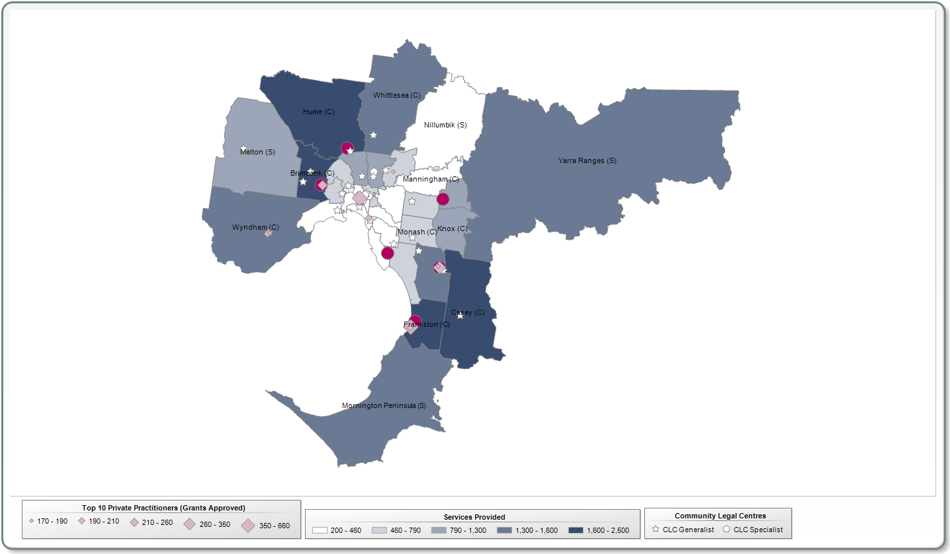
Map 2: Metropolitan Melbourne – Services Provided per 1000 residents; Grant of Aid, Legal Advice, Minor Work, Duty Lawyer (1 Jan 2011 to 31 Dec 2013)
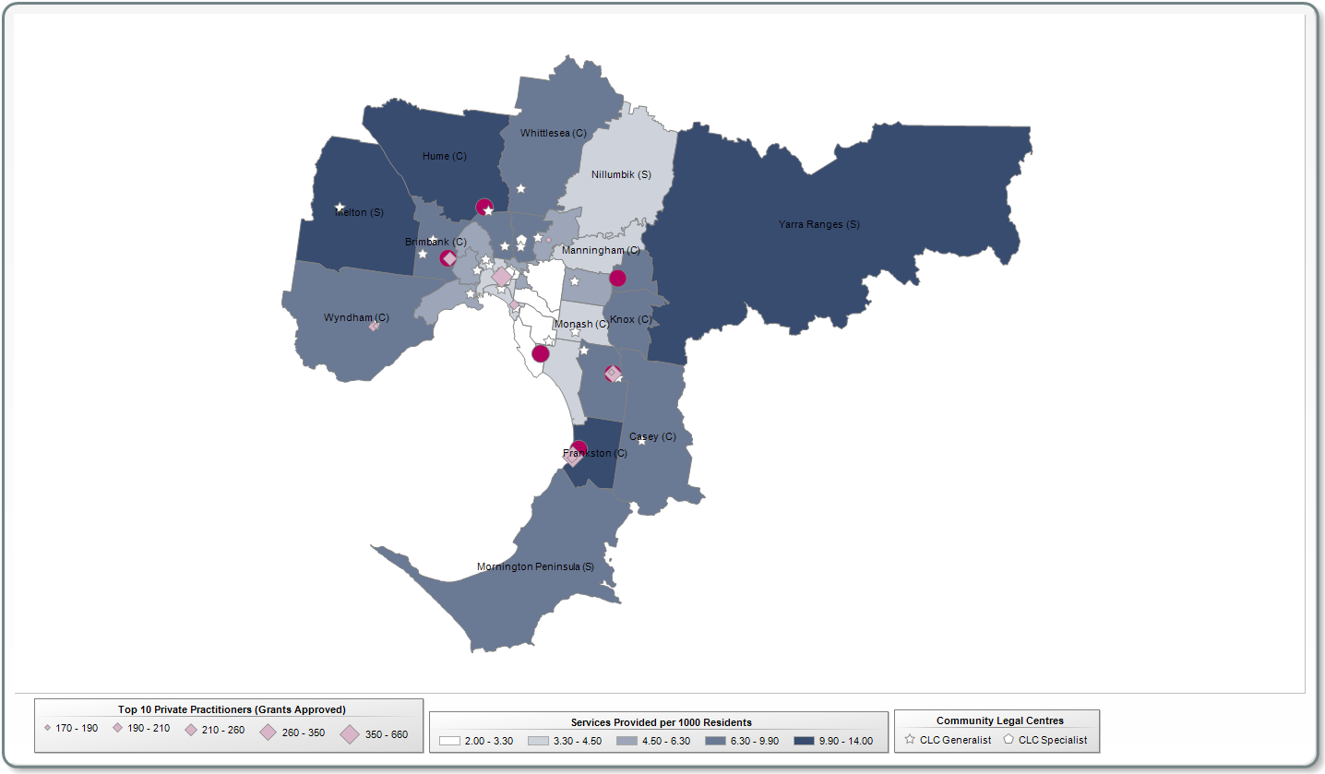
Map 3: Metropolitan Melbourne – Services Provided per 1000 residents; Grant of Aid (1 Jan 2011 to 31 Dec 2013)
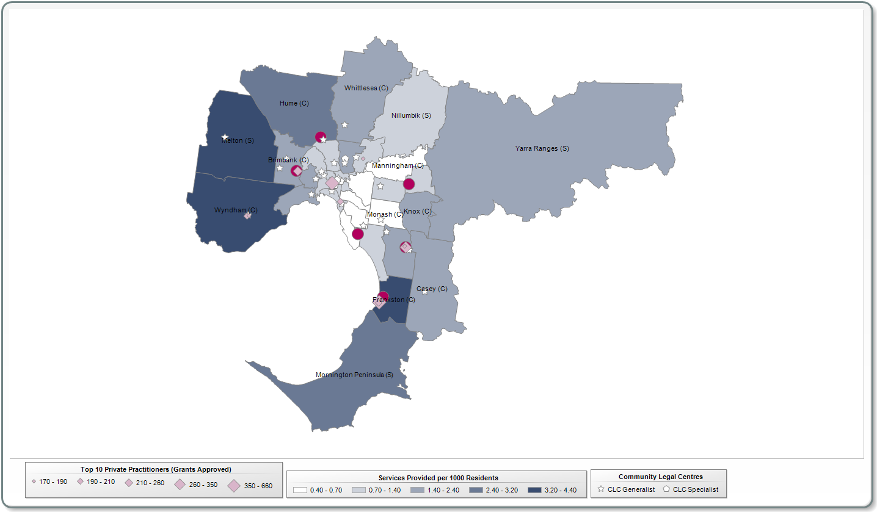
Map 4: Metropolitan Melbourne – Clients serviced per 1000 residents; Grant of Aid, Legal Advice, Minor Work, Duty Lawyer (1 Jan 2011 to 31 Dec 2013)
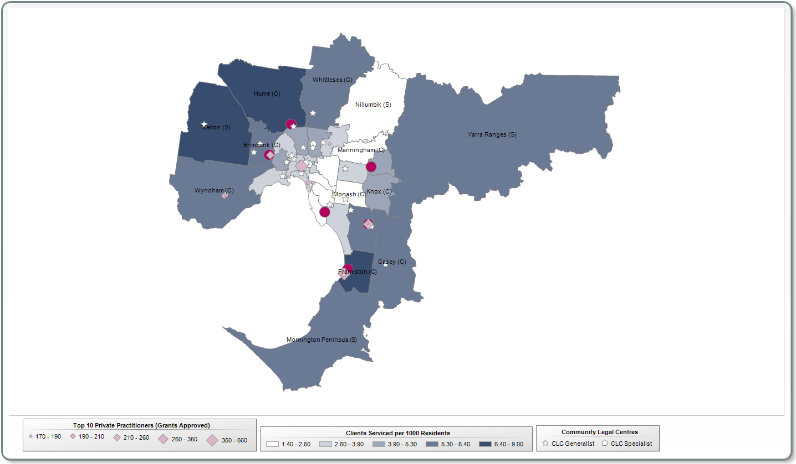
Map 5: Metropolitan Melbourne – Clients serviced per 1000 residents; Grant of Aid (1 Jan 2011 to 31 Dec 2013)
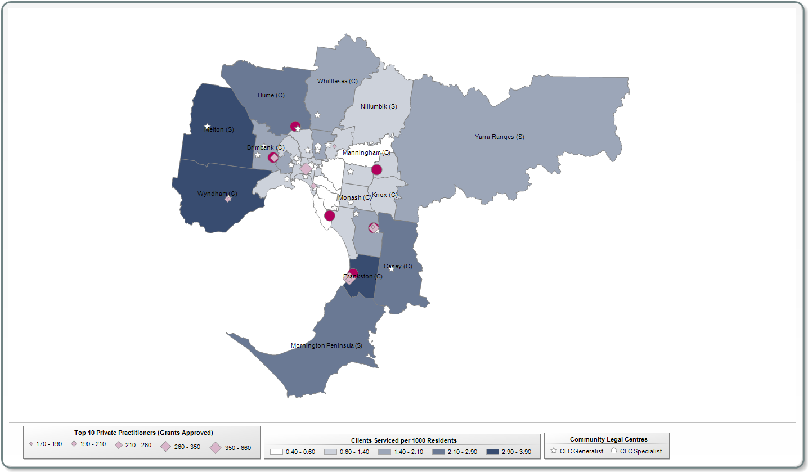
Map 6: Regional Victoria – Services; Grant of Aid, Legal Advice, Minor Work, Duty Lawyer (1 January 2011 to 31 December 2013)
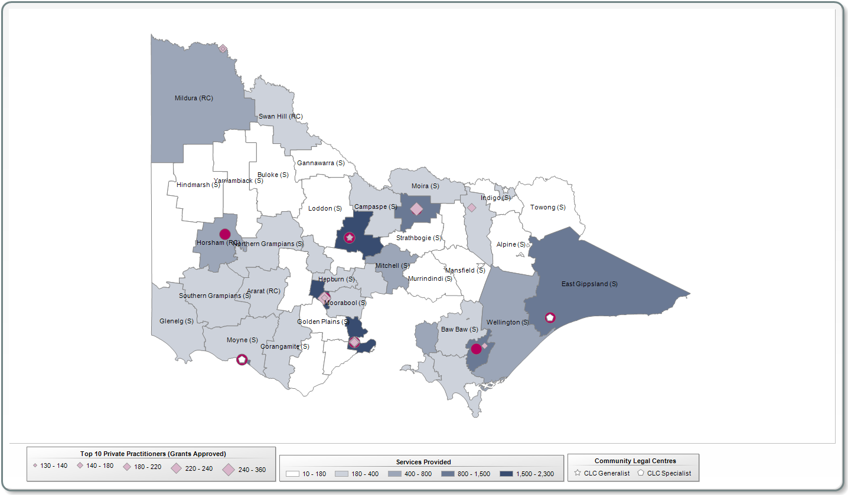
Map 7: Regional Victoria – Services Provided per 1000 residents; Grant of Aid, Legal Advice, Minor Work, Duty Lawyer (1 Jan 2011 to 31 Dec 2013)
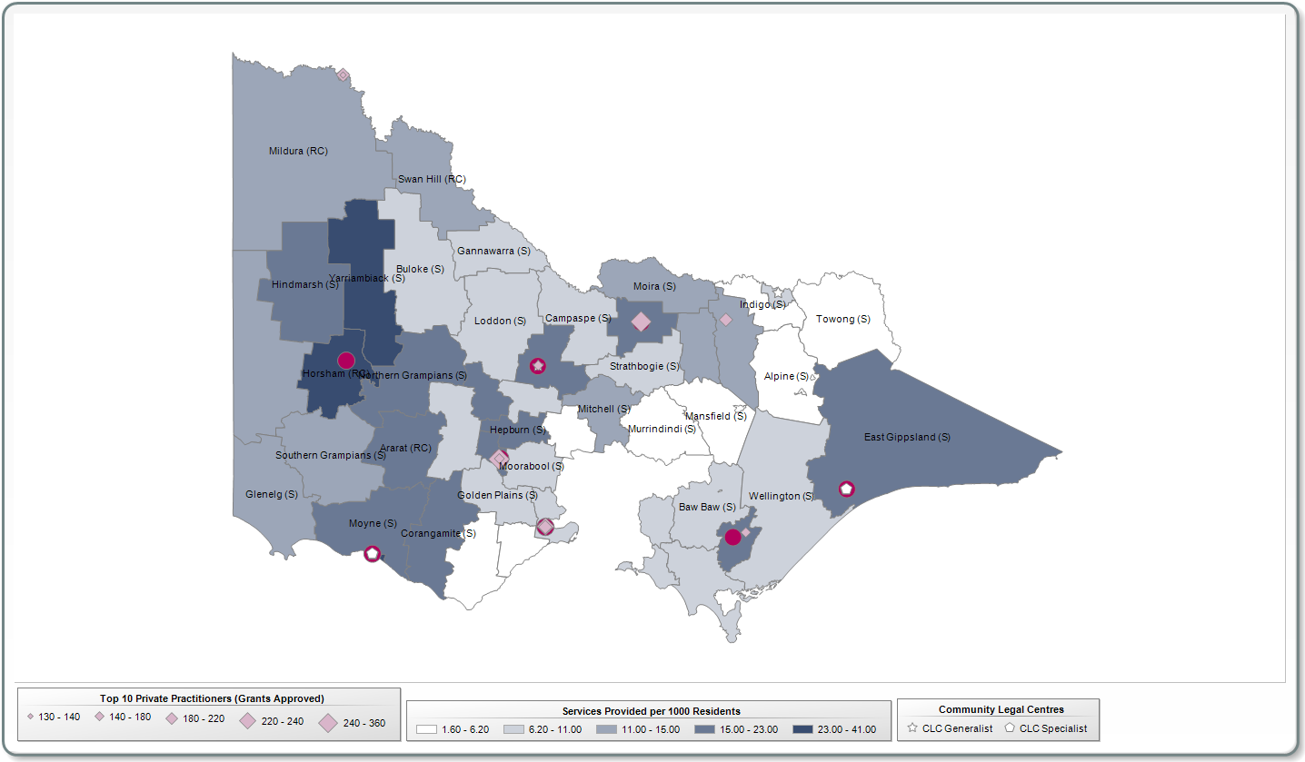
Map 8: Regional Victoria – Services Provided per 1000 residents; Grant of Aid (1 Jan 2011 to 31 Dec 2013)
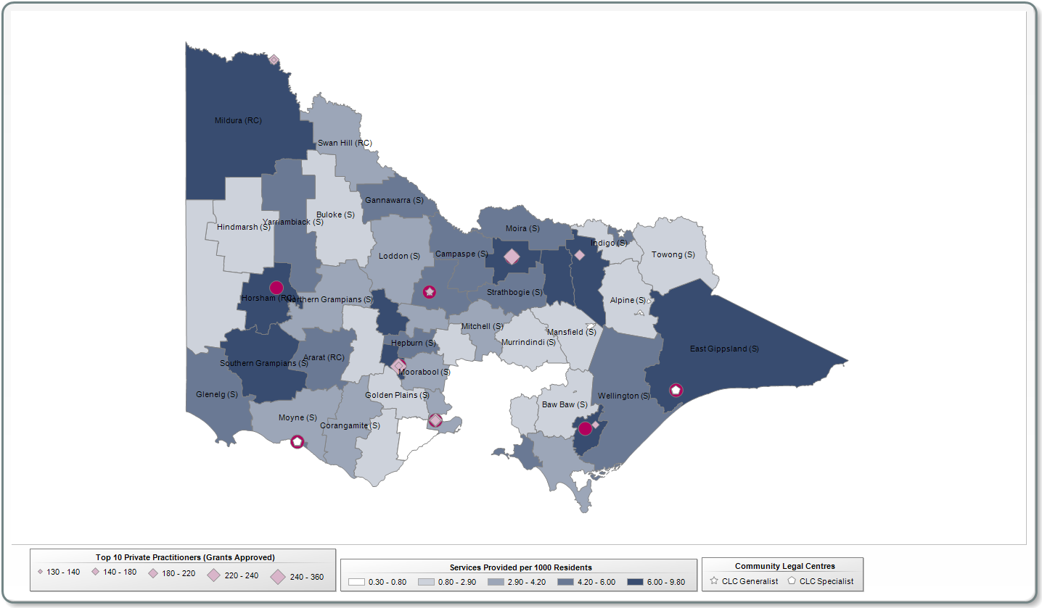
Map 9: Regional Victoria – Clients serviced per 1000 residents; Grant of Aid, Legal Advice, Minor Work, Duty Lawyer (1 Jan 2011 to 31 Dec 2013)
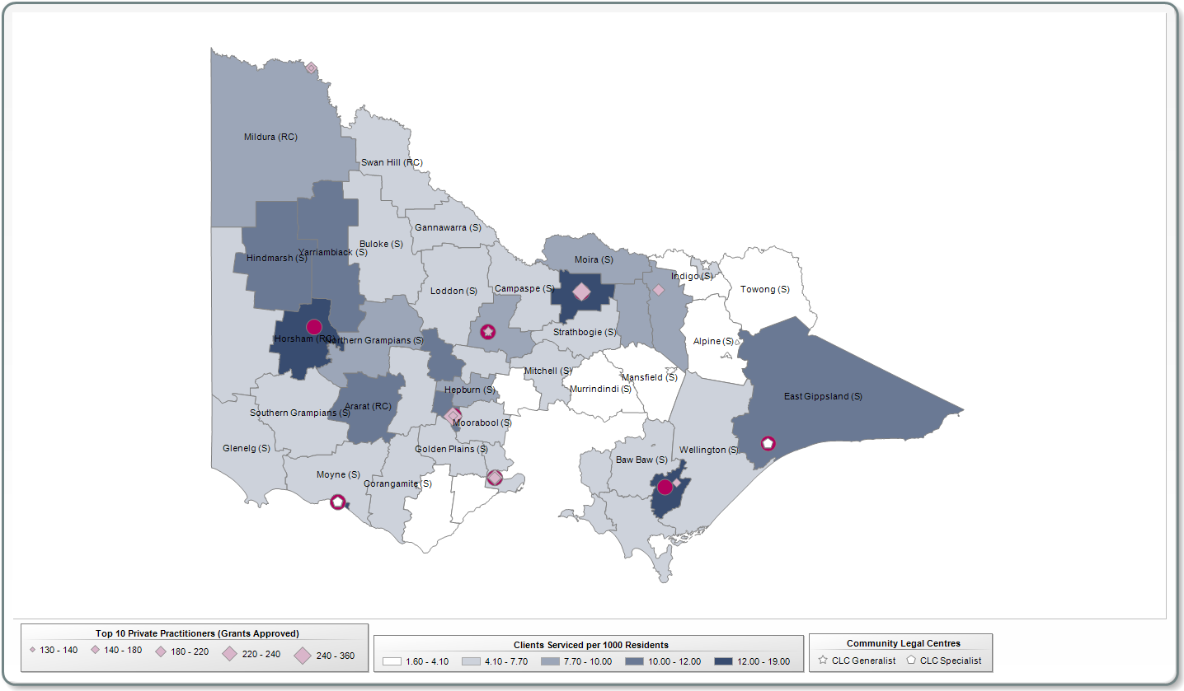
Map 10: Regional Victoria – Clients serviced per 1000 residents; Grant of Aid (1 Jan 2011 to 31 Dec 2013)
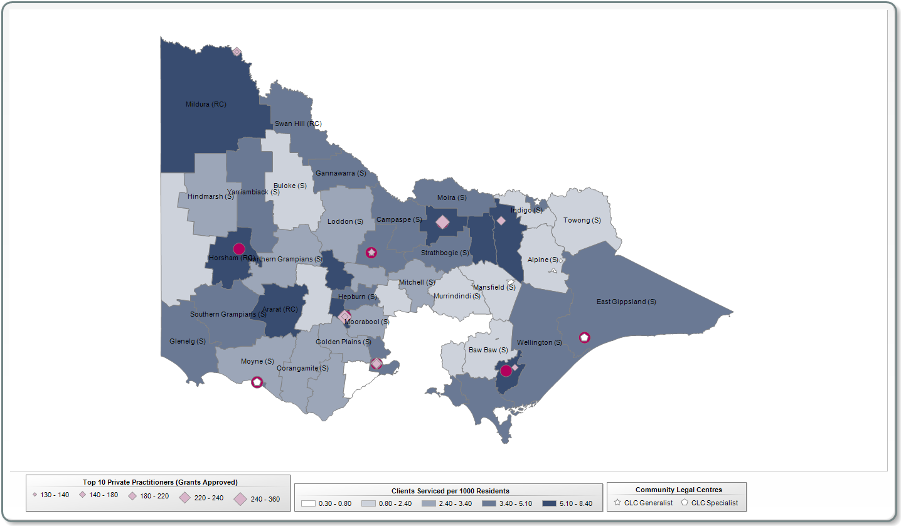

Council of Australian Governments, ‘National Plan to Reduce Violence Against Women and their Children 2010-2022’ (COAG, 2011).
Council of Australian Governments, 'Protecting Children is Everyone's Business: National Framework for Protecting Australia's Children 2009-2020' (COAG, 2009).
Clients who provided an address to VLA.
This percentage may be even higher, because VLA’s data system records the distance from the client’s address to the VLA service even if, for example, the service is provided through outreach where the lawyer travels to the client in a regional or remote location, rather than the client travelling to the service.
Unique clients are individual or distinct clients who access one or more of legal aid services during the year. Unique clients can be counted against legal advice and minor assistance, duty lawyer, dispute resolution and litigation services. They do not include people helped through services such as telephone information and community legal education sessions, as more detailed personal information is not collected from everyone who accesses these services.
L. Andressen, ‘Hotspots of Legal Need’ (Research Brief, Victoria Legal Aid, May 2014).
Victoria Police, ‘Victoria Police Code of Practice for the Investigation of Family Violence’ (2014).
Magistrates’ Court of Victoria, ‘Annual Report 2013-14’ (September 2014) 3.
Ibid.
Ibid.
C. Coumarelos et al., ‘Legal Australia-Wide Survey: Legal Need in Australia’ (Access to Justice and Legal Needs Monograph Vol 7, Law Foundation, 2012, xvi). For Victorians, a legal professional was used for only a minority – 16 per cent of all legal problems.
Council of Australian Governments, ‘National Partnership Agreement on Legal Assistance Services’ (COAG, 2010, 4).
Legal Aid NSW, Plan 2013-2014 (7 June 2013). <http://www.legalaid.nsw.gov.au/__data/assets/pdf_file/0018/16560/Legal-Aid-NSW-Plan-2013-14.pdf >.
Productivity Commission, ‘Access to Justice Arrangements’ (Inquiry Report No 72, Productivity Commission, 5 September 2014) 6.
Ibid, 113.
89.6 percent did not state they identified as Aboriginal and Torres Strait Islander. 8.1 percent of clients did not respond to the question.
M. Schwartz, F. Allison and C. Cunneen, ‘The civil and family law needs of Indigenous people in Victoria’ (A Report of the Australian Indigenous Legal Needs Project, 2013) 15.
Family Law Council, ‘Improving the Family Law System for Clients from Culturally and Linguistically Diverse Backgrounds’ (A report to the Attorney General, February 2012) 3.
Ibid, 15.
S. Forell and M. Cain, ‘An Evaluation of Legal Aid NSW’s Family Law Early Intervention Unit Duty Lawyer Service’ (Law and Justice Foundation of NSW, November 2012) 33.
COAG, above n Error: Reference source not found, 3.
C. Coumarelos et al., above n Error: Reference source not found, xiv.
Ibid.
Ibid, 30.
The general means test and Commonwealth merits test also apply.
Settlement rate is based on settlement of some or all issues in a dispute on an interim or ongoing basis.
See, for example, L. Qu et al., ‘Post Separation Parenting, Property and Relationship Dynamics after Five Years’, (Australian Institute of Family Studies, 2014) 59.
It is noted that VLA is currently undertaking a separate project in relation to the RDM service which will help to address the issue of delays by investing in significant upgrades to information and communication technology systems to streamline and integrate data entry, case management and conference bookings.
Legal Aid NSW, News April 2013 (April 2013), http://news.legalaid.nsw.gov.au/link/id/zzzz515a08aa45dcc754Pzzzz513915cd70bd8855/page.html>.
Legal Aid NSW, Submission to Productivity Commission, Access to Justice Arrangements Inquiry, May 2014,16.
S. Forell and M. Cain, above n Error: Reference source not found, 24-25 and 33-35.
M. Lam,, ‘Getting in Early’ (March 2013) Law Society Journal, 26, 28.
Family Law Council, ‘Litigants in Person’ (A Report to the Attorney General, August 2000), 3.
J. Dewar, B. Smith and C. Banks, ‘Litigants in Person in the Family Court of Australia’ (Research Report No 20. Family Court of Australia, 2000), 11-12.
QPILCH survey results cited in Productivity Commission, above n Error: Reference source not found, 491.
Federal Circuit Court, ‘Annual Report 2012-13’ (2013), 62.
Federal Circuit Court, ‘Annual Report 2011-12’ (2012) 69; Federal Circuit Court, ‘Annual Report 2010-11’ (2011) 48.
Above n Error: Reference source not found.
Family Court of Australia ‘Annual Report 2013-14’ (September 2014), 72. The proportion of litigants’ representation status for trials only is also included in the Annual Report and noted to have remained relatively steady for the past five years.
Above, 71
E. Richardson, T. Sourdin and N. Wallace, ‘Self-Represented Litigants: Gathering Useful Information’ (Final Report, Australian Centre For Justice Innovation, Monash University, June 2012).
J. Dewar, B. Smith, and C. Banks, above n Error: Reference source not found, 2.
R. Kaspiew et al., ‘Independent Children’s Lawyers Study’ (Final Report, Australian Institute of Family Studies, May 2013) xiii.
Child protection and family violence intervention order related legal services have been excluded from this mapping.
Legal services provided by CLCs (other than work undertaken by CLCs under grants of aid) are not included in this mapping.

