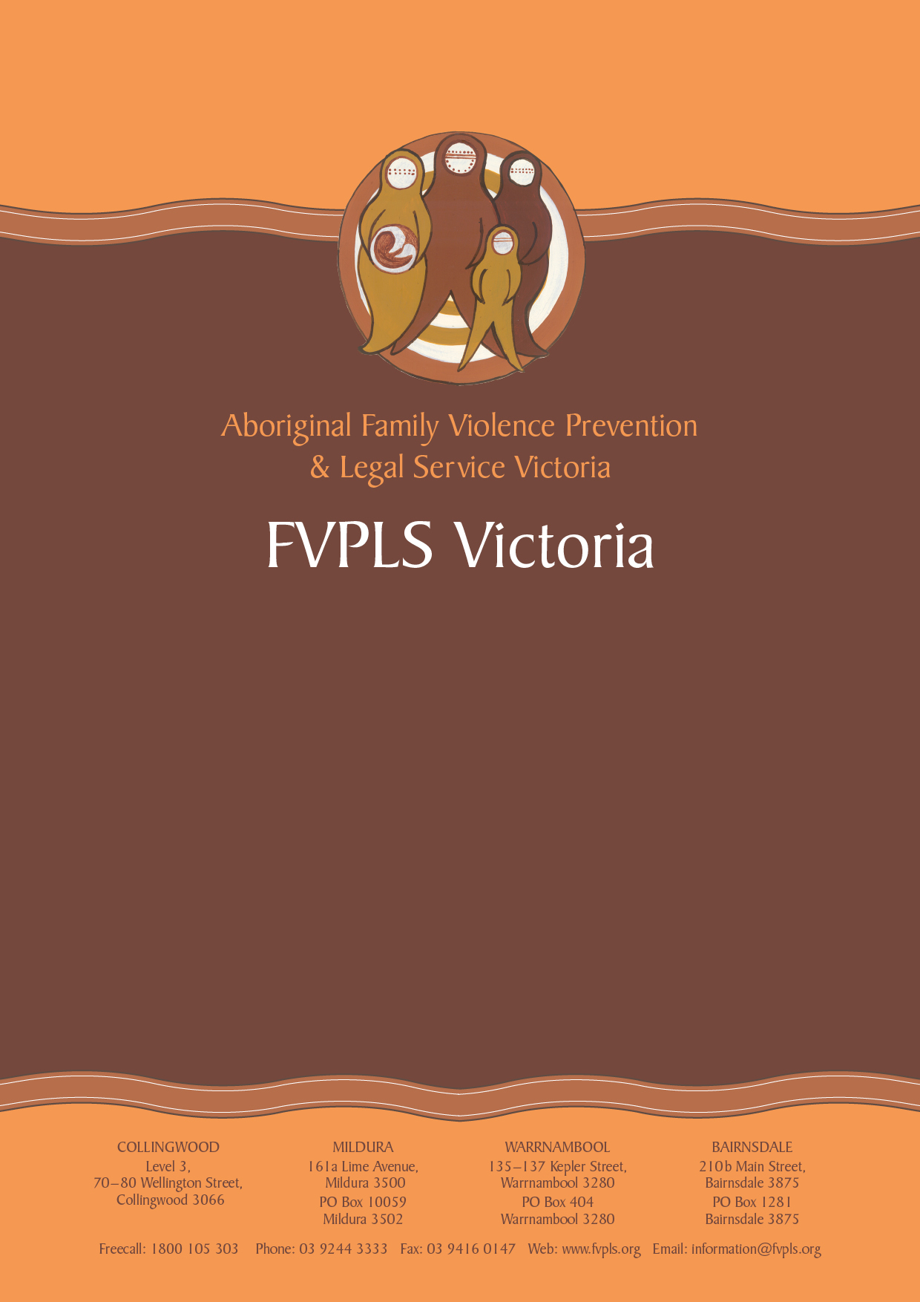
Submission to Victoria Legal Aid’s Family Law Services Review: Consultation and Options Paper

February 2015
Submission to Victoria Legal Aid’s
Family Law Services Review: Consultation and Options Paper

Introduction

The Aboriginal Family Violence Prevention and Legal Service Victoria (FVPLS Victoria) welcomes the opportunity to provide a submission to Victoria Legal Aid’s Family Law Legal Aid Services Review.

The following submission does not attempt to respond in detail to every aspect of VLA’s Consultation and Options paper (“the Paper”). Instead, this submission focuses on service delivery to Aboriginal clients and the importance of VLA supporting established Aboriginal legal service providers, such as FVPLS Victoria, to lead the delivery of services to Aboriginal clients.

FVPLS Victoria also refers to its Policy Paper Series June 2010 (available on our website), which includes:

- Paper 1: Strengthening law and justice outcomes for Aboriginal and Torres Strait Islander victims/survivors of family violence and sexual assault and women and children;

- Paper 2: Strengthening on-the-ground service provision for Aboriginal and Torres Strait Islander victims/survivors of family violence and sexual assault in Victoria;

- Paper 3: Improving accessibility of the legal system for Aboriginal and Torres Strait Islander victims/survivors of family violence and sexual assault.

About FVPLS Victoria

Established over 12 years ago, FVPLS Victoria is an Aboriginal Community Controlled Organisation who provide culturally safe and trauma-informed, holistic legal assistance to Aboriginal victims/survivors of family violence and sexual assault, as well as early intervention/prevention and community legal education for the Aboriginal community, the legal, Aboriginal and domestic violence sector. FVPLS Victoria is open to Aboriginal men, women and children who have experienced or are at risk of family violence or sexual assault, as well as non-Aboriginal carers of Aboriginal children who are victims/survivors of family violence. FVPLS Victoria is not gender specific, however more than 90 per cent of our clients are Aboriginal women and children.

FVPLS Victoria has a holistic, intensive client service model where each client is assisted by a lawyer and paralegal support worker to ensure the client is linked into culturally safe counselling and support services to address the underlying social issues giving rise to the client’s legal problem. As an Aboriginal Community Controlled Organisation, FVPLS Victoria is directed by an Aboriginal Board and has a range of systems and policies in place to ensure we provide culturally safe services in direct response to community need.

FVPLS Victoria’s legal services include advice, casework and court representation in the areas of:
- family law;
- child protection;
- family violence intervention orders;
- victims of crime assistance; and
- other civil law matters connected with a client’s experience of family violence such as: police complaints, housing, centrelink, child support and infringement matters.

Family law is one of FVPLS Victoria’s core legal service areas.

FVPLS Victoria’s legal services are provided free of charge and FVPLS Victoria’s family law (and other) practitioners regularly obtain grants of aid to fund disbursements such as counsel fees and expert reports.

FVPLS Victoria also often acts against VLA lawyers in family law matters.
FVPLS Victoria is grateful to receive VLA funding to enable us to employ a family lawyer and paralegal support worker. These positions are dedicated family law positions who service clients in the Melbourne metropolitan area. This supplements and supports the work undertaken by FVPLS Victoria’s regionally based lawyers who all undertake family law casework, as well as our other metropolitan lawyers who focus on child protection and family violence matters.

Response to the Consultation and Options Paper

- Characterisation of FVPLS Victoria’s role and services

We note that page 15 of the Paper states that FVPLS Victoria (as well as VALS and some CLCs) “provide family law legal information, advice and in some cases extended assistance (to complete one or more discrete tasks)”. This is incorrect. FVPLS Victoria provides intensive, ongoing casework and representation in all aspects of our clients’ family law matters and for the full duration of the matter. We understand that Aboriginal clients, especially those who have experienced family violence, often have multiple, complex legal (and social) problems and face significant barriers to accessing and effectively engaging with the legal system. We therefore remain engaged in our clients’ matters for as long as required to resolve the totality of the client’s legal issues. In some complex cases this means we remain engaged by a client for multiple years.

Another error can be found on page 22 of the Paper, which states that:

“The Victorian Aboriginal and Torres Strait Islander legal services consulted for this review, VALS and FVPLS Victoria, spoke about the significant demand on their practice arising from child protection matters and fewer resources thus available for other family law assistance.”

Insofar as this relates to FVPLS Victoria this is wholly incorrect and the FVPLS Victoria staff members who attended the VLA consultation have no recollection of any such discussion. FVPLS Victoria provides extensive services in both family law and child protection and both areas of law are part of the core focus of FVPLS Victoria’s legal practice. With more resourcing FVPLS Victoria could meet additional demand and we have advocated for additional resourcing to expand our services, including both family law and child protection services, to identified geographical areas of high unmet need.

- Servicing Aboriginal Clients

Option 5 on page 22 of the Paper relates to VLA developing “closer partnerships with” Aboriginal legal services (presumably referring to both VALS and FVPLS Victoria) “to meet unmet demand for family law services in Aboriginal communities.” This option goes on to discuss ways VLA could build trust within Aboriginal communities to encourage Aboriginal clients to engage with VLA. This is the only option provided in relation to addressing family law related legal need among Aboriginal clients.

We are concerned that this Option does not recognise the role and importance of Aboriginal legal service providers taking the lead in delivering services to Aboriginal clients. Aboriginal legal service providers (including VALS and FVPLS Victoria) were established by and for Aboriginal communities. They were established in direct response to community demand and reluctance by the Aboriginal community to access mainstream services. Aboriginal legal service providers remain the most appropriate legal provider for Aboriginal clients.

It is our position that VLA’s role should be one of supporting Aboriginal legal service providers to address unmet legal need, including family law. Both VALS and FVPLS Victoria have established family law practices and, as noted above, FVPLS Victoria’s family law practice is a core component of our work. With increased resourcing, FVPLS Victoria would have greater capacity to respond to the family law needs of family violence victims/survivors across Victoria.

The legacy and impact of Australia’s colonial history, including oppression through legal and government systems and policies of forced assimilation, cannot be overstated. This legacy continues in Aboriginal people’s ongoing disadvantage and dispossession in Victoria. It has resulted in profound levels of mistrust of the legal system by Aboriginal communities. Aboriginal legal service providers are best placed to respond to this.

Mainstream organisations can face significant difficulty in delivering and measuring culturally competent services to Aboriginal clients and they run the risk of token or ineffective ‘add-on’ attempts to cater for Aboriginal clients. Cultural safety cannot be achieved by simply employing a handful of Aboriginal staff. Indeed, Aboriginal staff in large mainstream organisations can easily become over-burdened by expectations to single-handedly represent ‘Aboriginality’ within the organisation, service Aboriginal clients and continually educate non-Aboriginal colleagues about cultural matters.

In addition, mainstream legal services, such as VLA, whose practitioners do not routinely assist Aboriginal clients may face challenges given the breadth and complexity of issues facing Aboriginal clients and the need to keep abreast of relevant case law, legislation and changing personnel within appropriately skilled referral partners and Aboriginal-specific agencies.

By contrast, FVPLS Victoria, delivers and demonstrates culturally safe service delivery by virtue of our organisational structure as an Aboriginal Community Controlled Organisation, with an Aboriginal Board of Directors, a suite of internal policies and operating procedures, staff who specialise in assisting Aboriginal clients all day every day, and strong, longstanding relationships with local Aboriginal communities.

Culturally appropriate service delivery by VLA necessitates VLA ensuring that all Aboriginal clients are provided with the option of being represented by an Aboriginal legal service and facilitating referrals accordingly. Where Aboriginal legal service providers do not have the expertise or capacity to assist (for example in areas other than family law) then a partnership approach and/or referral to VLA may be appropriate.

In summary, any efforts by VLA to address unmet family law need among Aboriginal people should be undertaken in consultation and partnership with Aboriginal legal service providers, with the clear and overarching goal being to support Aboriginal legal service providers to address unmet legal need.

