Schedule 5

Section 29A panel removal and certifier status revocation

Background
VLA’s section 29A panel removal and certifier status revocation model is informed by VLA’s panels model. The panels model differentiates between Providers and Panel Certifiers. The panels model enables VLA to suspend or remove a Provider’s panel membership and/or suspend or revoke a Panel Certifier’s certifier status where there is a breach of Panel Conditions, in order to preserve the quality of service delivery to an Assisted Person.
VLA is most likely to identify grounds for removal through its complaints, quality audit and compliance check functions. It is also possible that VLA practice areas may identify potential grounds (e.g. if a VLA lawyer sees poor quality representation at court).

Definitions
Assisted Person has the meaning given to the term 'Assisted Person' in the Legal Aid Act 1978 (Vic).
Panel Certifier means a member of Provider Personnel who is approved in writing by VLA to certify grants of legal assistance.
Panel Conditions means the conditions imposed on Providers as Panel members and the individual conditions imposed on Panel Certifiers
Panel Entry Requirements means the requirements for the Provider’s inclusion on the Panel and the individual entry requirements for Panel Certifiers.
Practice Standards means the Practice Standards as set out in Schedule 2 of the Panel Deed and as amended by VLA from time to time and published on VLA's website at http://www.legalaid.vic.gov.au/information-for-lawyers/doing-legal-aid-work/panels/panels-conditions.
Provider means a private law practice or an Australian legal practitioner who is an Independent Children’s Lawyer, that is a member of the Panel.
Provider Personnel means:
- where the Provider is a Private Law Practice, the Australian legal practitioners who are partners, directors or employed Australian legal practitioners of the Private Law Practice; and
- where the Provider is an Australian legal practitioner who is an Independent Children’s Lawyer, that Australian legal practitioner.
Quality Monitoring Outcome means the outcomes that VLA may initiate following quality monitoring of legally aided matters, as set out in Schedule 3 of the Panel Deed and as amended from time to time and as published on VLA’s website at http://www.legalaid.vic.gov.au/information-for-lawyers/doing-legal-aid-work/panels/panels-conditions.
Remove/Removal means the removal of a Provider’s section 29A panel membership and the revocation of Panel Certifier’s certifier status.
Suspend/Suspension means the suspension of a Provider’s section 29A panel membership and the suspension of a Panel Certifier’s certifier status.
Removal Process means the process that VLA will adopt when removing a Provider from the Panel or revoking a Panel Certifier’s certifier status.

Section 29A Removal model
The section 29A panel removal and certifier status revocation model and decision-making structure is depicted in Diagram 1.

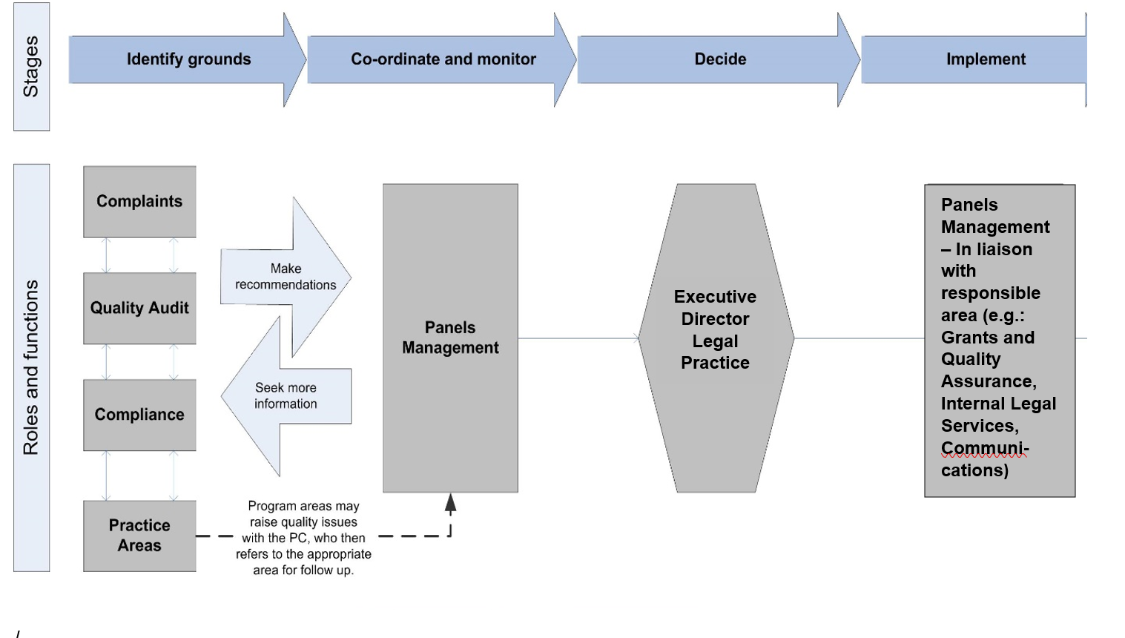Diagram 1

1. Suspension and Removal process

1.1 Suspension
VLA may suspend a Provider or Panel Certifier’s panel membership (see 2. Grounds for Suspension):
- if VLA is satisfied that there is a risk of harm to legally assisted persons or the Legal Aid Fund if the Provider or Panel Certifier is permitted to continue to work on legally assisted matters; or
- if VLA reasonably believes that the Provider or Panel Certifier has committed a serious breach of Panel Conditions; or
- pending an investigation by VLA into the conduct of a Provider or Panel Certifier.

If VLA decides to suspend a Provider or Panel Certifier’s panel membership, VLA will send the Provider or Panel Certifier a Notice of Suspension from the panel. This is an important step for ensuring that natural justice is provided, despite the immediate effect of the suspension.

The Notice of Suspension will contain the following:
- the date on which the suspension will commence
- the panels relevant to the suspension
- the length of the suspension
- VLA’s reasons and concerns leading to the suspension
- details about the action VLA proposes on taking during the suspension period
- details about what if any action VLA requires of the Provider or Panel Certifier during the suspension period
- invite the Provider or Panel Certifier to respond to the concerns raised and the length of the suspension
- the next steps that VLA will undertake with respect to the Provider or Panel Certifier’s panel membership.

VLA may extend the period of Suspension where an investigation by VLA or other regulatory or law enforcement body remains ongoing or the Provider or Panel Certifier has failed to complete any actions required by VLA as part of the Suspension.

Following the Suspension period, or in the course of the Suspension period, VLA may commence the Removal Process or impose any other Quality Monitoring Outcome.

1.2 Removal
VLA may remove a Provider or Panel Certifier’s panel membership if following investigation, grounds for Removal are identified (see 2. Grounds for removal).

The following steps represent the Removal Process:
a. Where grounds for Removal are identified (see 2. Grounds for removal), VLA will send the Provider or Panel Certifier a Notice of Intention to Remove them from the panel.
b. The Notice will outline the grounds for removal.
This notice is intended to enable the Provider or Panel Certifier to respond to all relevant grounds. Any response will then be considered by VLA before making a final decision. This is an important step for ensuring that natural justice is provided to the Provider or Panel Certifier.
- The Provider or Panel Certifier has 28 days to respond to any Notice.
- VLA will assess the Provider or Panel Certifier’s response to the Notice (if any) and make a final decision about whether or not to Remove them from the panel.
- Where the Provider or Panel Certifier fails to respond to the Notice, VLA will make the final decision of whether or not to Remove the Provider or Panel Certifier on the basis of the reasons outlined in the Notice.
- Where VLA decides not to Remove a Provider or Panel Certifier, an alternative Quality Monitoring Outcome may be applied (such as a formal caution).
- Where VLA makes a final decision to Remove a Provider or Panel Certifier, it will send a letter outlining the decision and reasons for decision to the Provider or Panel Certifier.
- VLA’s Removal letter will:
      - detail the reasons for Removal
      - address the Provider’s or Panel Certifier’s response to the Notice
      - specify the period of Removal
      - detail how the Provider or Panel Certifier can apply to be re-included to the panel or approved as a Panel Certifier.

2. Grounds for removal and suspension

2.1 Grounds for removal
VLA may remove a Provider from a section 29A panel or revoke a Panel Certifier’s certifier status on the following grounds:
- There is evidence that the Provider or Panel Certifier does not hold a practising certificate.
- Information supplied by the Provider or Panel Certifier in support of their application for panel membership or panel certifier status is found by VLA to be substantially and relevantly inaccurate or false.
- The Provider or Panel Certifier is found:
    - guilty of Professional Misconduct or Unsatisfactory Professional Conduct by the Legal Services Board, Legal Services Commissioner or any equivalent body in any jurisdiction, Victorian Civil and Administrative Tribunal or any other Court or Tribunal which includes any privately constituted body to discipline its members, in respect of a member of the Provider Personnel
    - guilty of any criminal offence except an infringement.
- The Provider or Panel Certifier has committed a serious breach of Panel Conditions. A breach of the Panel Conditions will be regarded as serious where VLA considers that:
    - the breach posed a risk of detriment to the Legal Aid Fund
    - the breach was a breach of the Practice Standards that had the potential to adversely impact a legally assisted person or VLA
    - the breach involved dishonesty or improper conduct in a professional capacity
    - the breach had the potential to adversely affect VLA’s reputation
    - the breach led to a court being deceived or, intentionally or otherwise, misled about the true status of VLA’s funding determinations regarding an applicant for legal assistance
- The Provider or Panel Certifier has breached their professional legal obligations as set out in the Legal Profession Uniform Law, regulations and rules governing the legal profession.
- The Provider or Panel Certifier has a history of failing to meet the VLA Practice Standards that, in the reasonable opinion of VLA, poses an unacceptable risk to the quality of services provided to an Assisted Person or applicant for legal assistance.
- The Provider or Panel Certifier has a history of non-compliance of Panel Conditions, including the Practice Standards that, in the reasonable opinion of VLA, may impose an unreasonable cost (including resource cost) burden on VLA.
- The Provider or Panel Certifier has failed to satisfy any conditions of panel membership or panel certifier status as specified in VLA’s offer of inclusion to the panel, or certification notice.
- Where VLA has concluded that the conduct or circumstances of a Provider or Panel Certifier has caused, or had the potential to cause detriment to:
    - VLA or its reputation
    - the Legal Aid Fund
    - an Assisted Person.
- VLA is satisfied that the Provider or Panel Certifier has failed to address non-compliance issues raised by VLA.
- The Provider or Panel Certifier has been removed from another section 29A panel or has had their panel certifier status revoked from another section 29A Panel.
- VLA has commenced the Removal Process in relation to the Provider or Panel Certifier in relation to another s.29A panel.
- The Provider or Panel Certifier requests, in writing to VLA to be removed from the panel.

2.2 Grounds for suspension
VLA may suspend a Provider’s panel membership or suspend a Panel Certifier’s certifier status on the following grounds:
- Where VLA becomes aware of information which reasonably indicates that the conduct or circumstances of a Provider or Panel Certifier has caused, or had the potential to cause detriment to:
    - VLA or its reputation
    - the Legal Aid Fund
    - an Assisted Person.
- VLA reasonably believes that the Provider or Panel Certifier has committed a serious breach of Panel Conditions.
- VLA becomes aware that:
    - the Provider or Panel Certifier is charged with any criminal offence, except an infringement
    - the Provider or Panel Certifier is found guilty of any criminal offence except an infringement
    - there is a current complaint or investigation into Professional Misconduct or Unsatisfactory Professional Conduct in respect of the Provider or Panel Certifier, being handled by the Legal Services Board, Legal Services Commissioner or any equivalent body in any jurisdiction, including any privately constituted body to discipline its members.
    - the Provider or Panel Certifier has been found guilty of Professional Misconduct or Unsatisfactory Professional Conduct by the Legal Services Board, Legal Services Commissioner or any equivalent body in any jurisdiction, Victorian Civil and Administrative Tribunal or any other Court or Tribunal which includes any privately constituted body to discipline its members, in respect of a member of the Provider Personnel.
    - the Provider or Panel Certifier has become bankrupt
    - a court, tribunal or professional body has voiced what VLA reasonably regards as serious criticisms of a Provider or Panel Certifier’s conduct.
- VLA becomes aware of allegations about a Provider or Panel Certifier’s conduct which VLA considers requires investigation.

3. Panel re-inclusion/re-certification following Removal
3.1 A Provider or Panel Certifier may apply for panel re-inclusion or certifier status at any time after their Removal period has expired.
3.2 A Provider or Panel Certifier must apply for panel re-inclusion or certifier status by completing the application requirements for the relevant panel which is available on the VLA website at http://www.legalaid.vic.gov.au/information-for-lawyers/doing-legal-aid-work/panels
3.3 In addition to meeting the entry requirements relevant to the panel, the Provider or Panel Certifier’s application must also satisfy VLA that:
a. they have addressed the issues that resulted in the Removal; or
b. there has been a material change in their circumstances such that the same issues are unlikely to arise again, or
c. they no longer pose a risk to clients or the legal aid fund.
3.4 The Provider or Panel Certifier’s application will be assessed as part of the next available panel assessment round for the relevant panel.

