
68 Charter St, Ringwood 3134
T: 03-9871 6300; F: 03-9879 7640
www.familyrelationships.gov.au

Attachment 1

Outer East Family Law Project

Project Data Analysis

May 2010 – Dec 2014

Background
A Commonwealth Government policy shift in 2009 enabled lawyers to be more actively involved with Family Relationship Centre’s.
In response to this policy change, in 2010 the Commonwealth Attorney Generals Department funded the Outer East Family Law Project to support active involvement by lawyers with the RFRC.
The Project funded was developed by a collaboration between:
- Eastern Community Legal Centre (ECLC),
- Ringwood Family Relationship Centre (RFRC)
- Victoria Legal Aid Ringwood office (RVLA)
- Eastern Domestic Violence Outreach Service (EDVOS).
Project Objectives
- Provide increased legal involvement and a collaboration with Ringwood Family Relationship Centre (RFRC)
- Improve legal assistance and support to families with indications of vulnerability related to family violence, disability and those who are otherwise practically excluded from family law processes because of other barriers
- Enhance collaboration between the Project partners.

CLIENT Data Summary –

Since 2010 RFRC has been collating the following statistics and data about legal referrals and collaboration resulting from the Project.

- LEGAL (WARM) REFERRALS BY FRC
Project Referrals: May 2010 – Dec 2014
Total for ECLC and RVLA: 936 – 541 (57%) female, 395 (43%) male
Total for ECLC: 540
Total for RVLA: 361
Total for Double Conflict – other: 35
Project Referrals: 1.7.13 – 31.12.14
Total for ECLC and RVLA: 315 – 184 (58%) female, 131 (42%) male
Total for ECLC: 243
Total for RVLA: 72
Total for double conflict: 0
- FDR status of clients referred
Number of FDR APPLICANTS referred 661
70% of all legal appointments
56% Female
44% Male

Number of FDR RESPONDENTS referred 275
30% of all legal appointments
63% female
37% male

- TIMING OF REFERRAL
- 15% referred before Assessment of suitability for FDR
- 63% referred before FDR process
- 22% referred during or after FDR
- .5% by Child Inclusive Practitioner

- OUTCOME of ADVICE – as recorded by lawyer * incomplete data
- Legal advice provided - 70%
- Referred to other legal service – 11%
- Referred to non legal service – 5%
- Development of Parenting Plan – %
- Drafting of consent Orders – 0.5%
- Client intends to seek orders by consent – 3%

- LEGAL APPOINTMENTS AT FRC CANCELLED or DID NOT ATTEND
- 20%

- Lawyer attendance at RFRC Information Seminar (initial 2 years of Project)
- ECLC - 39 seminars
- VLA - 7 seminars

- Improving Staff Knowledge

Lawyers and FDRP’s have developed a collaborative practice framework that is continuing to enhance professional knowledge and client outcomes.
In the 2013-2014 year:
- Project Reference group has continued to meet
- ECLC lawyer has attended the FRC on a fortnightly basis
- ECLC has scheduled appointments for clients referred by the FRC at sites convenient for the client through out the eastern region of Melbourne
- RVLA has scheduled appointments for people referred by FRC when ECLC was conflicted.
- FDRP’s attended 3 legal sessions organised by ECLC (Ringwood, Box Hill and Ringwood Magistrates Court)
- FRC visited ECLC sites to speak with lawyers and community staff about the FRC services on 2 occasions
- FRC has visited RVLA site and spoken with lawyers about the FRC services
- FRC has offered an FDR Information Seminar for VLA clients pre RDM as per the Victorian VLA FRC protocol
- FDRP’s have consulted with lawyers in relation to casework issues
- FDRP’s have consulted with EDVOS – referrals are routine
- EDVOS has consulted with FRC
- ECLC staff have attended information sessions held at the FRC about high conflict disputes and the Monash University Family Law Assistance Program
- ECLC RVLA and RFRC staff have shared Christmas social events

SUMMARY
The data available provides evidence of the efficacy of the Project:
- Increased legal involvement and collaboration with Ringwood Family Relationship Centre.
- Improved legal assistance and support to families with indications of vulnerability related to family violence, disability and those who are otherwise practically excluded from family law processes because of other barriers.
- Enhanced collaboration between the Project partners.
- Availability of integrated family law legal advice to clients engaged with the FRC.

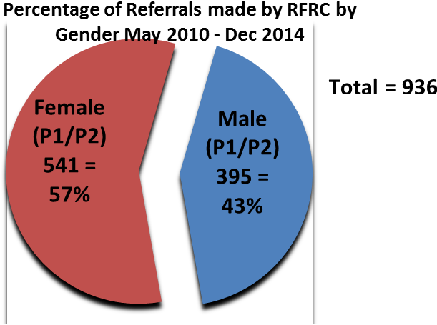

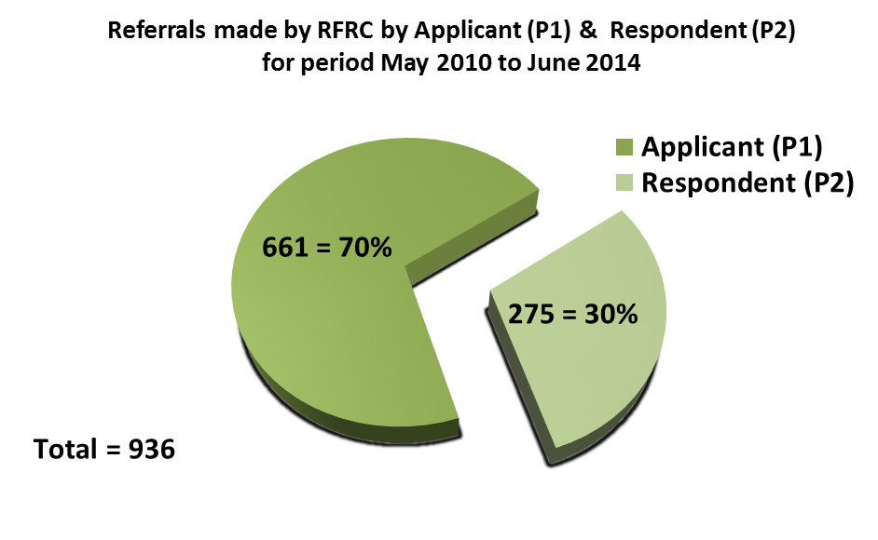
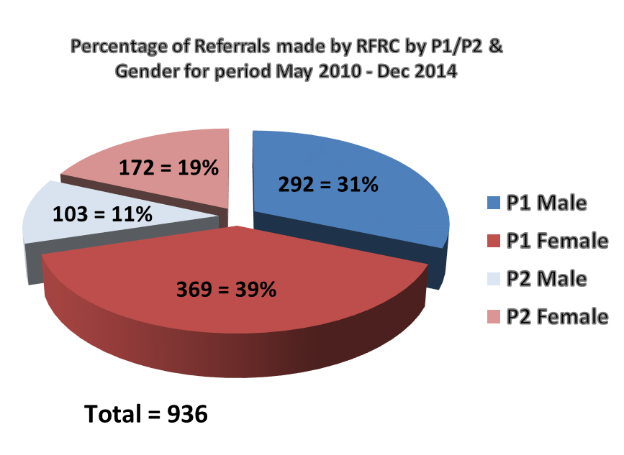

VLA involvement in the Project changed in 2011-2012 year due to loss of the funding which had enabled a lawyer to offer appointments at RFRC.

