A client may request that you take over the conduct of a matter where a grant of assistance is already in place with another practitioner. Use the ‘New Application’ function as this is considered a new file for your office.

Transfer IN from another practitioner

- Select New Application from the left hand menu, under Applications.

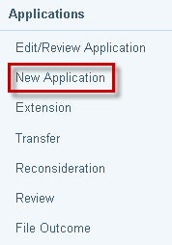

- Select Law Type:

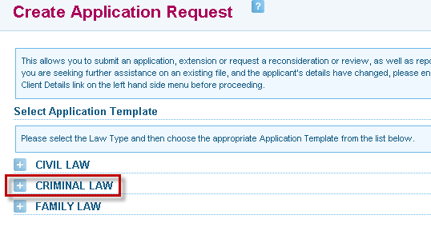

- Select the Application Template – Transfer From Another Office

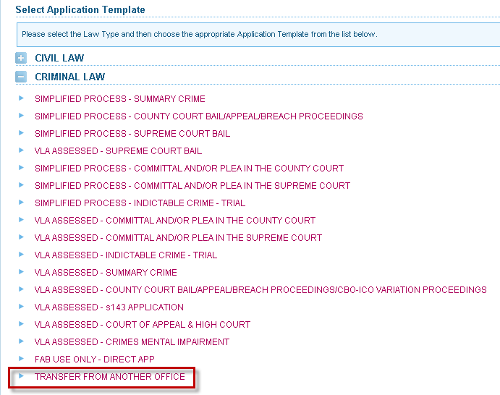

- The Search for Client screen will display. Enter the client’s details and click on Search.

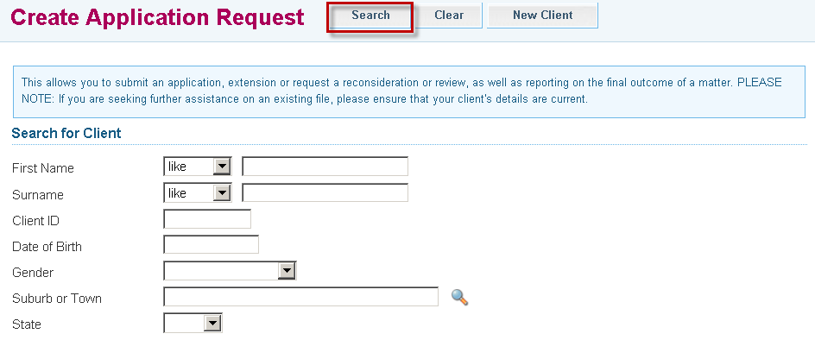

- Search results are returned at the bottom of the screen. Click on the client’s name to retrieve the client’s details.

- Matching results
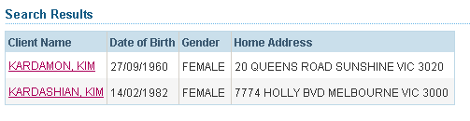
Only the names of current clients belonging to your firm will appear. Past clients will not be displayed.

- If no client record is found, you will need to create a new client in ATLAS


- Select New Client at the top of the screen.

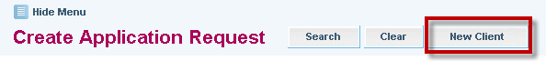

- An application form is displayed. A File ID is automatically assigned to the transfer request application. Use this number to retrieve and track the application. This file number will not be saved if the application is cancelled.



- The application remains in Draft Status until it is submitted. Applications can be partially completed and the Draft can be saved at any time by selecting Save at the top of the screen. A message at the top of screen will confirm the draft application has been saved successfully.

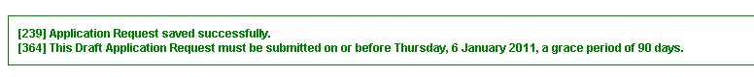
Note:
- Victoria Legal Aid can only process an application that is submitted
- Draft or saved applications cannot be processed
- Draft applications are deleted from ATLAS after 90 days

- Complete the relevant fields within the Applicant Details tabs: –
- Personal Details
- Additional Details
- FAP / Dependants
- Income
- Assets

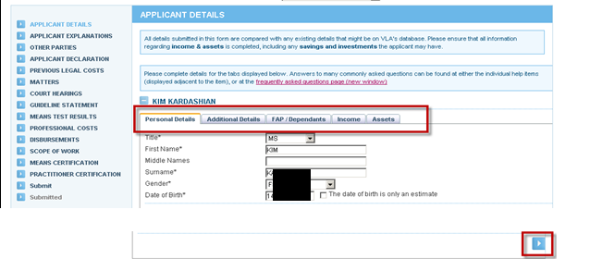
Use this arrow
to navigate through the Applicant Details tabs
OR
Click on the tab headers.

- To enter or edit an address, click Edit.

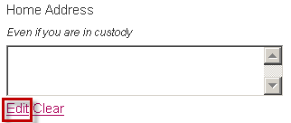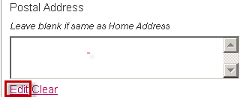

- The Address Details screen displays. Select the appropriate address format and street type from the drop down lists.
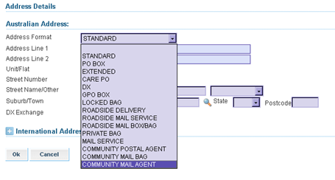

- Enter the suburb and postcode. If you do not know it, click on the pick list (magnifying glass icon). The Select a Suburb/Town search screen displays. Enter the suburb and click Search. Click on the correct option to continue.

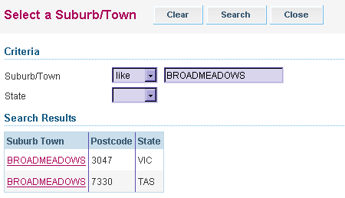

- Click the Next button to navigate to the next section of the application. At this point, the partly completed application will be saved automatically.
As a security measure, ATLAS ‘times out’ after 5 minutes of non activity.
To avoid loss of data, select Save at any time when entering client or application details.

- The Transfer Request screen displays. Complete the required sections.
- File number – provide the VLA grants reference (if known)
- Transfer reason
- Guideline
- Authority to transfer
.

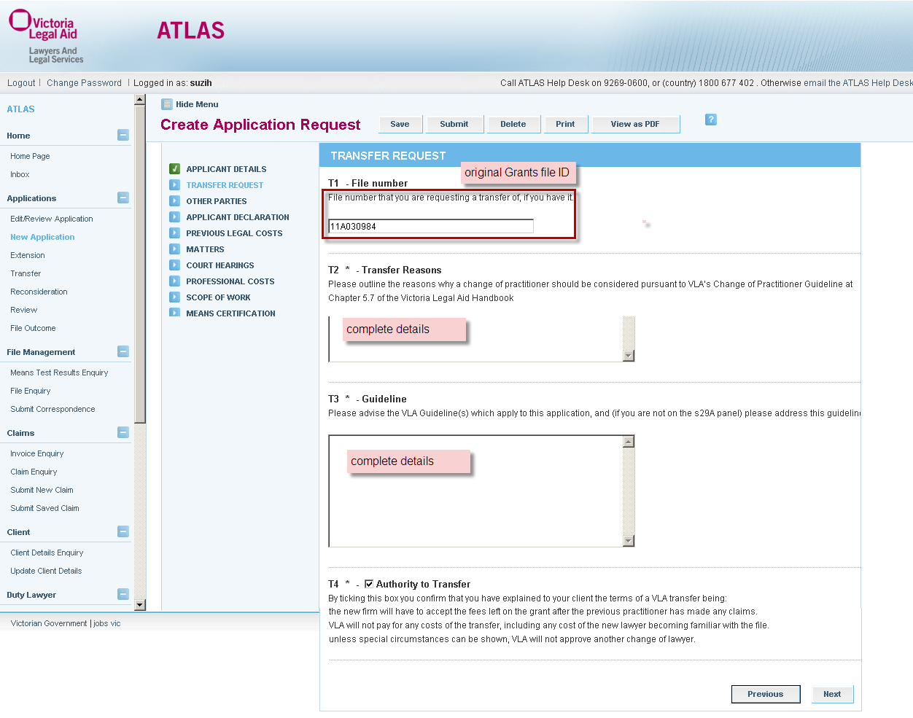

- Complete the Other Parties screen, if required. Select the Add button to add another party and complete their details. If Other Parties screen is selected in error, delete by clicking on theat the side of the screen and select Ok to the warning message. To continue through to the next screen, select Next.

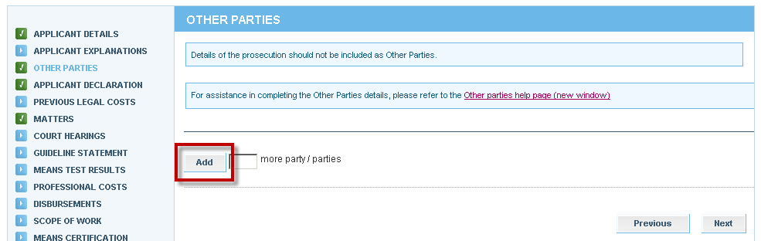

- The Applicant Declaration screen will display. Complete questions, enter the date and select Next.

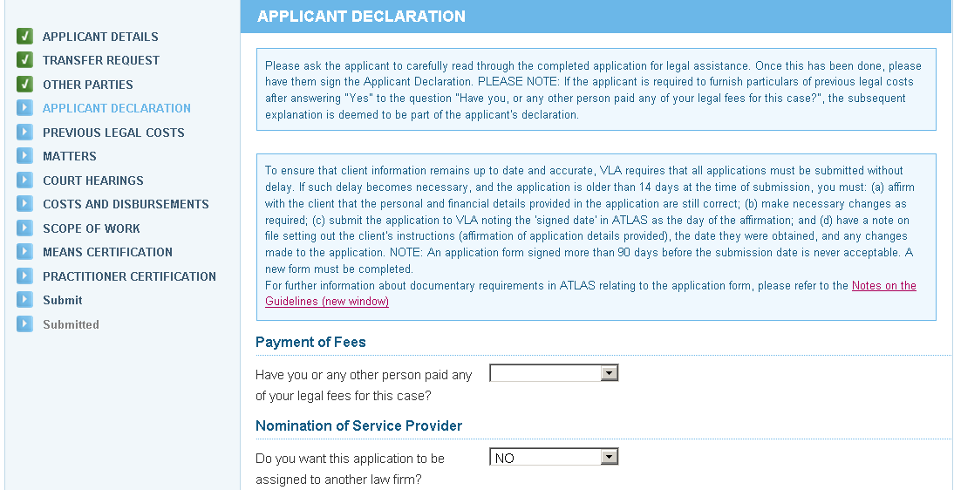

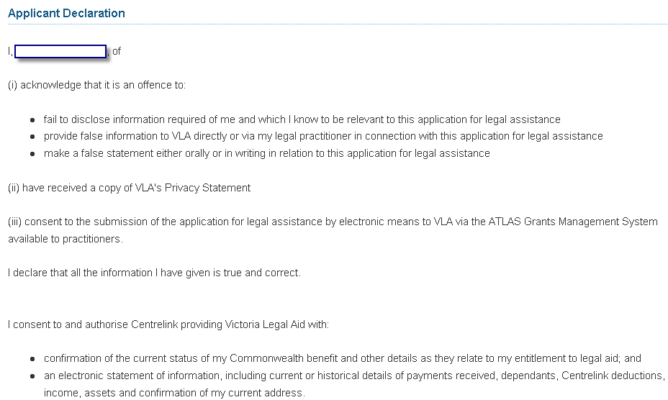

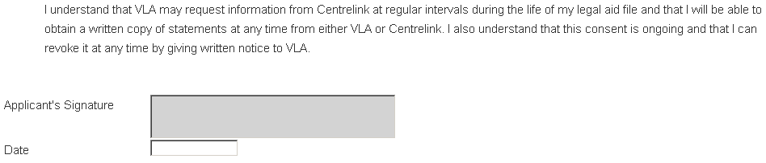

- The Matters screen will display. Complete the fields as required and select Next.
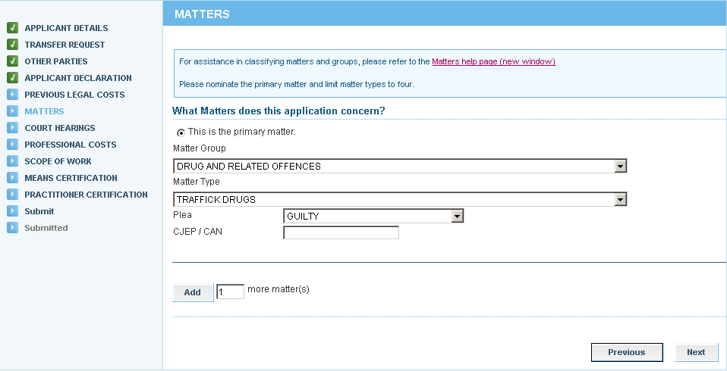

- The Court Hearings screen will display. Complete as required and select Next.
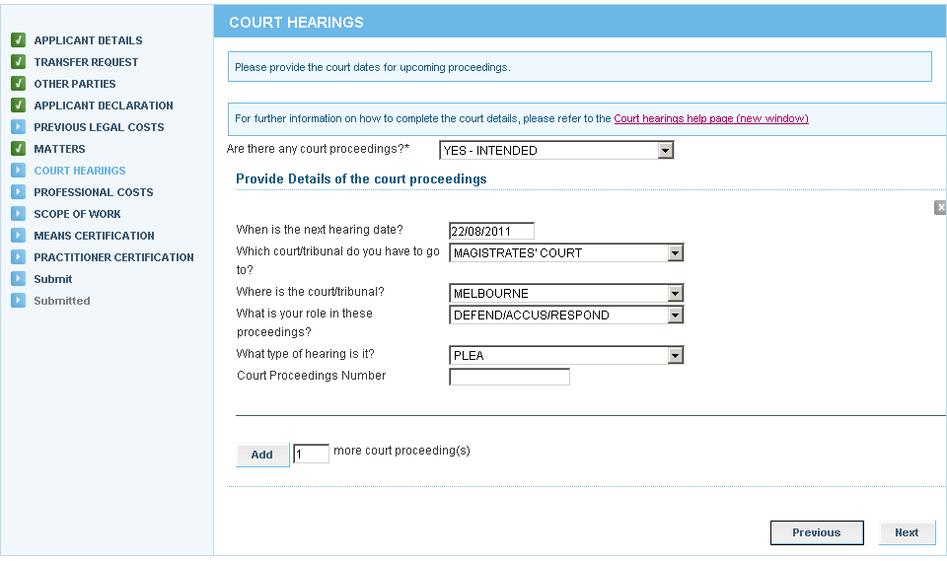

- The Costs and Disbursements screen will display. Complete and select Next.

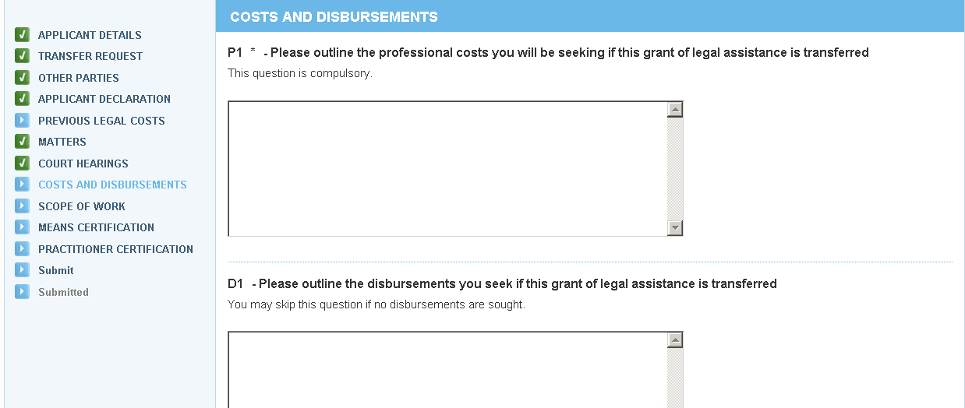

- The Scope of Work screen will display. This page remains blank until it has been processed by VLA.

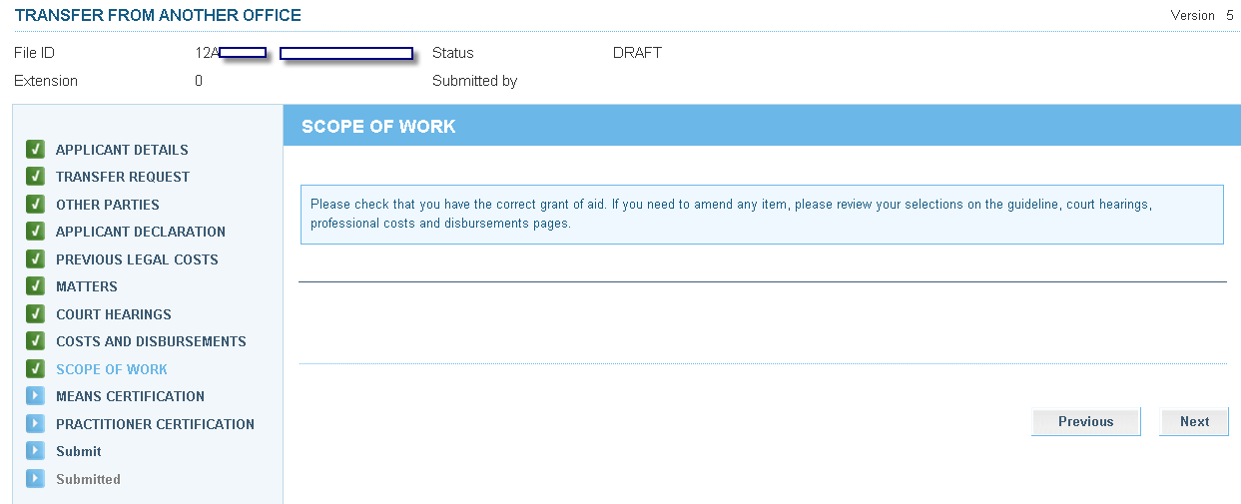

- The Means Certification screen will display. Select the appropriate certification and select Next.

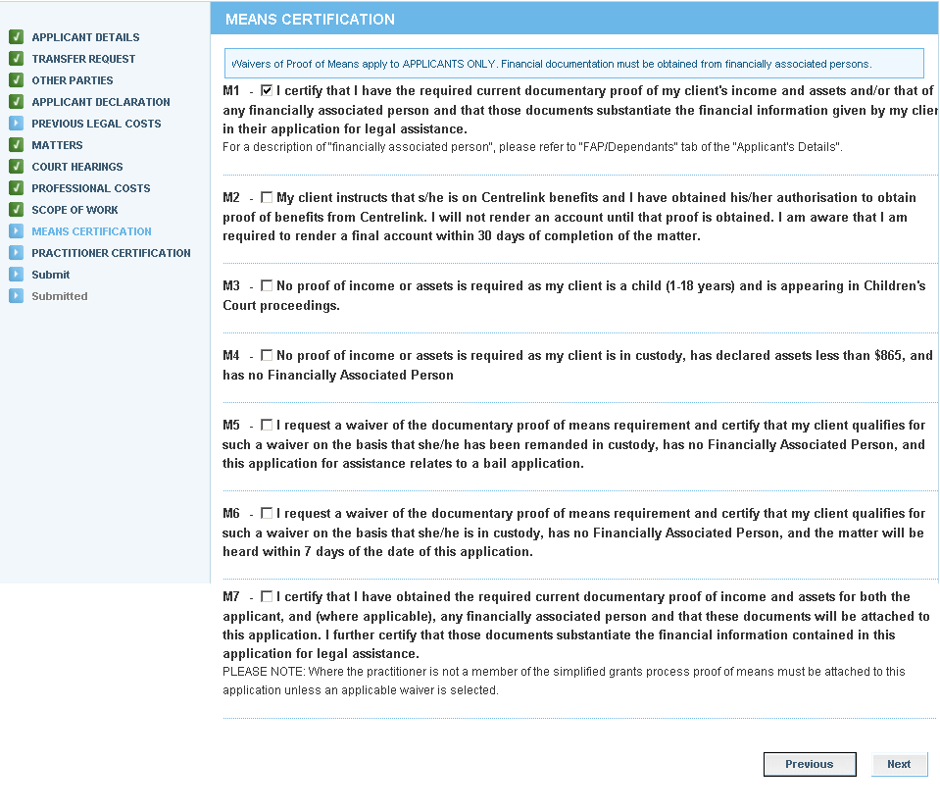

- The Practitioner Certification screen will display. The practitioner certifies that the application satisfies the applicable guidelines and merits tests. Complete the following fields and then select Next to proceed:
- Practitioner’s name (if not pre-populated)
Do not use symbols in any Reference field to avoid a systems error. Symbols are not compatible in ATLAS, for example:

. , / - + ( * ) ! @ # $ % ^ & _ *

- Date
- Practitioner’s Reference

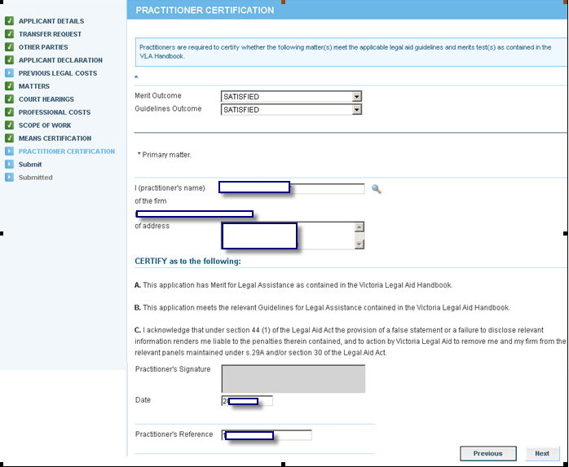

- The Submit screen will display. If the application is not ready for to be submitted, select Save to retain it as a draft or partially completed application. If required, Print a copy to be signed by the client. Select Submit to send it to Victoria Legal Aid for processing.

- 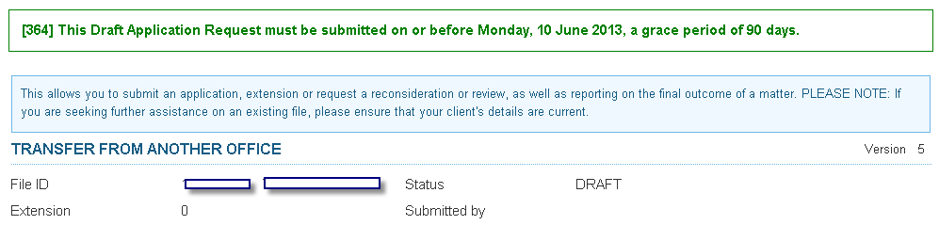
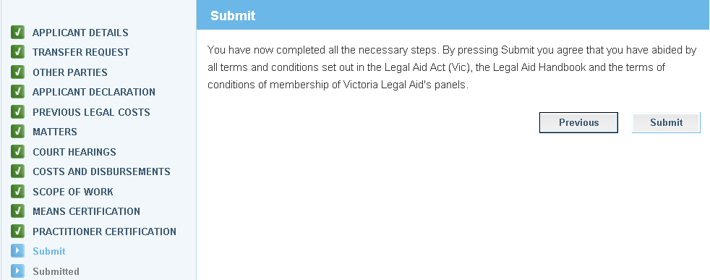
You can select
from the top menu if you want to submit at a later stage.

You can print a copy to be signed by the client prior to submitting.

- The Attach Supporting Documents screen displays. If you do not have any attachments, click Continue to proceed. To attach a document, click on Show File Upload Area.

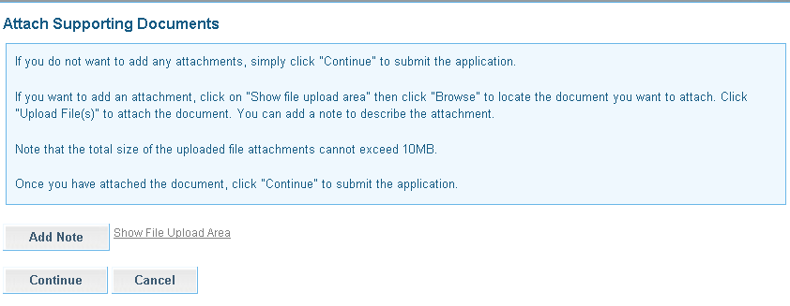

- The File Upload area will display. Click Browse and the Choose File dialogue box appears. Locate the file or document you wish to attach, click on Open to select it. The title of the selected document will populate in the field.
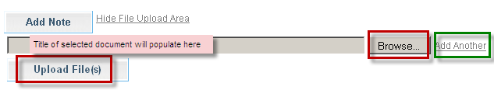

- Click Add Another if there are additional documents to be attached.

- Select Upload File.

- The File/Note Attachment grid will display with the relevant document(s).
To delete your attachment (if incorrectly attached) click the icon in the Action column.
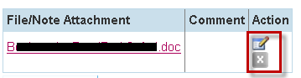

- To add or edit a Comment to describe the attachment, click the icon in the Action column.
Enter the comment, then click to save the comment. Click to delete the comment.

ATLAS has a 10 MB limit on the size of file attachments.

To avoid an error, split large attachments into two or more parts before attaching.

- To add a Note only, click Add Note.
Enter your Note and click to save the note or comment.
Click to delete the note or comment.

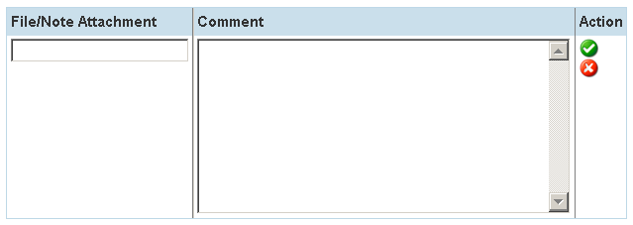

- Click Continue to submit the application. A message will display to confirm the application has been submitted successfully.

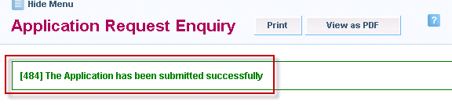

- Click either the Print or View as PDF button as required.



- A pdf copy of the extension application that has been submitted will be sent to your Inbox.

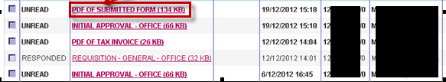

- The Transfer request is now completed. VLA Assignments will process the request to transfer the grant of assistance. They will send transfer notification letters to the:
- original assigned practitioner
- new practitioner
- client (unless the client has chosen not to receive any correspondence)

