Evaluation report: assessing the value of What’s the Law? Australian law for new arrivals
National Legal Aid- October 2013

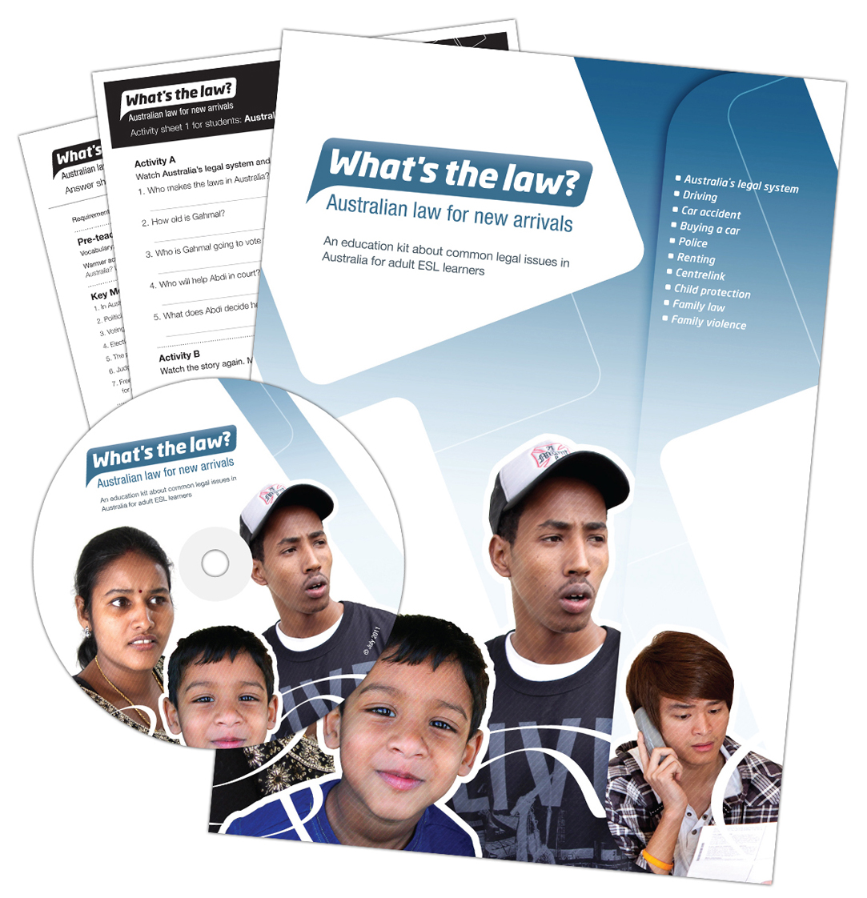
Monica Ferrari and Katie Fraser, October 2013

Acknowledgements
National Legal Aid (NLA) would like to acknowledge the resource Getting to know the law in my new country, produced by the Footscray Community Legal Centre in Victoria, which inspired the development of What’s the law? Australian law for new arrivals (WTL).
This report was authored by Monica Ferrari, Manager Community Legal Education, Victoria Legal Aid and Victorian representative on the NLA Community Legal Education Working Group. Katie Fraser, NLA Project Manager for the National Community Legal Education Strategy for New Arrivals, coordinated the production of WTL, developed the survey that informs this report, undertook data collection and drafted an initial report.
NLA would like to acknowledge the lead legal aid commissions involved in this project and the evaluation, Victoria Legal Aid, the Legal Services Commission of South Australia and Legal Aid Western Australia. Thanks also go to Minh Huynh, BAppSc (Psych), MAppSc (Stats), from the School of Mathematical and Geospatial Sciences, RMIT University, for the statistical and graphical analysis of the survey data and to Dr Diana Egerton-Warburton (MBBS, FACEM,
M Clin Epi), Southern Health, for advising on the representation of the data.
For more information about this report contact monicafe@vla.vic.gov.au
Table of Contents
Acknowledgements 2
Glossary 4
Acronyms 5
Introduction 6
What’s the law? Australian law for new arrivals 7
Executive Summary 8
Key findings 9
Respondents 9
The value of What’s the law? to respondents 9
The value of training 10
Reaching the target audience 10
The students and clients who receive What’s the law? 10
Methodology 10
Limitations 11
A.1 – What is your work role? 12
A.2 – How did you find out about the What’s the law education kit? 13
A.3 – Have you attended a training or presentation about What’s the law? 14
A.4 – Will the presentation or training you attended help you deliver What’s the law? 14
A.5 – Would training be useful in helping you use What’s the law? 14
A.6 – Will What’s the law have any of the following benefits? 16
A.7 – Do you know how to contact the legal aid commission in your state or territory? 17
A.8 – Would you feel confident to refer a student who needs legal help to a legal aid commission? 17
A.9 – Have you used the kit? 18
A.10 – Do you plan to use What's the law? 20
A.11 – Do you think What's the law will be useful in your work? 20
A.12 – How many sessions have you run using What's the law? 21
A.13 – How many students or clients have attended these sessions? 22
A.14 – Who attended these sessions? For example, did you deliver sessions to refugees or migrants? 23
A.15 – How long had the refugees or migrants in the audience been in Australia? 24
A.16 – Did you find What's the law a useful tool to provide information about legal issues? 25
A.17 – What did students or clients like about What’s the law? What didn’t they like? 26
A.18 – Are there stories that stand out as the most useful for your clients or students? 27
A.20 – Can we contact you in 12 months to ask you about your use of this resource? 28
Conclusion 29
Appendices 30
Appendix A – Q. 1 What is your work role? 30
Appendix B – Q. 2 How did you find out about the What's the law education kit? 32
Appendix C – Q. 4 Will the presentation or training help you deliver What's the law? 33
Appendix D – Q. 5 Would training be useful in helping you use What's the law? 33
Appendix E – Q. 6 Will What's the law have any of the following benefits? 35
Appendix F – Q. 9 Have you used the kit? 37
Appendix G – Q. 11 Do you think the What's the law will be useful in your work? 39
Appendix H – Q. 14 Who attended these sessions? E.g., did you deliver sessions to refugees or migrants? 39
Appendix I – Q. 16 Was What's the law a useful tool to provide information about legal issues? 41
Appendix J – Q. 17 What did students like about What's the law? What didn't they like? 43
• Appendix K – Q. 19 What other legal topics would be useful to cover in What's the law? 49
Appendix L – Survey instrument 52
References 1

Glossary
Categorical variables - a categorical variable can take on one of a limited, and usually fixed, number of possible values, for example, car make is a categorical variable.
Chi-square tests of association - a statistical test of the association between two categorical variables presented in a cross-tabulation.
Cross-tabulation - a statistical table showing the distribution of one categorical variable across the levels of another categorical variable.
Descriptive statistics - descriptive statistics describe the essential features of data using simple summaries and measures. Together with graphic analysis, descriptive statistics form the basis of quantitative analysis of data.
Inferential statistics - inferential statistics draw inferences about a population using sample data.
Modal response - the most frequent value in a distribution of data.
p-value - A p-value indicates the degree to which it is probably that a result didn’t happen by chance alone. The value is based on a ratio of 1:20. For every 20 times something happens, one time it will be by chance alone and nineteen times it is likely to be statistically real. Statistically, a p-value less than 0.05 is likely to be a true association. If a p-value is more than 0.05 the result is deemed not statistically significant. Note: p-value is arbitrary. For example, a p-value of 0.06 is likely to be a true association but it would not pass the p-value test.
Significance level – the significance level, usually set at 0.05, is the threshold used to make a decision about using a p-value (see above). If a p-value falls below the level of significance, the results of a statistical test are said to be statistically significant.
Variable - any characteristic, number or quantity that can vary in the population.

Acronyms
AMEP – Adult Migrant English Program
CALD – Culturally and linguistically diverse
CLE Community Legal Education
CLEWG – National Legal Aid Community Legal Education Working Group
DIAC – Department of Immigration and Citizenship
ESL – English as a second language
HSS – Humanitarian Settlement Services
LAW Survey – Legal Australia-Wide Survey: legal need in Australia
WTL – What’s the law? Australian law for new arrivals

Introduction
National Legal Aid (NLA) represents the Directors of the eight state and territory legal aid commissions (commissions) in Australia. The commissions are independent statutory authorities established under respective state or territory legislation. The commissions are funded by state or territory and Commonwealth governments to provide legal assistance to disadvantaged people.
The NLA Community Legal Education Working Group (CLEWG) is comprised of one representative from each commission, a Director of a commission, and the NLA Executive Officer. The CLEWG works to identify common issues and develop national community legal educational strategies and tools to leverage limited funds for the benefit of disadvantaged communities.
What’s the law? Australian law for new arrivals (WTL) was developed by the CLEWG. It is a legal education kit designed for use in the Adult Migrant English Program (AMEP). The kit is also applicable in community settings and in other ESL programs. The kit was developed in 2010-11 and distribution started in October 2011.
This evaluation report is based on a national survey of teachers and workers who received a copy of WTL. The evaluation aims to determine whether the kit is reaching its primary target audience, ESL teachers and relevant community workers. It also aims to assess the value of the kit in terms of how useful it is to teachers as an education tool, the benefits for teachers in using the kit and whether training helped teachers and workers to use the kit. Other research is underway to assess the impact of the kit on the attitudes of students.
Six legal aid commissions distributed the survey and the responses were collated by online Survey Monkey software (see Appendix L). The descriptive statistics and graphic analysis were provided by a statistician in the School of Mathematical and Geospatial Sciences at RMIT University in Melbourne.
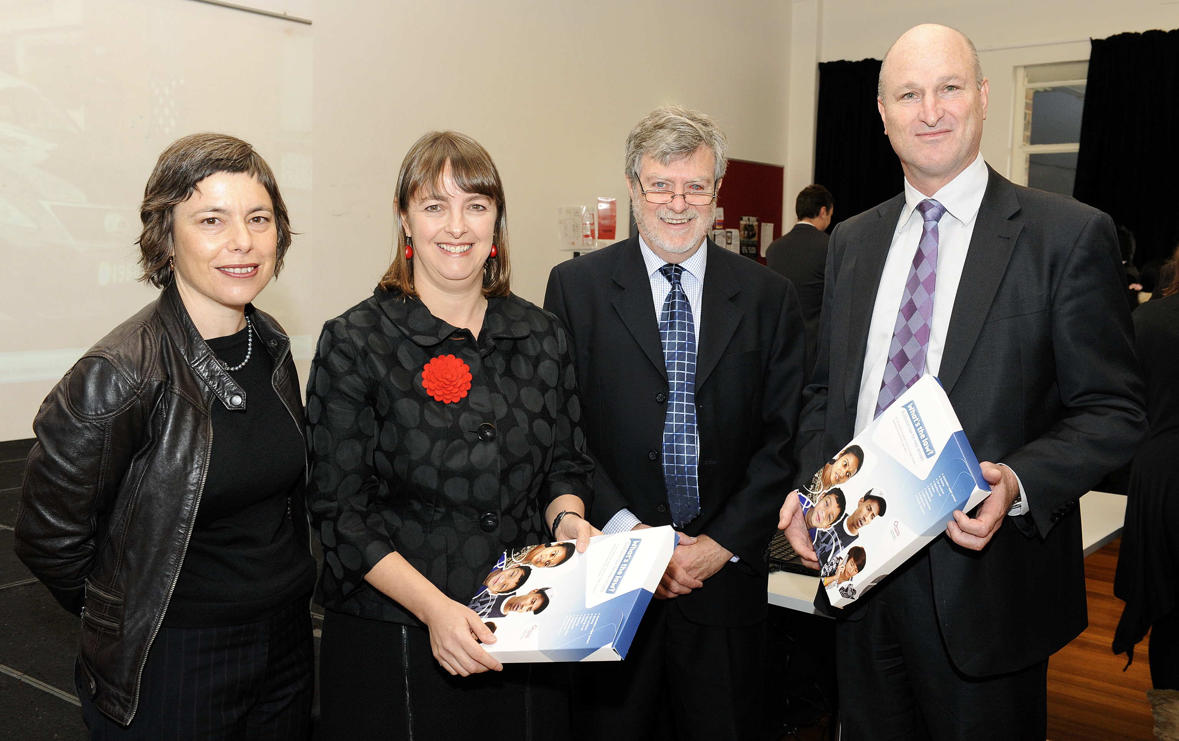
The Honourable Nicola Roxon, former Federal Attorney General, launches What’s the law? Australian law for new arrivals at Footscray Community Legal Centre, 2012. L-R. Monica Ferrari, Manager Community Legal Education, Victoria Legal Aid; Honourable Nicola Roxon, former Federal Attorney-General; Dennis Nelthorpe (AM), Manager Footscray Community Legal Centre; Bevan Warner, Managing Director, Victoria Legal Aid and Director with the National Legal Aid Community Legal Education Working Group.

What’s the law? Australian law for new arrivals
What’s the law? Australian law for new arrivals (WTL) is an education kit based on ten common legal issues faced by new arrivals in the first years of settlement. WTL is the central tool in a National Community Legal Education (CLE) Strategy for New Arrivals undertaken by the National Legal Aid Community Legal Education Working Group (CLEWG). The strategy was developed in response to the need to better inform new arrivals about their legal rights and responsibilities in Australia. It involved engaging with the Department of Immigration and Citizenship (DIAC) to gain endorsement of the kit and support for its promotion. The strategy also involved building relationships with Adult Migrant English Program (AMEP) providers to support the distribution and delivery of the kit. Commissions offered training or presenting to AMEP staff. This was also offered to some community services.
The national strategy was informed by a wide range of research produced by government agencies and the community sector about the pressing need to address preventable legal issues experienced by new arrivals. .
Research produced by Footscray Community Legal Centre and Katie Fraser, a community lawyer at the centre, directly informed the development of the national strategy . Fraser argues that to work effectively with newly arrived communities, agencies in the justice sector need to work more collaboratively and strategically. The evaluation of WTL represents the final stages in this collaborative, strategic national project.
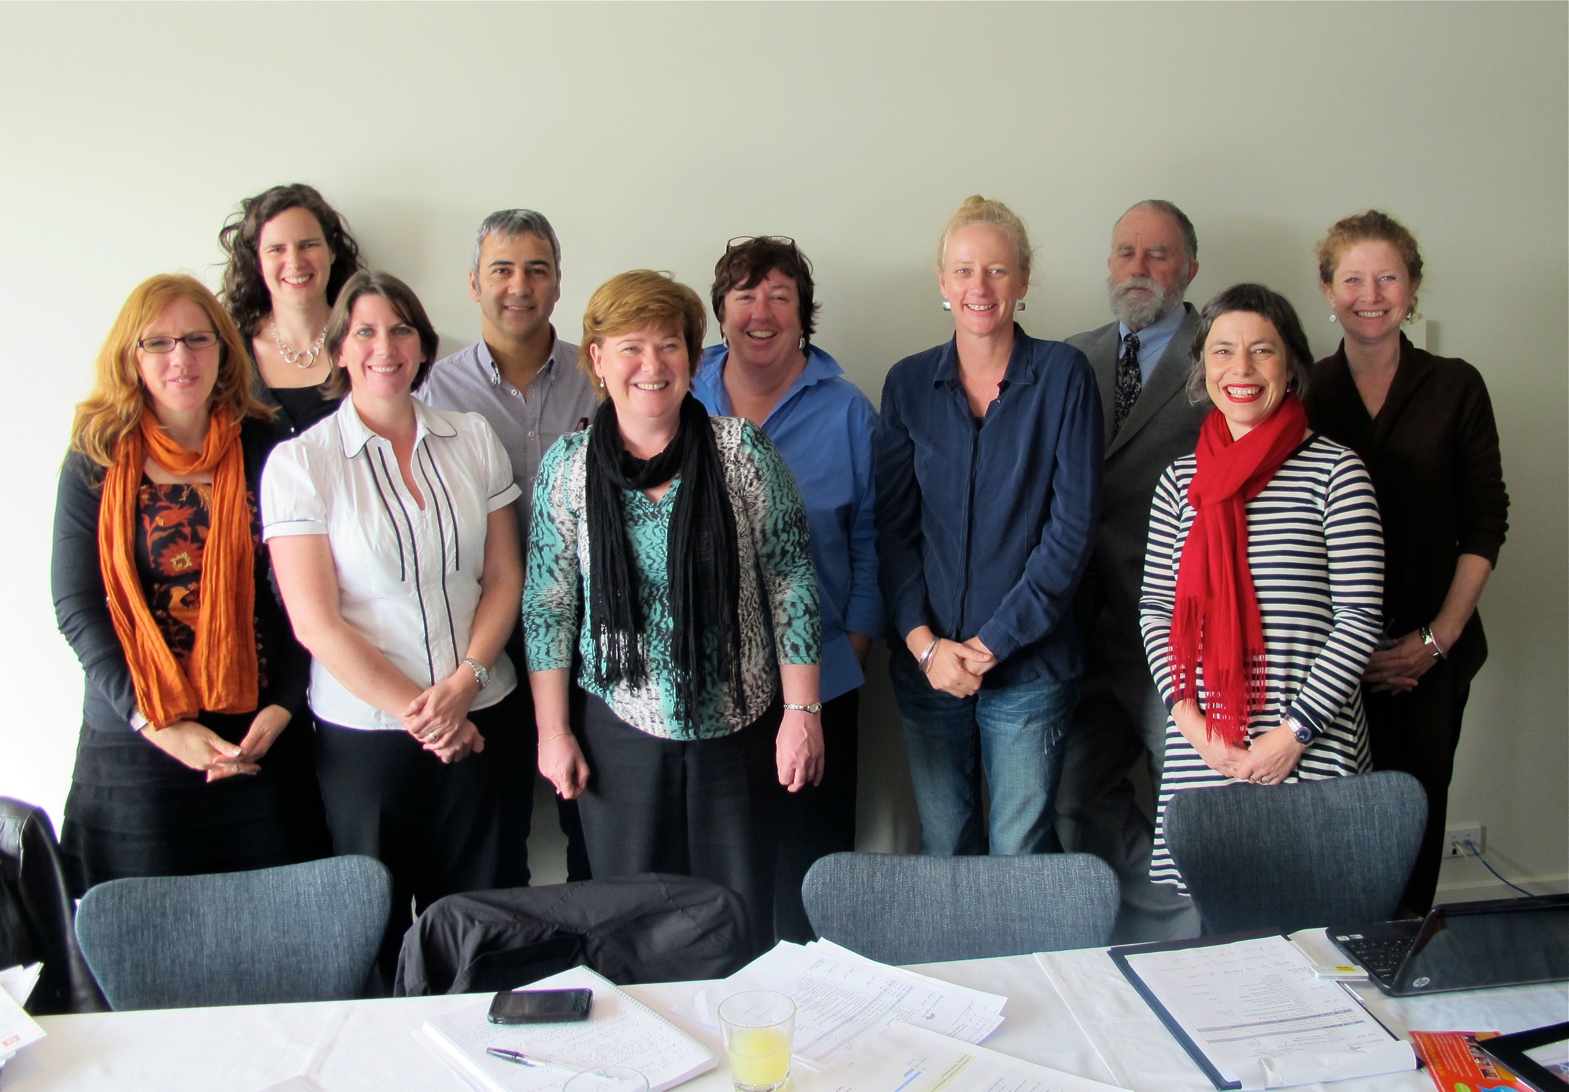
National Legal Aid Community Legal Education Working Group. L-R Linda Richards (QLD); Katie Fraser (Project Manager); Danielle McKee (TAS); George Hatzirodos (SA); Kirsten Cameron (NSW); Colleen Brown (WA); Fiona Hussin (NT); Geoff Stewart (ACT); Monica Ferrari (VIC), Lou Smith (Executive Officer, National Legal Aid ). Absent: Bevan Warner, Managing Director, Victoria Legal Aid and Director with the National Legal Aid Community Legal Education Working Group.

Executive Summary
- Two hundred and eighteen people responded to the survey. Over half the sample were in ESL teaching roles, the primary audience for WTL.
- Over half the respondents had used WTL and 97 percent of these respondents indicated that it was a useful tool to provide information about legal issues. A large majority also said they would use the kit more than twice.
- Ninety seven percent of respondents who hadn’t used the kit also perceived it as a useful tool for their work.
- The benefits of using the kit were identified as increasing the users' legal knowledge and their ‘ability to recognise a legal problem and refer a client’. Once respondents used the kit, they were more likely to identify an ‘increased confidence to teach legal issues’ and the ability to ‘meet requirements to provide legal education’ as benefits, which were primary reasons for creating WTL.
- Most respondents knew how to contact a legal aid commission and felt confident referring a student.
- Thirty six percent of respondents had attended training or a presentation about how to use WTL. Ninety-six percent of these respondents said this would help them deliver WTL. Of those who hadn't attended training, the majority indicated it would help them use WTL. This indicates an unmet need for training.
- Respondents reported that students like the kit because it is clear, simple and practical. They also commented on the relevance of the stories and actors to students and the effective use of humour to engage students.
- The topics that addressed legal issues around driving and renting were identified as the most useful to students.

Key findings

Respondents
The survey was sent to people who had received the kit and/or attended training or a presentation about how to use the kit. Two hundred and eighteen people responded to the survey. Most survey respondents were AMEP teachers (68) or community workers (67). A further 42 respondents were teachers, mostly working in an ESL setting. This indicates that over half (110) of the total sample were in teaching roles, the primary audience for WTL.

The value of What’s the law? to respondents
Over half the respondents (114) had used WTL and 97 percent of these respondents indicated that it was a useful tool to provide information about legal issues. A large majority said they would use the kit more than twice, with the majority indicating they would use it between two and five times. Teachers and workers will only use, and then re-use, high quality teaching resources that engage their students. This finding confirms the value of the kit to the primary audience and points to the likelihood that its preventive legal education content will reach more new arrivals than anticipated.
Benefits
Over half of the respondents identified the benefits of using WTL as ‘increasing their legal knowledge’ (105 /185). Respondents also identified other benefits as ‘increasing their confidence to teach legal issues’ and ‘helping them meet requirements to deliver legal education’. These results were strengthened once respondents used the kit. This is positive as the kit was developed, in part, following changes to the AMEP contract requiring providers to deliver legal education. It is therefore important that teachers and other workers have access to resources that increase their confidence to teach legal issues.
Capacity to make good referrals
Respondents were also asked if they knew how to contact a legal aid commission and whether they would feel confident referring a student to a commission. Of the 210 responses, 79 percent answered ‘yes’ to knowing how to contact a commission and 74 percent felt confident to refer clients. These are important outcomes given that non-legal professionals are widely recognised as the first point of contact for people with legal problems yet they have low levels of awareness about legal services (Australian Government, 2009, p.78; Coumarelos, 2012, p.218). While these professionals have ‘the potential to substantially enhance early legal intervention and resolution’, research has also indicated that they may not be well equipped to act as legal gateways based on limited knowledge of the law, insufficient knowledge to make appropriate legal referrals, lack of up-to-date legal information, limited capacity to provide legal help outside their core functions, and lack of well-established links with legal services (Clarke & Forell 2007; Forell et al. 2005; Karras et al. 2006; Scott & Sage 2001 in Legal Australia-Wide Survey: legal need in Australia). The findings of this survey suggest that community legal education tools such as WTL can, to some degree, address barriers that non-legal professions experience when acting as vital gateways to legal services.

The value of training
Of the 36 percent of respondents who had attended training or a presentation about how to use WTL, 96 percent said it would help them deliver WTL. This result points to the value of the training and presentations provided by commissions.
We also asked the respondents who hadn’t attended training if it would be of value to them. Of the 131 who responded, 93 (70 percent) indicated that training would help them use WTL. Again, this is not unexpected but does provide evidence of the need for training in how to use WTL with students and clients.
These findings demonstrate the value of engaging teachers and workers, through training and presentation, to support the delivery of WTL. This is pertinent given recommendations in the Legal Australia-Wide Survey: legal need in Australia that ‘Non-legal professionals could be more formally trained and equipped to identify legal problems and to more systematically provide timely referral to legal information and advice services’ .

Reaching the target audience
Direct mail was the most common and effective way for respondents to receive the kit (30 percent). A further 22 percent of respondents received the kit via an interagency meeting where a legal aid representative was likely to have spoken. Another 22 percent of respondents found the kit on a commission’s website. These results indicate that it is appropriate to continue to use multiple methods to distribute and promote the kit.

The students and clients who receive What’s the law?
Teachers and workers are delivering WTL to an equal number of migrants and refugees. This is expected given that the AMEP is delivered to both groups.
We collected qualitative data about what students liked or didn’t like about WTL. The most frequent comments were about the clarity, simplicity and practicality of the information in WTL (27), the relevance of the stories and actors to students (18) and the use of humour to engage and entertain students (17). A smaller number of respondents noted the content was too hard (5), while others noted it was too simple (5). See Appendix J for a full list of comments.
We also asked teachers to identify which of the ten digital stories were the most useful to clients or students? The stories about driving and renting were identified as the most useful, by a narrow margin. This finding is supported by other research and is unsurprising given the immediate needs of new arrivals for housing and transport. The least useful story was child protection. This also is not surprising given that this issue, compared with other issues covered in the kit, will affect a smaller proportion of students. Also, it is a sensitive topic and may not be as attractive to teach.

Methodology
The national survey was created between November 2011 and March 2012, in consultation with members of the National Legal Aid CLE Working Group. Commissions in all states and territories participated in the survey, apart from NSW and the ACT. Legal Aid NSW completed its own evaluation and Legal Aid ACT had not started to roll out WTL in time to use the national survey.
A link to the online survey was sent to people who had received the kit and/or attended training or a presentation about how to use the kit. Data was collected over a five month period: the first survey was logged on April 1st 2012 and the last on 26 September 2012. In total, 218 people started the survey and 204 completed it.
Due to a significant difference in state collection rates (see: Table 01) caution is advised when interpreting the results at a state level. For the purposes of this report, all of the survey responses have been collated into one group and the results have been analysed to provide a ‘national’ picture.
The survey was made up of multi-choice questions, some with an additional open-ended question to seek more information (see: Appendix L). Some multi-choice questions included an ‘other’ option, in case respondents were unable to select from existing options. The survey also included two open-ended questions. Not all respondents answered all questions and, as a result, the denominator changes throughout the results presented in this report.
This report primarily provides a quantitative analysis of data from the multi-choice questions. Analysis of qualitative data was undertaken in some cases, for example, where a large number of respondents selected the category ‘other’ and this selection skewed results. In this situation an informal thematic analysis was undertaken to group types of responses. These responses were then quantified and added in. Additional thematic and quantitative analysis was undertaken of Q. 17 What did students or clients like about WTL. What didn’t they like? This question was singled out because of the perceived value of the data. Analysis of the remaining open-ended questions was outside the scope of this evaluation report.
A normality test was applied to the quantitative data and confirmed that it normally distributed. Statistical tests, such as Chi-squared tests, were then applied to the data to determine whether the results demonstrate a true difference, or one that is by chance only.
Table 01. Distribution of respondents across states
State | Survey responses | % of Survey Responses
Victoria | 94 | 43%
Queensland | 41 | 19%
Northern Territory | 38 | 17%
South Australia | 25 | 12%
Western Australia | 18 | 8%
Tasmania | 2 | 1%
Total | 218 | 100%

Limitations
The data collection process did not include a calculation of the number of surveys that were sent out. It is therefore not possible to determine a response rate. However, the large number of responses to the survey means that it is likely to be representative. To build on the validity of this evaluation, future surveys should include the capacity to determine a response rate.
As discussed, caution should be applied to extrapolating the results nationally given that the ACT and NSW did not participate and there is a low response rate from Tasmania. However, the remaining regions are well represented. Future evaluations should endeavour to include all regions.
The report does not include an analysis of all open-ended questions. Any future development of the kit should be informed by a thematic analysis of these questions and, in particular, responses to the question ‘How could the kit be improved?’

Statistical Analysis

A.1 – What is your work role?
A total of 226 valid responses were provided. We note that the group with the largest number of responses (101) falls within the ‘other’ category. A full list of the other occupations has been provided in Appendix A.
An analysis of the responses in the ‘other’ category showed six AMEP teachers had incorrectly selected this category, increasing the total number of AMEP teachers from 62 to 68. It is also worth noting that a further 17 teachers in the ‘other’ category work in an ESL setting.
Sixteen community workers had also incorrectly nominated the ‘other’ category, taking this cohort from 53 to 67. After adjusting this data, well over half (135) of the responses were from the primary or secondary audience for the kit.
The most prevalent role nominated in the ‘other’ category was non-AMEP teacher or trainer. Aside from the 17 ESL teachers, we are uncertain if the remaining teachers work with CALD and new arrivals. However, it is fair to assume they had a connection to the target audience given they responded to the survey.
Table A.1 Descriptive statistics for respondent’s work role
What is your work role? | Response Count | Response Percentage
Other | 101 | 45%
AMEP teacher | 62 | 27%
Community worker | 53 | 24%
SGP worker | 7 | 3%
HSS worker | 3 | 1%
Total | 226 | 100%

A.2 – How did you find out about the What’s the law education kit?
A total of 218 valid responses were provided. The modal response was ‘It was sent to my organisation’ (28 percent). A further 18 percent of respondents found the kit on a legal aid commissions’ website or via an interagency meeting (15 percent). These percentages increased to 30 percent, 22 percent and 22 percent respectively following an analysis of the 'other' category, which showed that some respondents had selected the wrong category. A full list of the other methods of hearing about the kit has been provided in Appendix B.
Table A.2 Descriptive statistics for how respondents heard about the kit
How did you find out about the What’s the law education kit? | Response Count | Response Percentage
It was sent to my organisation | 62 | 29%
I saw it on the legal aid web site | 40 | 18%
Other | 53 | 25%
I heard about it at an interagency or network meeting | 33 | 15%
I saw it in a legal aid order form | 18 | 8%
I saw it in the AMES catalogue | 8 | 4%
I heard about it from DIAC | 4 | 1%
Total | 218 | 100%

Figure A.2 Bar chart for how respondents heard about the kit

A.3 – Have you attended a training or presentation about What’s the law?
A total of 218 respondents completed this question. Seventy-eight respondents (36 percent) had attended training and 140 (64 percent) hadn’t.

A.4 – Will the presentation or training you attended help you deliver What’s the law?
A total of 76 respondents (35 percent) answered this question, with 55 percent agreeing it would help them deliver WTL and a further 41 percent indicating it would help ‘to some extent’. Only three respondents indicated that training would not help them deliver WTL. This indicates the value of providing teachers and workers with support to deliver tools such as WTL. Participant’s qualitative responses for ‘how could the presentation have been improved,’ are provided in Appendix C.
Table A.4 Descriptive statistics for item 4 (Will the presentation/training help you deliver What’s the law?)
 | Observed N | Observed N (%)
Not at all | 3 | 4%
To some extent | 31 | 41%
Yes | 42 | 55%
Total | 76 | 100%

Figure A.4 Bar chart for whether presentation or training will help deliver What’s the law
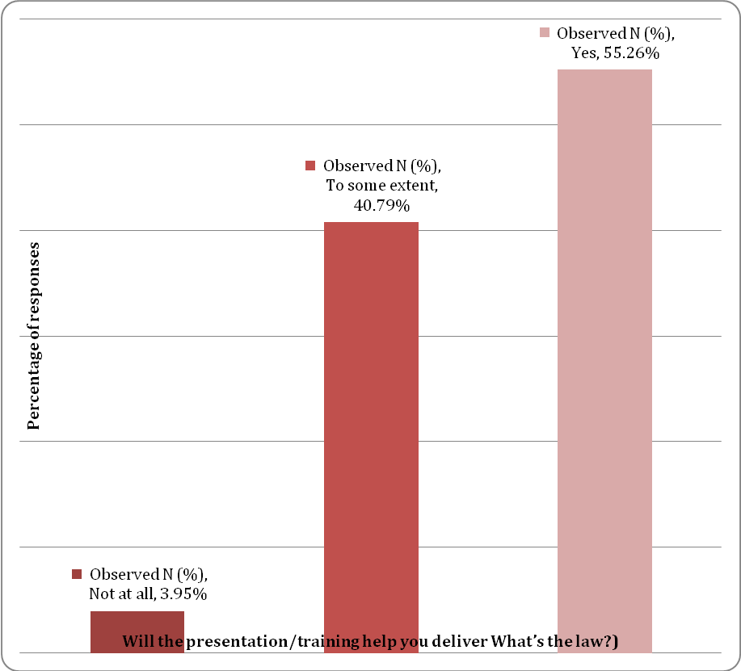

A.5 – Would training be useful in helping you use What’s the law?
This question was asked of the 140 respondents who didn’t attend training or a presentation about WTL. A total of 132 respondents (61 percent) provided a valid response to this item. The modal response for this item was that the ‘training would be useful in helping to use What’s the law?’ n = 54 (41 percent). When combined with other positive responses, 93 (70 percent) respondents indicated that training would be useful in helping them use WTL. A full list of responses for respondents who answered ‘Do you need more information about any specific topics’ is provided in Appendix D.
Table A5. Descriptive statistics for item 5 (Would training be useful in helping you use What’s the law?)
Would training be useful in helping you use What’s the law? | Response Count | Response Percentage
Useful | 54 | 41%
Quite useful | 20 | 15%
Very useful | 19 | 14%
Not very useful | 33 | 25%
Not useful at all | 6 | 5%
Total | 132 | 100%

Figure A.5 Would future training help respondents use What’s the law?

A.6 – Will What’s the law have any of the following benefits?
A total of 185 respondents (84.86 percent) provided valid responses for this question (with multiple selections being permitted). The modal response for this item was ‘increase my legal knowledge,’ with 103 respondents (55.68 percent) selecting this option. A full list of ‘other benefits’ as identified by respondents is provided in Appendix E.
It is worth noting that approximately half of the respondents had not used the kit, which may explain why there is a lower response rate to some benefits. The relationship between using the kit and its benefits are explored further in A.9.
Table A.6 Descriptive statistics for perceived benefits
Will What’s the law have any of the following benefits? | Response Count | Response Percentage
Increase my legal knowledge | 103 | 55%
Enable me to recognise a legal problem and refer a student/client to a lawyer | 81 | 44%
Increase my confidence to teach legal issues | 73 | 39%
Help me to meet requirements to provide legal education | 67 | 36%

Figure A.6 Bar chart for perceived benefits

A.7 – Do you know how to contact the legal aid commission in your state or territory?
A total of 210 respondents (96 percent) provided a valid response for this question, with the majority of respondents (79 percent) stating that they do know how to contact the legal aid commission in their state or territory.

A.8 – Would you feel confident to refer a student who needs legal help to a legal aid commission?
A total of 210 respondents (96 percent) provided a valid response for this question.
Table A.8 Descriptive Statistics comparing item 7 and item 8
 | Do you know how to contact the legal aid commission in your state or territory? |  |  | Would you feel confident to refer a student or  client who needs legal help to the legal aid  commission In your state or territory?
 | Response Count | Response Percentage |  | Response Count | Response Percentage
Yes | 165 | 79% |  | 155 | 74%
To some extent | 36 | 17% |  | 46 | 22%
Not at all | 9 | 4% |  | 9 | 4%
Total | 210 | 100% |  | 210 | 100%

Figure A.8 Bar chart for confidence to refer
0.00%
20.00%
40.00%
60.00%
80.00%
100.00%
120.00%
Yes
To some extent
Not at all
Total
Confidence to refer
Percentage of participants

A.9 – Have you used the kit?
Two hundred and eight people responded with 114 (54 percent) answering ‘yes’ and 98 (46 percent) answering ‘no’. The majority of people who hadn’t used the kit said it was because they had only just received it. See Appendix F for a full list of reasons why respondents hadn’t used the kit. To avoid violating the assumption of independence, multiple chi-square tests of association were conducted to determine if there was significant relationship between using the kit and perceived benefits (item 6 of the survey).
There was a significant association for the second perceived benefit (Meet requirements to provide legal education) and the third perceived benefit (Increase my confidence to teach legal issues), χ²(1,N=212)=10.09, p=.001 and χ²(1,N=212)=23.57, p<.001. This indicates that once respondents used the kit, they were more likely to feel able to ‘meet requirements to provide legal education’ and it ‘increases their confidence to teach legal issues’.
There was no significant association for the first and forth comparisons, χ²(1,N=212)=.18, p=.67 and χ²(1,N=212)=.02, p=.89. In relation to the first comparison, the perception of ‘increased legal knowledge’, the data suggests that regardless of usage there is a 50/50 chance that respondents will nominate this benefit. This suggests that half of the target audience feel confident about their existing legal knowledge.
With the fourth comparison, the data suggests that regardless of usage, respondents do not perceive that WTL will assist them to ‘recognise a legal problem and refer’ students. This result is not surprising given the majority of respondents (155/210) indicated in Q. 8 that they are confident to refer a client to a legal aid commission.
Table A.9.1. Cross-tabulation of usage of kit and perceived benefits (Increased my legal knowledge)
Note: If you use assistive technology such as a screen reader and require tables A.9.1. to A.9.4. below in an accessible format, please contact Community Legal Education at Victoria Legal Aid on email cle@vla.vic.gov.au or phone (03) 9269 0223.

 |  |  | Perceived benefit -  (Increased my legal knowledge) |  | Total
 |  |  | No | Yes | Total
Have you used the kit? | No |  | 51 (24%) | 47 (22%) | 98 (46%)
Have you used the kit? | Yes |  | 56 (26%) | 58 (28%) | 114 (54%)
Total |  |  | 107 (50%) | 105 (50%) | 212 (100%)
Table A.9.2. Cross-tabulation of usage of kit and perceived benefits (Meet requirements to provide legal education)
 |  |  | Perceived benefit -  (Meet requirements – legal ed.) |  | Total
 |  |  | No | Yes | Total
Have you used the kit? | No |  | 79 (37%) | 19 (9%) | 98 (46%)
Have you used the kit? | Yes |  | 69 (33%) | 45 (21%) | 114 (54%)
Total |  |  | 148 (70%) | 64 (30%) | 212 (100%)
Table A.9.3. Cross-tabulation of usage of kit and perceived benefits (Increase my confidence to teach legal issues)
 |  |  | Perceived benefit -  (Increased confidence to teach legal) |  | Total
 |  |  | No | Yes | Total
Have you used the kit? | No |  | 81 (38%) | 17 (8%) | 98 (46%)
Have you used the kit? | Yes |  | 58 (28%) | 56 (26%) | 114 (54%)
Total |  |  | 139 (66%) | 73 (34%) | 212 (100%)
Table A.9.4. Cross-tabulation of usage of kit and perceived benefits (Recognise a legal problem and refer)
 |  |  | Perceived benefit -  (Recognise legal problem and refer) |  | Total
 |  |  | No | Yes | Total
Have you used the kit? | No |  | 61 (29%) | 37 (17%) | 98 (46%)
Have you used the kit? | Yes |  | 72 (34%) | 42 (20%) | 114 (54%)
Total |  |  | 133 (63%) | 79 (37%) | 212 (100%)

Figure A.9 Bar charts for usage of kit and perceived benefits
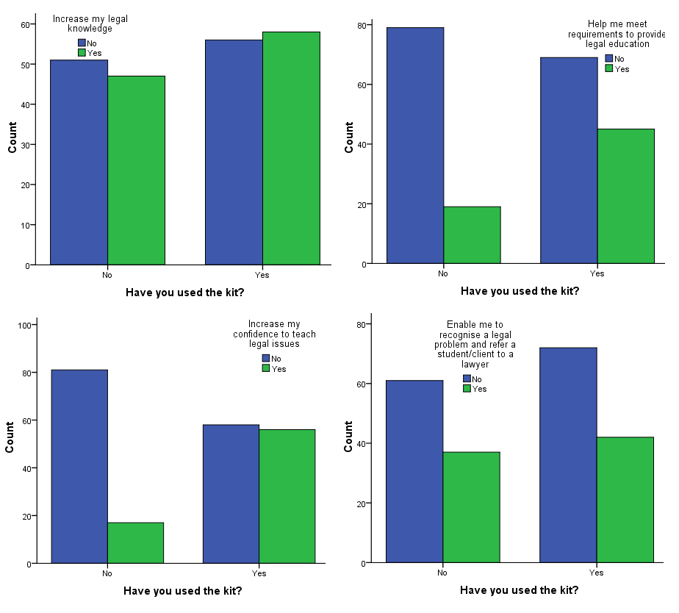

A.10 – Do you plan to use What's the law?
We asked people who had not used WTL whether they planned to use it in the next year. Ninety-eight people responded to this question with 50 percent reporting they were unsure when they would use the kit. Of the 47 people who planned to use it, most were planning to do so in the next three months (25).
When do you intend to use What's the law? | Response count | Response percentage
3 months | 25 | 25.50%
6 months | 14 | 14.30%
12 months | 8 | 8.20%
Unsure | 49 | 50%
Never | 2 | 2%
Total | 98 | 100.00%

Figure A.10 Bar chart for number of sessions of using What's the law?

A.11 – Do you think What's the law will be useful in your work?
We also asked people who had not used the kit whether they thought it would be useful in their work. Of the 95 responses, 94 (97 percent) indicated the kit would be useful.
It is not surprising that people who had used the kit were more likely to nominate that the kit would be ‘very useful’ in their work, whereas people who hadn’t used the kit (98) were more likely to nominate it as potentially ‘useful’. Regardless of usage, 97 percent of respondents confirmed the usefulness of the kit in their work.

A.12 – How many sessions have you run using What's the law?
This question was asked of respondents who had used WTL. A total of 99 respondents (45 percent) provided a valid response for this question, with the modal response (55 percent) coming from respondents who intend to run '2-5' sessions of WTL.
Table A.12 Descriptive statistics for number of sessions of using What's the law?
How many sessions have you run using What's the law? | Response Count | Response Percentage
One | 25 | 25%
2-5 | 55 | 56%
6-10 | 11 | 11%
11 or more | 8 | 8%
Total | 99 | 100%

Figure A.12 Bar chart for number of sessions of using What's the law?

A.13 – How many students or clients have attended these sessions?
A total of 98 respondents (45 percent) provided a valid response for this question, with the modal response (50 percent) coming from respondents who selected '11-30.'
Table A.13 Descriptive statistics for number of students/clients that have attended the sessions
How many students or clients in total have attended these sessions? | Response Count | Response Percentage
Less than 10 | 28 | 29%
11-30 | 49 | 50%
31-50 | 10 | 10%
51 or more | 11 | 11%
Total | 98 | 100%

Figure A.13 Bar chart for number of students or clients attending sessions

A.14 – Who attended these sessions? For example, did you deliver sessions to refugees or migrants?
Respondents have the option of selecting refugees or migrants, or both. A full list of 'other' attendees has been provided in Appendix H. This question was only asked of respondents who had run a What's the law? session.
Table A.14 Descriptive statistics detailing the type of people that attended the sessions.
Who attended the sessions? | Response Count | Response Percentage
Refugees | 67 | 75%
Migrants | 70 | 79%

Figure A.14 Bar chart for detailing the type of people that attended the sessions.

A.15 – How long had the refugees or migrants in the audience been in Australia?
A total of 97 respondents (45 percent) provided a valid response, with the modal response (41 percent) stating that 'most had been here less than 12 months.' This question was only asked of respondents who had run a What's the law? session.

Table A.15 Descriptive statistics for duration of attendees in Australia
How long had the refugees or migrants in the audience been in Australia? | Response Count | Response Percentage
Most had been here less than 12 months | 40 | 41%
Most had been here more than 12 months but less than 5 years | 30 | 31%
Most had been here more than 5 years | 5 | 5%
The audience was from a mix of backgrounds | 19 | 20%
I'm not sure | 3 | 3%
Total | 97 | 100%

Figure A.15 Bar chart for duration of attendees in Australia

A.16 – Did you find What's the law a useful tool to provide information about legal issues?
This question was asked of the 114 respondents who had run a What's the law? session and there were 101 responses. The majority of responses (46 percent) came from respondents who found the kit to be a 'very useful' way to provide legal information. The vast majority of respondents (97 percent) identified that WTL was a useful tool to provide information about legal issues. A full list of qualitative suggestions for 'How could What's the law? be improved' is provided in Appendix I.
Table A.16 Descriptive statistics for usefulness of What's the law?
Did you find What's the law a useful tool to provide information about legal issues? | Response Count | Response Percentage
Not useful at all | 2 | 2%
Not very useful | 1 | 1%
Useful | 25 | 25%
Quite useful | 26 | 26%
Very useful | 47 | 46%
Total | 101 | 100%

Figure A.16 Bar chart for usefulness of What's the law?

A.17 – What did students or clients like about What’s the law? What didn’t they like?
This was an open-ended question. There were 77 responses to this question with many respondents raising multiple points. These points were reviewed and grouped into themes. A point was allocated each time a particular theme was referenced. This process indicated that positive themes (13) outweighed negative themes (7). There were also fewer negative points made. The negative points were mostly that the content was too hard for clients (five references) or too easy for clients (two references). The most frequent positive comments were about the clarity, simplicity and practicality of the information in WTL (27), the relevance of the stories and actors to students (18) and the use of humour to engage and entertain students (17). See Appendix J for a full list of comments.

A.18 – Are there stories that stand out as the most useful for your clients or students?
Ninety-three respondents answered this question. The most useful stories were identified as ‘driving’ (57 percent) and ‘renting’ (47 percent). The least useful story was child protection. Question 19 asked respondents to identify other topics that could be covered in WTL. The most commonly requested topics were consumer law (buying a phone, dealing with debt), going to court, going to see a lawyer, discrimination, workplace issues, and the consequences of legal issues (e.g. criminal records and what they mean). A full list of ‘other topics’ are listed in Appendix K.
Stories that stand out as the most useful | Response count | Response percentage
Driving | 53 | 57.00%
Car accident | 38 | 40.90%
Buying a car | 34 | 36.60%
Police | 34 | 36.60%
Renting | 44 | 47.30%
Centrelink | 22 | 23.70%
Child protection | 19 | 20.40%
Family law | 22 | 23.70%
Family violence | 29 | 31.20%

A.20 – Can we contact you in 12 months to ask you about your use of this resource?
Cross-tabulations of item 20 (Can we contact you in 12 months?) against item 3 (Have you attended a training/presentation session?) and item 9 (Have you used the kit?) are provided below. Chi-square analyses indicated that there was no significant association for both comparisons, χ²(1,N=200)=.51, p=.48 and χ²(12,N=197)=.29, p=.59 respectively. These results suggest that irrespective of attending a training/presentation session or having used the kit, respondents more likely to allow the researchers to contact them again in 12 months. This indicates good will from respondents.
Note: If you use assistive technology such as a screen reader and require tables A.20.1 and A.20.2 below in an accessible format, please contact Community Legal Education at Victoria Legal Aid on email cle@vla.vic.gov.au or phone (03) 9269 0223.

Table A.20.1 Cross-tabulation of future contact and having attended a training/presentation
 |  |  | Have you attended a training/presentation about What's the law? |  | Total
 |  |  | No | Yes | Total
Can we contact you in 12 months to ask about your use of this resource? | No |  | 34 (17%) | 17 (8%) | 51 (25%)
 | Yes |  | 91 (46%) | 58 (29%) | 149 (75%)
Total |  |  | 125 (63%) | 75 (37%) | 200(100%)

Table A.20.2 Cross-tabulation of future contact and having used the kit
 |  |  | Have you used the kit? |  | Total
 |  |  | No | Yes | Total
Can we contact you in 12 months to ask about your use of this resource? | No |  | 25 (13%) | 25 (13%) | 50 (26%)
 | Yes |  | 67 (34%) | 80 (40%) | 147 (74%)
Total |  |  | 92 (47%) | 105 (53%) | 197(100%)

Figure A.20 Bar charts for future contact
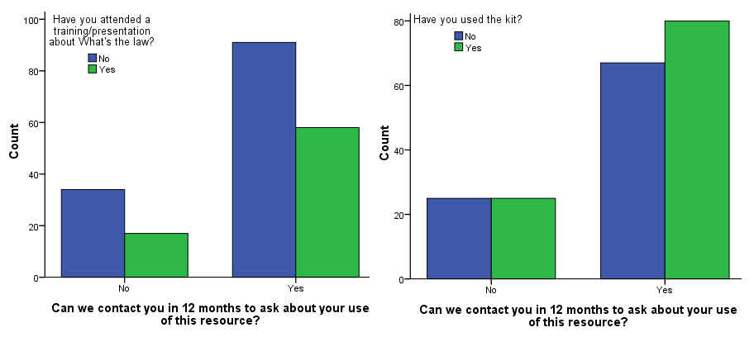

Conclusion
This evaluation set out to determine whether the teachers’ kit What’s the law? Australian law for new arrivals reached its primary target audience; ESL teachers and community workers. It also aimed to assess the value of the kit in terms of its usefulness to teachers as an education tool, the benefits to teachers in using the kit and whether training helped teachers to use the kit.
The evaluation confirms that WTL is reaching its primary audience, ESL teachers and relevant community workers. It also provides data that confirms the usefulness of the kit for 97 percent of this audience, with most planning to use the kit multiple times. This is a positive result as teachers and workers will only use, and then re-use, high quality teaching resources that engage their students.
A primary purpose of the kit is to give teachers and workers a resource that will increase their confidence to teach legal issues. Once teachers and workers use the kit, half of them confirm that this is the outcome. This is encouraging given that approximately 30 percent of respondents identified they were part of the AMEP program.
The evaluation shows that there is also a positive link between respondents participation in training or a presentation about WTL and their subsequent ability to use the kit. This is particularly relevant given the LAW Survey emphasises the need to formally train and equip non-legal workers to identify legal problems in order to provide timely referral to legal information and advice services . This evaluation confirms that respondents are both confident to refer clients to legal services and also that they value and benefit from training.
The evaluation also identified an unmet need for training. Some legal aid commissions have well established training programs for workers who support new arrivals and other CALD communities. Other commissions have built on opportunities provided by WTL to extend their work in this area. The findings in this evaluation encourages commissions, and other legal service providers, to consider the relative weight given to training and suggests there is further potential to seek partnerships and funding to increase this type of activity.
The National CLE Strategy for New Arrivals works on different levels to develop and deliver an effective CLE tool for non-legal staff. It works ‘on the ground’ to address barriers for non-legal workers, identified in the LAW Survey, such as a lack of legal knowledge, nominated by the majority of respondents as a primary benefit of the kit. It also worked strategically, enabling commissions to build or extend existing relationships with AMEP providers and other projects have developed as a result. As indicated in the LAW Survey, these kinds of links between services and sectors are critical in ensuring access to legal services for disadvantaged clients.
The findings of this survey indicate that WTL is a useful tool with a range of benefits for non-legal workers in the ESL and community sector. There is an opportunity to build on these findings through further evaluation. There is also an opportunity for further analysis of the responses to open-ended questions to inform the future development of What’s the law? Australian law for new arrivals.

Appendices

Appendix A – Q. 1 What is your work role?
Work role | qty
AMEP & Neighbourhood House Volunteer | 1
AMEP Student Counsellor | 1
AMEP Tutor | 2
AMEP Home tutor | 1
CALD project officer, Relationships Australia | 1
CLC Lawyer | 1
CLE worker from a CLC | 1
Commerce teacher | 1
Community Based Detention EAL Teacher - Secondary | 1
Community citizen being harassed by the Caulfield Police | 1
Community Detention Case Manager | 1
Co-ordinator AMEP | 1
Cultural officer | 1
Curriculum leader in an IEC | 1
Customer service rep - City Council | 1
English Home Tutor | 1
ESL Home Tutor | 1
ESL Pre-accred teacher | 1
ESL Specialist Coach | 1
ESL teacher | 3
ESL teacher (students above AMEP level) | 1
ESL teacher in a neighbourhood house | 1
ESL tutor | 1
ESL tutor at neighbourhood house | 1
ESOL TAFE teacher | 1
Family Dispute Resolution Practitioner | 1
FARS Project Worker | 1
Financial Counsellor | 3
FLPN Project Officer | 1
Government | 1
LAMP Officer | 1
Lawyer | 2
Lecturer | 2
Legal Studies Teacher | 1
Librarian | 1
Library manager | 1
Literacy lecturer | 1
LLNP Lecturer | 1
LLNP teacher | 3
Local church minister | 1
Manager | 2
Mental Health/Training | 1
Multicultural Service Officer with Department of Human Services (Centrelink) | 1
NT Police Youth Engagement Officer | 3
NTLAC employee - Family Dispute Resolution Service | 1
Orientation Program Coordinator | 1
Police Officer | 4
Policy team member, state government department | 1
Program Manager | 1
Programs manager detention | 1
Public Servant | 2
Public Servant - Program Manager | 1
Public Servant NT Government, Safe Places Coordinator | 2
Sales team member | 1
School Police Officer | 1
Secondary school teacher | 3
Service advisor | 1
Service Manager | 1
Social worker | 1
Solicitor | 2
St. V.D.P Financial Counsellor | 1
Student | 1
Student in Advance dip of justice | 1
TAFE ESL teacher | 1
TAFE lecturer | 1
TAFE lecturer, Trades | 1
TAFE teacher | 1
TAFE Teacher delivering Cert in Transition Education course for students with learning needs and disabilities | 1
Teach legal studies to Horn of Africa mature aged students at VU TAFE | 1
Teacher | 1
Trainer of Interpreters and Translators | 1
Trainer with employment agency | 1
Unemployed | 1
VCAL teacher | 1
Volunteer | 1
Volunteer ELS tutor | 2
Volunteer Tutor Program Manager | 1
Volunteer tutor to newcomers of non-English background | 1
Youth Worker | 2
Total | 101

Appendix B – Q. 2 How did you find out about the What's the law education kit?
How respondent found out | Qty
Advertised in NT News | 1
At a workshop on legal literacy for new arrivals (What's the Law)? | 1
At the workshop - "What's the law" | 1
Browsing the internet | 7
Colleague told me about it | 2
Demonstrated at ES workshop | 1
Email | 2
Email distribution list | 2
Email from colleague | 2
Email from manager re feedback on resource | 1
ES Conference | 1
ES conference handouts | 1
Family Law Pathways Network | 2
Found it on TELLS Intranet class resources | 1
From a contact at NT Legal Aid Commission | 1
From multicultural worker | 1
heard about it at the FECCA conference | 1
Heard about it from Katie | 1
Heard from a contact at NT Legal Aid Commission | 1
I had the previous version of it and heard there was an update | 1
I Heard about it at TAFE | 1
I heard about it in the office | 1
I never saw or heard anything about it | 1
I received a copy from the presenter of a talk arranged for my students | 1
I received it during a workshop in LSC | 1
I saw it at ELS TAFE | 1
Interest | 1
Involved in development | 1
It's part of our resource bank | 1
Legal Aid brought it to us | 1
Networking prior to production | 1
NT Legal Aid Commission | 1
PD Legal Aid W.A | 1
Presentation | 1
Presentation at Stakeholder meeting | 1
Professional Development Day | 1
Received info from the Darwin FLPN | 1
Resources on our Library shelves | 1
There was a presentation at our agency | 1
Through NT Legal Aid Commission worker | 1
Through other staff | 1
Virtual ILC linked to Victorian kit - sought it for our use | 1
The contact details were on the back of another brochure we had from legal aid and I then saw the website | 1

Appendix C – Q. 4 Will the presentation or training help you deliver What's the law?

How could the presentation have been improved?
- Audio visual aids did not function properly
- Excellent resources
- Have the kit available before the session
- It was great!
- It was more of an overview of why the kit was developed
- It will help me promote it - we do not offer a direct service therefore cannot deliver the kit
- Not relevant to my work
- Possibly by using a slower pace and giving the students more time to familiarise themselves with the topics
- The DVD presentation needs to show the correct process that the new immigrants need to follow.
- The DVD presented could have reflected NT examples, scenarios
- Unfortunately I was unable to stay for the whole thing so have no feedback on this
- Whilst not intending to deliver 'What's the law?' it is a useful resource for the community, and community based organisations who have direct contact with clients

Appendix D – Q. 5 Would training be useful in helping you use What's the law?

Do you need more information about any specific topics?
Information needed | Qty
A copy | 1
Consumer rights | 1
Drink Driving | 1
English class many are getting learners' permits and licences in preparation for work. | 1
Gearing publications for school | 1
Haven't used it yet the Te will be using it in the next month. A brief overview would be helpful - perhaps a video link on your website because travelling is difficult for us (we are RRR) | 1
How to make it suitable for volunteers to use | 1
I work with young people so a lot of them are interested in their rights and the law. | 1
In relation to apply "what's the law" against Victoria Police | 1
LAND LAW AND ADMINISTRATIVE LAW | 1
Legal issues relating to children and immigration visa issues when there is family Violence would be useful | 1
More detail - more scenes on renting buying a car Centrelink etc | 1
No | 5
Not at this stage | 4
Not really reasonably familiar with them all there may be specifics or details that would be good to know about | 1
Only if it could be pitched to ESL (English as a Second Language) learners | 1
Only wanted to provide the resources for the teacher | 1
Road rules practical tests popular with my student but very hard to find online from Qld Transport recently | 1
The driving clips and worksheets look good for my low level LLNP | 1
Using public transport - purchasing tickets and the police move on laws | 1
Using public transport and fare evasion penalties | 1
Yes | 2

Appendix E – Q. 6 Will What's the law have any of the following benefits?

Other (please describe):
- An extra resource to have in our tool kit
- And to refer to other services
- Appreciate issues for CALD communities and know where to go for help/legal education
- Assist newly arrived to understand the legal issues in Australia
- Assist with young people we engage as a resource although can't answer until had a proper look!
- Free work for discussion/learning
- General and basic knowledge about some legal issues.
- Gives me a ready resource to conduct CLE in plain English
- Haven't used the resource yet.
- Help in understanding needs of emerging communities.
- Help introduce my students to the issues in a fun way
- Help to know what is being said to CALD people about the law
- Helped me to better understand needs of group I assist
- Helped me to refer members of the community
- I thought it would be a helpful tool for new international residents/students
- Ideally be a resource for clients
- Invaluable entry level information
- None of the above
- Pass on a great resource to practitioners
- Provide information for me to use as part of language training and settlement training
- Provide me with legitimate resources to impart information
- Provide some resources to use within existing programs
- Provide visual info and simple written exercises for my low level English learners
- Provides me with an excellent ideas for the classroom
- Provision of resources for secondary students
- Reduce preparation time for planning and delivering CLE
- Refer to others
- The contact details for each state are really great!
- This is a helpful brochure for me to provide to clients who have possible legal issues not personally useful
- To be able to pass on information to multicultural community
- Unfortunately the material is too difficult for the students I teach I have tried to simplify it but it is quite difficult to do. The pictures in the DVD do not convey meaning in a manner that makes the content accessible to level students. I feel this is a great pity as the bulk of new migrants entering the country are in fact level 1
- Very useful for my assessments
- Volunteers can help clients adjust to new laws
- We have a large Sudanese population at our school and I have given it to the people that support these files
- Help me to answer questions from students
- I believe it can do all of the above for those directly in contact with the community and who have this role

Appendix F – Q. 9 Have you used the kit?

If you answered no, why haven't you used What's the law?
Why haven't you used What's the law? | Qty
About to deliver workshops for volunteer tutors - potentially attendees and more workshops booked for term | 1
Attended session yesterday | 1
But I have referred others to it as it appears to reach a demographic in need | 1
But we will be using it twice in the next month. We did use the previous version once when speaking to intellectually disabled young people because it was pitched well to their needs. | 1
Did not get it | 1
Didn't know about it | 1
Disseminated to cultural workers to use | 1
Got it today | 1
Hasn't had direct relevance to systems advocacy. Is used within orientation program but with some difficulty to low literacy clients. | 1
Have planned to use it in settlement classes | 1
Have told other colleagues about it but I haven't used it with a client because I'm not directly involved with service delivery | 1
Haven't been asked to present to this target group | 1
Haven't had a chance to get a group together | 1
Haven't had time to with the other demands of my class | 1
Haven't need to date | 1
I am not working with clients but I have passed the resource on to relevant people. | 1
I looking for community groups where some teaching of What's the law be welcome | 1
I not in a client contact role | 1
I not sure how to use it and when. I usually refer people to the Mackay | 1
I not teaching Legal Studies this year | 1
I do not teach on the settlement course and my students have very low literacy. | 1
I don't know about it | 1
I have heard it's useful from the teachers I deal with regularly who teach with the resource | 1
I have tried to use but it is too difficult I have spent days trying to scaffold unit to make it accessible to my students but the language structures used in the presentation are far too difficult and it is very difficult to build up in the traditional way. | 1
I haven't been involved in providing legal education so far | 1
It does not directly relate to my area of work | 1
I've read it but I have no need to use it as yet | 1
Just received it | 16
Modified the idea to meet the needs and request of local CALD community | 1
More for clinical staff | 1
My job doesn't include presentation of CLE sessions | 1
My student is at beginner level and the language would be too "confusing" for her. She only has. hours tuition per week so progress is very gradual. | 1
My students are working at a higher level than that of the kit so I will need to adapt the resources; not a suitable time in the schedule as yet | 1
New role working with families and individual within community not yet commenced with client | 1
No client requirement | 1
Not applicable | 1
Not had that issue as yet | 1
Not in current program of work - will in future | 1
Not in curriculum yet | 1
Not needed yet | 1
Not part of the curriculum I currently deliver | 1
Not relevant to my role at present. | 1
Not required in my project | 1
Not teaching law this semester | 1
Not yet | 2
Not yet but plan to this term. | 1
Not yet. I'll be doing a unit in term and have given copies to all tutors who will be commencing unit once all course assessment completed. | 1
Only found out about it today will use it this week. | 1
Only to pass on information | 1
Partially | 1
Program is yet to commence | 1
Provided resources for teacher | 1
Received today but plan to use in some of my lessons | 1
Regional Community Legal Centre for free Legal Advice and free Migration Advice. | 1
Survey completed at time of training | 3
The kit is not relevant to my work. | 1
The videos online don't work but I have seen the activity sheets / answers | 1
Viewed the kit and resources - our agency only delivers education sessions on one topic | 1
Waiting for the client needing this info. | 1
We do not offer a direct service therefore cannot deliver the kit | 1
We only had copy it was hard to distinguish who would be most needing of the pack | 1

Appendix G – Q. 11 Do you think the What's the law will be useful in your work?

Comments
- As a reference guide
- Based at Migrant Refugee Centre [SVDP] hoping to set up a group interested also in touch with Parks Parent group
- Being much simpler than the rental book makes it accessible to low level students
- If we have a workshop for our clients and invite legal aid to facilitate then it will be of value
- Images could be more NT specific
- In teaching as a resource and for welfare officer
- It is a useful resource for community organisations that have direct contact with clients
- It is a very useful resource to pass on to FLPN members
- It will be useful for certificate students but it requires a lot of work for a teacher to use it. A teacher needs to build up a lot of support materials to make the information accessible for the students. In addition I don't like the way it makes light of the law as though you can go to legal aid and all your problems will be solved. Life does not work like that and for migrant youth they misread the intent.
- Not sure yet
- Only if translations or DVD interpretations are used
- Our tutors and students are very interested. please pass on our thanks
- Possible as a teaching resource and as community information
- To refer others to use the kit
- Tutor often respond to individual issues and will feel confident to refer clients for assistance
- Useful to know there's a resource like that around
- Will need adapting but provides great information

Appendix H – Q. 14 Who attended these sessions? E.g., did you deliver sessions to refugees or migrants?

Other (please specify)
- International students
- Class students
- Fellow students
- Interpreters and translators
- New arrivals to Australia - mainly refugees
- Refugees, migrants, AMEP staff, service providers
- School aged students
- Service providers
- Settlement class
- Staff at ELS
- Students with learning needs and disabilities, question
- Teenagers studying Legal Studies
- Unemployed persons
- Vocational Education students
- Youth

Appendix I – Q. 16 Was What's the law a useful tool to provide information about legal issues?

How could What's the law? be improved?
- It can be improved by - Using the actual voices of the people represented in the clips. Perhaps making the dialogue a lot more realistic - e.g. script with young Horn of African males could be much improved to reflect real conversations
- More in depth worksheets
- Provide the key messages in a simple format for students as the final conclusion for the worksheet / lesson
- Put Legal Aid contact number on the screen at each program and make the transcript available to the EP teachers in class teaching
- Have the material presented in different levels of English
- More scenes with transcripts
- Maybe something about public transport laws?
- I haven't used it sufficiently to provide ideas, but Kit was used as a teaching resource so had to fit in with Learning Outcomes. It doesn't lend itself to fit in with reading outcomes. So short reading (information or opinion) texts could be added, e.g. to summarize or extend topic. Possibly based on background information provided in kit for teachers
- Only parts of the kit were used in combination of other resources
- Supplementary materials e.g. slides handouts in basic English
- Development of more advance worksheets for those with more advanced levels of English
- In other languages
- Depending on the English language level spoken by the refugee or migrant
- More subjects needed to be covered
- Teacher to create more activities/worksheets
- Just difficult re driving issues as our clients are in a unique position due to lack of identification
- For my students who are still beginners/intermediates it was great
- Lower level needed please
- The audio (speaking) could be a bit slower to help people with low levels of English proficiency to understand what is being said
- More dialogues or scenarios
- Have more topics on more issues
- The language is complex for some new arrivals but I've used it for teen refugees and it's good for them
- The scenarios could be filmed one day
- Useful for myself
- By providing some very simple/basic gap filling exercises for new arrivals that have very little or no English. I couldn't have taught this without interpreters

Appendix J – Q. 17 What did students like about What's the law? What didn't they like?
- The family law content relates to the syllabus. It's something different in terms of how the DVD has been produced so it captures the attention of the audience. Adds variety to lessons
- Understanding the differences
- Feedback tells me that it is simple good information
- Very clear. They can relate to the stories
- Able to recognise and understand legal issues in Australia. Gave relevant contact information at the end - when students recognised the importance of these contacts
- They liked the videos. The language was far too difficult for CSWE level students but a lot of information was clear from the scenarios acted out in the videos
- Practical information about local laws
- Contact information discussion it evoked
- Videos are simple interesting mode of delivery English is easy to understand
- They liked the clear delivery and use of examples
- Simple messages but very comprehensive coverage of the issues. Was great to raise discussion on broader issues. Story telling is easier to follow than hypothetical legal principles and this appealed to our clients
- The story about buying a car seemed unresolved. It should have had key messages at the end about how not to get in that situation in that first place. The still images are a bit awkward. A proper video would be much better
- The video program made it easy to understand about court Centrelink requirement or parking fine with actors of various nationalities. But the talks are still to fast for some new Level students in CSWE classes
- The videos were entertaining
- Dependant on the group. lower levels liked the licence and driving information
- Since they were all young people they found it useful in helping them understand the Australian legal system
- Real scenarios that affect them; able to identify with clients
- The videos were good in engaging students. They were easy to access too
- Simple easy to follow learn English whilst learning about Australia and the Law
- 1. That they could use it themselves. 2. It gave them valuable information. .3 It helped them improve their English Skills
- I haven't asked them yet but will do so soon
- Liked the clarity too hard vocab for beginners but can be adapted. Great stuff
- Easy to understand and simple presentation
- The video was very accessible and they found the information very helpful
- We really liked the stories as the language is clear and simple not having moving images using still photos meant it was not "too busy" so the students could concentrate on the information. We really liked the "real people real stories" it was great for discussion afterwards we watched the same stories for different states to see "spot the difference" as we thought this show differences in state laws however the two stories we watched story for the future could demonstrate the difference between the states? We really liked the subtle humour and that there were different age groups represented although my students are not migrants it really suited their needs and I could adapt content to suit their learning needs and styles. Well done!
- Easy to understand and follow stories and the written questions were good to reinforce knowledge
- Informative and educational tool
- Easy English; good starting point for discussion and researching more information Introduction (Australia's legal system) a bit too simplistic; but still good starting point to talk about e.g. corruption in the police
- DVD stories
- Liked - English subtitles Disliked - too simplistic
- The stories - they loved the 'real' people
- Those with lower levels of English tend to enjoy the worksheets
- I encouraged students to take home the kit so that they could watch the video segments again as sometimes one family member has communicative English.
- Visuals are very helpful with lower levels
- Information on driving domestic violence leasing or rent and child protection
- Few subjects were known to them like rent & driving
- They found it very informative
- The language level was quite suitable for our clients. I think that it is good to have it in sections also as it is more relevant to different age groups within the client body
- They like the way how simple it was to understand
- They enjoyed all aspects and the fact that the presentation had some humour and that the characters resembled some of their friends' attitudes!
- Haven't asked them but can find out they seemed to like it all
- There was a question in Story 2 (driving) where they were asked to order the sequence of events and then also to write them out. They thought it was silly to do that. They liked the fact that they could listen to the videos and listen to the conversations
- Photo collage wasn't realistic sometimes voices weren't clear. some stories seem to end up unresolved e.g. buying a car - legal aid refers her to financial counsellor & then what? It would be good if they could say clearly with text counsellor & then what? It would be good if they could say clearly with text on screen what people should / should not do when purchasing a car. Key messages need to be included in the video in a more explicit way and supported with info on a separate sheet in the kit
- The level is too high
- People represented were "real" people from communities like theirs
- The students liked the video to help with understanding
- Students enjoy the scenarios and taking part in discussions
- Clear and informative
- The photo stories were a great aid to understanding the issues. Also liked the variety of actors from different backgrounds. They engaged the students well
- They could relate to the situations. It addressed relevant issues. It had contact details of where they could get help. It had great information - things that they needed to know as people new to Australia and Australian Law.
- Simple (perhaps even - for native English speakers (NES) - rather too simplistic). For NES "what's the difference" examples would perhaps be useful - e.g. driving law differences legal responsibility for children (e.g. mandatory bike helmets!) etc
- Simple and clear messages
- Knowing there rights which gave them more confidence
- Easy to follow speakers were very clear and did not speak too fast accompanying worksheets
- It related to real life incidents that they could come across in their lives
- How different states have different laws its crazy
- Easy to follow informative
- Obviously each student was interested in specifics but as an overall they were interested in driving /accident laws renting and buying a car
- Simple format humour useful information
- Language used is too difficult for migrants or refugees with little or no education or language skills
- They like the useful scenarios. The reading of the details at the end of the scene is slow for some client groups but I just mute it as they already have the info from previous stories.
- Easy to understand, engaging
- Range of actor backgrounds usefulness of info. Didn't like contrived acting
- Clear and relevant to their age (-year olds)
- Raised relevant issues which we could discuss - cultural comparisons etc
- They learnt a lot from it
- The rent information was popular with older respondents. Used in conjunction with a visit to Legal Aid office & looking for Consumer Affairs and Legal Aid Vic online was good
- Relevance of the information - great discussions
- They liked the vocabulary and having the key words and phrases explained to them such as third party insurance
- Simplicity of presentation
- It was straightforward but didn't always focus on each client’s particular need
- Opened their eyes to their rights
- The video presentation made it interesting and helped with discussion. They also enjoyed doing the supplementary questions.
- The provision of a DVD with visuals was an added plus point that enabled them to understand better and relate to the characters.
- They really liked watching the DVD even if they didn't understand all the language. I didn't show every story as I only had one day.
- Relevant helpful information.
- Those with lower levels of English tend to enjoy the worksheets
- I encouraged students to take home the kit so that they could watch the video segments again as sometimes one family member has communicative English.
- Visuals are very helpful with lower levels
- Information on driving domestic violence leasing or rent and child protection
- Few subjects were known to them like rent & driving
- They found it very informative
- The language level was quite suitable for our clients. I think that it is good to have it in sections also as it is more relevant to different age groups within the client body
- They like the way how simple it was to understand
- They enjoyed all aspects and the fact that the presentation had some humour and that the characters resembled some of their friends' attitudes!
- Haven't asked them but can find out they seemed to like it all
- There was a question in Story 2 (driving) where they were asked to order the sequence of events and then also to write them out. They thought it was silly to do that. They liked the fact that they could listen to the videos and listen to the conversations
- Photo collage wasn't realistic sometimes voices weren't clear. some stories seem to end up unresolved e.g. buying a car - legal aid refers her to financial counsellor & then what? It would be good if they could say clearly with text counsellor & then what? It would be good if they could say clearly with text on screen what people should / should not do when purchasing a car. Key messages need to be included in the video in a more explicit way and supported with info on a separate sheet in the kit
- The level is too high
- People represented were "real" people from communities like theirs
- The students liked the video to help with understanding
- Students enjoy the scenarios and taking part in discussions
- Clear and informative
- The photo stories were a great aid to understanding the issues. Also liked the variety of actors from different backgrounds. They engaged the students well
- They could relate to the situations. It addressed relevant issues. It had contact details of where they could get help. It had great information - things that they needed to know as people new to Australia and Australian Law.
- Simple (perhaps even - for native English speakers (NES) - rather too simplistic). For NES "what's the difference" examples would perhaps be useful - e.g. driving law differences legal responsibility for children (e.g. mandatory bike helmets!) etc
- Simple and clear messages
- Knowing there rights which gave them more confidence
- Easy to follow speakers were very clear and did not speak too fast accompanying worksheets
- It related to real life incidents that they could come across in their lives
- How different states have different laws its crazy
- Easy to follow informative
- Obviously each student was interested in specifics but as an overall they were interested in driving /accident laws renting and buying a car
- Simple format humour useful information
- Language used is too difficult for migrants or refugees with little or no education or language skills
- They like the useful scenarios. The reading of the details at the end of the scene is slow for some client groups but I just mute it as they already have the info from previous stories.
- Easy to understand, engaging
- Range of actor backgrounds usefulness of info. Didn't like contrived acting
- Clear and relevant to their age (-year olds)
- Raised relevant issues which we could discuss - cultural comparisons etc
- They learnt a lot from it
- The rent information was popular with older respondents. Used in conjunction with a visit to Legal Aid office & looking for Consumer Affairs and Legal Aid Vic online was good
- Relevance of the information - great discussions
- They liked the vocabulary and having the key words and phrases explained to them such as third party insurance
- Simplicity of presentation
- It was straightforward but didn't always focus on each client’s particular need
- Opened their eyes to their rights
- The video presentation made it interesting and helped with discussion. They also enjoyed doing the supplementary questions.
- The provision of a DVD with visuals was an added plus point that enabled them to understand better and relate to the characters.
- They really liked watching the DVD even if they didn't understand all the language. I didn't show every story as I only had one day.
- Relevant helpful information
- Raised relevant issues which we could discuss - cultural comparisons etc
- They learnt a lot from it
- The rent information was popular with older respondents. Used in conjunction with a visit to Legal Aid office & looking for Consumer Affairs and Legal Aid Vic online was good
- Relevance of the information - great discussions
- They liked the vocabulary and having the key words and phrases explained to them such as third party insurance
- Simplicity of presentation
- It was straightforward but didn't always focus on each client’s particular need
- Opened their eyes to their rights
- The video presentation made it interesting and helped with discussion. They also enjoyed doing the supplementary questions.
- The provision of a DVD with visuals was an added plus point that enabled them to understand better and relate to the characters.
- They really liked watching the DVD even if they didn't understand all the language. I didn't show every story as I only had one day.
- Relevant helpful information.
- Appendix K – Q. 19 What other legal topics would be useful to cover in What's the law?
- Consumer law Criminal law Being on a jury Administrative Appeals Tribunal
- Paying bills
- Consumer rights - advertising taking products back Taxes consumerism anti-discrimination bullying rights and responsibilities as residents/citizens
- Discrimination issues
- I have only used the above stories for my classes that are a mix of new certificate one and preliminary level students. To-date the above topics are sufficient for them.
- Accessing legal representation and Accessing interpreters and translators. We also know that discrimination is a serious issue for people from culturally and linguistically diverse backgrounds who are from new and emerging communities. We also know that many do not know where to go when they experience racial/religious discrimination (e.g. employment) or racist attacks. A video providing some avenue of the process and who to turn to when experiencing discrimination or a racist attack would be helpful. (E.g. discrimination or bullying in an employment context or what to do if subject to racist abuse or threats by neighbours etc).
- 'Going to Court' - court processes etiquette and outcomes (and perhaps how to avoid going to court i.e. resolution before reaching that stage). Tenancy issues are a good story telling platform for this. Also 'Going to see a lawyer' - the role of a lawyer in the context of the legal system what is relevant information to tell a lawyer about your problem what you can expect from a Legal Aid lawyer.
- Freedom of speech and religion
- More about consumer law eg. buying mobile phones. Dealing with debt. Scams and ID fraud internet safety. Personal safety e.g. travelling on public transport and walking alone. Reporting a crime. Different types of law eg. civil/criminal. Different levels of courts.
- Fire season preparation fire safety at home burglar report skin protection insurance liability road rules tests
- More on parenting leaving children alone the expectation that Australians have to provide for their children and not get assistance from the government (Africans) general parenting guidelines of what is expected as well as lawful.
- Signing contracts. Employee rights and responsibilities rights of parents dealing with schools other public transport issues disputes with neighbours.
- Fishing more driving laws workplace discrimination workplace related topics
- A separate section on fines and how to deal with them what happens if they are ignored etc.
- These are great ones - be just more scenes to get the messages across
- Hoon drug and alcohol laws
- Drink Driving scenarios
- Protection from crime. Students and business migrants opening stores. To what extent can they use self-defence?
- Disability Laws/Acts and to add to the police story if you are asked questions stopped by the police procedure/rights if you have a disability. In our department we have had students directed to us because they have a learning need which not have been picked up in their past country/refugee etc and cultural differences means that the families have not asked for assistance or sought help or acknowledged with others. In some cultures the child's disability is "bled on the mother" and it be that the mother has the sole responsibility of meeting the child's needs we have had families who have come to Australia to escape this she! Public transport laws Bicycle Laws and safety we still need to work through all the stories only got this material late last week.
- Yes
- Taxation Employment
- Can't say; haven't had sufficient opportunity to use kit
- Employment migration
- Employment laws
- Discrimination and anti-discrimination law
- I have only used the two above Police and Renting
- How to co-operate with the child protection and with Social workers in order to come to successful outcome without going to court
- Managing a business wills Rights & Obligations as a citizen and what that mean to Migrants & Refugees and how to respect the law women's rights Money laundering and the criminal law Community organisations and how to establish one and what legal steps should be taken.
- Educational aspects related to migrants/refugees
- The types of punishment for crimes especially for younger clients so they are aware of the consequences. Also it would be good to show an actual courtroom scene as the clients come from countries where the system is different.
- My family seem happily married and as their English is not strong I haven't talked about child protection or family violence as yet but sure once their English is stronger they will be useful units. Other legal topics Consumer Rights Wills Power of Attorney? Insurance? (Not sure if that a legal issue?
- Buying a house or a property in Australia. The law and workplace issues. The law and New Business.
- Awareness of scams. Internet fraud unsolicited phone calls. Neighbour disputes: noise pets trees. Community safety
- Separation and divorce issues
- Child safety. e.g. more on child restraints / capsules in cars seatbelts per passenger driving on a Learner's licence alone and legal issues with neighbours re noise/violence.
- Equality in employment. Domestic violence against women
- A (written or online - multimedia probably not necessary) "second (or advanced) level" of more detailed comparative information would be useful as many people who have experienced English speaking countries or those with similar legal systems assume identical laws and are not aware of the small differences leading to possible contravention (and occasional conflict with the police/others!)
- Rights of women who have been sponsored as wives to come to Australia - their rights during first two year period
- Students need to understand cause and effect or what can happen to you when you break the law. Such as a criminal record and what that means or getting a fine and what that means and how these things can affect their lives. The units don't show the results of the actions and that bothers me.
- Purchasing goods environmental laws
- Sexual assault internet alcohol drugs
- Not killing/cooking livestock in your back yard not allowed to carry weapons not sharing drivers license
- Haven't yet used all the stories in the kit so not sure
- De facto abuse. I started looking in to my rights after my boyfriend who works for the NSW police Association manipulated the courts to take custody of our child and full possession of my home.
- Difference between federal state and local laws. Why it is important to integrate and create a healthy democratic free society. Getting a job and education would also be good topics to cover for the target audience.
- Fines banking working for cash
- Purchasing goods on credit
- Fishing what to do after a break in making a will
- Using public transport and fare evasion. Members payments to clubs (ie gyms) and claiming back money that continues to be withdrawn from private bank accounts. Tips for Reading the fine print
- Employment
- Cooling off periods consumer rights and bullying and cyber bullying
- Divorce and citizenship/sponsoring family (for immigrants on spouse visas) was asked about. Family violence and child protection was contentious but good to talk about some left as they didn't want to see it. More comfortable with only pragmatic stuff. Could include phone numbers of child line parent line or lifeline in child protection one
- (although I might have missed it and you did? ) We've only done that one once & quickly so far.
- Contracts - mobile phone
- Neighbourhood disputes Shopping rights returns etc
- Harassment bullying stalking laws
- Most were covered as I use the books to be taken by whoever feels they need to have one. I don't always offer them they are used as part of a pack of information given to jobseekers when attending my training groups
- Suing a government official, leasing land, marriage

Appendix L – Survey instrument

Survey to ask teachers about What's the law?
This survey can help us evaluate the What's the law kit. Please take the time to complete the survey. Thank you.

1. What is your work role?
AMEP teacher
HSS worker
SGP worker
Community worker
Other (please specify)

2. How did you find out about the What's the law education kit?
It was sent to my organisation
I saw it in a legal aid order form
I saw it on the legal aid web site
I saw it in the AMES catalogue
I heard about it from DIAC
I heard about it at an interagency or network meeting
Other (please specify)

3. Have you attended a training or presentation about What's the law?
Yes
No

4. Will the presentation or training you attended help you deliver What's the law?
Yes
To some extent
Not at all
How could the presentation have been improved?

5. Would training be useful in helping you use What's the law?
Not useful at all
Not very useful
Useful
Quite useful
Very useful
Do you need more information about any specific topics?

6. Will What's the law have any of the following benefits?
Increase my legal knowledge
Help me meet requirements to provide legal education
Increase my confidence to teach legal issues
Enable me to recognise a legal problem and refer a student/client to a lawyer
Other (please describe)

7. Do you know how to contact the legal aid commission in your state or territory?
Yes
To some extent
Not at all

8. Would you feel confident to refer a student or client who needs legal help to the legal aid commission in your state or territory?
Yes
To some extent
Not at all

9. Have you used the kit?
Yes
No
If you answered no, why haven't you used What's the law?
10. Do you plan to use What's the law? in the next
3 months
6 months
12 months
Unsure
Never

11. Do you think the What's the law? resource kit will be useful in your work?
Not useful at all
Not very useful
Useful
Quite useful
Very useful
Comments

12. How many sessions have you run using What's the law?
One
2-5
6-10
11 or more

13. How many students or clients in total have attended these sessions?
Less than 10
11-30
31-50
51 or more

14. Who attended these sessions? For example, did you deliver sessions to refugees or migrants?
Refugees
Migrants
Other (please specify)
15. How long had the refugees or migrants in the audience been in Australia?
Most had been here less than 12 months.
Most had been here more than 12 months but less than 5 years.
Most had been here more than 5 years.
The audience was from a mix of backgrounds.
I'm not sure.

16. Did you find What's the law a useful tool to provide information about legal issues?
Not useful at all
Not very useful
Useful
Quite useful
Very useful
How could What's the law be improved?

17. What did students or clients like about What's the law? What didn't they like?

18. Are there any stories that stand out as the most useful for your clients or students?

Australia's legal system
Driving
Car accident
Buying a car
Police
Renting
Centrelink
Child protection
Family law
Family violence

19. If we were to develop additional What's the law stories, what other legal topics would it be useful to cover?

20. Can we contact you in 12 months to ask about your use of this resource?
No
Yes
Please insert phone or email as preferred

References

Note: all participating commissions provided some form of training or presentations about WTL and how to use it.
The '226' valid responses came from respondents selecting more than one work role on this question.

