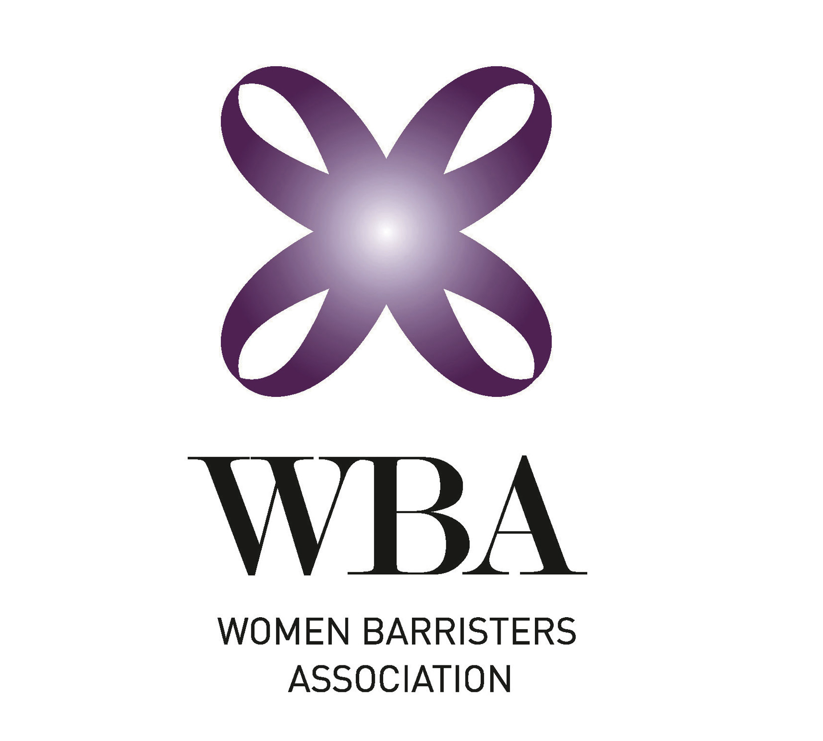
11 March 2014
Victoria Legal Aid
By email: highqualitytrials@vla.vic.gov.au
Women Barristers Association Response
Victoria Legal Aid Consultation and Options Paper: Delivering High Quality Criminal Trials
This submission is in response to the Victoria Legal Aid Consultation and Options Paper: Delivering High Quality Criminal Trials. The Women Barristers Association (WBA) is an independent association of women at the Victorian Bar. Many of our members are talented criminal law barristers providing high quality representation in legally aided matters.
The Criminal Bar Association and the Victorian Bar has submitted a detailed response to the Consultation Paper. WBA supports the submissions contained within the Victorian Bar Response. The purpose of this response is to supplement those submissions.
There are many talented women at the Victorian Bar, at both the junior and senior level. Such barristers have earned positive reputations for their advocacy skill, legal knowledge and thorough preparation. For example, many women barristers were selected to join the Victoria Legal Aid (VLA) Trial Counsel Development Program. Briefing women at the Victorian Bar also ensures that VLA clients have access to specialist advocates with a diverse range of skills and experiences.
WBA acknowledges VLA is committed to equitable briefing. VLA made a commitment to briefing more women in significant cases and briefing advocates in a more transparent manner in its Strategic Plan 2011-2014. This commitment was reiterated in the Annual Report 2012-2013, which stated that VLA seeks to improve its briefing practices by equitably briefing barristers who are women or from an Indigenous background.
We submit that transparent briefing practices, and the policy of equitable briefing, underpins the provision of high quality criminal trials. Trials and major trials can and are run effectively, and efficiently, by women at the Victorian Bar. In addition, many women barristers have demonstrated a commitment to serving VLA clients by providing high quality representation in summary matters. It is in the interests of both clients and VLA that these women barristers are identified and encouraged to undertake indictable work.
Kind regards,
Diana Price
Convenor
Women Barristers Association

